2. Tourism Services

2.1 Tourist Information Centre (TIC) - Reported by Shirley

2.1.1 Monthly Sales Figures for TIC (April – August 2022)

Merchandise
Month | Total Sales (RM) | Total Profit (RM)
April 2022 | 0.00 | 0.00
May 2022 | 0.00 | 0.00
June 2022 | 297.00 | 130.31
July 2022 | 120.00 | 69.59
August 2022 | 407.00 | 211.06
Total | 824.00 | 410.96

- Due to COVID-19 pandemic, not much sales were recorded from April until August 2022.

    - Number of visitors from April – August 2022 based on TIC visitor record
Month | Number of visitors
April 2022 | 84
May 2022 | 157
June 2022 | 294
July 2022 | 525
August 2022 | 750

- Effective June 2022, TIC resumed requesting tourists to fill up the visitors’ log book.
- Based on the visitors’ log book, below are the countries where the tourists from:
Malaysia, Singapore, Indonesia, Japan, Australia, UK, USA, France, Spain, Germany, Italy, Belgium, Netherlands, South Korea, Thailand, Canada, Philippines, Sweden, Slovakia, Dubai, Switzerland, Brazil, Poland, Ireland, Uruguay, Czech Republic, Argentina, Ecuador, China, Taiwan, Brunei, Romania, India, Holland, Vietnam.

    - SOP: COVID-19 - Precautionary Measure & Guidelines

The following rules are our practises in Tourist Information Centre (TIC):-

- It is compulsory for all the staff and visitors to wear face masks at all times.
- Physical distancing must be practised in the premise at all times.
- “No Handshaking Policy” in the premise.
- All staff and visitors are not required to perform body temperature screening and check-in using MySejahtera app upon arrival from June 2022.
- No limit on number of visitors allowed in the premise at any one time.
- Sanitization and disinfection process implemented after the visitors leave the premise and daily for all common areas.
- All staff are required to do self-tests before resuming work after off days.
    - TIC Updates

Tourist Information Centre (TIC) has replaced a new POS system cash drawer which is out of order and unable to open and not repairable. (Refer picture 1)

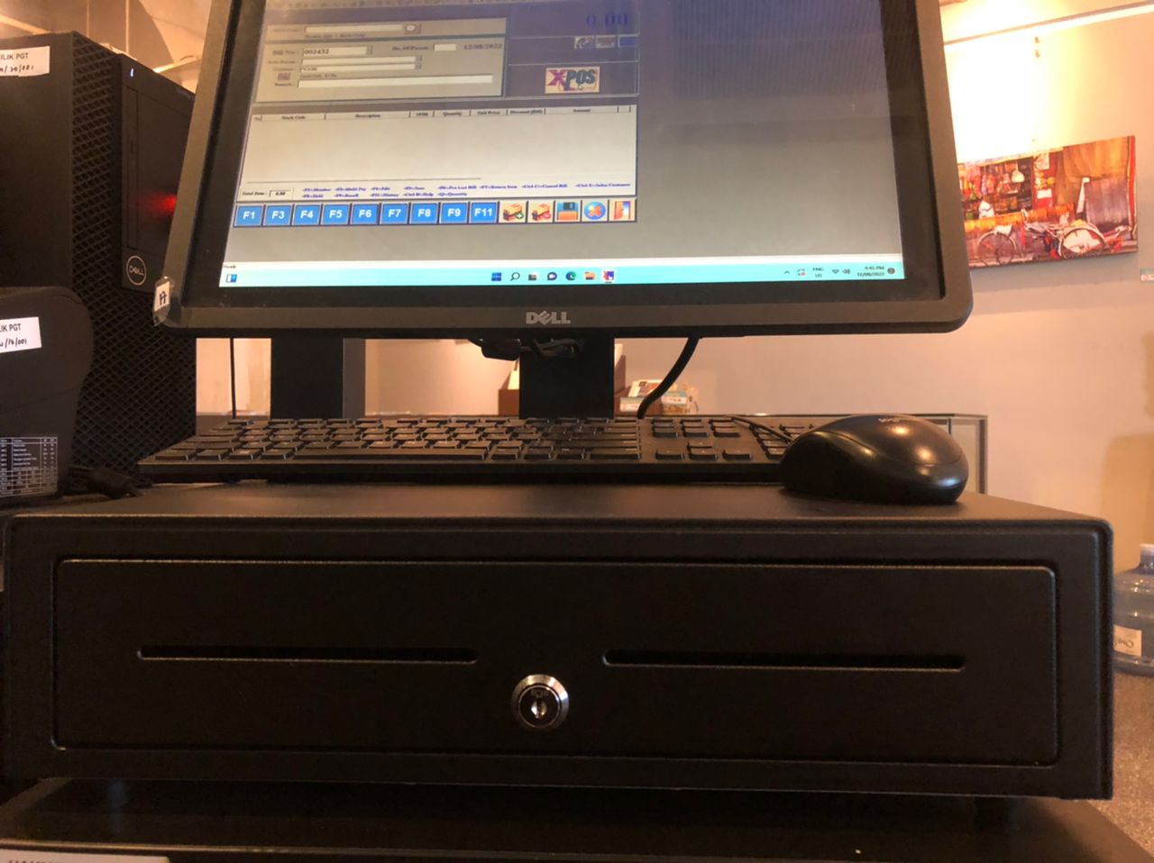
Picture 1

Tourist Information Centre (TIC) front door has replaced the door access power supply which is out of order and installed a new override key switch urgently to function if the door access power supply problem persist in future. (Refer picture 2 & 3)

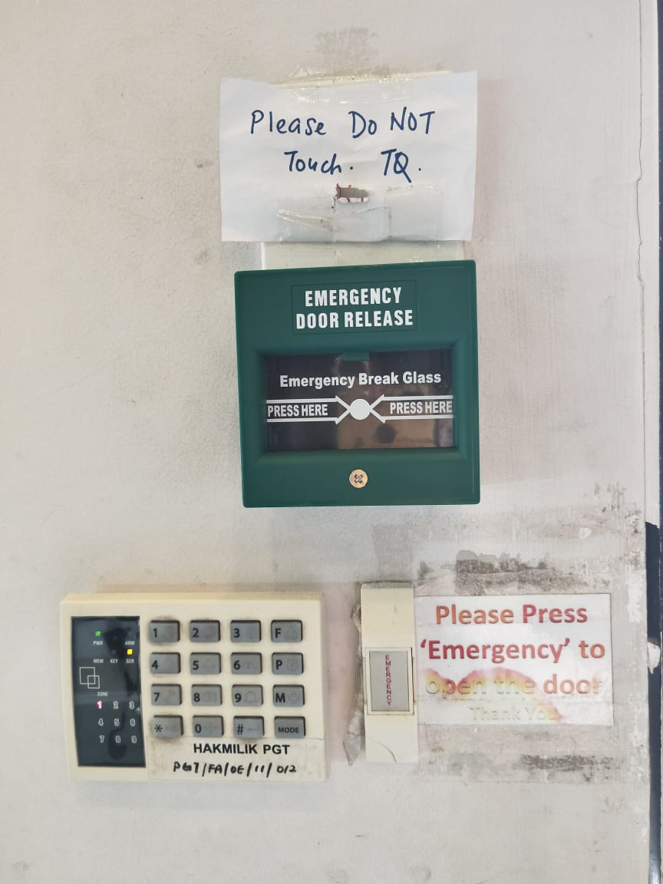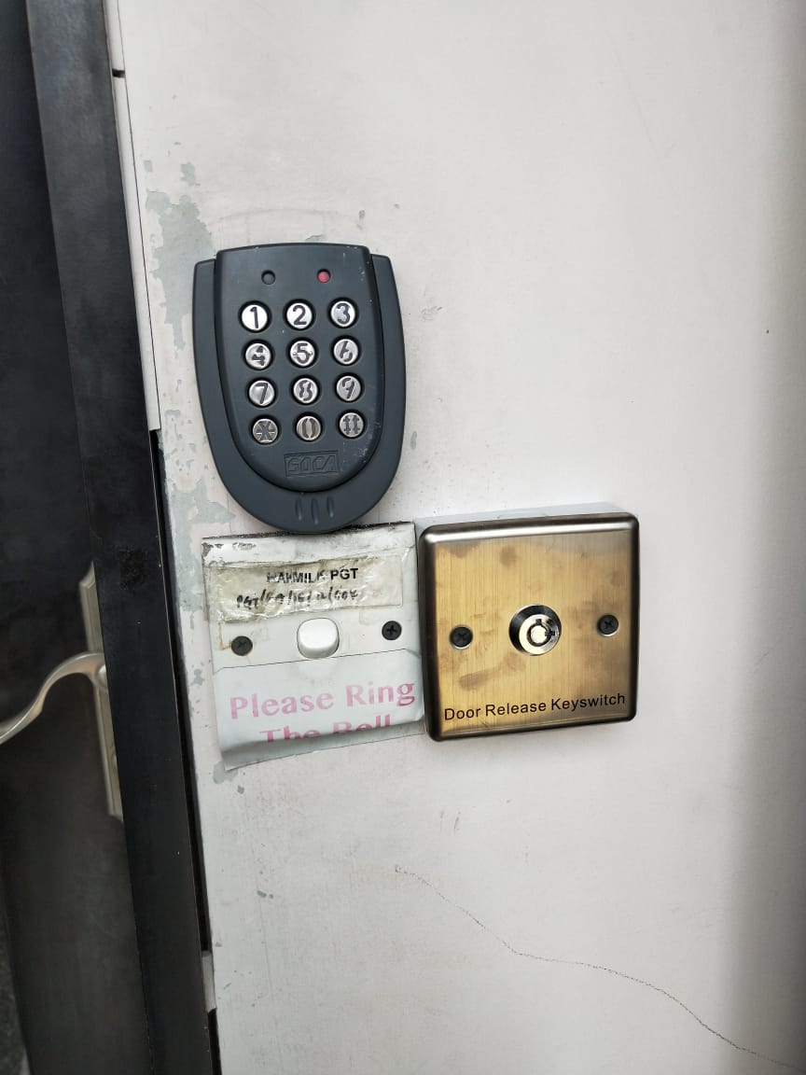
Picture 2
Picture 3

