PICAF Social Media Posting Draft

Date and Time | Content | Caption | Platform | Remarks
26/11/2020  Facebook post  12PM | Repost from PGT account on recent videos about PICAF  Link :  https://www.facebook.com/113833301998405/posts/3434265806621788/ | Who would've guessed that 𝐵𝑎𝑙𝑖𝑘 𝑃𝑢𝑙𝑎𝑢 hides such a amazing secret! 🥰😍😱  Take a moment of your day to virtually explore this 𝑐𝑜𝑛𝑡𝑎𝑖𝑛𝑒𝑟 𝑎𝑟𝑡 at Balik Pulau via a flying drone!  Source: Penang Global Tourism  📍: 𝐾𝑎𝑚𝑝𝑢𝑛𝑔 𝑇𝑒𝑟𝑎𝑛𝑔, 𝐵𝑎𝑙𝑖𝑘 𝑃𝑢𝑙𝑎𝑢  #Picaf2020 #ExperiencePenang2020  #PenangInternationalContainerArtfEstival202 | Facebook
7/12/20  Facebook post  2 PM  15/12/20  Facebook Story  2PM  21/12/20  Instagram Post  11 AM  8/12/20  Instagram Story  11PM | Sharing posts of public photos on Instagram and Facebook posts and story.  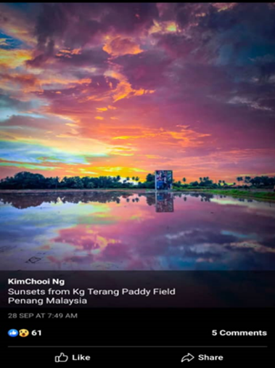 | The only 𝑠𝑢𝑛𝑠𝑒𝑡𝑠 that I dont like are the one I missed. Dont forget to catch the amazing Sunset of Penang in 𝐾𝑎𝑚𝑝𝑢𝑛𝑔 𝑇𝑒𝑟𝑎𝑛𝑔 𝑃𝑎𝑑𝑑𝑦 𝐹𝑖𝑒𝑙𝑑, 𝐵𝑎𝑙𝑖𝑘 𝑃𝑢𝑙𝑎𝑢, 𝑃𝑒𝑛𝑎𝑛𝑔, 𝑀𝑎𝑙𝑎𝑦𝑠𝑖𝑎. 🌄 ☀️📸  📍: 𝐾𝑎𝑚𝑝𝑢𝑛𝑔 𝑇𝑒𝑟𝑎𝑛𝑔, 𝐵𝑎𝑙𝑖𝑘 𝑃𝑢𝑙𝑎𝑢  📸 : KimChooi Ng  #sunsets #Picaf2020 # ExpriencePenang2020  #PenangInternationalContainerArtFestival2020 | Facebook and Instagram
9/12/20  Facebook post  3PM  17/12/20  Facebook Story  3PM  23/12/20  Instagram Post  11 AM  10/12/20  Instagram Story  11 AM | Sharing posts of public photos on Instagram and Facebook posts and story.  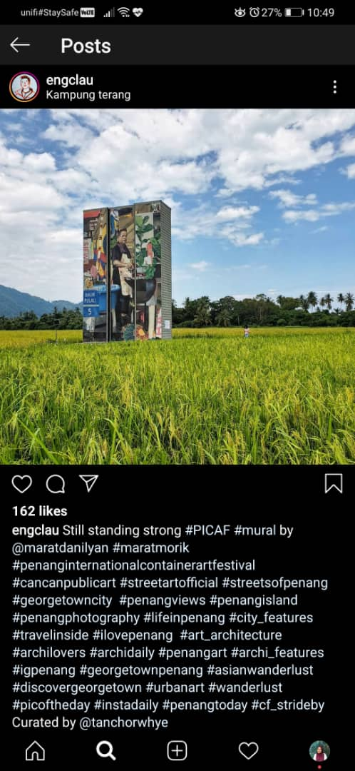 | This art is created to respect the 𝐻𝑎𝑟𝑑𝑤𝑜𝑟𝑘 𝑜𝑓 𝑜𝑢𝑟 𝑃𝑒𝑛𝑎𝑛𝑔 ℎ𝑎𝑤𝑘𝑒𝑟'𝑠 𝑙𝑜𝑐𝑎𝑙 𝑏𝑢𝑠𝑖𝑛𝑒𝑠𝑠 . 😋🍴  Catch the amazing 𝑐𝑜𝑛𝑡𝑎𝑖𝑛𝑒𝑟 𝑎𝑟𝑡𝑤𝑜𝑟𝑘 by artist @maratdanilyan.  Credits to @englau for this amazing shot!  📍: 𝐾𝑎𝑚𝑝𝑢𝑛𝑔 𝑇𝑒𝑟𝑎𝑛𝑔, 𝐵𝑎𝑙𝑖𝑘 𝑃𝑢𝑙𝑎𝑢  #Hawkers #Picaf2020 # ExpriencePenang2020  #PenangInternationalContainerArtFestival2020 | Facebook and Instagram
9/12/20  Facebook post  1PM  19/12/20  Facebook Story  1 PM  25/12/20  Instagram Post  12 PM  12/12/20  Instagram Story  12 PM | Sharing posts of public photos on Instagram and Facebook posts and story.  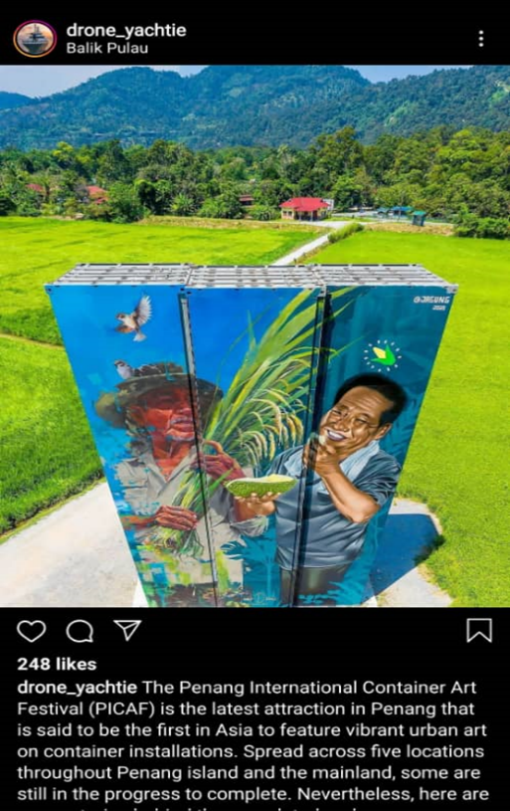 | Another amazing 𝑐𝑜𝑛𝑡𝑎𝑖𝑛𝑒𝑟 𝑎𝑟𝑡𝑤𝑜𝑟𝑘 in 𝐵𝑎𝑙𝑖𝑘 𝑃𝑢𝑙𝑎𝑢. This container art work potrays the ℎ𝑎𝑟𝑑𝑤𝑜𝑟𝑘𝑖𝑛𝑔 f𝑎𝑟𝑚𝑒𝑟𝑠 in Balik Pulau for ℎ𝑎𝑟𝑣𝑒𝑠𝑡𝑖𝑛𝑔 𝑑𝑢𝑟𝑖𝑎𝑛𝑠 𝑎𝑛𝑑 𝑐𝑜𝑟𝑛𝑠🌽🌾☺️  📸: drone_yatchie  📍: 𝐾𝑎𝑚𝑝𝑢𝑛𝑔 𝑇𝑒𝑟𝑎𝑛𝑔, 𝐵𝑎𝑙𝑖𝑘 𝑃𝑢𝑙𝑎𝑢  #Durians #Corn #Picaf2020  # ExpriencePenang2020  #PenangInternationalContainerArtFestival2020 | Facebook and Instagram
14/12/20  Facebook post  4 PM  11/12/20  Facebook Story  3 PM  18/12  Instagram Post  3 PM  22/12  Instagram Story  4 PM | Sharing posts of public photos on Instagram and Facebook posts and story.  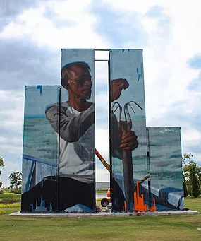  Photo from PicafPenang Website. | This art work shows with a 𝑙𝑜𝑐𝑎𝑙 𝑓𝑖𝑠ℎ𝑒𝑟𝑚𝑎𝑛 𝑠𝑎𝑖𝑙𝑖𝑛𝑔 on a boat who is working at sea will be enough to lead you through seeing and be amazed with the bravery of a man of who is working hard on his job.🐟🌊  Artist : Emmanuel Jarus  📍: Aspen Vision, 𝐵𝑎tu Kawan  #Fisherman #Sea #Picaf2020  # ExpriencePenang2020  #PenangInternationalContainerArtFestival2020 | Facebook and Instagram
16/12/20  Facebook post  2 PM  24/12/20  Facebook Story  3 PM  21/12/20  Instagram Post  12 PM  26/12/20  Instgram Story  12 PM | Information posting on attraction / intresting places around container art areas.  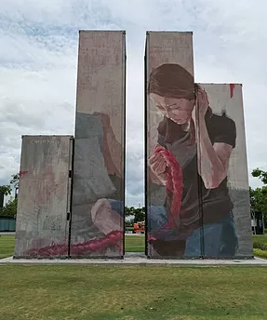  Photo from Picaf Penang Website | 𝐵𝑎𝑡𝑢 𝐾𝑎𝑤𝑎𝑛 was once a sleeping hamlet where the second Penang Bridge now is. The girl is a friend of the artist - grasping on a rope while seating and looking down the ropes on her hands.  This symbolises the 𝑒𝑠𝑡𝑎𝑏𝑙𝑖𝑠ℎ 𝑐𝑜𝑛𝑛𝑒𝑐𝑡𝑖𝑜𝑛 𝑏𝑒𝑡𝑤𝑒𝑒𝑛 𝑡ℎ𝑒 𝑐𝑜𝑛𝑡𝑎𝑖𝑛𝑒𝑟 𝑎𝑛𝑑 𝑎𝑐𝑟𝑜𝑠𝑠 𝑡ℎ𝑒 𝑢𝑛𝑘𝑛𝑜𝑤𝑛.  Artist : Caryn Koh  📍: Aspen Vision, Batu Kawan  #Connections #SecondPenangBridge  #Penang #Picaf2020  # ExpriencePenang2020  #PenangInternationalContainerArtFestival2020 | Facebook and Instagram

