PICAF Social Media Posting Draft

Date and Time | Content | Caption | Platform | Remarks
17/12/20  Facebook post and story  3PM  Instagram post and story  7PM | Sharing posts of public photos on Instagram and Facebook posts and story.  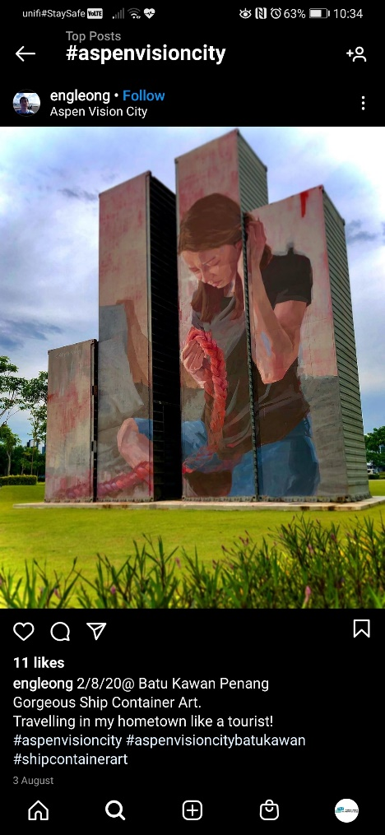 | 𝐵𝑎𝑡𝑢 𝐾𝑎𝑤𝑎𝑛 was once a sleeping hamlet where the second Penang Bridge now is. The girl is a friend of the artist - grasping on a rope while seating and looking down the ropes on her hands.  This symbolises the 𝑒𝑠𝑡𝑎𝑏𝑙𝑖𝑠ℎ 𝑐𝑜𝑛𝑛𝑒𝑐𝑡𝑖𝑜𝑛 𝑏𝑒𝑡𝑤𝑒𝑒𝑛 𝑡ℎ𝑒 𝑐𝑜𝑛𝑡𝑎𝑖𝑛𝑒𝑟 𝑎𝑛𝑑 𝑎𝑐𝑟𝑜𝑠𝑠 𝑡ℎ𝑒 𝑢𝑛𝑘𝑛𝑜𝑤𝑛.  Source: PICAF Website  Artist : Caryn Koh  📍: Aspen Vision, Batu Kawan  📸: engleong  #Connections #SecondPenangBridge  #Penang #PICAF2020  # ExpriencePenang2020  #PenangInternationalContainerArtFestival2020 | Facebook and Instagram | Done (7/1/2021)
19/12/20  Facebook post and story  3PM  Instagram post and story  8PM | Sharing posts of public photos on Instagram and Facebook posts and story.  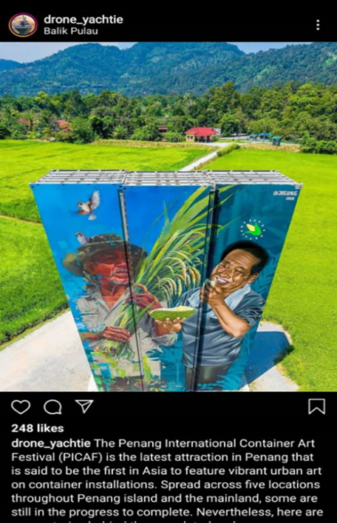 | Another amazing 𝑐𝑜𝑛𝑡𝑎𝑖𝑛𝑒𝑟 𝑎𝑟𝑡𝑤𝑜𝑟𝑘 in 𝐵𝑎𝑙𝑖𝑘 𝑃𝑢𝑙𝑎𝑢. This container art work potrays the ℎ𝑎𝑟𝑑𝑤𝑜𝑟𝑘𝑖𝑛𝑔 f𝑎𝑟𝑚𝑒𝑟𝑠 in Balik Pulau for ℎ𝑎𝑟𝑣𝑒𝑠𝑡𝑖𝑛𝑔 𝑑𝑢𝑟𝑖𝑎𝑛𝑠 𝑎𝑛𝑑 𝑐𝑜𝑟𝑛𝑠🌽🌾☺️  📸: drone_yatchie  📍: 𝐾𝑎𝑚𝑝𝑢𝑛𝑔 𝑇𝑒𝑟𝑎𝑛𝑔, 𝐵𝑎𝑙𝑖𝑘 𝑃𝑢𝑙𝑎𝑢  #Durians #Corn #PICAF2020  # ExpriencePenang2020  #PenangInternationalContainerArtFestival2020 | Facebook and Instagram | Done (6/1/2021)
31/12/20  Facebook post and story  1PM  Instagram post and story  8PM | Sharing posts of public photos on Instagram and Facebook posts and story.  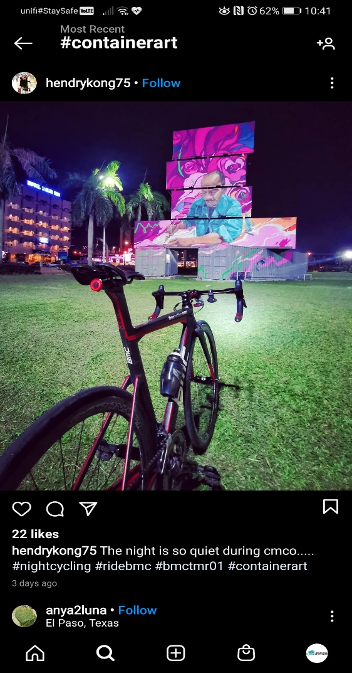 | 𝑇ℎ𝑒 𝑎𝑟𝑡 𝑜𝑓 𝐶𝑟𝑎𝑓𝑡𝑖𝑛𝑔 𝐵𝑒𝑎𝑑𝑒𝑑 𝑆ℎ𝑜𝑒𝑠 (𝐾𝑎𝑠𝑢𝑡 𝑀𝑎𝑛𝑒𝑘)👠  A collaborative artwork by a Penangnite-Abdulrashade and Malacca based artist Andharas despicts 𝑎 𝑙𝑜𝑐𝑎𝑙 𝑎𝑟𝑡𝑖𝑠𝑎𝑛 𝑝𝑎𝑖𝑛𝑡𝑖𝑛𝑔 𝑏𝑎𝑡𝑖𝑘. Painting batik involves several processes. Despite the time consuming process, some passionate artisans remains loyal to the traditional craftsmanship and still insists on handcrafting batik to conserve traditional art. 🌸  Source: PICAF website  📍: Dataran Pemuda Merdeka  📸: hendrykong75  #Batik #Artisans #Traditionalart #Loyalty #Penang #PICAF2020  # ExpriencePenang2020  #PenangInternationalContainerArtFestival2020 | Facebook and Instagram Posting
2/1/21  Facebook post and story  12PM  Instagram post and story  8PM | Sharing posts of public photos on Instagram and Facebook posts and story.  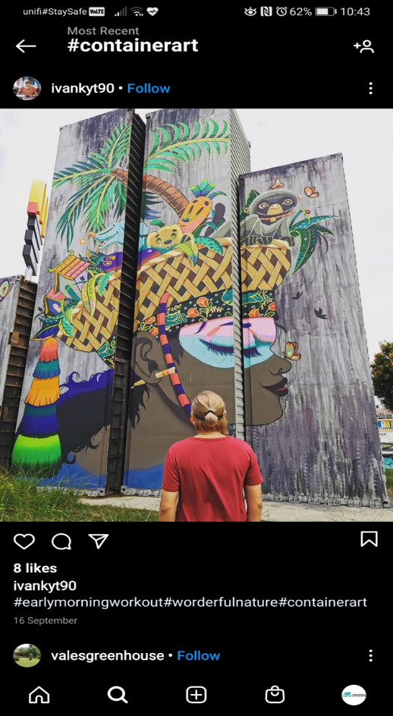 | Title: Preserving Cultural Roots for Sustainability  Artist: Kenji Chai  The subject of this colourful piece is to highlight 𝑚𝑢𝑙𝑡𝑖𝑐𝑢𝑙𝑡𝑢𝑟𝑖𝑠𝑚 in Penang.  The mural features a girl with a blissful smile, wearing a Batik headband and balancing basket containing images closely associated with Penang such as Pinang tree and dusky leaf monkey🌴🐒  Source: PICAF website.  📍: Karpal Singh, Drive  📸: ivankyt90  #Batik #Multiculturism #Pinangtree #Monkey #Penang #Traditionalart #Loyalty #Penang #PICAF2020  # ExpriencePenang2020  #PenangInternationalContainerArtFestival2020
4/1/21  Facebook post and story  1PM  Instagram post and story  8PM | Post and Credit Photos from those who take picture at Dataran Pemuda Merdeka, Butterworth  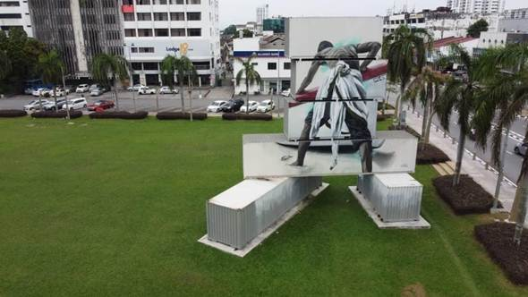 | Tittle: Fire  Artists: Judith De Leeu  The mural shows a 𝑓𝑖𝑠ℎ𝑒𝑟𝑚𝑎𝑛 pushing his boat into the water with his last remaining energy💪🏻. His passion and love for the job is the burning flame 🔥 inside the fisherman, that motivates him into the wild water every day to face his challenges. 🌊  This mural is a compelling visual story about the fire in us to pursue our passion and love, no matter what circumstances, exhaustion and danger. 🔥💪🏻💪🏻  📍 : Dataran Pemuda Merdeka  #Fisherman #Flameinus #Passion #Love #Loyalty  #Penang #PICAF2020  # ExpriencePenang2020  #PenangInternationalContainerArtFestival2020 | Facebook and instagram
6/1/21  Facebook post and story  1PM  Instagram post and story  8PM | Sharing Videos about PICAF from Youtube.  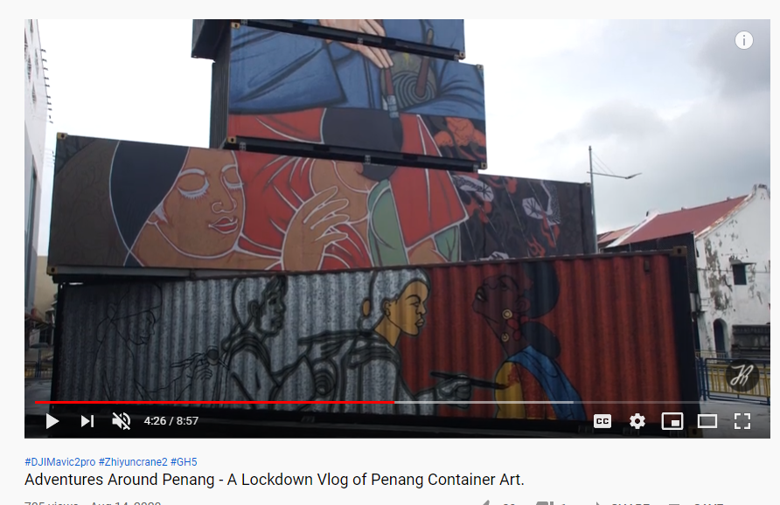 | Check out various Penang’s amazing container art through a drone shot through Jack’s adventure vlog in Penang!  Credits: Jackrubycrew  Link :  https://www.youtube.com/watch?v=thdTurkAA4g&ab_channel=jackrubycrew  #Penang #PICAF2020  # ExpriencePenang2020  #PenangInternationalContainerArtFestival2020 | Facebook and Instagram

