PICAF Social Media Posting Draft

Date and Time | Content | Caption | Platform | Remarks
26-11-2020  12 PM | Repost from PGT account on recent videos about PICAF  Link :  https://www.facebook.com/113833301998405/posts/3434265806621788/ | Who would've guessed that 𝐵𝑎𝑙𝑖𝑘 𝑃𝑢𝑙𝑎𝑢 hides such a amazing secret! 🥰😍😱  Take a moment of your day to virtually explore this 𝑐𝑜𝑛𝑡𝑎𝑖𝑛𝑒𝑟 𝑎𝑟𝑡 at Balik Pulau via a flying drone!  Source: Penang Global Tourism  📍: 𝐾𝑎𝑚𝑝𝑢𝑛𝑔 𝑇𝑒𝑟𝑎𝑛𝑔, 𝐵𝑎𝑙𝑖𝑘 𝑃𝑢𝑙𝑎𝑢  #Picaf2020 #ExperiencePenang2020  #PenangInternationalContainerArtfEstival202 | Facebook
27-11-2020  12 PM | Sharing posts of public photos on Instagram and Facebook posts and story.  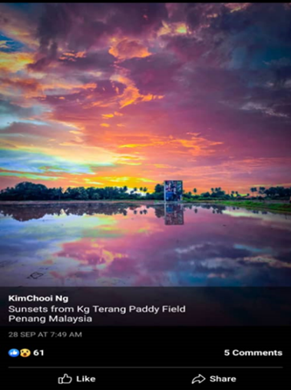 | The only 𝑠𝑢𝑛𝑠𝑒𝑡𝑠 that I dont like are the one I missed. Dont forget to catch the amazing Sunset of Penang in 𝐾𝑎𝑚𝑝𝑢𝑛𝑔 𝑇𝑒𝑟𝑎𝑛𝑔 𝑃𝑎𝑑𝑑𝑦 𝐹𝑖𝑒𝑙𝑑, 𝐵𝑎𝑙𝑖𝑘 𝑃𝑢𝑙𝑎𝑢, 𝑃𝑒𝑛𝑎𝑛𝑔, 𝑀𝑎𝑙𝑎𝑦𝑠𝑖𝑎. 🌄 ☀️📸  📍: 𝐾𝑎𝑚𝑝𝑢𝑛𝑔 𝑇𝑒𝑟𝑎𝑛𝑔, 𝐵𝑎𝑙𝑖𝑘 𝑃𝑢𝑙𝑎𝑢  📸 : KimChooi Ng  #sunsets #Picaf2020 # ExpriencePenang2020  #PenangInternationalContainerArtFestival2020 | Facebook and Instagram
03-12-20  12PM | Sharing posts of public photos on Instagram and Facebook posts and story.  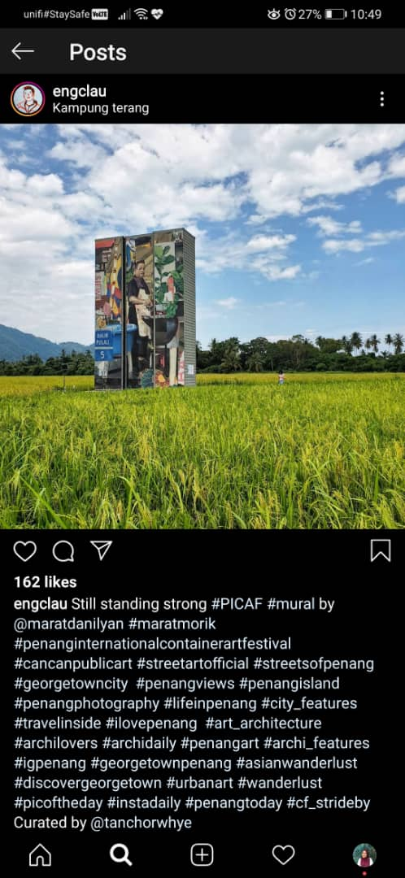 | This art is created to respect the 𝐻𝑎𝑟𝑑𝑤𝑜𝑟𝑘 𝑜𝑓 𝑜𝑢𝑟 𝑃𝑒𝑛𝑎𝑛𝑔 ℎ𝑎𝑤𝑘𝑒𝑟'𝑠 𝑙𝑜𝑐𝑎𝑙 𝑏𝑢𝑠𝑖𝑛𝑒𝑠𝑠 . 😋🍴  Catch the amazing 𝑐𝑜𝑛𝑡𝑎𝑖𝑛𝑒𝑟 𝑎𝑟𝑡𝑤𝑜𝑟𝑘 by artist @maratdanilyan.  Credits to @englau for this amazing shot!  📍: 𝐾𝑎𝑚𝑝𝑢𝑛𝑔 𝑇𝑒𝑟𝑎𝑛𝑔, 𝐵𝑎𝑙𝑖𝑘 𝑃𝑢𝑙𝑎𝑢  #Hawkers #Picaf2020 # ExpriencePenang2020  #PenangInternationalContainerArtFestival2020 | Facebook and Instagram
04-12-20  12 PM | Sharing posts of public photos on Instagram and Facebook posts and story.  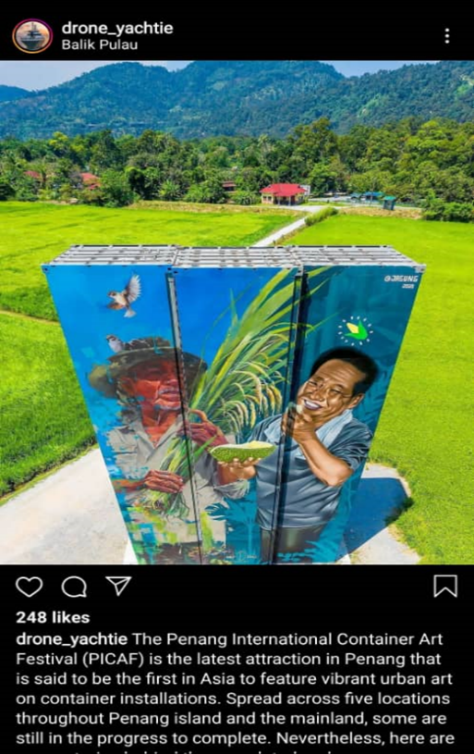 | Another amazing 𝑐𝑜𝑛𝑡𝑎𝑖𝑛𝑒𝑟 𝑎𝑟𝑡𝑤𝑜𝑟𝑘 in 𝐵𝑎𝑙𝑖𝑘 𝑃𝑢𝑙𝑎𝑢. This container art work potrays the ℎ𝑎𝑟𝑑𝑤𝑜𝑟𝑘𝑖𝑛𝑔 f𝑎𝑟𝑚𝑒𝑟𝑠 in Balik Pulau for ℎ𝑎𝑟𝑣𝑒𝑠𝑡𝑖𝑛𝑔 𝑑𝑢𝑟𝑖𝑎𝑛𝑠 𝑎𝑛𝑑 𝑐𝑜𝑟𝑛𝑠🌽🌾☺️  📸: drone_yatchie  📍: 𝐾𝑎𝑚𝑝𝑢𝑛𝑔 𝑇𝑒𝑟𝑎𝑛𝑔, 𝐵𝑎𝑙𝑖𝑘 𝑃𝑢𝑙𝑎𝑢  #Durians #Corn #Picaf2020  # ExpriencePenang2020  #PenangInternationalContainerArtFestival2020 | Facebook and Instagram
10-12-20  12 PM | Sharing posts of public photos on Instagram and Facebook posts and story.  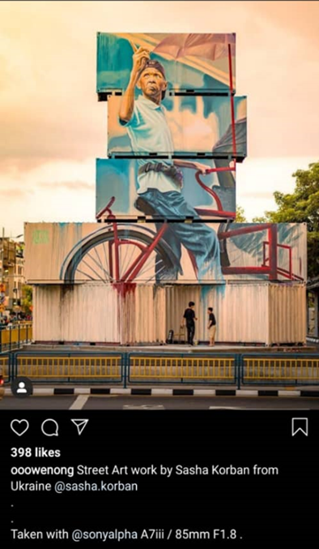 | This container art is specialy featuring one of 𝑃𝑒𝑛𝑎𝑛𝑔'𝑠 𝑓𝑎𝑚𝑜𝑢𝑠 𝑡𝑟𝑖𝑠ℎ𝑎𝑤 𝑟𝑖𝑑𝑒𝑠😉 by @sasha.korban  📍: 𝐾𝑎𝑚𝑝𝑢𝑛𝑔 𝑇𝑒𝑟𝑎𝑛𝑔, 𝐵𝑎𝑙𝑖𝑘 𝑃𝑢𝑙𝑎𝑢  📸:@ooowenong  #Trishawrides #Penang #Picaf2020  # ExpriencePenang2020  #PenangInternationalContainerArtFestival2020 | Facebook and Instagram
11-12-20  12 PM | Information posting on attraction / intresting places around container art areas.  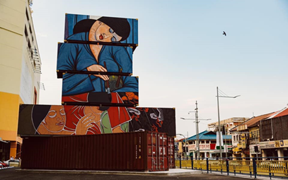 | Catch this amazing 𝑐𝑜𝑛𝑡𝑎𝑖𝑛𝑒𝑟 𝑎𝑟𝑡 nearby Prangin Mall which pays a tribute to the late 𝐶ℎ𝑢𝑎ℎ 𝑇ℎ𝑒𝑎𝑛 𝑇ℎ𝑒𝑛𝑔 a Malaysian artist who contributes to 𝐵𝑎𝑡𝑖𝑘 𝑝𝑎𝑖𝑛𝑡𝑖𝑛𝑔 𝑡𝑒𝑐ℎ𝑛𝑖𝑞𝑢𝑒𝑠.🌸  Beside this container art, you can find many eateries such as restaurants,cafes and hotels nearby🍴🏨.  Plus, Prangin Mall is nearby a few walking distance 🚶‍♂️🚶🏻‍♀️ shopping malls such as Komtar and First Avenue.🛍️🛒  Photo taken from PICAF facebook page.  📍: 𝑃𝑟𝑎𝑛𝑔𝑖𝑛 𝑀𝑎𝑙𝑙,𝑃𝑒𝑛𝑎𝑛𝑔, 𝑀𝑎𝑙𝑎𝑦𝑠𝑖𝑎  #Tribute #Batik #Penang #Picaf2020  # ExpriencePenang2020  #PenangInternationalContainerArtFestival2020

