KTMB Brochure Rack
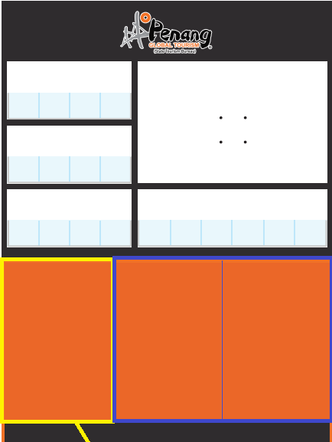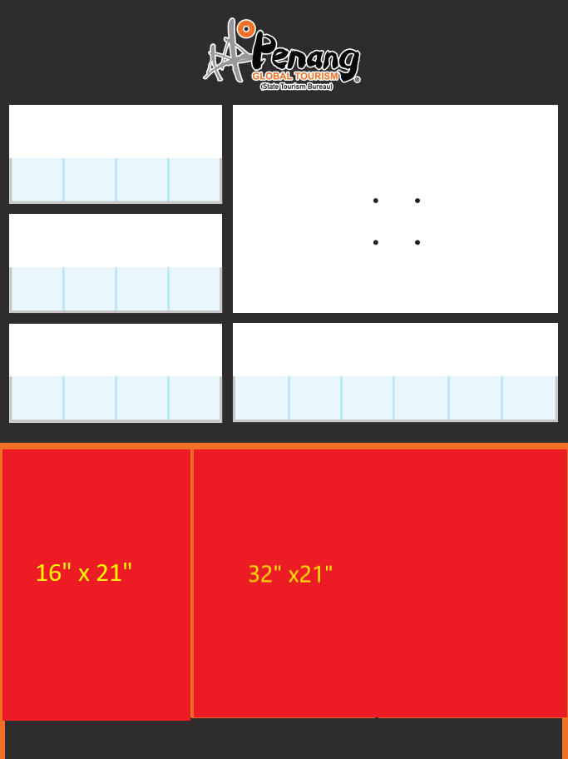
2 Doors for 1 Current campaign poster
1 Door for Permanent information
32” x 21”
These 3 panels are storage compartments doors for brochures; hence, the measurements are not the same compare to Penang Sentral brochure rack. That is why it is divided to 1/3 and 2/3. Thus, it will not be the same to follow the top alignment.
16” x 21”
16” x 21”
16” x 21”

