GUIDES & INFORMATION PROVIDING AT VARIOUS ENTRY POINTS

INTRODUCTION
Similar to what it was done in Penang International Airport (PIA), Penang Global Tourism (PGT) is looking at enhancing the entry point in Penang by providing guides and directions for a better journey planning of the travellers. It will also serve as a platform highlighting the promotional campaigns and videos of Penang at the various entry Points.

The entry points include:
- Penang Sentral
- KTM Butterworth Station
- Ferry terminal Pengkalan Sultan Abdul Halim
- Sg Nibong Bus Terminal
- Swetteham Pier, Penang Port

PENANG SENTRAL
A brochure racks similar with the concept design of rack at Penang International Airport will be place at Penang Sentral respectively. The racks will be equipped with a LED panel / TV to display the tourism promotional videos and promotional campaigns, other than that, it will also have partitions for brochures as well as information panel to promote Seberang Perai.
The management of Penang Sentral agreed with the measurement 6ft (W) x 6ft (H) x 2ft (L) to place the customized brochure rack at the Penang Sentral information counter, Level 2. The suggested location is the perfect and strategic pathway from KTM Butterworth to Ferry Terminal Pengkalan Sultan Abdul Halim.
Followings are the concept design for Penang Sentral brochure rack:
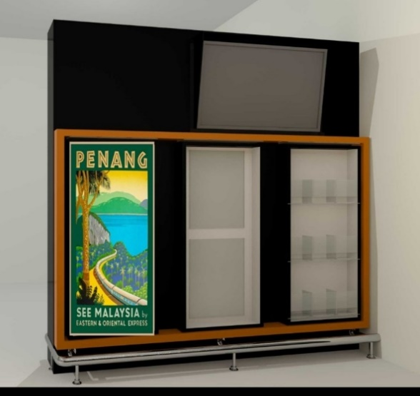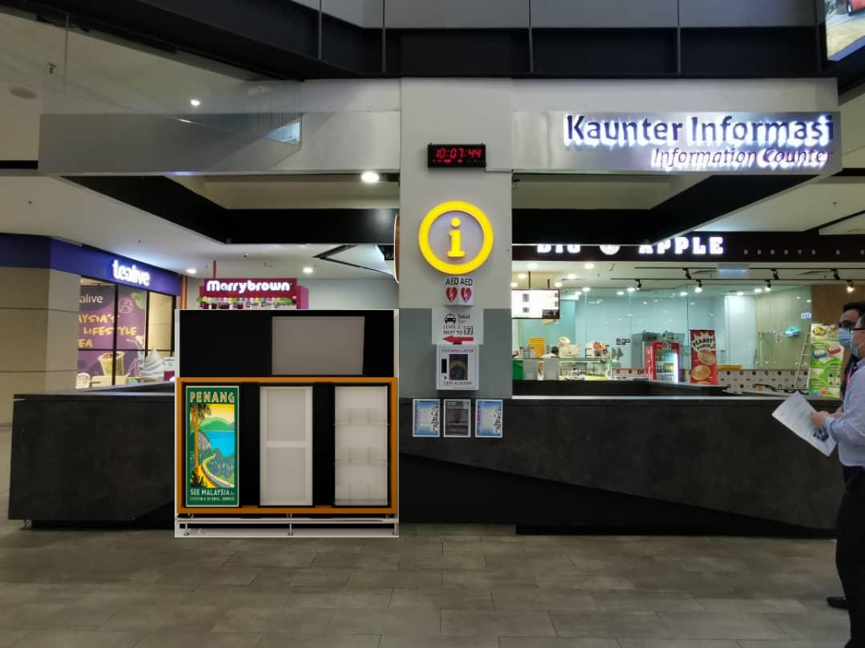
Suggested timeline to place and install the customize brochure rack approximately in the mid of December 2020 until further notice. PGT also requested to place the brochure rack for 1 year, from January 2021 – December 2021. Any further application for placement of the brochure rack, PGT will request it if required.

  - KTM Butterworth
As for the KTM Butterworth, the concept design is similar to the Penang Sentral brochure rack, however, the rack that will be provided for KTM Butterworth will be modified according to the size and height space allowed by the KTM Butterworth management.
Suggested places sent to KTM Butterworth to place the brochure rack are as follows:
- Second floor near elevator door and stairs
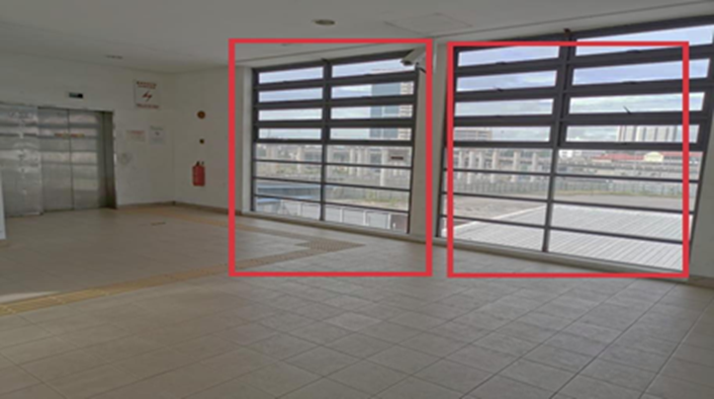
- At the pathway before the ticketing counter

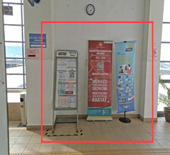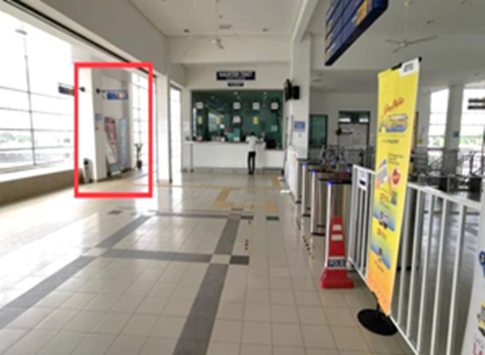

A reply from KTM Butterworth on PGT’s request is yet to be confirmed by them as there are many structural layers of procedure before approval. Suggested timeline to place the brochure rack is before the end of 2020 until further notice.

  - Ferry Terminal (Pengkalan Sultan Abdul Halim)
For the Ferry Terminal at Pengkalan Sultan Abdul Halim (PSAH), PGT will be utilizing 2 advertising space/panels by Rapid Ferry located at the passenger waiting area. Two panels that will be utilized with measurements and information details with superimpose design on the panel as follows:
Panel 1: Focus on Bus route information from Ferry Terminal Pengkalan Raja Tun Uda and Penang Map of attraction’s nearby
Measurement: 99.75”(W) x 52.5”(H)
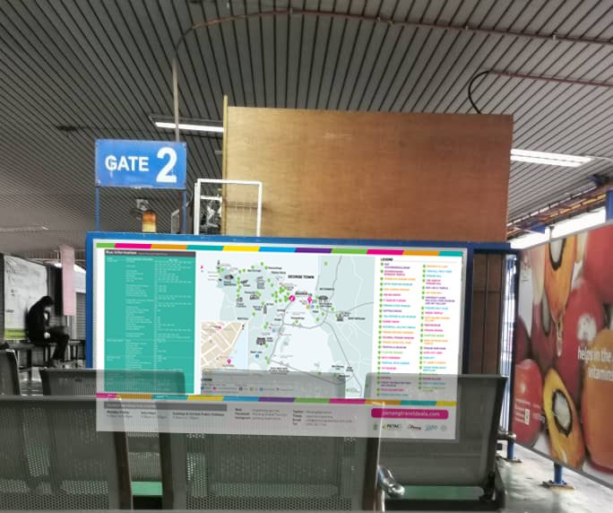

Panel 2: Focus on Jom! Experience Penang Campaign and Penang Travel Deals
Measurement: 147”(W) x 65”(H)
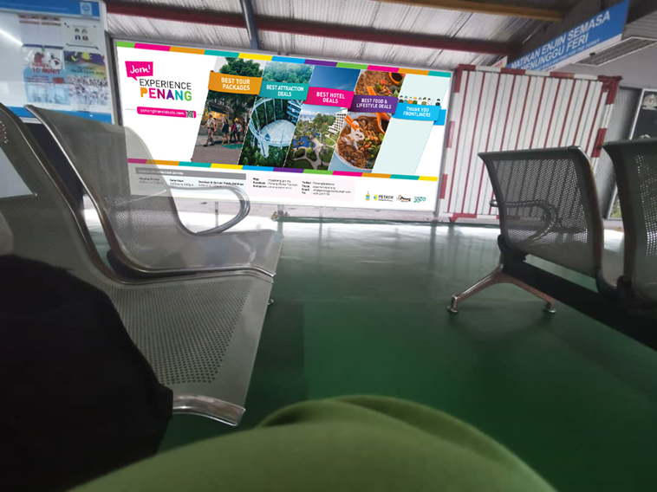

The rental for the advertising panels last for a month (December 2020), as the ferry terminal handle by Rapid Ferry will be changed to a new management company. Therefore, PGT will make new rental arrangement once the change has been with the concerning party. Installation of PGT’s printing advertisement has been set on Wednesday, 2 December 2020 at 10.30 am.

  - Sungai Nibong Bus Terminal
Sungai Nibong Bus Terminal is one of the entry points that served as one of the main hub for Penangites especially for bus express services and inter-city bus services. PGT plans to utilize 3 information panels available located at Rapid Penang bus stop in Sg Nibong Bus Terminal that showcase a strategic place to display Penang state tourism-related information.
Information on Penang state tourism that will be displayed on the 3 panels are map of Penang, nearby attractions, list of emergency telephone numbers and Penang State tourism promotion campaign. The measurement for each panels is 52”(W) x 29”(H).
The following photo is the 3 panels PGT would like to utilize in Sg Nibong Bus Terminal:
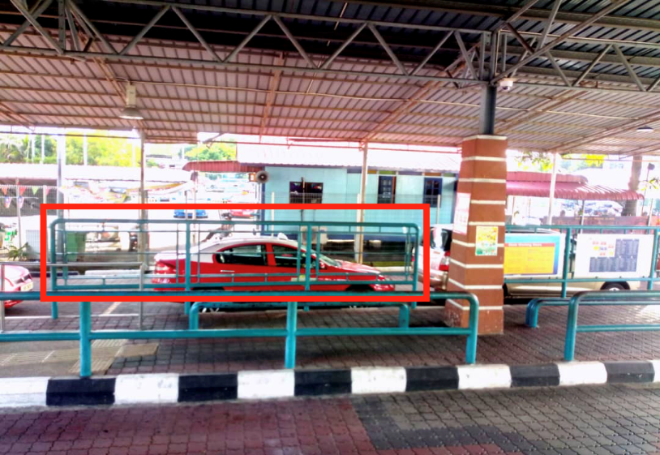
PGT requested to Rapid Penang about the placing of the 3 information panels for 1 year. Additionally, the information displayed are not for commercial purposes, which PGT also requested to exclude any charged fees by Rapid Penang. The suggested timeline to install these information panels are by the end of year 2020.
  - Swettenham Pier, Penang Port
Swettenham Pier, Penang Port is a hub port for passengers or tourist that arrived in Penang by cruise ship. As of that, PGT plans to refurbish the brochure stalls that was placed at Penang Port. Refurbishing the brochure stalls such as replacing to new and sturdier tires, cleaning and polishing along with changing to new artworks on the 4 sides. The following are the changes that has been done to the brochure stalls:
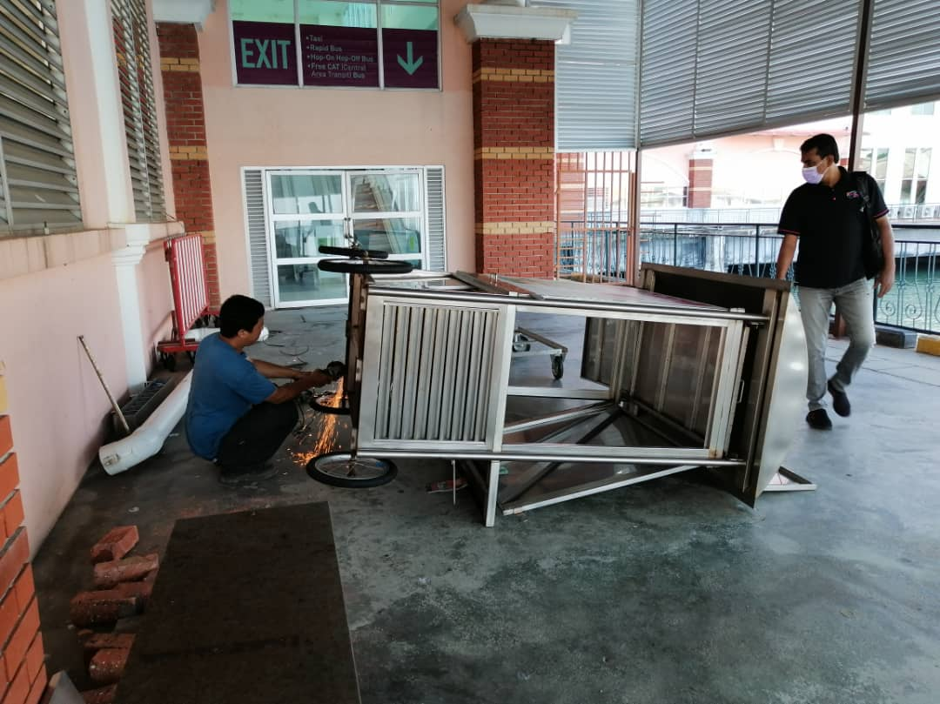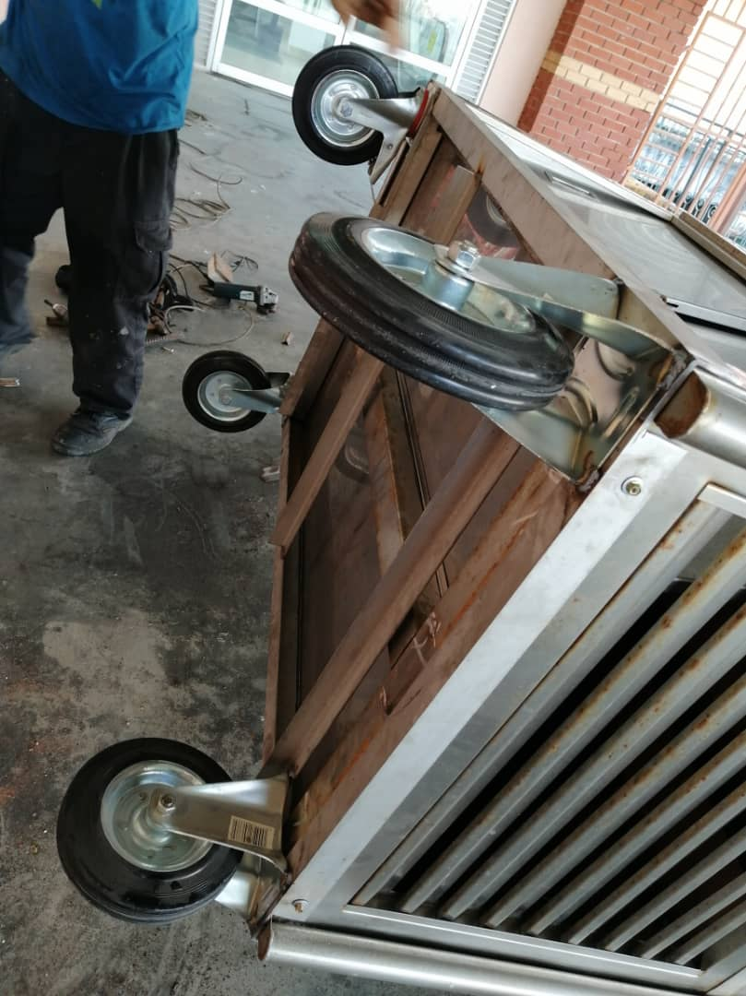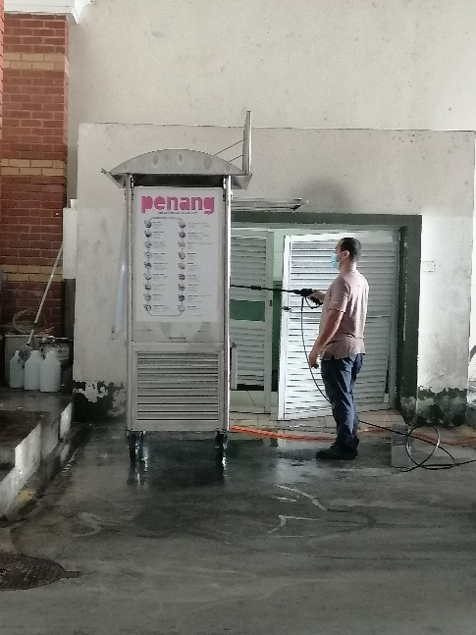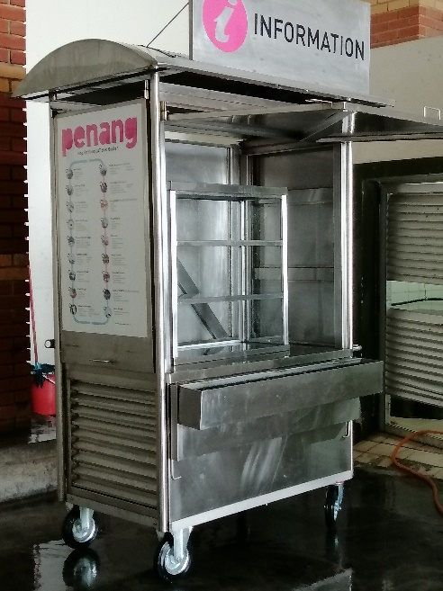
Once the changes have been done, the brochure stall will then be placed indoors for safekeeping due to avoiding it from rusting and will be placed out in the open when the cruise trip resume once more.
  - Supporting Cost for Enhancing Entry Points
The total supporting cost for enhancing entry points is RM 51,500 which is part of PGT’s budget for 2020. The detailed breakdown for the supports is as below:
No | ITEMs | RM
1 | KTM Butterworth Station  - To have a brochure rack similar concept with PIA | 20,000
2 | Penang Sentral  - To have a brochure rack similar concept with PIA | 20,000
3 | Ferry Terminal (Pengkalan Sultan Abdul Hamid)  - Information board at existing advertising slot | 5,000
4 | Sg Nibong Bus Terminal  - Information board at existing advertising slot | 5,000
5 | Swettenham Pier, Penang Port  - Touch up and maintenance of the existing brochure display and storage cart | 1,500
 | TOTAL | 51,500

