1.0 COVID-19 SAFETY ACCREDITATION
1.1 AUDITING PROCESS
The auditing process continues as per the details below:
Hotels | Attractions | Shopping Malls
Air Itam (30 July 2020)
 | Penang Hill Corporation
 | The Habitat
 | David Brown’s Restaurant
George Town (5 & 6 August 2020)
Cititel Express
Wembley
Jen Hotel
M Summit
Macalister Hotel
Travelodge Hotel
Red Rock Hotel
Seberang Perai (10 August 2020)
Ixora Hotel |  | Sunway Carnival Mall
 |  | Design Village
George Town (12, 17 August 2020)
Hutton Central | The TOP
Ropewalk Piazza Hotel
The Edison
Campbell House
Areca Hotel
Royal Chulan
The Prestige
Berjaya Hotel
George Town, Bayan Lepas & Batu Feringghi (9 September 2020)
Vouk Hotel
U Hotel
LEXIS Suite Penang
Lone Pine Hotel
Seberang Perai Tengah & Seberang Perai Selatan (14 September 2020)
Galaxy Hotel |  | Juru Auto-City
George Town & Tanjung Bungah (2, 21 October 2020)
Kimberly Hotel George Town
Mercure Penang Beach
Courtyard by Marriott Penang

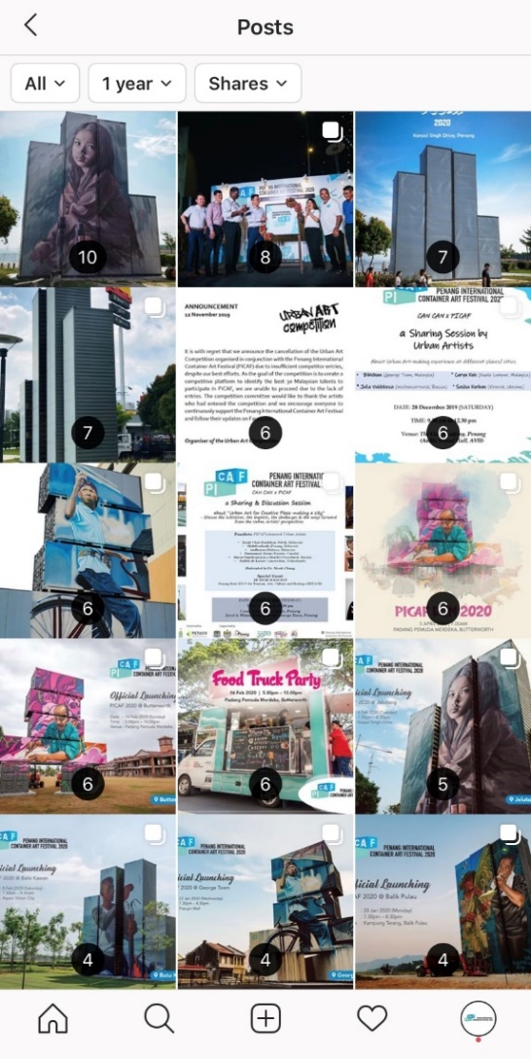
Some photos taken during the accreditation process as follows:
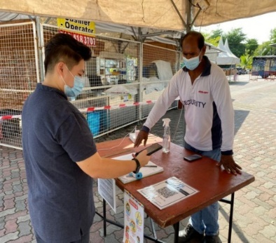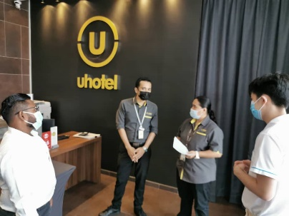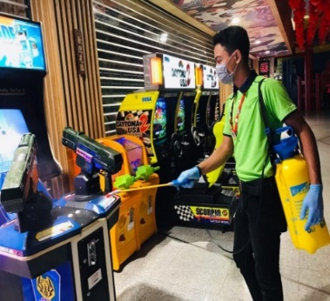
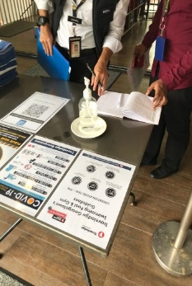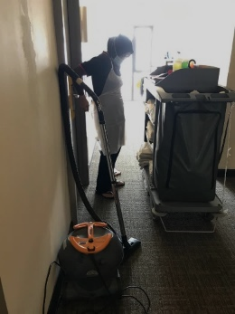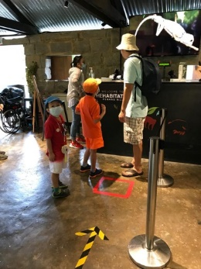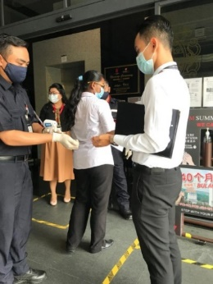

1.2 TOTAL APPLICATION
Until 9 November 2020, there are total 60 applicants have application for COVID-19 Safety Accreditation Program which includes 47 (Hotels) + 7 (Attractions) + 6 (Shopping malls). The listing have been updated at PENANG LAWAN COVID-19 website, https://penanglawancovid19.com/accreditation. The details are as follows:
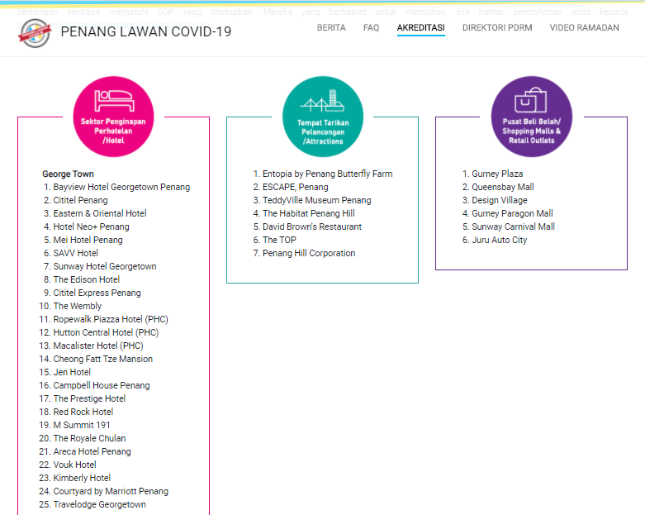
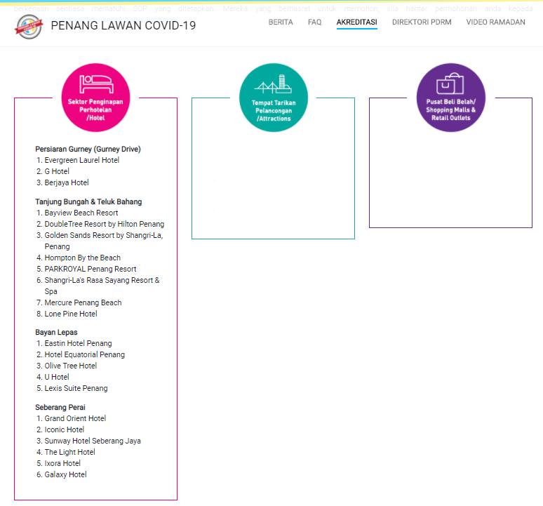

1.3 COVID-19 SAFETY ACCREDITATION CERTIFICATION CEREMONY
The COVID-19 Safety Accreditation Certification Ceremony was organized a second time with the present of Penang Chief Minister, YAB Chow Kon Yeow with the launching of Responsible Tourism campaign. Detail of the ceremony are as follows:

COVID-19 Safety Accreditation Certification Ceremony
Date : 30 July 2020
Time : 2pm - 5pm
Venue : Centre Atrium, Ground floor, Queensbay Mall

Attendees:
Hotels  - Savv Hotel  - Hotel Neo+ Penang  - Cititel Penang  - Eastern & Oriental Hotel  - Mei Hotel  - Sunway Hotel George Town | - Bayview Hotel George Town Penang  - Olive Tree Hotel  - Eastin Hotel Penang  - Hotel Equatorial Penang | Shopping Malls:  Queensbay Mall
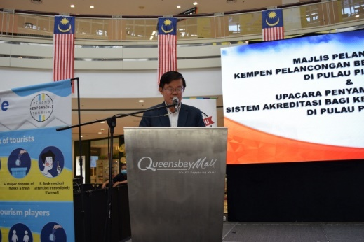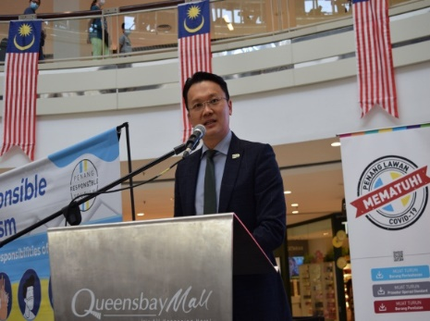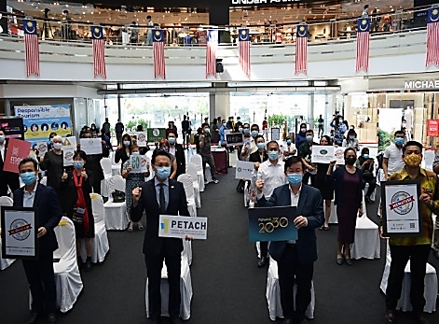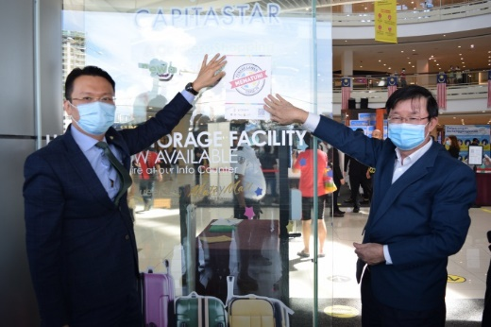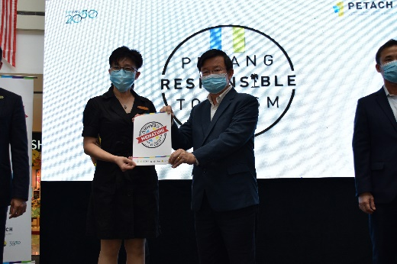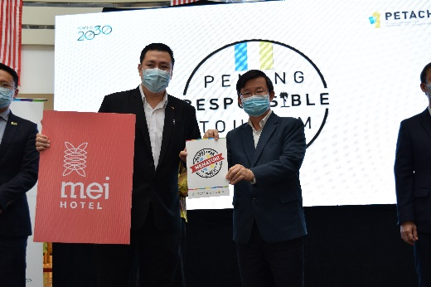

2.0 PENANG TOURISM MASTER PLAN 2020 – 2030 (PGTMP)
2.1 PROGRESS UPDATES

A presentation session was specifically arranged to update and get feedbacks from all the members of Dewan Undangan Negeri, members of Parliaments as well as the PGTSB Board of Directors. This is the last round of engagement before tabling it at Penang State EXCOs meeting for approval. YZD Consult will incorporate the comment collected into the master plan accordingly.

Special Presentation Session for Penang Tourism Master Plan
Date : 12th September 2020 (Saturday)
Time : 12.00 p.m - 4.30 p.m
Venue : Royale Ballroom, Ground Floor, Hotel Royale Chulan
Participants : 26 participants & 20 media representatives

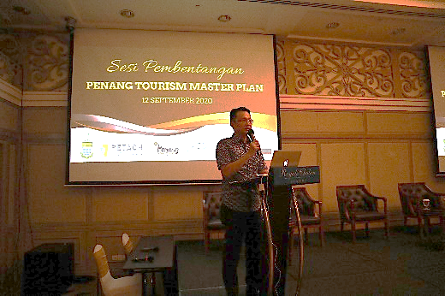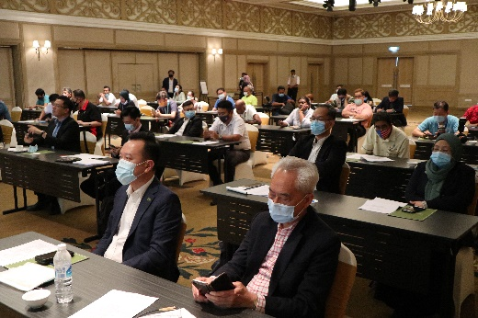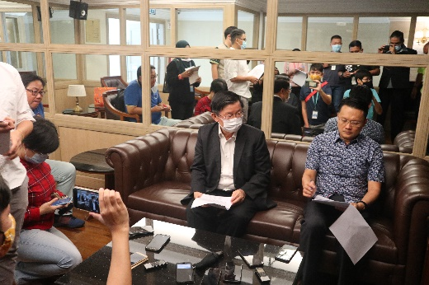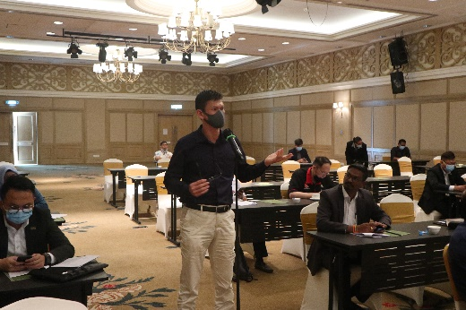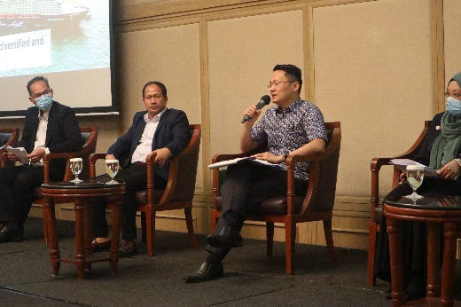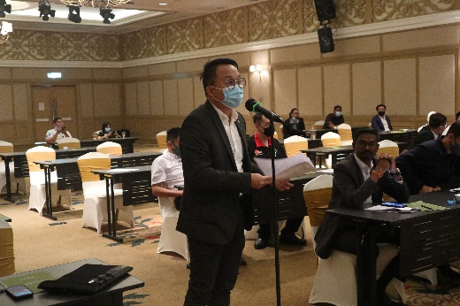

The Penang Tourism Master Plan (PGTMP) is expected to be finalised by the end of this year.
3.0 PENANG INTERNATIONAL CONTAINER ART FESTIVAL (PICAF)
3.1 PROGRESS UPDATES

Due to travel restrictions and the closure of international border, PGTSB has been focusing on domestic tourism. As one of the efforts to promote domestic tourism, PICAF container art installations will be extended until 31 Jan 2022. Unlike festival and celebrations that gather crowd, PICAF will be a long-term project whereby it encourages gradually visit instead of gathering a big crowd at one time. All site events and programme will only be conducted after it is allowed by the government.

The extension of PICAF will be focused in 2 phases as follows:

Phase 1
To extend the container art installation until 31 Dec 2020 at the current location. During this process, CCPA have to request for extension with various land owner every 3 months. At this stage, landowners of all the 5 sites have given their consent to remain the container art installation until 31 Dec 2020.

Phase 2
To extend the container art installation until 31 Jan 2022. During this phase, CCPA is required to:
- Looking for new venue to place the art installation before the landlords decided to discontinue the artwork.
- While searching for new venues, CCPA required to apply for the extension with the landowners every 3 months.
- In the case that we are not able to get extension of PICAF from the landlords, CCPA will look for a temporary location for safekeeping of the container.

The status of the container art installations is summarised as below:

Site | Approval status by land owner | Approval by local council
Karpal Singh Drive | - Agreed to extend until 31 Dec 2020 | - MBPP has agreed with all 3 sites to be extended until end of January 2022
Balik Pulau | - Agreed to extend until 31 Dec 2020  - Further consent to extend beyond that date needed. Request needed to be made every 3 months for consideration.
Prangin Mall | - Agreed to extend until 31 Dec 2020  - Further consent to extend beyond that date needed. Request needed to be made every 3 months for consideration.
Aspen Vision City, Batu Kawan | - Agreed to extend until 31 Dec 2020, however, it is not possible to extend until 31 Dec 2021 as the site will undergo upgrading works.  - Aspen will support by relocating the art piece to a new location, the structure needed to be move when construction work starts. | - MBSP has agreed with all 2 sites to be extended until end of January 2022
Dataran Pemuda Merdeka, Butterworth | - MBSP agreed and allowed to extend until Jan 2022
Relocation
PGTSB have a preliminary meeting with PDC by looking into the possibility of moving the container art installations to Batu Kawan, the estimated date of readiness for PDC sites are as follows:
- PARK SPACE @ PDC GALLERY: Target completion date - August 2021
- BKIP ENTRANCE: Target completion date - August or September 2021
- ROUNDABOUT BANDAR CASSIA - Target completion date - July 2021

3.2 BUDGET REQUIRED FOR PICAF EXTENSION
With the extension period to 2022, an additional cost of RM185,500 would be needed. The detail of the revised budget for PICAF is as follow:

Description | Prangin Mall | Karpal Singh Drive | Balik Pulau | Aspen Vision City | Dataran Pemuda Merdeka | Total
PHASE 1 (Till 31st Dec 2020)
1. Coordination and application process with MBSP | ── | ── | ── | RM 300 | RM 300 | RM 600
2. Coordination and application process with MBPP | RM 1,800 | RM 1,800 | RM 5,600* | ── | ── | RM 9,200
3. Maintenance of lighting, wiring & power supply | RM 1,000 | RM 1,000 | RM 3,500** | RM 1,000 | RM 1,000 | RM 7,500
4. Rewiring, repair and replace bulbs @ Balik Pulau | ── | ── | RM 3,800 | ── | ── | RM 3,800
5. CCPA Administrative & Management Fee | ── | ── | ── | ── | ── | RM 15,000
6. Public Liability Insurance Coverage Expenses | ── | ── | ── | ── | ── | RM 1,600
Total for Phase 1 |  |  |  |  |  | RM 37,700
The Budget Exclude Vandalism & Other Repair Cost if applicable during the Phase 1 extension period.
*Covers resubmission fee paid to MBPP for adjustment of earlier approved plan of Ernest’s installation (which was then replaced with the current installation)
**Monthly electric bill and token for home owner at Balik Pulau.

Description | Prangin Mall | Karpal Singh Drive |  | Balik Pulau | Aspen Vision City | Dataran Pemuda Merdeka | Total
Phase 2 (1st Jan 2021 to 31st Dec 2021)
1. Maintenance of lighting, wiring, power supply & etc. | RM 3,000 | RM 3,000 |  | RM 9,600* | RM 3,000 | RM 3,000 | RM 21,600
2. Maintenance of container installation at site & Site conditions | RM 2,400 | RM 2,400 |  | RM 2,400 | RM 2,400 | RM 2,400 | RM 12,000
3. Public Liability Insurance Coverage Expenses | ── | ── |  | ── | ── | ── | RM 3,200
4. CCPA Administrative &  Management Fee | RM 7,200 | RM 7,200 |  | RM 7,200 | RM 7,200 | RM 7,200 | RM 36,000
Sub Total |  |  | RM 72,800
5. **Contingency Budget | ── | ── |  | ── | ── | ── | RM 75,000
Total for Phase 2 |  |  |  |  |  |  | RM 147,800
GRAND TOTAL (Phase 1 & Phase 2) |  |  |  |  |  |  | RM185,500
All costs are budget for 12 months.
*includes the Monthly Electric Bill and Token for home owner at Balik Pulau.
**Contingency Budget to cover repair costs on damages due to vandalism & other unforeseen circumstances if applicable during the extension period.
However, the budget excludes the cost for relocation and reinstallation to new site; the cost for construction of footing / foundation at new site; the expenses for supervision at site & etc. in the event of relocation & reinstallation is required during the extension period.

Description | Prangin Mall | Karpal Singh Drive | Balik Pulau | Aspen Vision City | Dataran Pemuda Merdeka | Total
Budget required for Relocation & Reinstallation of PICAF Container Artworks @ Batu Kawan
Professional Technical Consultation Fee  Structural engineer and soil testing consultant, technical drawings, coordination with MBPP & MBSP | RM6,000 | RM6,000 | RM6,000 | RM6,000 | RM6,000 | RM30,000
Relocation/Transportation of Container Artwork to Batu Kawan | RM5,000 | RM5,000 | RM5,000 | RM5,000 | RM5,000 | RM25,000
Construction of Foundation/Footing | RM24,000 | RM20,000 | RM20,000 | RM20,000 | RM24,000 | RM108,000
Reinstallation of Container Artwork | RM15,000 | RM15,000 | RM15,000 | RM15,000 | RM15,000 | RM75,000
Management & Supervision | RM12,000 | RM12,000 | RM12,000 | RM12,000 | RM12,000 | RM60,000
Contingency & Others  *Subject to change based on soil/ground condition, additional structural drawings, foundation  **Eexcludes application cost of relevant license (if applicable) | RM20,000 | RM20,000 | RM20,000 | RM20,000 | RM20,000 | RM100,000
Total | 82,000 | 78,000 | 78,000 | 78,000 | 82,000
GRAND TOTAL (for all 5 installations) |  |  |  |  |  | RM398,000
Remark: The proposed costing excludes all power supply for electrical wiring and lighting connection needed at site

4.0 NEW EVENT PROPOSAL
4.1 INTERNATIONAL BASE JUMP
Penang Global Tourism has been approached by the President of Ababil Base Jump Club, Captain A. Aziz Ahmad to seek the possibility of organising International Base Jump in Penang. The club have 19 years’ experience in organising Base Jump event in Malaysia.

4.2 INTRODUCTION
Base Jump
BASE is an activity that employs the use of a parachute or the sequenced use of a wing suit and parachute to jump from fixed/stationary objects such as Building, Antenna, Span and Earth (BASE) with the parachute unopened at the start of the jump.

Similar programmes were organised in 2019 at various location namely: Menara Alor Setar at 105m (11 – 13 Sep), Gua Damai, Batu Caves at 100m (15 – 17 Sep), Wisma Sanyan at 125m (19 – 22 Sep) and KL Tower at 300m (26 – 29 Sep).
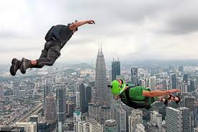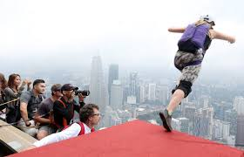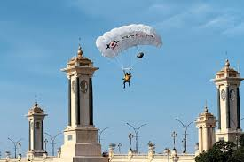
The Organiser
Name : CAPT A. AZIZ AHMAD amn pjm
Position : Vice President of Malaysia Sports Aviation Federation (MSAF)
Founder Base Malaysia (Ababil Base Jump Club)

Parachuting Experience:
- First Jump : 1977
- Total Jumps : 3000+
- Total BASE Jumps : 500 +
- Parachuting License : Civil Aviation Authority Malaysia
- Parachuting Instructor/Examiner since 1982

Parachuting Achievements:
- First Malaysian Parachutist to jump off Menara Kuala Lumpur (1999)
- Holder of World Record in Canopy Formation held in Kassel, Germany in 1996.
- Holder of 3 world record in BASE Jump 2000/2001. (GUINESS WORLD RECORD RECIPIANT)
    - Jumping from the world tallest building.
    - Participant in the highest number of jumpers jumping from a building simultaneously.
    - To jump from millennium to another.
- Participated in the opening ceremony (PARACHUTING DISPLAY) for: SUKMA Games 1996/2002
- SEA Games 1989/2001
- COMMWEALTH GAMES 1999
- Represented Malaysia in numerous skydiving competitions such as:
    - World skydiving championships in Australia (1984/1994)
    - World skydiving championship in China (1992)
    - Thailand skydiving championship 1982-1999.
    - Indonesia skydiving championships 1983-2014.
Organized Events.
- Organizer of various Parachuting Competition in Malaysia since 1986.
- Organizer of all the skydiving during the Air Carnivals held by DCA Malaysia since 1995.
- Organizer for the Annual KL Tower International BASE Jump since 1999
- Co-Organizer of the annual KLCC BASE Jump since 2000-2003
- Co-Organizer of the Exotic Sky Adventure boogie held in Langkawi 1993, Terrenganu 1994, Sabah 2001, Sabah 2002.
- Air Operations/coordinator for MILD SEVEN OUTDOOR QUEST adventure Race 2002/2003.
- Co organize an aerial event at the Tiger conservation sanctuary in Tembling, South west Sumatra, Indonesia for Mr Tommy Winata in 2010.

Flying Achievements.
- Flying licence with Jump Pilot Endorsement with approximately 2000+ hrs.
- Flew the Zodiac aircraft on behalf of the Sports Ministry to the various ASEAN Countries delivering the 2001 SEA Games invitation.

4.3 PROJECT PROPOSAL
Venue:
KOMTAR, PENANG

Proposed date
Proposed to have the event together with the other cities as per the details below:
SIBU : 23/9 - 26/9 2021
KL TOWER : 30/9 - 3/10 2021
KOMTAR : 2 days event, proposed to be before SIBU or after KL TOWER.

Preparation
Minimum of 6 months publicity prior of the event would require to notify the international participants.

Duration
Session 1 : 0830-1230
Session 2 : 1430 -1800

No of participants
- Estimated 40 pax
- 75% international participants & 25% local participants
- Participants will pay their own accommodation and travelling cost, we need share with them the list of hotels nearby to KOMTAR.

Total costing

No. | Items | Amount (RM)
1. | Technical team of 6 people | RM 30,000
2. | Accommodation (2 weeks) | RM 20,000
3. | 2 days welcoming lunch, dinner & refreshment for the 40 pax participants | RM 4,000
4. | Medical team, Fire & Rescue team | RM 8,000
5. | Contingency (Public Liability insurances and others) | RM 8,000
 | TOTAL | RM70,000

