Preliminary Proposed Budgets for
Landmarking Farlim/ Paya Terubong with Small Fun Street Art

Location : Farlim/ Paya Terubong

Aim : To place-make and rejuvenate Farlim/Paya Terubong neigbourhood into an attractive visiting place by injecting creative fun and interesting small-scaled street artworks towards making Farlim/Paya Terubong another visiting spot for fun street art hunting.

Objectives :
- To place-make Farlim/Paya Terubong neighbourhood into an attractive visiting place by injecting creative, fun and interesting small-scaled street artworks towards creatively revitalise the neighbourhood as an attractive and fun visiting site for Penang locals as well as for visitors.

- Landmarking the surroundings within Farlim/ Paya Terubong neighbourhood by adding in some attractive and fun artistic element -- turning it another must-visit attractions towards complementing and supporting Farlim/Paya Terubong’s tourism and generating spin-off economic activities to Farlim/Paya Terubong and its nearby neighbourhoods.

- Through the relevant and fun artworks that openly showcased and incorporated within the neighbourhood, it creates a friendly and welcoming ambience that could engage the local communities and the visitors towards establishing a ‘sense of place’

- To attract routine visits, new visits and revisits to the site, especially to attract the younger generations to visit and take Instagrammable photos for sharing in social media in which will eventually promote Farlim/Paya Terubong.

Preliminary conceptual Artist’s Impression
- Telephone Booth

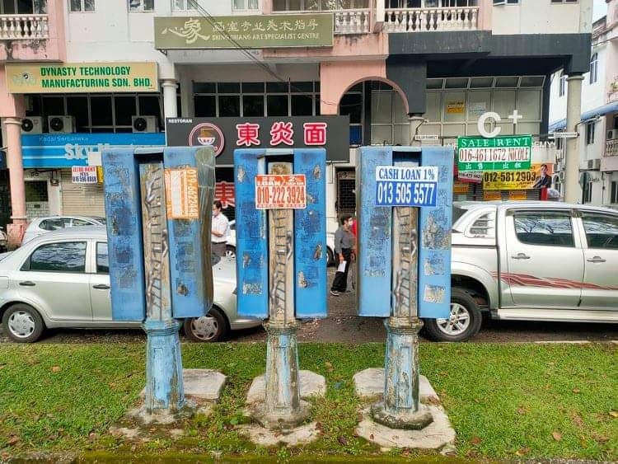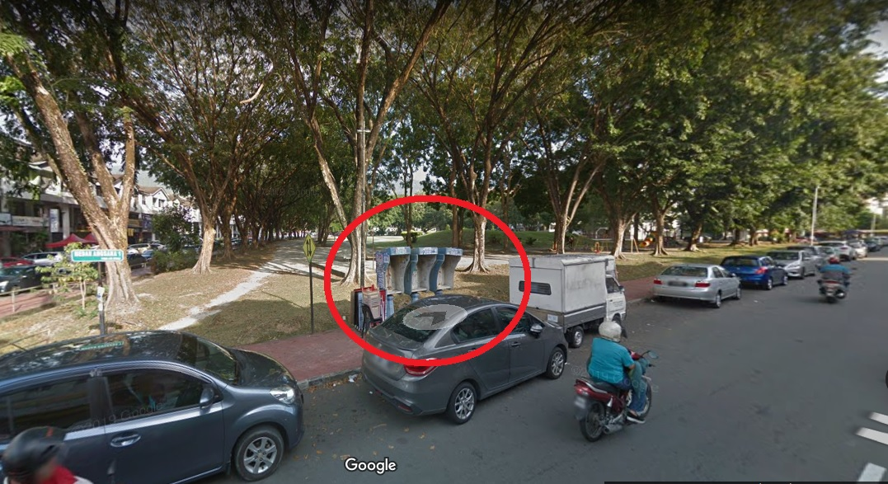
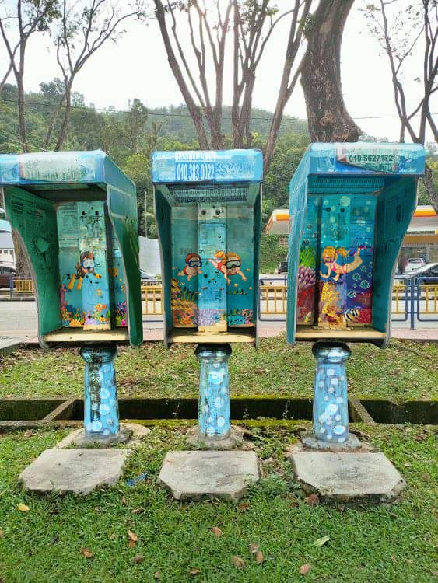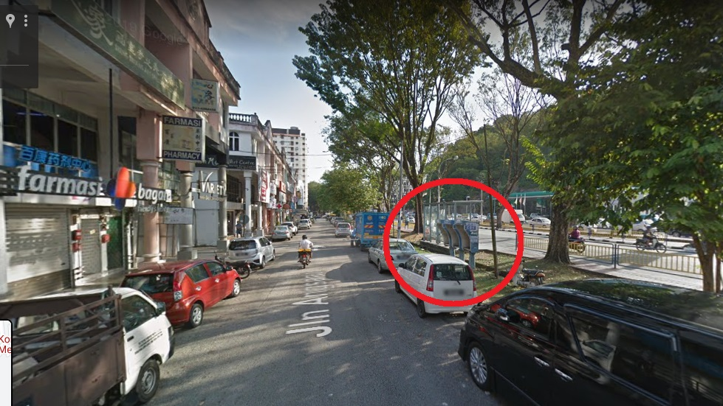

- Cat on Staircase
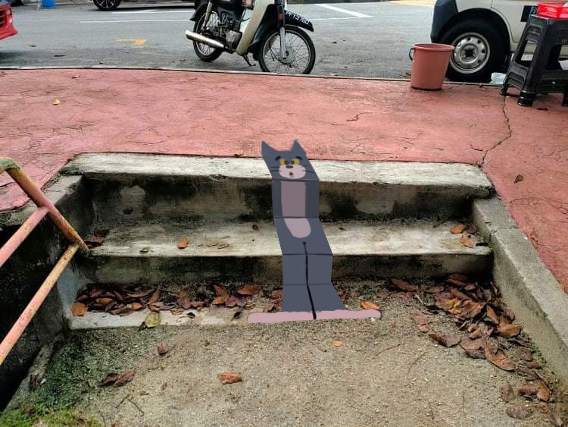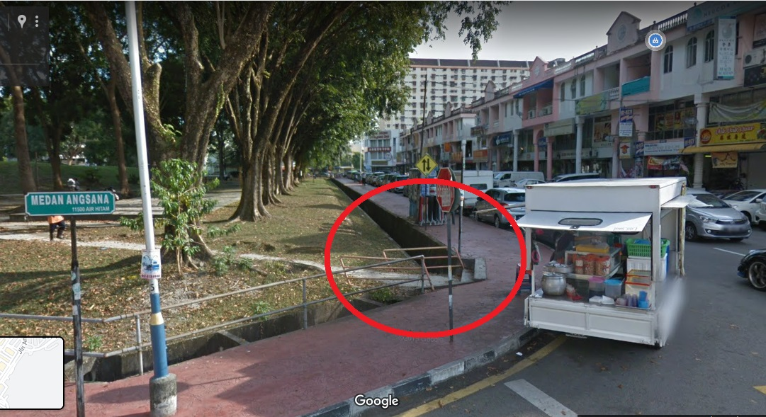
- TNB – Panda
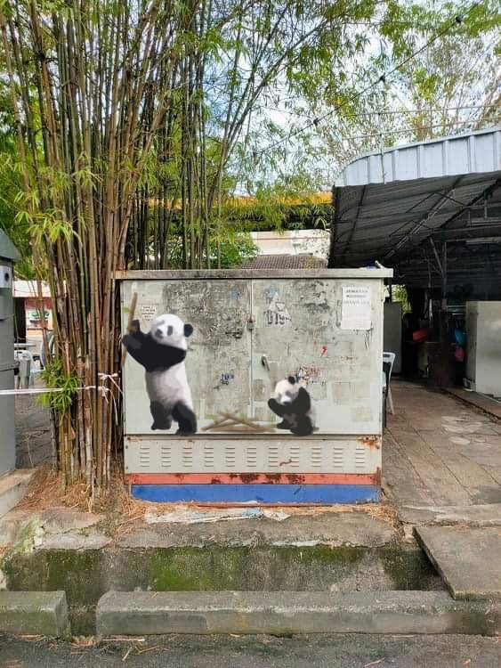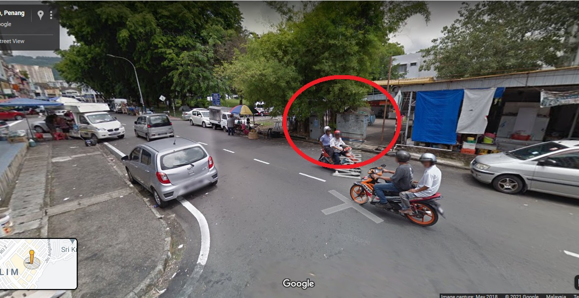
- TNB - Heritage Houses
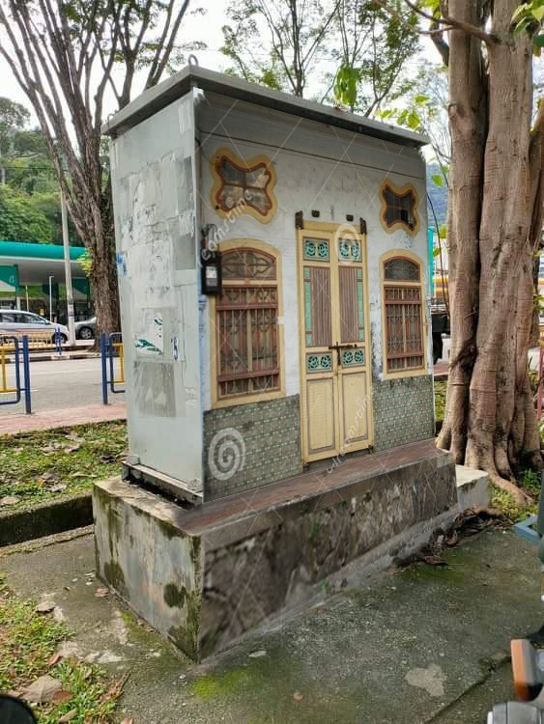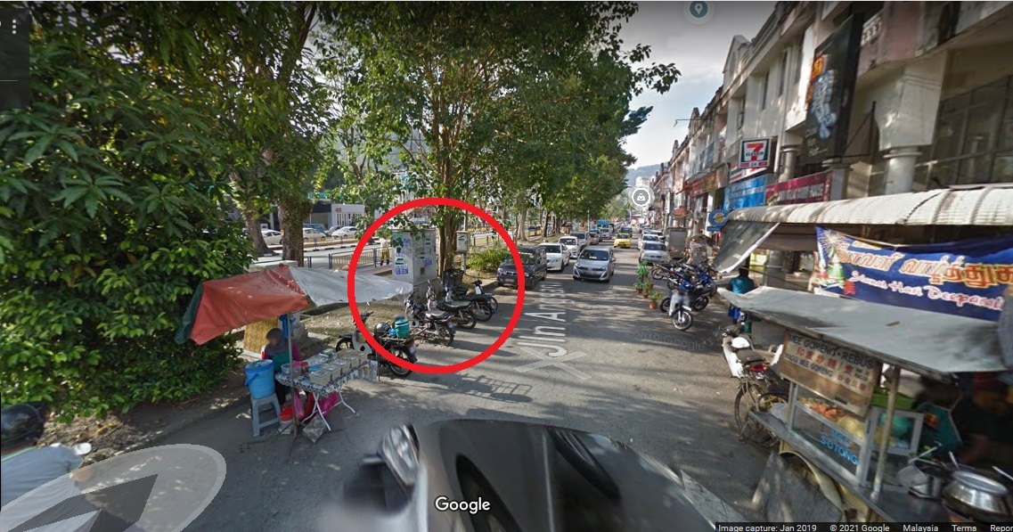

- Shark at Playground
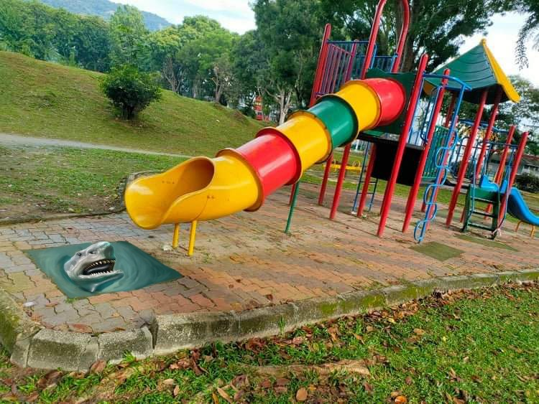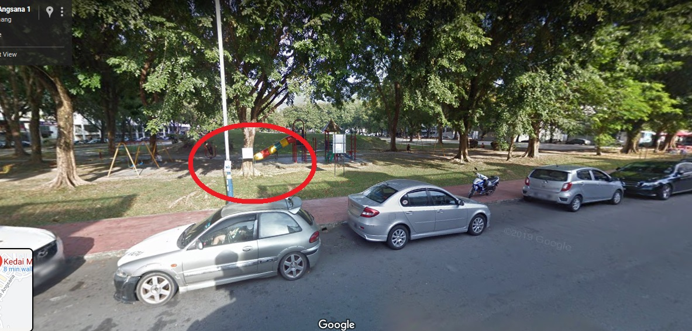

6) MBPP Drainage - Cat in a Box
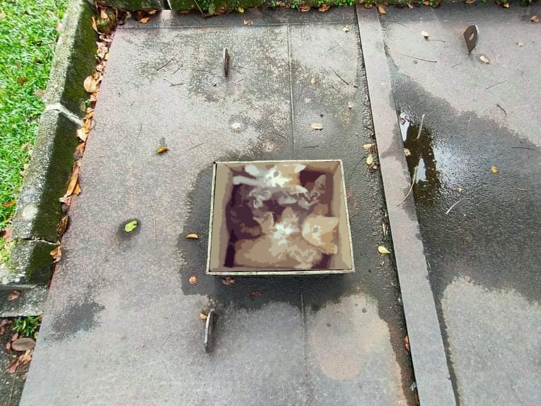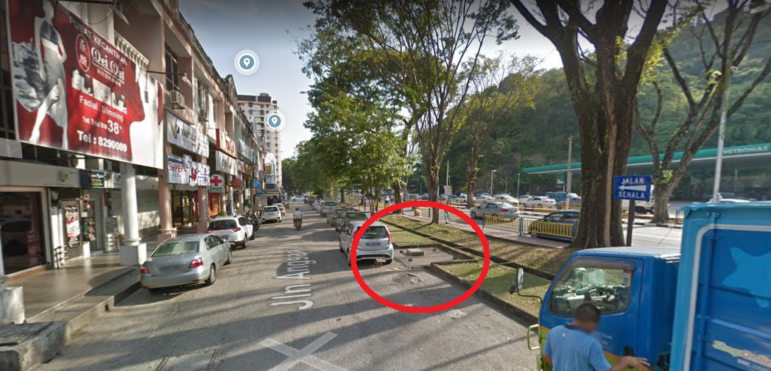

7) Walkway with Fish
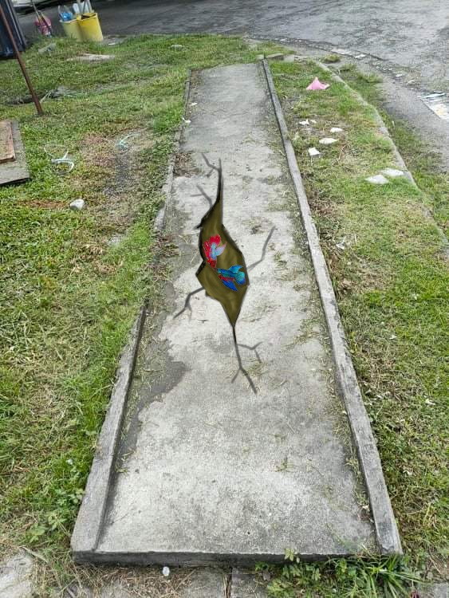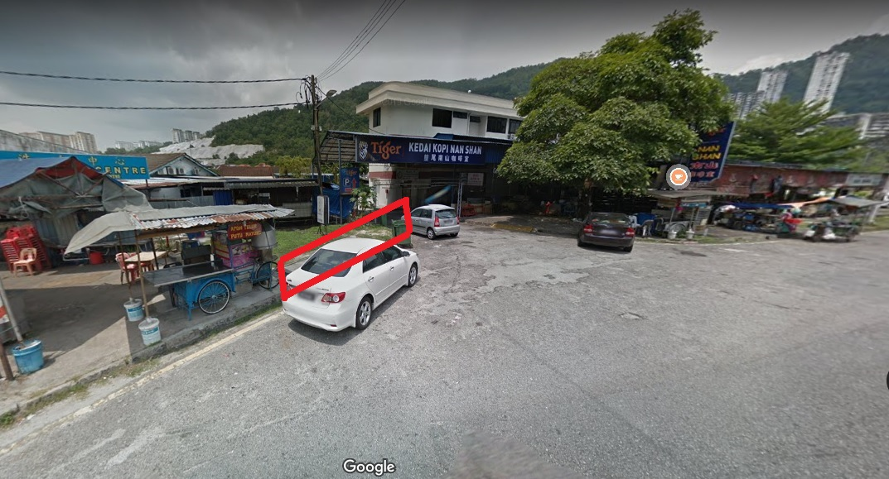
8) Switch Box at Market
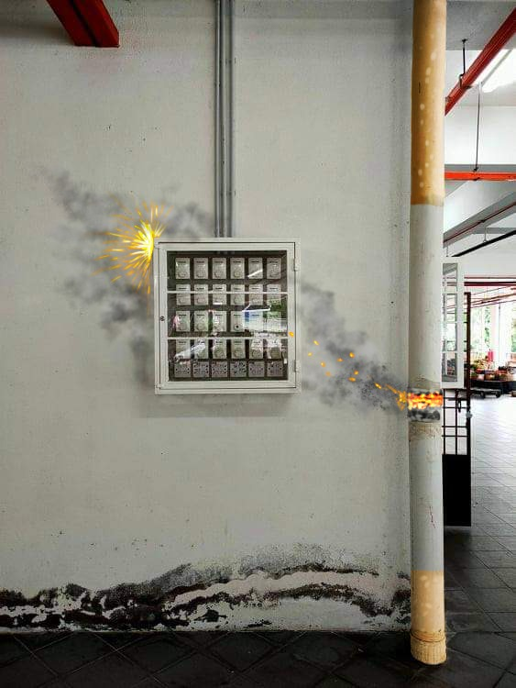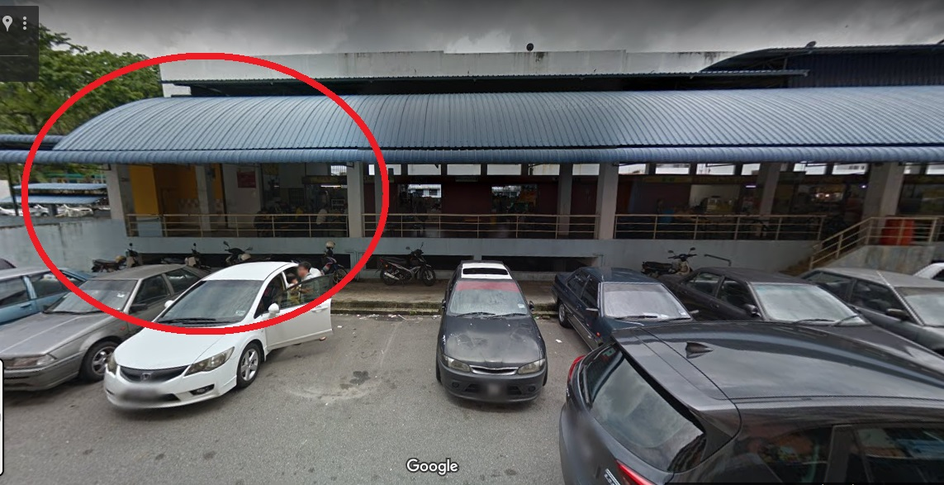

9) Yellow Wall with Goldfish
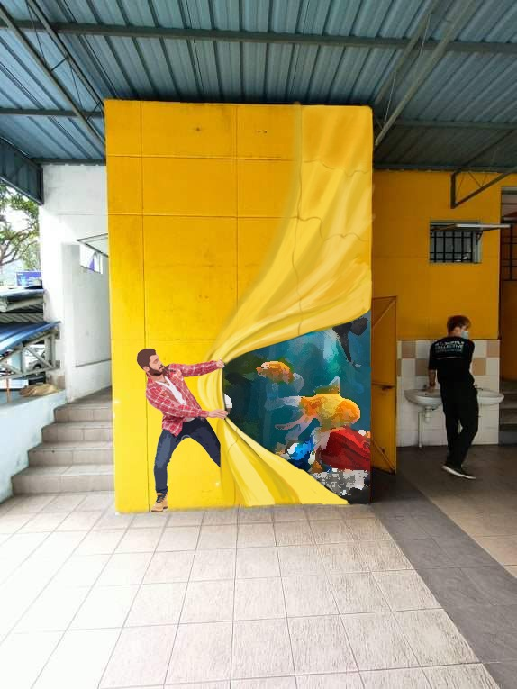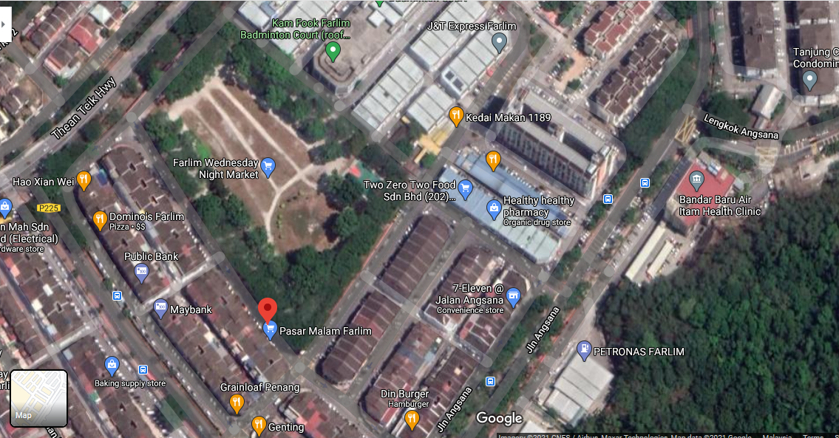
1a, 2,5
3
8,9
1b
4
6

KIV Artworks:
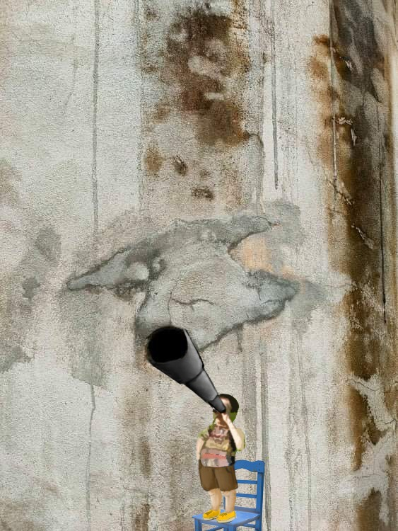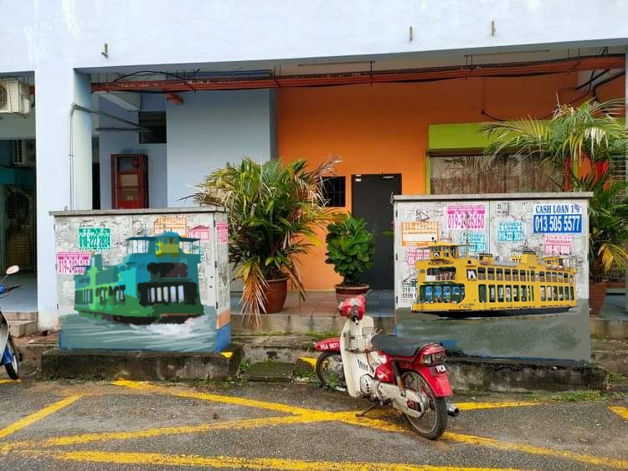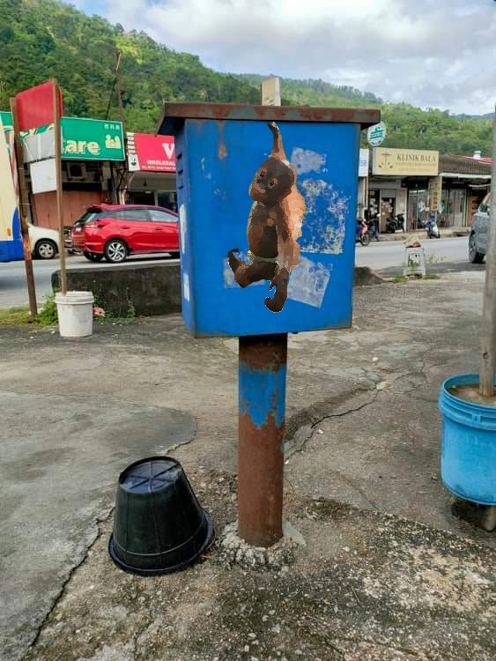
- Artwork at Chinese Temple 2. TNB – Ferry 3. Orang Utan at Blue Box

**Undertaking for Non-disclosure

Kindly take note that this preliminary proposal and the contents including the images/pictures enclosed are compiled and prepared by Can Can Public Art solely for the project of Landmarking Farlim/Paya Terubong with Small Fun Street Art. For the protection of the team’s creative ideas/concepts and contents as well as the privacy of our artists & the copyright of the images/pictures taken or produced by our artists or the respective photographers, we strictly insist our clients of this project to undertake to safe keep the contents of this proposal as confidential and strictly restricted to be disclosed to other parties with no prior discussion for agreement with Can Can Public Art Team. Your understanding and cooperation are greatly being appreciated.

Proposed Preliminary Budget for project:
Cost Items | Cost (RM) | Total (RM)
1. Telephone Booth (design could be further discussed)  Option (a)  Option (b) | RM600  RM1200
2. CAT on Staircase | RM600
3. TNB - Panda | RM1200
4. TNB - Heritage Houses | RM1500
5. Shark at Playground | RM900
6. MBPP Drainage - Cat in a Box | RM900
7. Walkway with fish (can be located at any walkway at Farlim) | RM900
8. Switch Box at Market - No Smoking (design could be further discussed) | RM900
9. Yellow Wall with Goldfish | RM1800
10. Project Management & Coordination | RM3000
SCOPE of Services:
- To manage and coordinate the execution of project
- To engage artists to design & get artists to collaborate to paint onsite progressively
- To arrange and provide necessary allowance (i.e. food, travel and accommodation) to the artists & working team
- To prepare all required materials & etc.
- To get consent from MBPP with assistance & support from Councillor & YB Yeoh’s Office
For KIV Artworks:
1. Artwork at Chinese Temple | RM900
2. TNB - Ferry  To paint 1 artwork on 1 TNB Box  To paint 2 artworks on 2 TNB Boxes | RM700  RM1200
3. Jalan Paya Terubong - Orang Utan at Blue Box | RM800

Proposed Project Timeline:
1. Project work at site tentatively starts after 25 January 2021 after getting confirmation with notice at least 3 days in advance
2. Whole project duration is estimated within ~ 6 weeks, subject to the date of receiving confirmation before 25 January 2021, while artists are currently engaged with another project based in Penang.
3. Confirmation after 25 January 2021, the project timeline may have to be rescheduled in accordance with the artists availability.

