Experience the Romantic Side of Penang
Due to the state’s diverse landscapes and attractions — hills, beaches, charming villages and plenty more — there are many spots in Penang to rekindle an old flame, charm a new beau or keep the passion burning. From high-altitude city breaks to alluring beachside getaways, we summarise the many romantic spots in Penang you can treat your sweetheart — each one is romantic in its own way.
Take a leap of faith in George Town

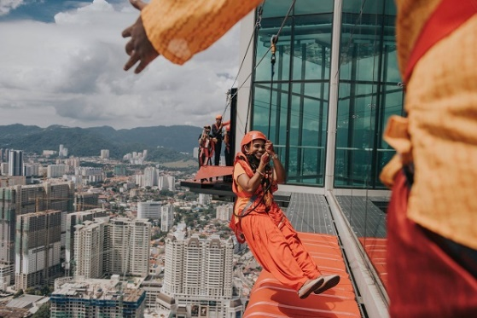
Credit: Momento Wedding

Make your time in George Town an affair to remember at KOMTAR. The state's tallest skyscraper is home to The TOP Penang where couples can take a walk on the wild side at The World's First Tower Curved Skywalk — The Rainbow Skywalk and then take a leap of faith at The World's Highest Ropes Course Challenge — The Gravityz. Can a ropes course challenge ever be romantic? Shri Yoganthiran Manikam and his wife, Dr Mohana Baskaran, think so.
The couple opted for something unique to seal their marriage and achieved it at an altitude of 239 metres above sea level at The Gravityz. The feat made it into the Malaysian Book of Records as Highest Altitude Ropes Course Register Of Marriage Ceremony in 2019. According to Vernon Kong of Momento Wedding who captured the high-altitude romance, The Gravityz is an unexpectedly romantic spot as couples are increasingly looking for a unique location to mark a special occasion. "It’s true when they say love conquers all. Love overcomes all barriers, including any form of fear," says Vernon.
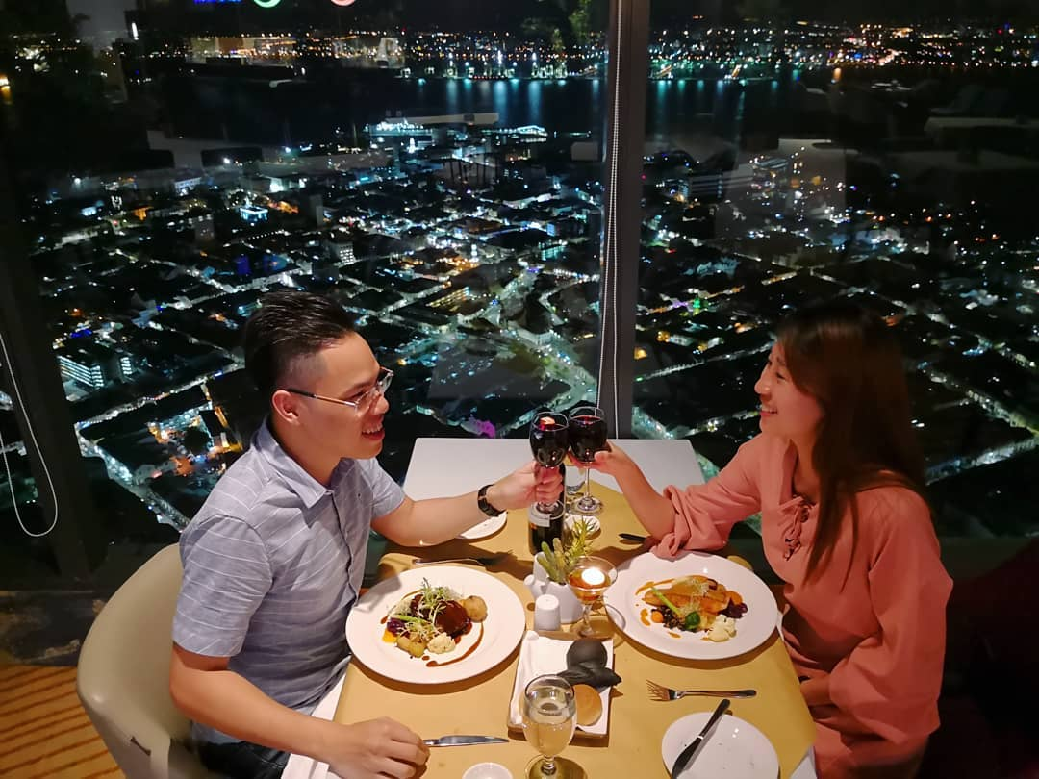
Credit: wilsonbo0 (Instagram)

Thirsty after an adrenaline-filled date? Cap off your evening at Coco Cabana Bar & Bistro — the highest place to grab a drink in George Town. Grab a table by the window so you can cosy up to your date with a side of the cityscapes at night. The views are breathtaking, and there isn't a single piece of George Town and beyond you can't see.
Name: The TOP Penang
Address: 1, Jalan Penang, 10000, George Town
Contact: +604 262 3800
Website: https://thetop.com.my/
Treat your sweetheart to a rustic romance at the Balik Pulau-Teluk Bahang Ecotourism Belt

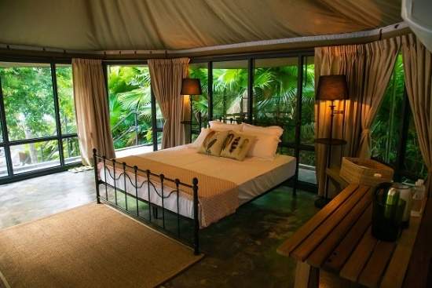
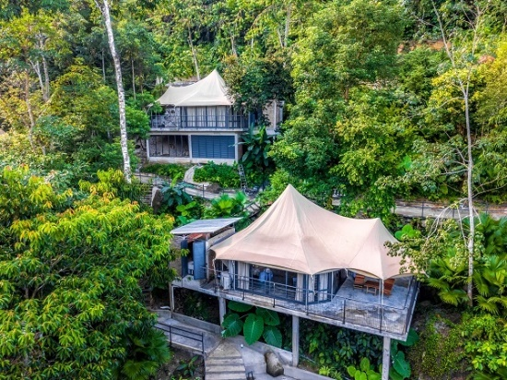
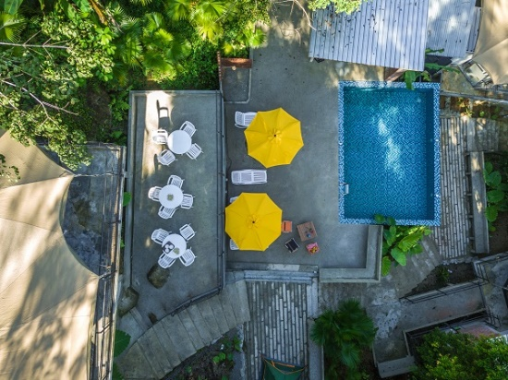
Looking to disconnect from the world and focus on the person you love most? Glam it up at Boulder Valley Glamping site, a luxurious paradise nestled within the Teluk Bahang rainforest. Lovebirds can wake up to the sounds of chirping birds, take a dip in the swimming pool and snuggle up under the stars by the campfire at night. You can go off the grid without sacrificing modern comforts as the spot offers luxurious accomodations with ensuite bathrooms.
To spice up a nature-filled date, head to the nearby Tropical Spice Garden. Take your other half for a stroll along towering nutmeg trees and ponds with floating water lilies and swimming koi fishes. Don’t forget to take a well-deserved break upon the garden’s Instagrammable swing and soak up the sweeping views of the rainforest.

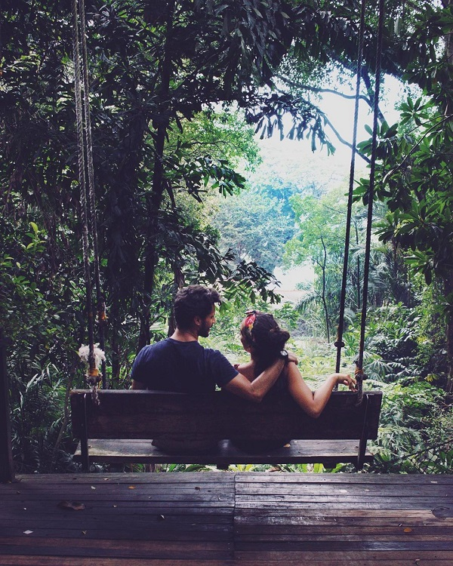
Credit: giulia_ppiderosa (Instagram)

Then, indulge in an ocean-view lunch at the Tree Monkey Restaurant within the garden’s compound. It's the only tree house restaurant overlooking the Straits of Malacca in Penang. Some standout dishes from the Thai-inspired menu include Thai tapas and crispy sea bass with herbs. Chances are, you will be greeted by curious dusky leaf monkeys while enjoying the restaurant’s Sunset Paradise mocktails.

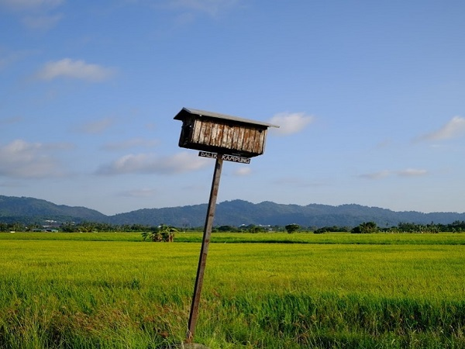
Credit: zorogoh (Instagram)

If falling in love with a quaint town is in your travel checklist, then head to Balik Pulau for the rest of the day. Rent bicycles and traverse through farms, orchards, and paddy fields before heading to Pantai Malindo to catch a postcard-perfect sunset.

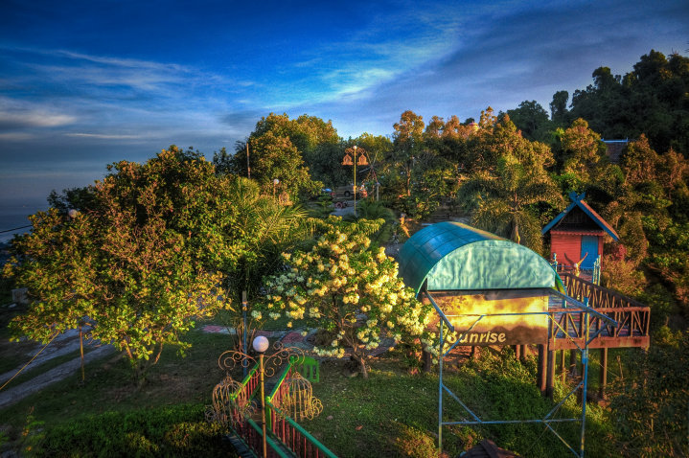
Credit: Bukit Genting Hill Leisure Park and Restaurant (Facebook)
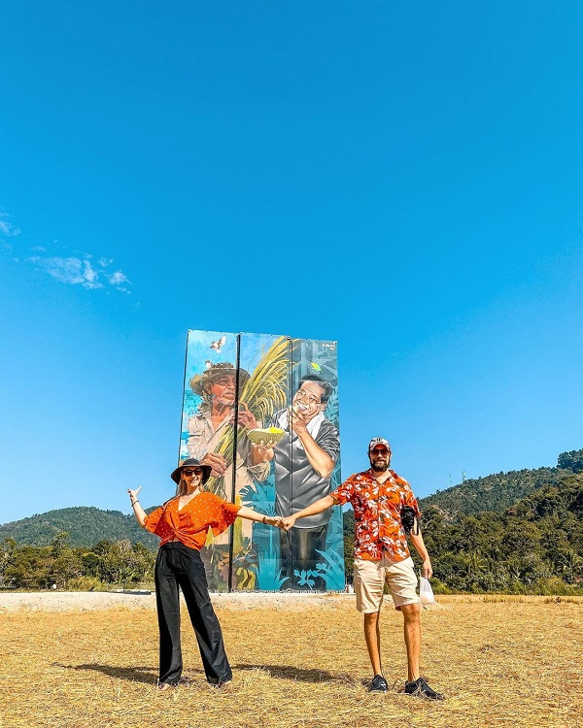
Credit: kokladunyayi (Instagram)

Credit: kangcolourz.jpeg (Instagram)

After treating your partner to rural views and landscapes, a bowl of hearty tom yam goong made from locally sourced ingredients at Bukit Genting Hill Leisure Park and Restaurant is the order of the day. Diners go to the hilltop restaurant for mouthwatering Thai cuisines and are sure to stay for the chilly night breeze and gorgeous views of Balik Pulau streetscapes below.
Name: Boulder Valley Glamping
Address: 8 Jalan Teluk Bahang, 11050 Teluk Bahang,
Contact: +6012 490 6882
Website: https://www.facebook.com/bouldervalleyglamping/

Name: Bukit Genting Hill Leisure Park and Restaurant
Address: Bukit Genting Hill, Jalan Teluk Kumbar
Contact: +6016 492 8778
Website: https://www.facebook.com/bukitgenting/

Name: Tropical Spice Garden
Address: Lot 595 Mukim 2, Jalan Teluk Bahang, Teluk Bahang
Contact: +604 8811 797 (796) (795) or +6012 430 7795
Website: https://tropicalspicegarden.com/

Seek out mainland’s hidden gems

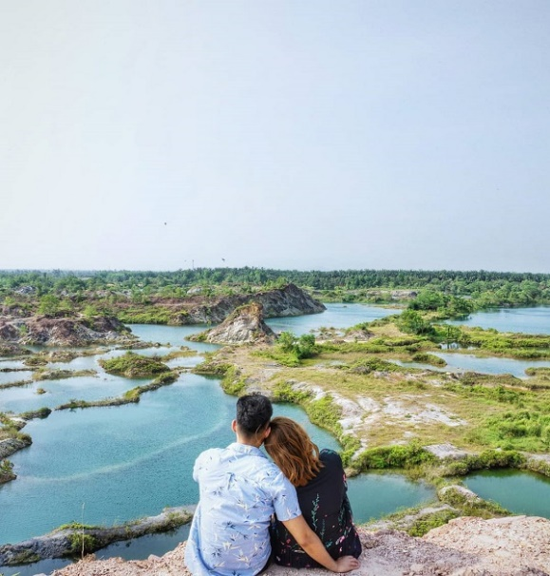

Credit: emjayy.l (Instagram)
Mainland Penang has hidden gems perfect for a great escape from the bustling city. Snap a #relationshipgoal photo at Frog Hill, one of the few attractions in Penang that still feels hidden. The 40-minute journey to Frog Hill from Penang island unfolds some of the most picturesque rural views. Getting to the top of the hill requires going through rough and patchy terrains (like all relationships), but the sweeping vistas atop the abandoned tin mining site are worth the hike.
Travel reminder: Frog Hill is a remote area so visitors are advised to exercise extra precautions.

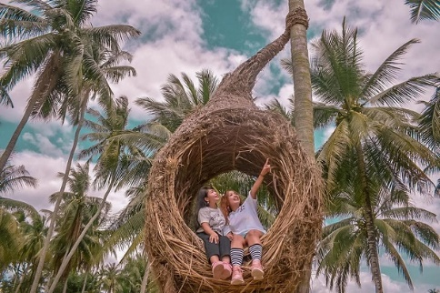
Credit: desy_hotniar_sihombing (Instagram)

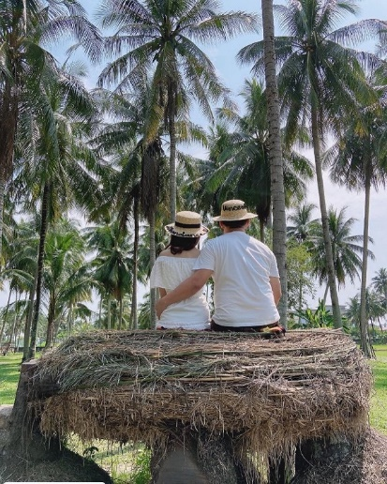
Credit: happyhead25 (Instagram)

You don't have to leave Penang to experience the romantic island of Bali. Just head over to Kampung Agong and feed your Instagram with #couplegoals shots of Bali-inspired swings and giant egg nests amidst towering coconut trees. Looking for the best place to wine and dine in the mainland? Head over to G9 Dining House at Icon City. The restaurant's high ceilings, impressive iron chandelier and leather booths set the mood for a romance-filled night.

Name: Frog Hill
Address: No road signs point to this abandoned stone and clay quarry. To get there, enter these into your GPS navigator: 5.436643, 100.485111.
Name: Kampung Agong
Address: Lot 20, Mukim 05, Bakar Kapur, Penaga, Seberang Perai Utara
Contact: +6016 429 7795
Website: https://www.facebook.com/Kampung-Agong-1873406712955702/
Name: G9 Dining House
Address: 19-GF, Jalan Icon City, 14000 Bukit Mertajam
Contact: +6017 892 7113
Website: https://www.facebook.com/g9dininghouseiconcity/

Turn up the heat at Penang Hill

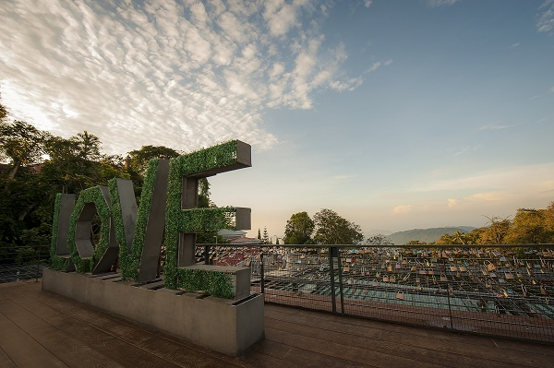



If you need a reason to keep the passion alive, then whisk yourself and your partner away for a chilly retreat at Penang Hill, the first and oldest hill resort in South East Asia. The newly-opened Hillside Retreat at the iconic Penang Hill offers lovebirds the rare opportunity of waking up to toasty toes and warm cuddles! Choose to camp under the blanket of stars or pamper yourself in a private English colonial-style bungalow—make your choice when booking.
Penang Hill also has a host of attractions and facilities for a dreamy date. At Love Lock, couples can ‘lock’ their love by fixing padlocks to its 80-meter wide fence that overlooks the city of George Town. Then share a lip-smacking afternoon tea at David Brown’s Restaurant and Tea Terrace because English scones are the way to a person’s heart.
Don’t head back just yet. Instead, take your date to the next level at Penang’s highest bar! The adjacent David Brown’s Sky Terrace features live music which goes well with the company of your special someone and a few cocktails at the bar, along with stellar views of the island and mainland and surrounding natural beauty.
Name: Penang Hill
Address: Jalan Stesen Bukit Bendera, Air Itam
Contact: +604 828 8880
Website: http://penanghill.gov.my/
Train schedule: Daily from 6.30am - 11.00pm. Last train from the Upper Station departs at 11.00pm

Indulge in a beachside retreat at Batu Ferringhi

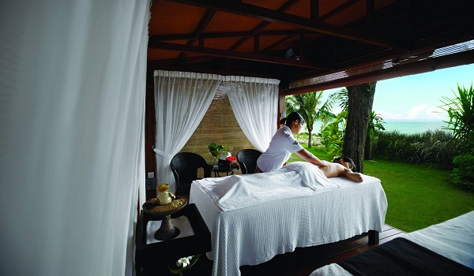
Credit: Hard Rock Hotel Penang

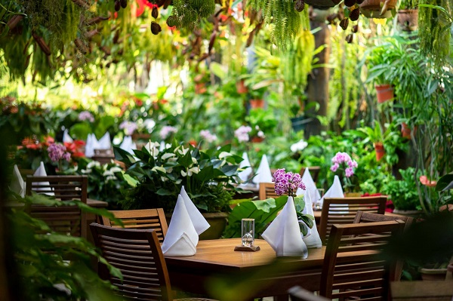
Credit: Ferringhi Garden Restaurant

It may sound like a cliché, but you won’t go wrong with a sultry beachside retreat at Batu Ferringhi. The idyllic coastline is where most of the hotels, vacation rentals and spa centres are clustered. Though most spas offer similar treatments, each spa has its variation of relaxing experiences and unique ambience. Some of these beach hotels boast sprawling lawns too, so you can take your pampering outside with your loved one as you rejuvenate your soul.
Batu Ferringhi is where the sun sets on the island, ideal for a sunset-soaked stroll along the sandy beach. Right after, you can continue with a romantic seaside dinner overlooking the moon-dappled sea. However, if you prefer to sit amongst blooming orchids, hydrangeas, tuberoses and an elaborate water feature, do it at the Ferringhi Garden, a restaurant with lush interiors and garden vibes that serves Western grilled favourites as well as cocktails.
Name: Ferringhi Garden Restaurant
Address: 34-A/B/C, Jalan Batu Ferringhi
Contact: +604 881 1193
Website: https://www.facebook.com/ferringhigarden/

https://mypenang.gov.my/all/my-stories/130/

The Jalan Hutton Old-Time Chinese Barber
This old-timey Chinese barber has discontinued ear cleaning services but he still cuts hair the old-school way.
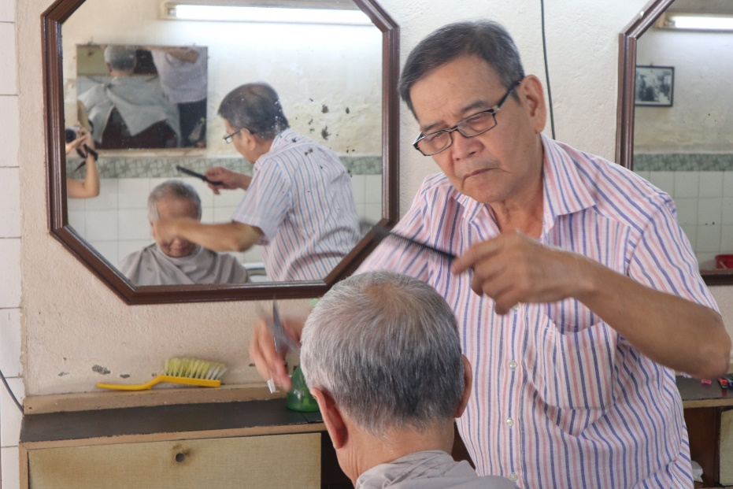
Uncle Ling giving one of his long-time clients a haircut.

Ling Chew Chin, fondly known as Uncle Ling, is a traditional Chinese barber at Jalan Hutton. His vintage shop, Huang Koong Barber Shop, had been operating in the same old pre-war shophouse since 1968.
Now in his 70s, Uncle Ling picked up the trade when he was just 13 years old. “Back then, all Chinese barbers were known for two things: the gentlemen’s crew cut and ear cleaning. We used hydrogen peroxide to soak the ear and then used a woolen ear pick to get rid of the ear wax. Any Chinese barber worth his salt was able to clean ears.
“It’s quite addictive too. Some of my customers would come back just to get their ears cleaned. They said their ears get itchy if I didn’t clean them,” says Uncle Ling.
Ear cleaning, it may seem, is a service at its tail end. Not many old-school Chinese barbers offer ear cleaning services anymore – not even Uncle Ling. Age has caught up with him; his slowed reactions forced him to discontinue his ear cleaning services.
Uncle Ling’s hearing is not as good anymore, too. Customers sometimes need to speak louder to him which prompted his daughter, Ling Boon Yen, to digitise his business.
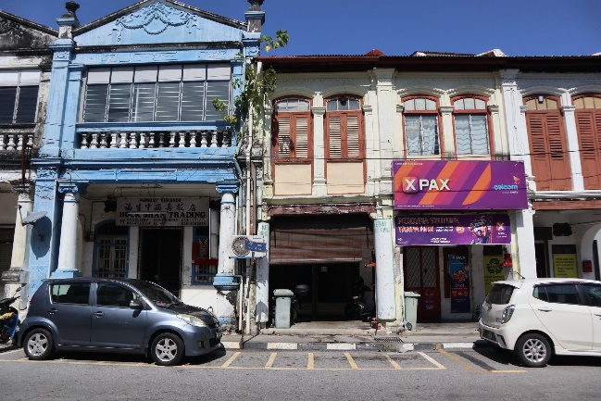
Huang Koong Barber Shop is located in between the phone shop and blue building.
“I work in Kuala Lumpur, so I am not always around to explain to customers that he’s hard of hearing. I started a Facebook page for his shop to notify new customers to speak loudly and clearly to him,” says Boon Yen.
Business has picked up since, though. The shop has been getting customers from all walks of life – foreigners from Japan, Korea and Australia and out-of-state visitors.
Uncle Ling does not speak foreign languages, so nonverbal communication is often used. “There’s a phrase Hokkien people use to describe situations such as this: chicken and duck talk. They gesticulate to show me what they want and I show them the OK sign or simply nod.
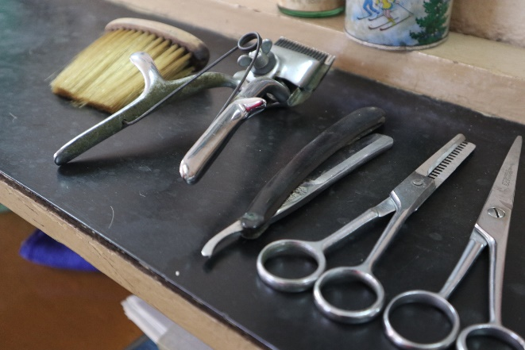
Tools of the trade.

“Sometimes, customers will show me a picture of a celebrity, which is actually the best approach. Of course if they show me a picture of Andy Lau, I cannot guarantee they will look like Andy Lau even after the haircut,” he laughs.
According to Uncle Ling, most new customers want to experience traditional cut-and-snip in a retro atmosphere. Except for the air conditioner which was installed in the 90’s and the electric shaver, nothing has changed here since the 60’s. The same barber chair and the same brand of talcum powder are still being used. Small details of yesteryear still exist in the shop such as the countertop, switches and water heater.
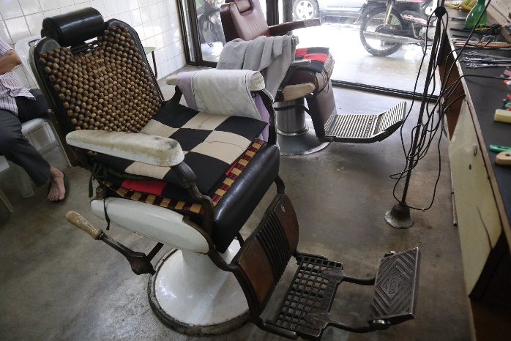
The barber chair from the 60’s.

Uncle Ling has a great sense of humour. When asked what was his favourite cut, he said “Botak! I was happy when I was called to shave the heads of the extras who were hired as monks in the movie Anna and the King,” says Uncle Ling. Botak is a local term for bald.

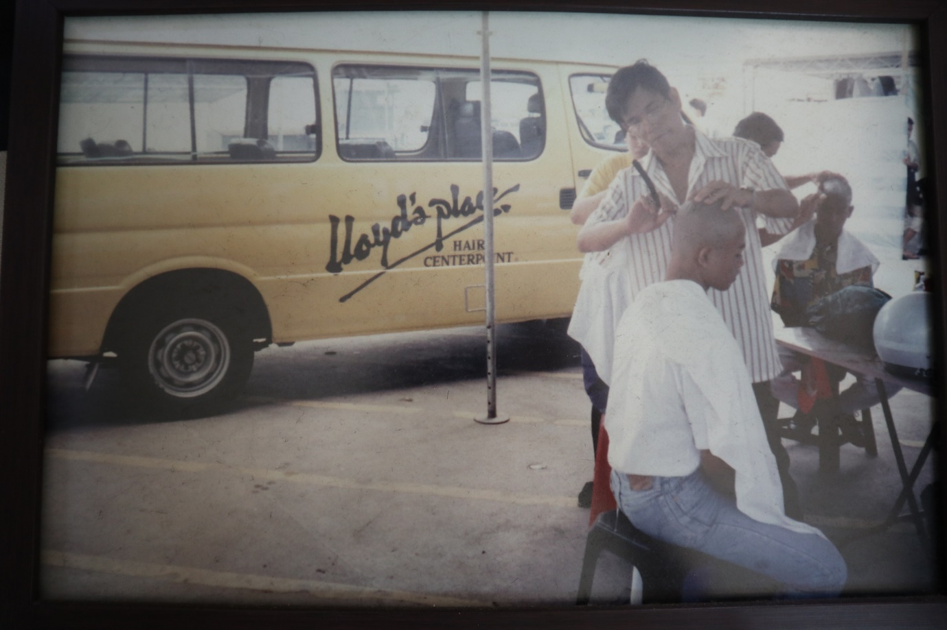
Uncle Ling was one of the on-site barbers for the extras in the movie Anna and the King.The production was shooting in Weld Quay.

This humble barber shop has important clients, too. Penang’s Chief Minister, Chow Kon Yeow, has been a regular customer since the 90’s. “He has been coming in for his haircut ever since he was Lim Kit Siang’s staff because his office was nearby.
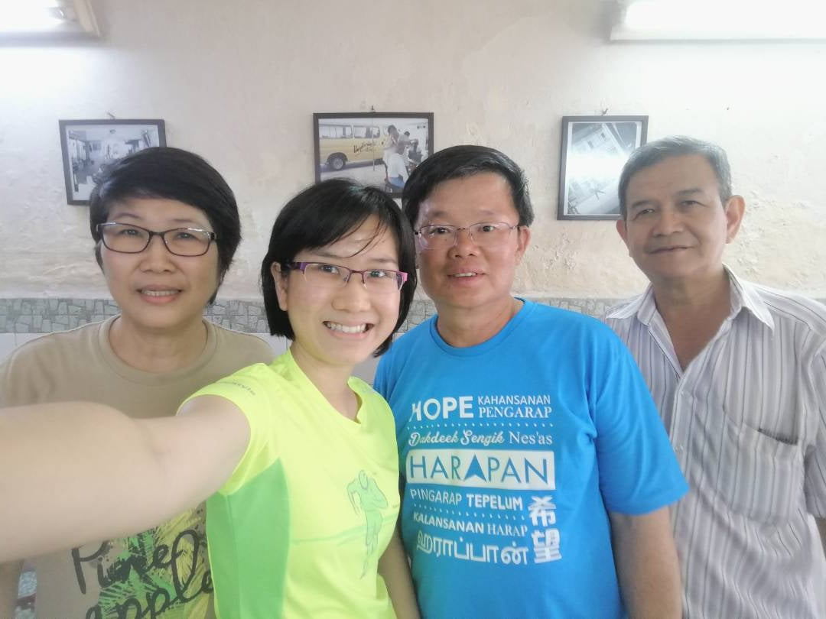

With Chief Minister Chow Kon Yeow.
“It has been close to 30 years now. You know, I have been cutting his hair even before he got married. Now, he drops by with his children!” says Uncle Ling.

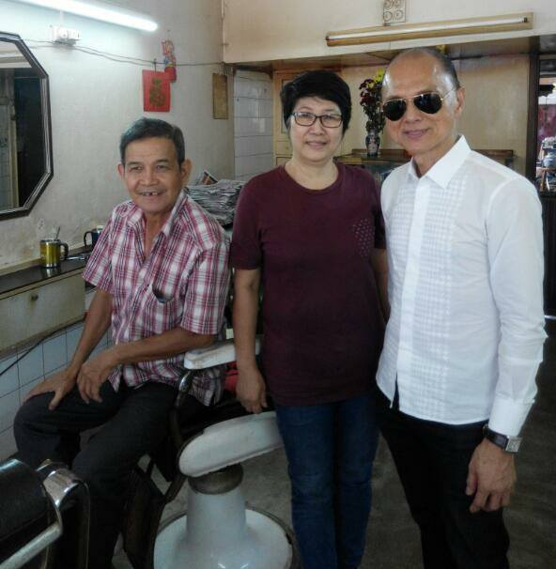
Shoemaker Jimmy Choo is also a client.

Uncle Ling has one pet peeve: beards. “Chinese men generally are not hairy; we can’t grow beards even if we wanted to. So when foreign customers want a shave, I will usually ask them to go to an Indian barber instead. It is better to get a shave from Indian barbers as they are used to shaving thick beards,” he says.
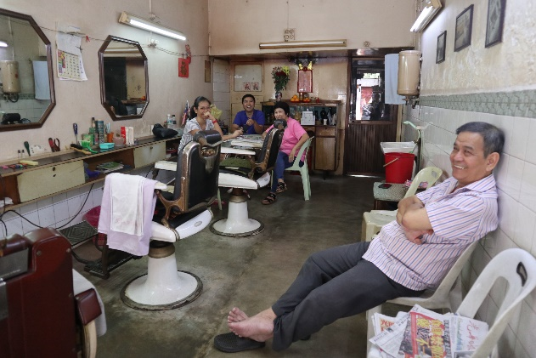
This pre-war shophouse too has been a home to Uncle Ling’s family.

Moving forward, Uncle Ling wishes to spend his remaining days in his shop. “It has been our home. My three children grew up here. My wife and I still stay here at the back of the shop and upstairs. I can’t foresee a life away from familiar faces. My neighbours are people I have seen since we were little children,” says Uncle Ling.
Find Huang Koong Barber Shop at 76B, Jalan Hutton. The vintage barber shop is open from Mondays to Saturdays, 10am to 7pm, and can be contacted at +6012 489 8651 or huangkoong@gmail.com. Visit their Facebook page for details.

https://mypenang.gov.my/all/my-stories/124/

Penang International Container Art Festival 2020
Title: Hope for the future
By Julia Volchkova

The artwork shows a little Malay girl playing her old toy blocks, building up her dream structures for her dream city while looking over the existing site at Karpal Singh Drive (a new developed modernised suburb situated within the unique city of George Town which has gone through centuries of development).
Expanding her vision a little further, she sees, with wonders, George Town capturing both well -preserved heritage streetscape as well as the new and trendy modernised cityscape at the same time. In her mind, she started to ponder with hope, imagining how her dream future city would look like.
Title: Preserving Cultural Roots for Sustainability
By Kenji Chai

The subject of this colourful piece of art is to highlight the multiculturalism in Penang. The mural features a girl with a blissful smile on her face, wearing a Batik headband and balancing a basket containing several imageries closely associated with Penang such as Pinang tree and a dusky leaf monkey.
The mural is a powerful statement to Penang’s cultural and natural heritage in producing well-balanced youth. It reflects kids living happily within the neighbourhoods in Penang where they are well nurtured under the vibrant art and cultural scene with easily accessible knowledge and resources about their local identities.
The girl’s pleasant facial expression reflects inner joy due to the contentment of her mind and soul, filled with the positive content of thoughts that generates the pride towards her beloved city. It is also a dynamic visual display to remind viewers that preserving Penang’s cultural and natural heritage is essential to ensure Penang’s sustainability.
Title: The Trishaw Rider
By Sasha Korban

The subject of art is to highlight the living heritage elements found in George Town heritage site. The artwork shows a local trishaw rider who is making a living providing trishaw rides to the tourists, offering them a memorable touring experience within the heritage site on this old-fashioned vintage transport.
Nowadays, trishaw rides or trishaw riders in George Town has become a part of the city’s living heritage. In the artwork, the man stopped by a heritage site talking excitedly about the story of a heritage building to a tourist who is sitting on his trishaw.
Title: Tribute to The Late Chuah Thean Teng
By Bibichun

Artist painted this piece of work to pay a tribute to Chuah Thean Teng – The Father of Batik Art. The artwork portrays a Malay lady, inking a Batik painting of her self-portrait, dressed in a traditional kebaya top and batik sarong, and a toddler which is being a subject matter that fascinated Chuah Thean Teng and also inspired Chuah Thean Teng to try painting in the style that eventually become a lifelong passion in art.

Title: Once at Balik Pulau’s Street Market
By Marat Danilyan

This is the collage of local elements that relevantly showcasing the local community’s lifestyle which the artist found interesting during his visit at Balik Pulau. The artwork shows a collage with a mixture of textures, patterns, plants, floors, walls and objects found on Balik Pulau streets.
The highlight of the compositions given to the local street hawker who looks very positive, performing his daily living routines with a sunny spirit. Artist pays attention to no only on the specific attractions or spots but he is amazed by the simple ordinary things and ordinary people who live their own life happily and positively.
He found that relevantly reflecting the local community within the neighbourhoods in most parts of Penang Island. In this artwork, artist intends to paint the full details which will be interesting to view on the installation at site.
Title: The Joy of Harvest
By Leonard Siaw and Jagung

Leonard’s artwork pays homage and deep respect to all the hardworking rice farmers. Despite the modern and advanced machinery has slowly replaced many manual farming tasks, the rice farmers in Balik Pulau still practising the traditional mean of planting and harvesting rice by hand. They remain to cultivate each stalk of a rice plant by hand with care, hoping to ensure the supply quality harvest every season.
Jagung’s artwork shows a local durian farmer who is checking out the quality of his harvest of durian fruits before sending out the supply to the fruit stalls at the town. This being the usual daily routines of the durian farmers in Balik Pulau where most of the great quality durians are harvested every season. Durian cultivation has continuously flourished in Balik Pulau, passing down from one generation to another generation.
Overall, the collaborative piece of art expresses the acknowledgement of the contribution of local farmers in supporting the local economy in Balik Pulau as well as in Penang.
Title: Offshore
By Emmanuel Jarus

A short boat ride sailing along together with a local fisherman who is working at sea has enough to lead you through seeing and be amazed with the bravery of a man who is working hard for a simple but meaningful livelihood.
The artwork is about a local fisherman getting ready to fish in the ocean. The ocean connects the island and the mainland of Penang by supplying the source of food from sea to the people living on the island as well as on the mainland.
The concept of the artwork relates to an idea about how each group of community coming from different fields or different groups could contribute and support each other in the society of a city towards better future in life for all.
Title: Connection
By Caryn Koh

Batu Kawan, a once sleepy fishing hamlet, is where the second Penang Bridge is. It links Batu Maung on the Penang Island. The girl, a close friend to the artist, is seen grasping on to the braided rope. She stays still, seated cosily, looking down at the rope in her hand.
Establishing the connection between containers and across to unknown, link the bridge, that represents the past and the future it may hold; she seems hesitant, yet the connection lives on, with hope of what may come.
Title: Fire
By Judith De Leeuw

The mural depicts a fisherman pushing his boat into the water with his last remaining energy. His passion and love for the job is the burning fire inside the fisherman, pushing him into the wild water every day to face his daily challenges. This mural is a compelling visual story about the fire inside us to pursue our passion and love, no matter the circumstance, no matter the exhaustion, no matter the danger.
Title: The Art of Crafting Beaded Shoes (Kasut Manek)
By Abdulrashade and Andharas

The collaborative mural by Penangite Abdulrashade and Malacca-based artist Andharas depicts a local artisan painting batik – a prized intangible heritage in Malaysia. Making batik involves several processes including applying wax to the cloth, dyeing or painting and drying. Despite its time-consuming processes, some passionate artisans remain loyal to this traditional craftsmanship and still insist on handcrafting batik to conserve the traditional art.

https://www.picafpenang.com/

