Print ads on Experience Penang 2020 - inflight magazines’ advertorials 2020

JANUARY 2020

-QANTAS, January Issue 2020, NO.319 - Advertorial on Experience Penang 2020, page 101

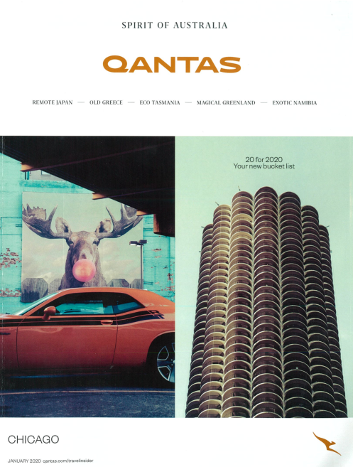

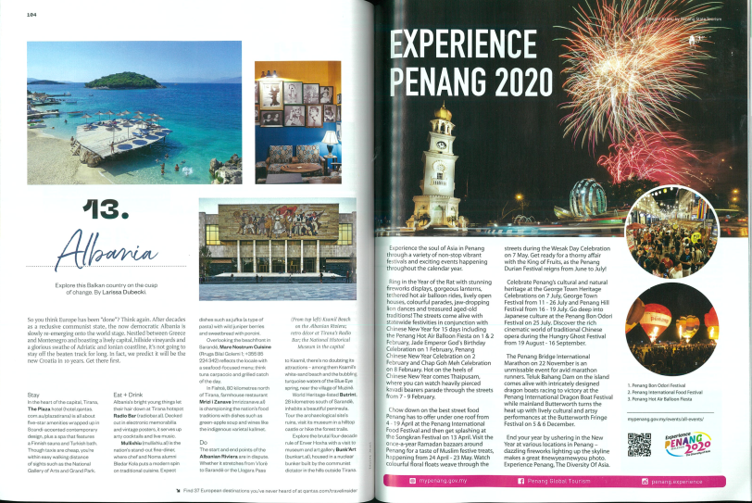

-GATEWAY, January 2020 Issue, Vol.314 - Advertorial on Experience Penang 2020 (Mandarin), page 011

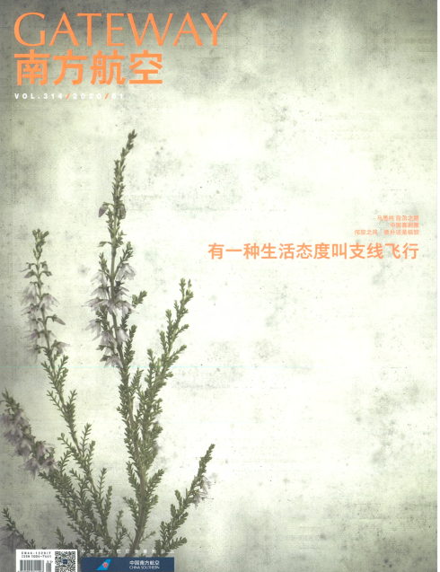
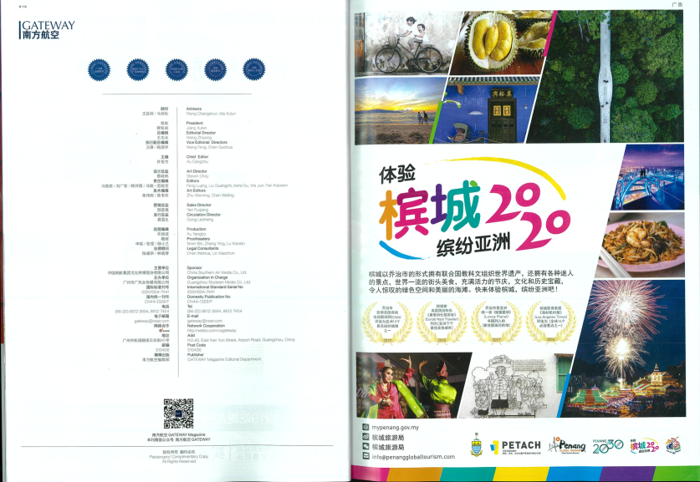

-LINKERS (Citylink), January 2020 Edition - Advertorial on Experience Penang 2020 : Diversity of Asia, Page 20-21.

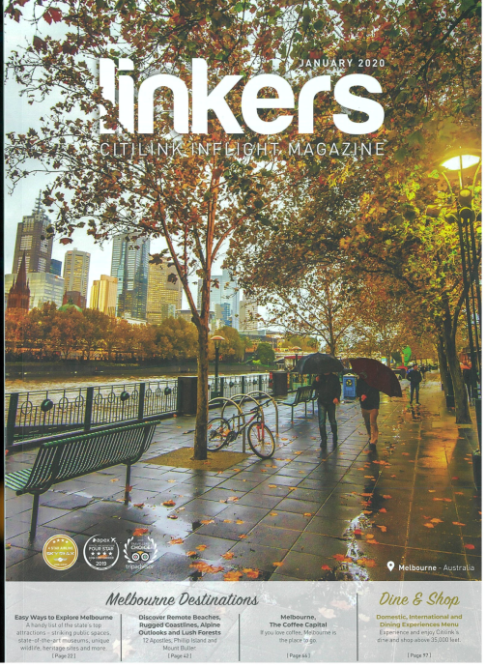

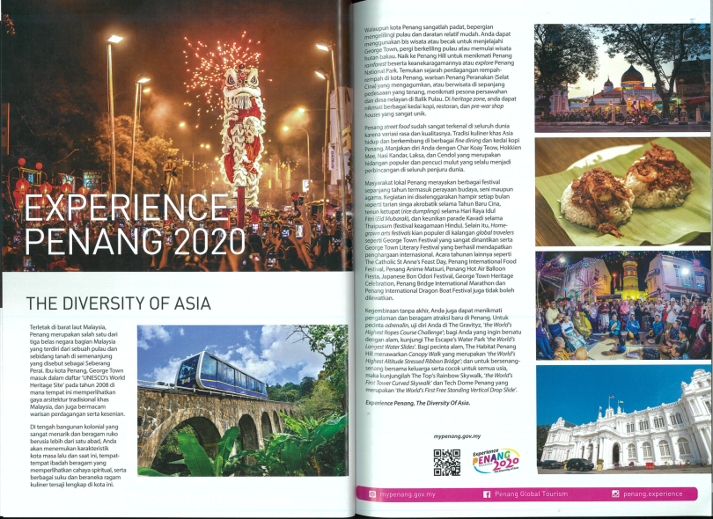

-SAWASDEE, January 2020 -Advertorial on Experience Penang 2020 (back cover)

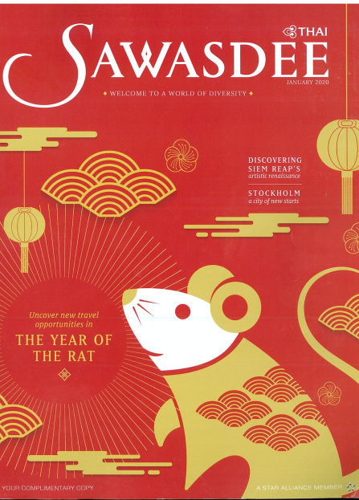
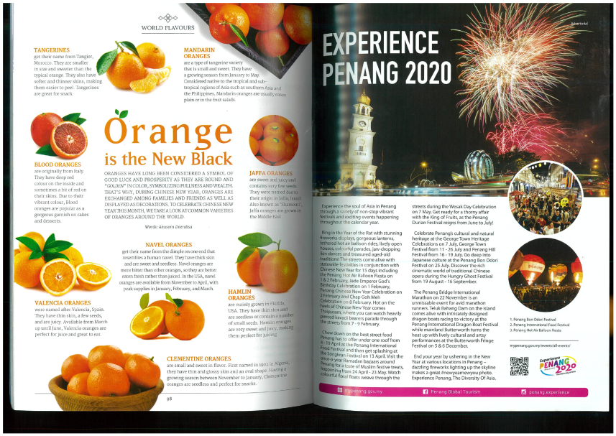

FEBRUARY 2020

- SILKWINDS, February 2020 -Advertorial on Experience Penang 2020, page 35

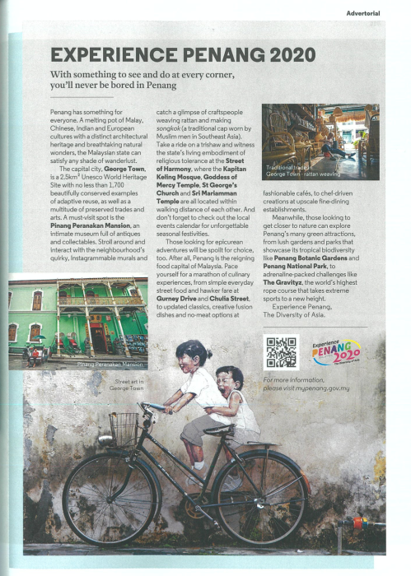
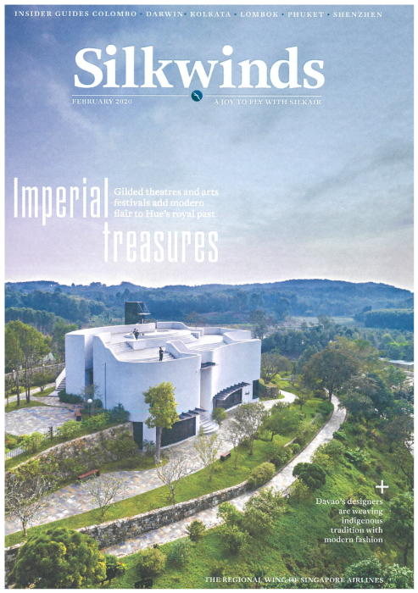

-SilverKris, February 2020 - Advertorial on Experience Penang 2020, page 99

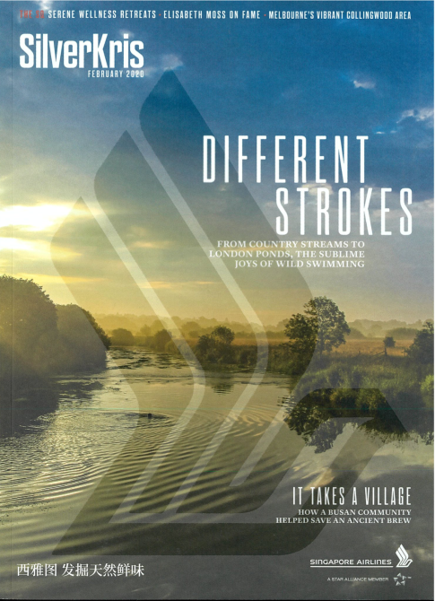
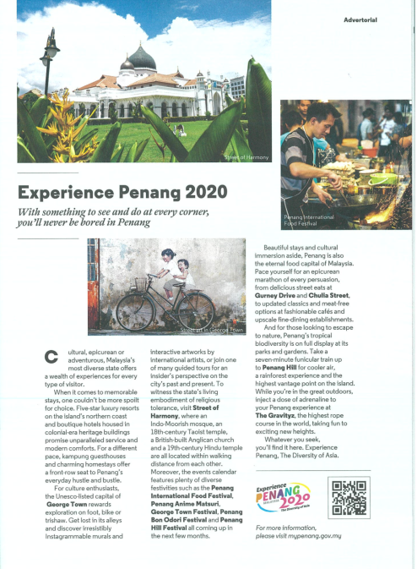

-SAWASDEE, February 2020 - Advertorial on Experience Penang 2020 (back cover)

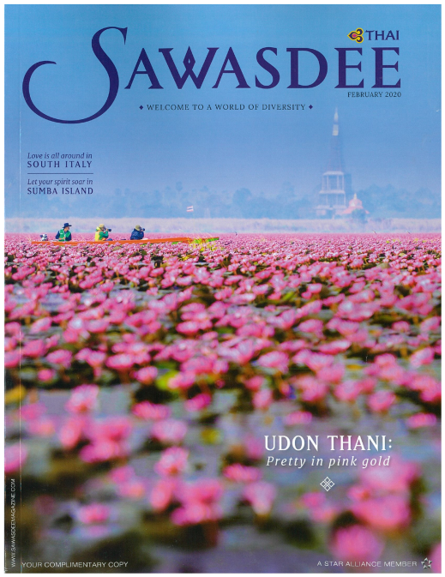

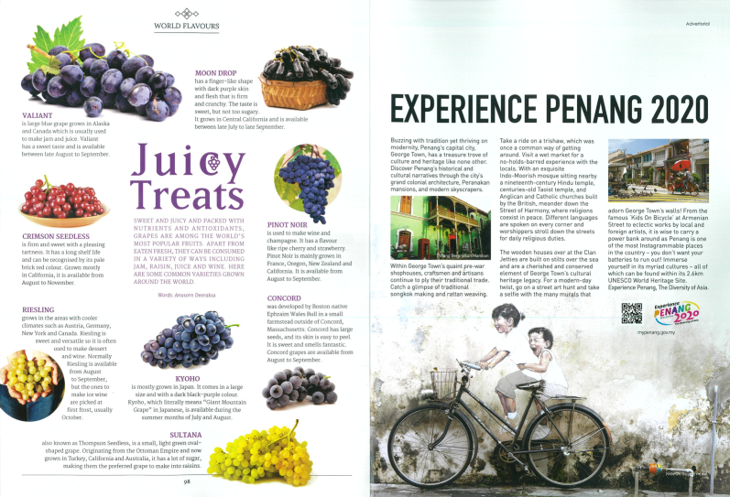

- QANTAS (Spirit of Australia), February 2020, No.320 - Advertorial on Experience Penang 2020, page 089.

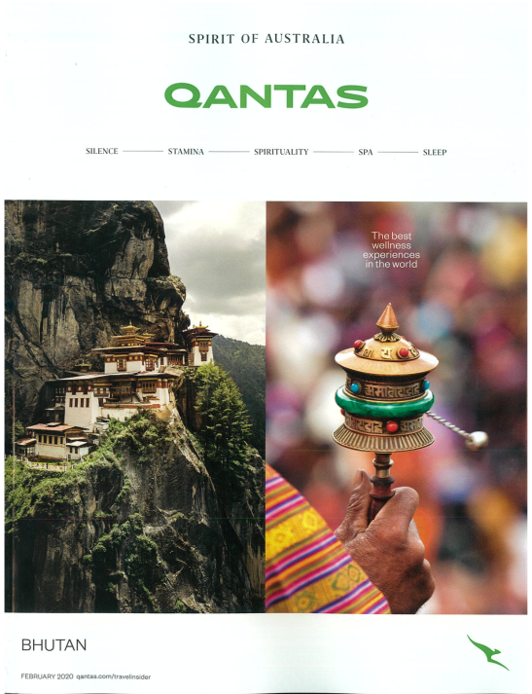

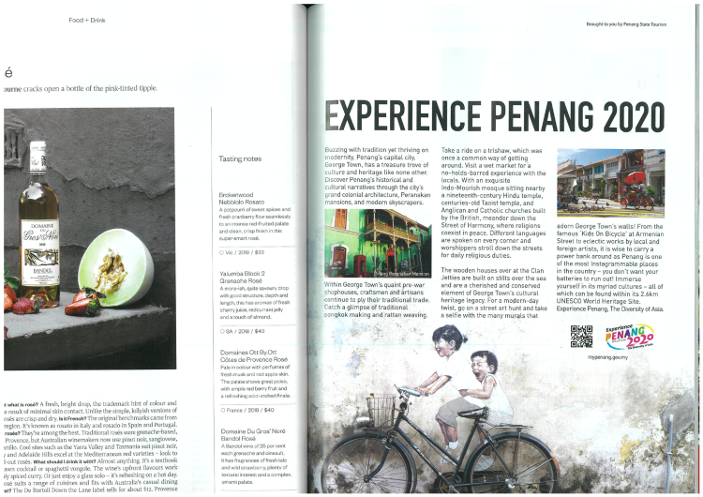

- EZ MALAYSIA ( The Art of Contemporary Luxury), Vol.57-19/20 - Advertorial on Experience Penang 2020 : The Diversity of Asia, page 62-63

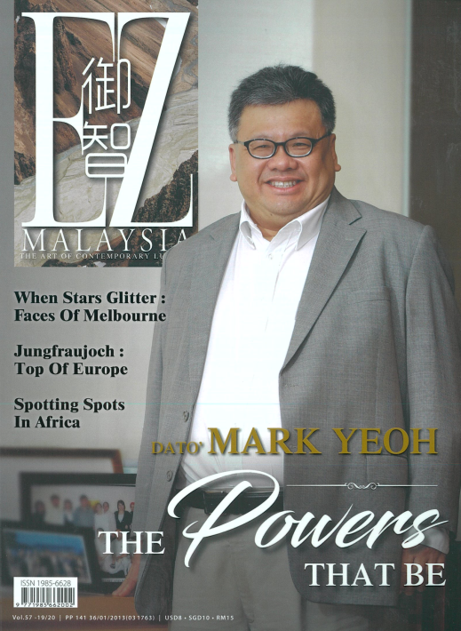

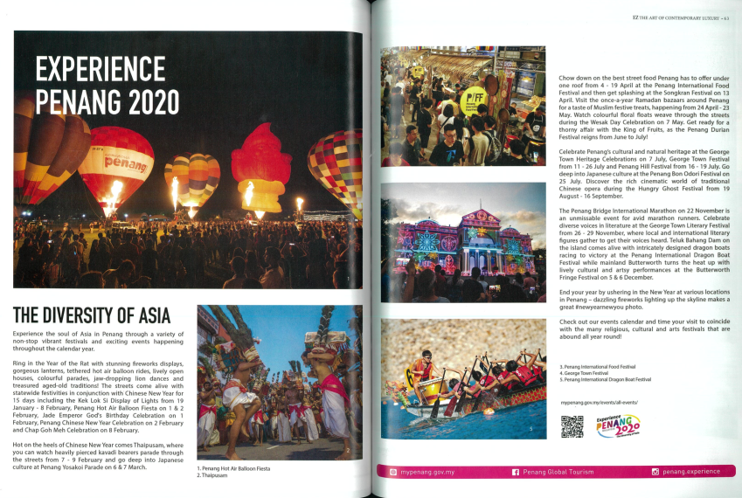

- EZ MALAYSIA ( The Art of Contemporary Luxury), Vol.57-19/20 - Advertorial on Hot Air Balloon Fiesta 2020 (page 64) & Penang Yosakoi (page 65)

