Print ads on Experience Penang – inflight magazines’ advertorials
- Travel 360 September 2019 Issue – Advertorial on Experience Penang 2020
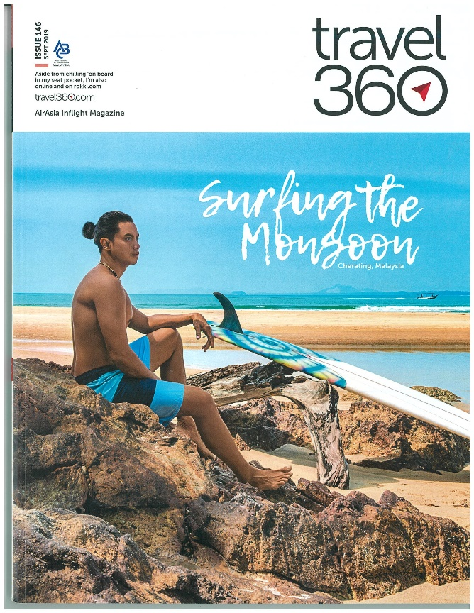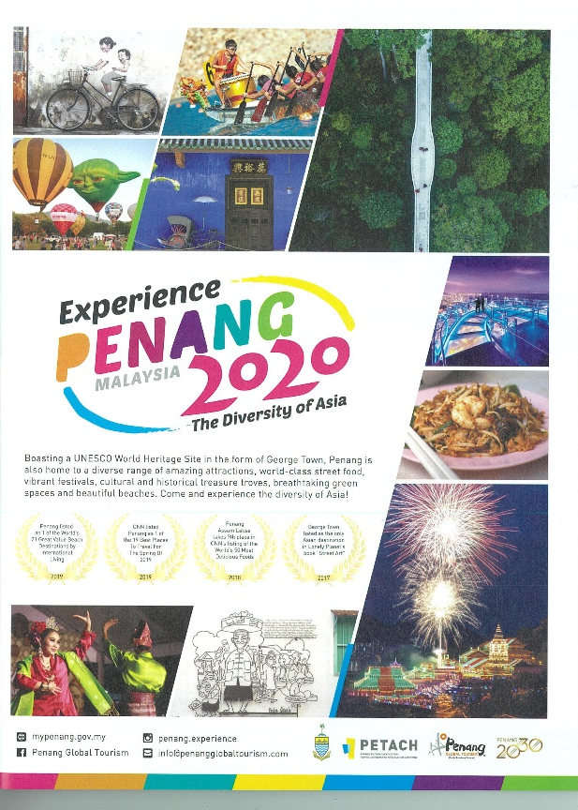
- EZ Malaysia, Faces of Penang Vol.55 – 19 – Advertorial on Penang Asian Food & Culture Festival
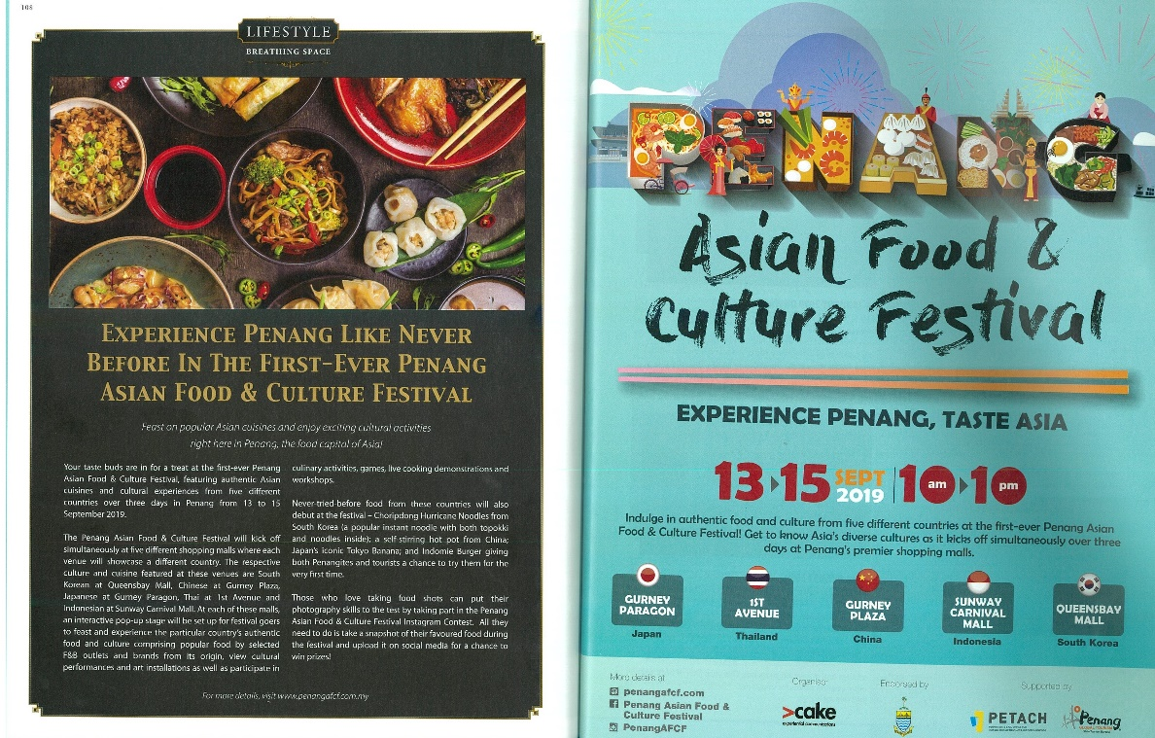
- EZ Malaysia, Faces of Penang Vol.55 – 19 – Advertorial on YB Yeoh Soon Hin

