Print ads on Experience Penang – inflight magazines’ advertorials
- Oryx’s June 2019 issue – advertorial on Experience Penang (Culture & Heritage)
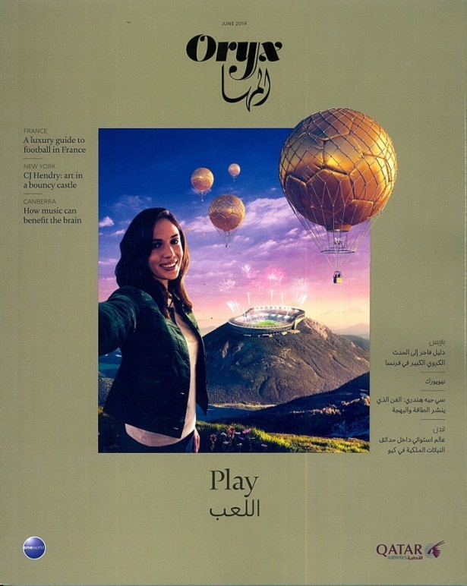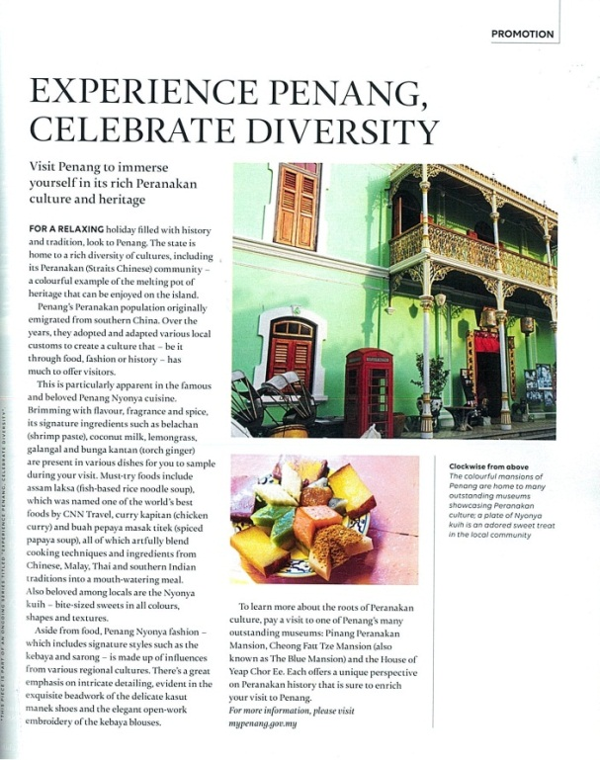
- Oryx’s July 2019 issue – advertorial on Experience Penang (Street Art, Food & Heritage)

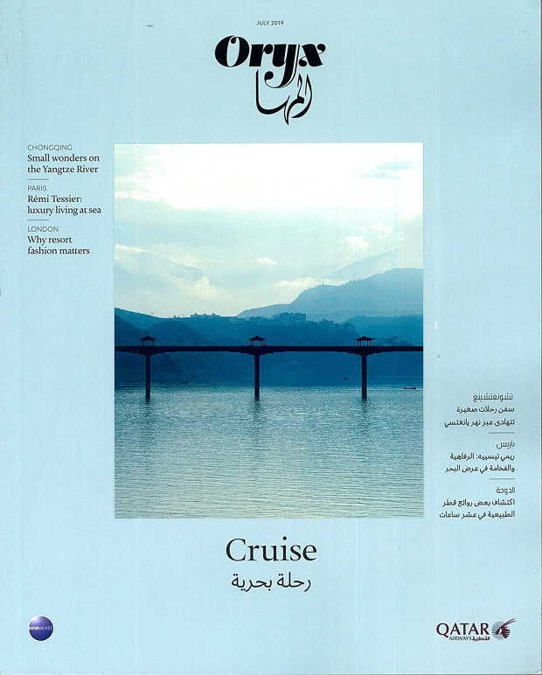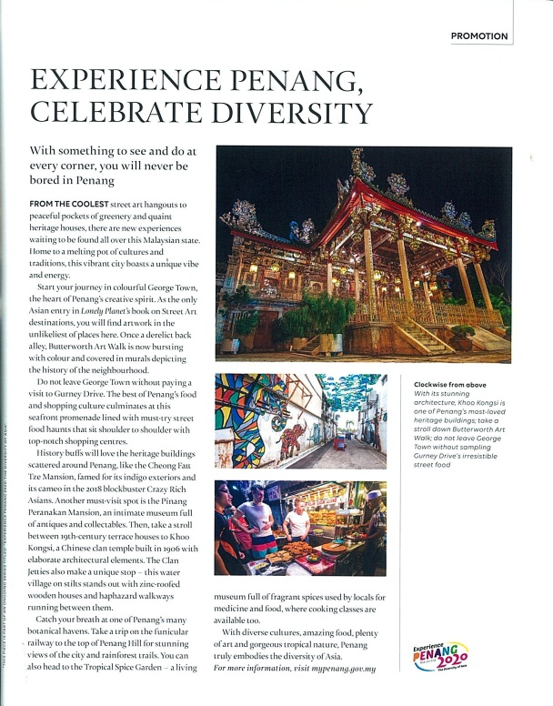

- SilkAir’s (Silkwinds) June 2019 issue – advertorial on Experience Penang (George Town Heritage Celebration, George Town Festival & Penang Hill Festival)
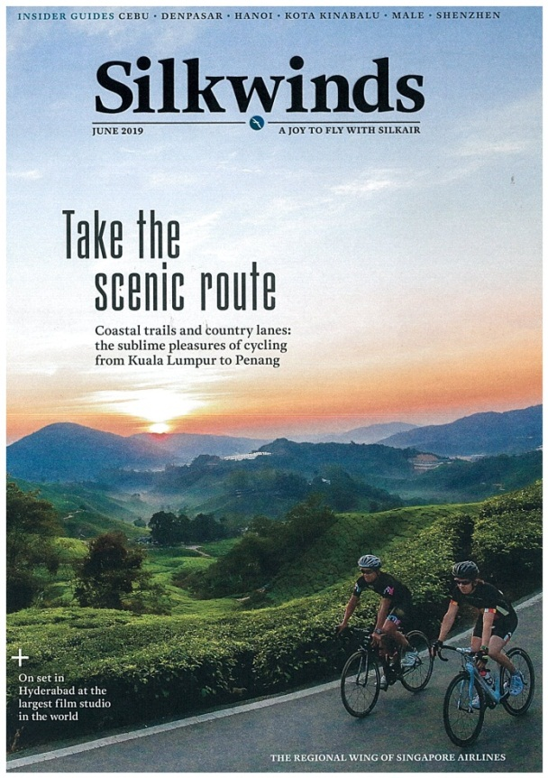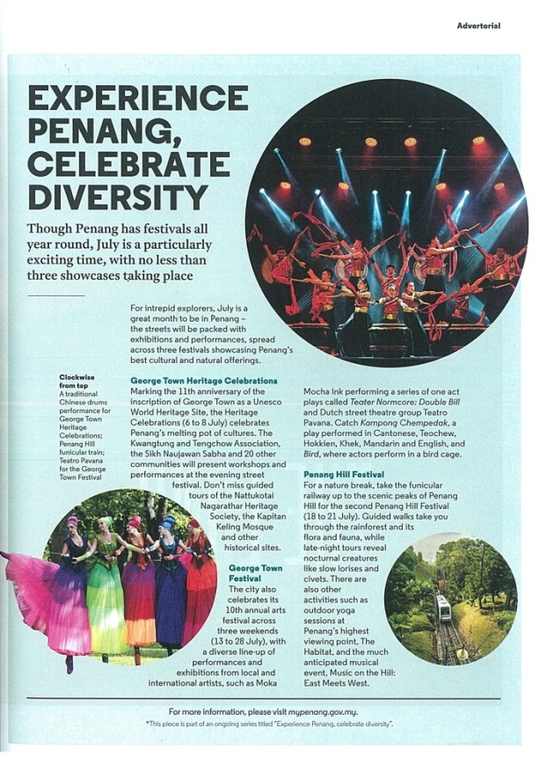
- SilkAir’s (Silkwinds) July 2019 issue – advertorial on Experience Penang (Attractions & Food)

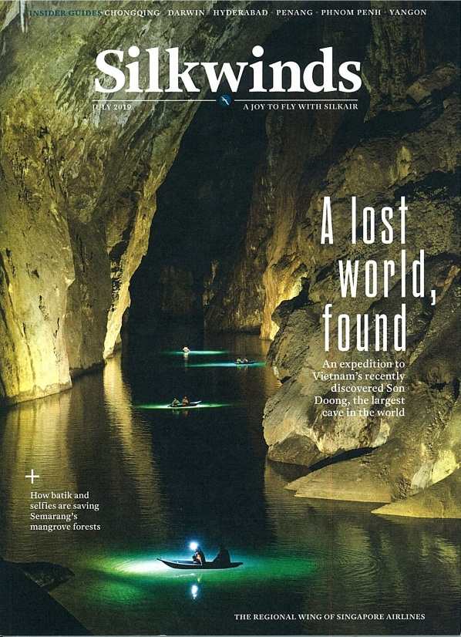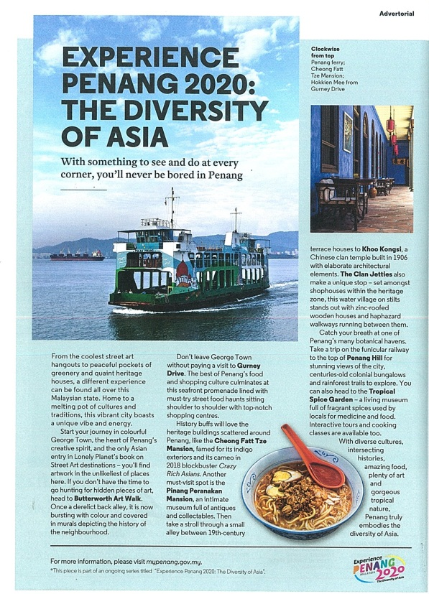
- SIA’s (SilverKris) June 2019 issue – advertorial on Experience Penang (Culture & Heritage)
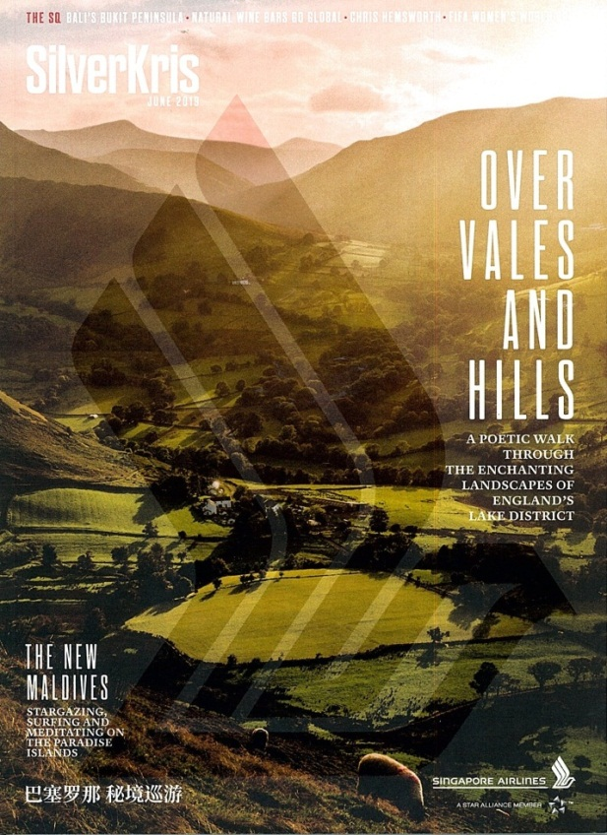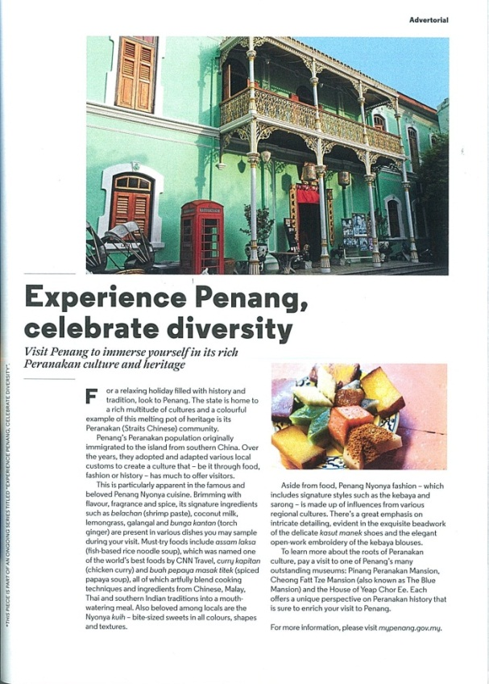
- SIA’s (SilverKris) July 2019 issue – advertorial on Experience Penang (Culture & Heritage, Food & Art Wall)
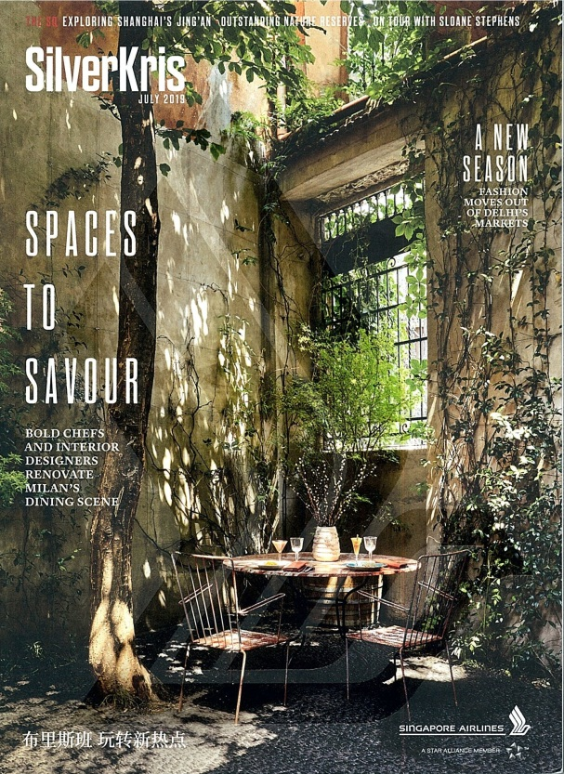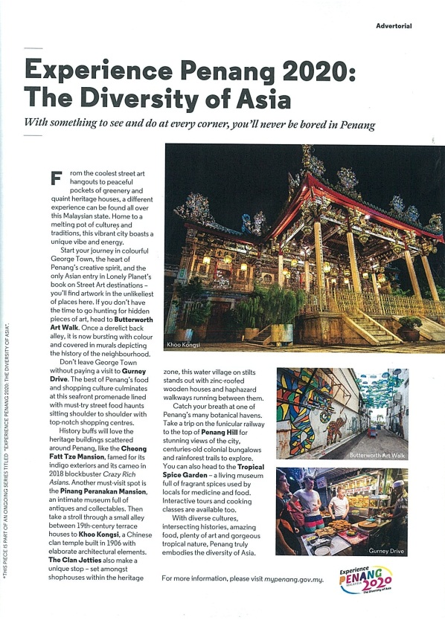
- Travel 360 July 2019 issue – advertorial on Experience Penang (George Town Heritage Celebrations, George Town Festival & Penang Hill Festival)

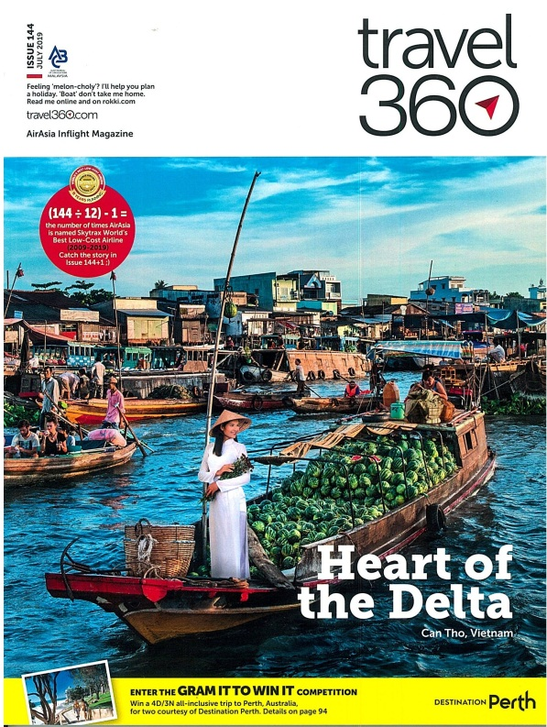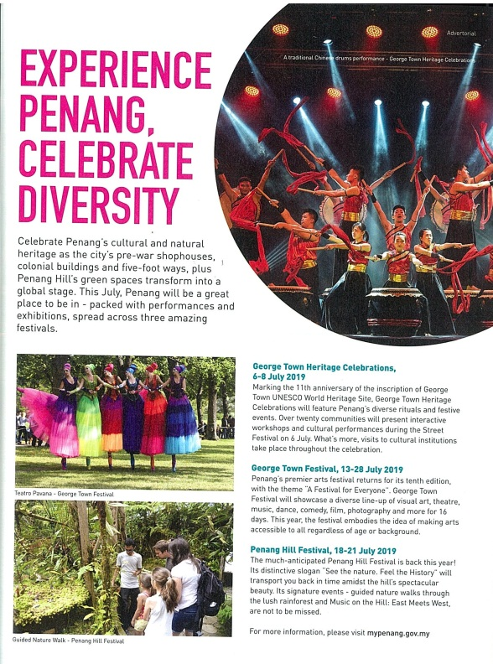

- Travel 360 August 2019 issue – advertorial on Asian Food & Culture Festival
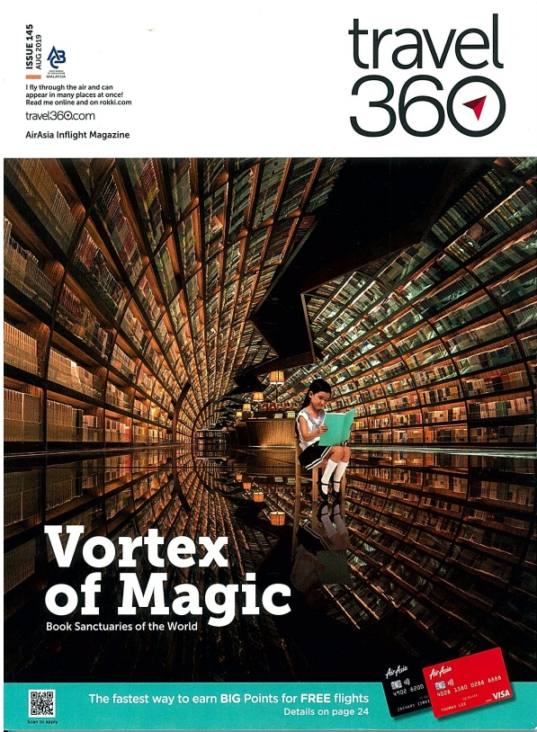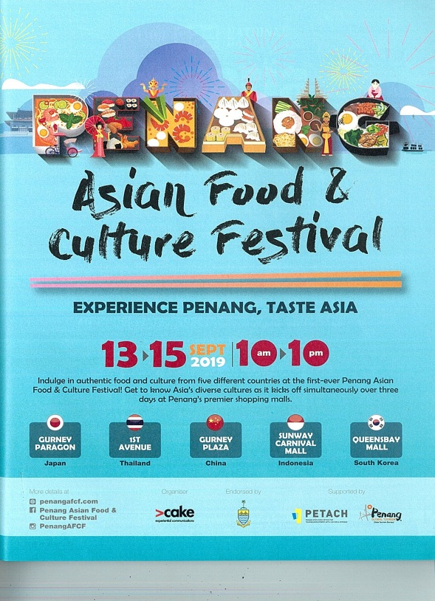

- Travel 360 September 2019 Issue – Advertorial on Experience Penang 2020
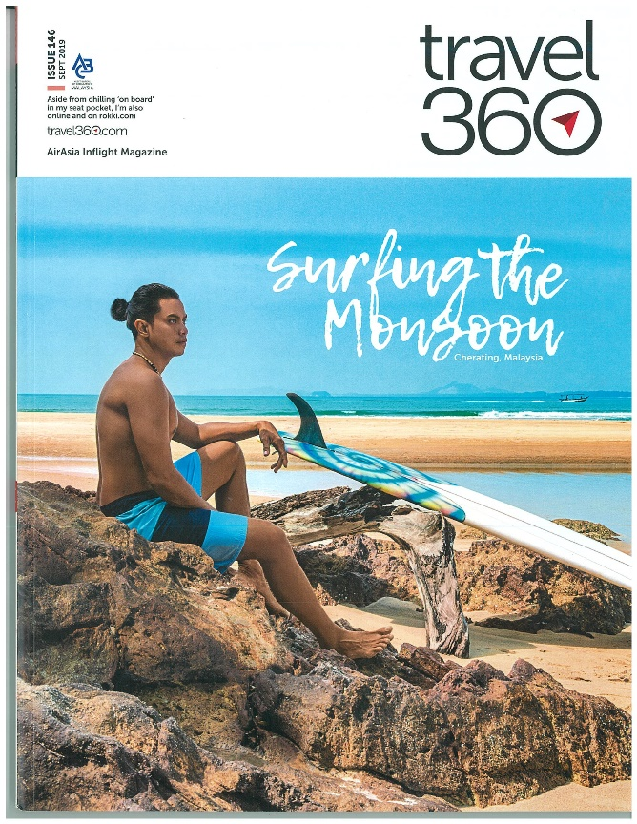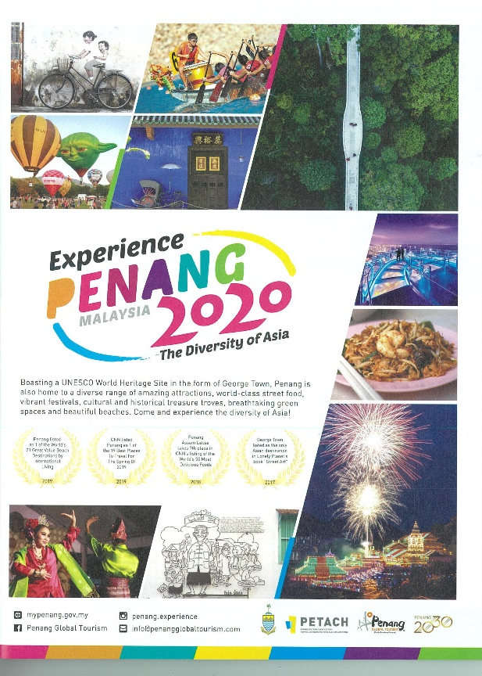

- EZ Malaysia, Faces of Penang Vol.55 – 19 – Advertorial on Penang Asian Food & Culture Festival
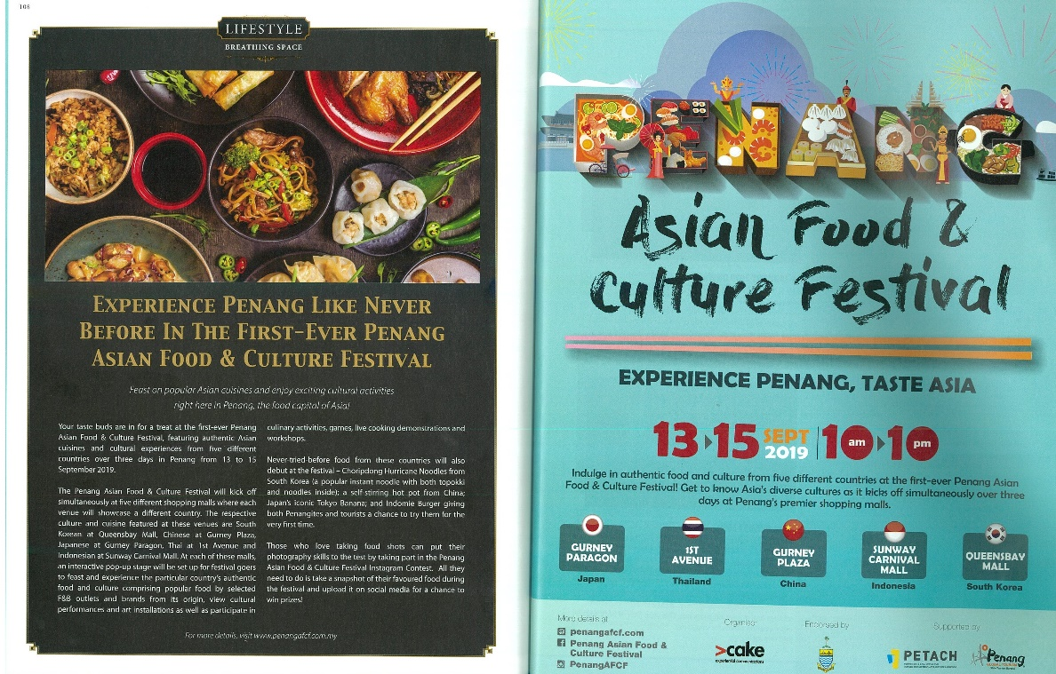
- EZ Malaysia, Faces of Penang Vol.55 – 19 – Advertorial on YB Yeoh Soon Hin

