Print ads on Experience Penang – inflight mags’ advertorials

- SilkAir’s (Silkwinds) Mar 2019 issue – advertorial on Experience Penang (Nature):
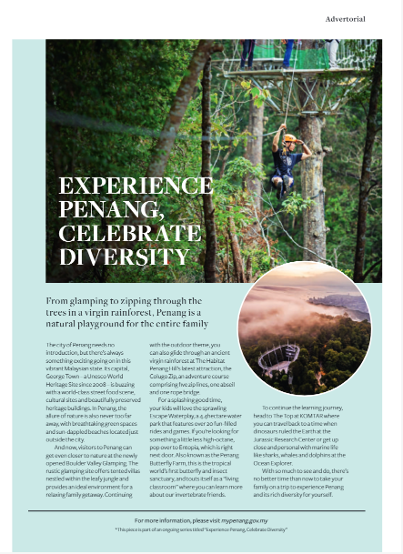
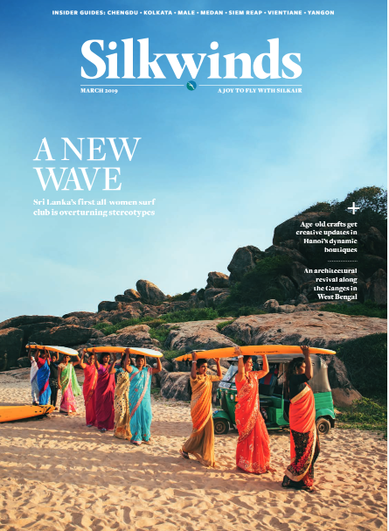

- SilkAir’s (Silkwinds) Apr 2019 issue – advertorial on Experience Penang (Food & PIFF):
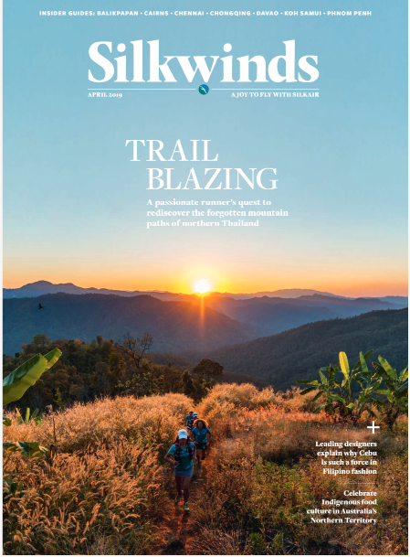
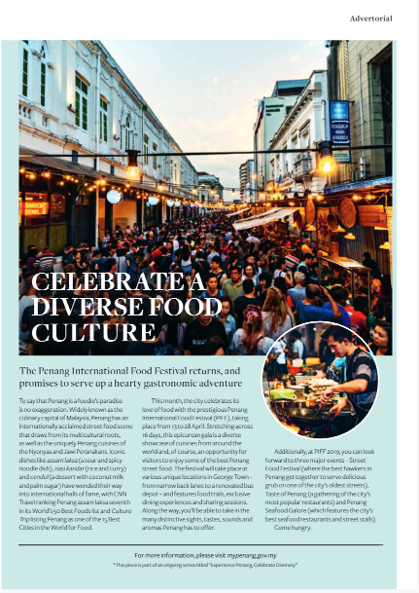

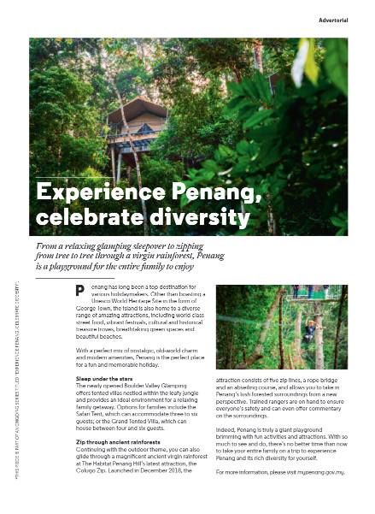
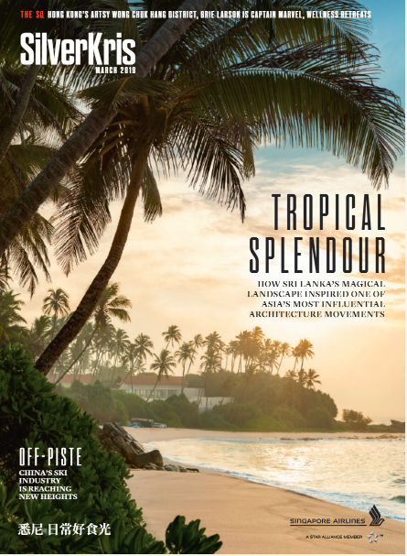
- SIA’s (SilverKris) Mar 2019 issue – advertorial on Experience Penang (Nature):

- SIA’s (SilverKris) Apr 2019 issue – advertorial on Experience Penang (Culture):
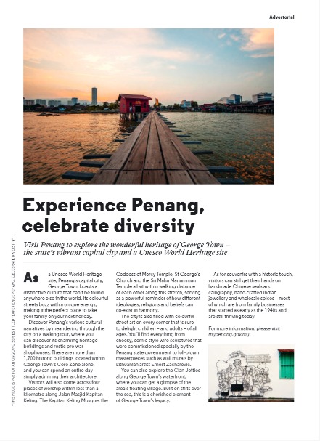
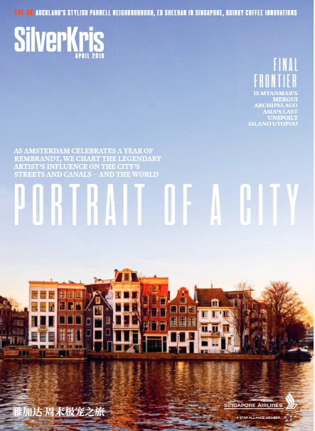

- Qatar’s (Oryx) Mar 2019 issue – advertorial on Experience Penang (Nature):
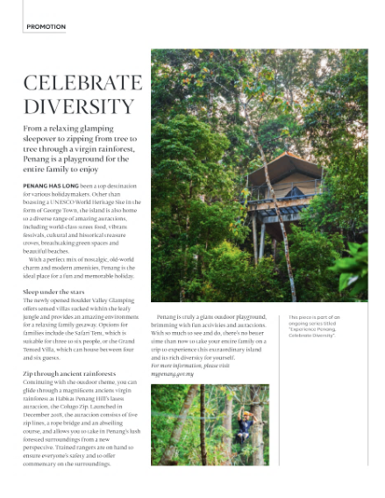
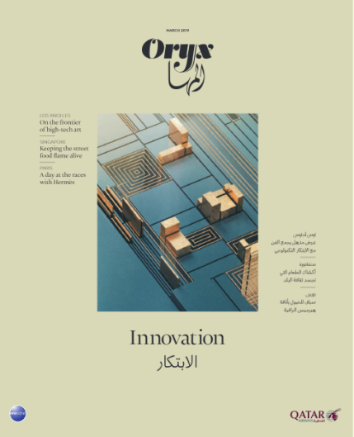

- Qatar’s (Oryx) Apr 2019 issue – advertorial on Experience Penang (Heritage):
