BALLOON ACTIVITIES
Over this two-day event, ticketed tethered balloon rides will be available where one can go up as high as 60 feet. There will also be the ‘cold inflation’ activity where anyone can walk into a balloon envelope that’s filled with cold air as it lies on the ground. In addition, F&B stalls and family friendly activities will be available throughout the event such as inflatables, creative workshops, paddle boat rides on a huge pool, reverse bungees for adults and kids, giant trampoline and more!
TICKETS
On both days, three tethered balloons are open for rides to the public at RM50 per person while cold inflation (where anyone can walk into a balloon envelope that’s filled with cold air as it lies on the ground) is RM5 per person.
There will be two tethered balloon ride sessions a day. Tethered balloon ride is chargeable at RM50 per person on first-come first-served basis. Tickets are limited to the first 150 persons (with numbered tags) in the queue and there will only be one ticket sold to each person. Numbered tags will be given out 30 minutes prior to the opening of the ticket counter. Tethered ride ticketing details are as follows:
Ticket Counter Operating Times:
7.15am [tickets sold only for morning session]
5.45pm [tickets sold only for evening session]
- * Tickets sold each day will be applicable for the particular day only, e.g. purchase of tickets on 1 Feb can only be used on the same day for the specific morning or evening session.
- * Children below 4ft are prohibited to ride the balloon due to safety reasons.
- * Tethered rides are subject to weather conditions.
- * Should weather conditions prohibit the ride, visitors can claim a full refund from the ticket counter within 3 hours of ticket purchase.
- * Safety is utmost priority; however, passengers are to ride at their own risk.
- * Appropriate clothing is advised such as pants or shorts for the ride.

FUN ZONE ACTIVITIES
In addition to the impressive hot air balloons, there will be fun activities for the whole family to participate such as giant inflatables, creative workshops, paddle boat rides, reverse bungees, trampoline and many more. Here are a list of the Fun Zone Activities and its charges. Note that the images are for reference only as the equipment may vary on actual day.
Activity | Price (RM)
Water Orb  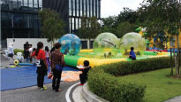 | 15 per head
Roller Orb  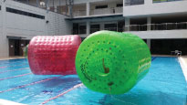 | 15 per head
Paddle Boat  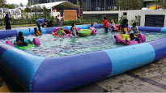 | 15 per boat
Trampoline  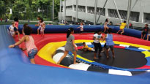 | 10 per head
Hamster Orb  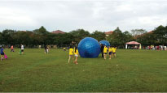 | 10 per head

Activity | Price (RM)
Reverse Bungee (adults only)  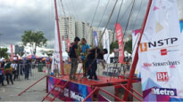 | 30 per head
Junior Bungee  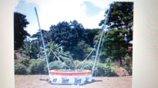 | 20 per head
Petting Zoo  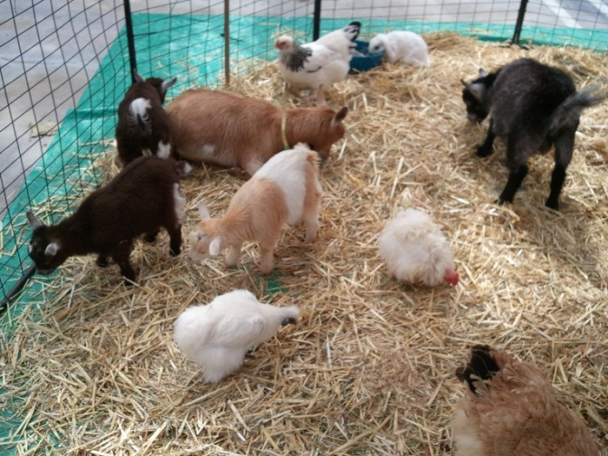 | 15 per person
Inflatable Zone (10 units)  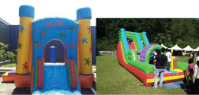  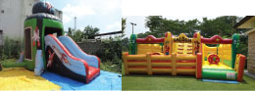 | 15 per entry
Bull Ride  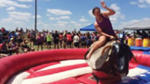 | 15 per head

FACILITIES
Food and beverage stalls as well as a variety of arts & crafts stalls will be available on both event days from 7am to 9pm. Additional mobile toilets will also be in place throughout the event area to accommodate the large crowd.

