Date | Original Post | Change to | Visual
11.09 | You can start your own mukbang show with all the different kinds of Korean food coming to you at Penang Asian Food & Culture Festival this 13-15 September.  Chow down on the usual Korean fare like Mandu and Topokki or try out something different yet familiar. We're talking about Laksa Japchae and Korean Instant Ramyeon Machine!  Come join us this weekend for 3 days of Asian food & culture!  #PAFCF #ExperiencePenangTasteAsia #Korea | Meet your tantalising Mukbang co-stars this 13-15 September at Penang Asian Food & Culture Festival!  Chow down on Korean mandu and topokki and try out Korean eats with local and modern twists!  We're talking Laksa Japchae and Korean Instant Ramyeon Machine!  #PAFCF #ExperiencePenangTasteAsia #Korea | No change
11.09 | Everyone's favorite instant noodle Indomie will be available this weekend, in the form of a doughnut!  Also, don't miss out on great and authentic Indonesian food like satay lilit, kopi luwak, gado gado and more.  For the full Indonesian culinary experience, come to Penang Asian Food & Culture Festival this 13-15 September!  #PAFCF #ExperiencePenangTasteAsia #indonesia #penang | Everyone's favourite instant noodles Indomie will be at Sunway Carnival Mall this weekend – in the form of a doughnut!  Also, don't miss out on authentic Indonesian food like satay lilit, kopi luwak, gado gado and more.  For a full Indonesian culinary experience, come to Penang Asian Food & Culture Festival this 13-15 September!  #PAFCF #ExperiencePenangTasteAsia #indonesia #penang | 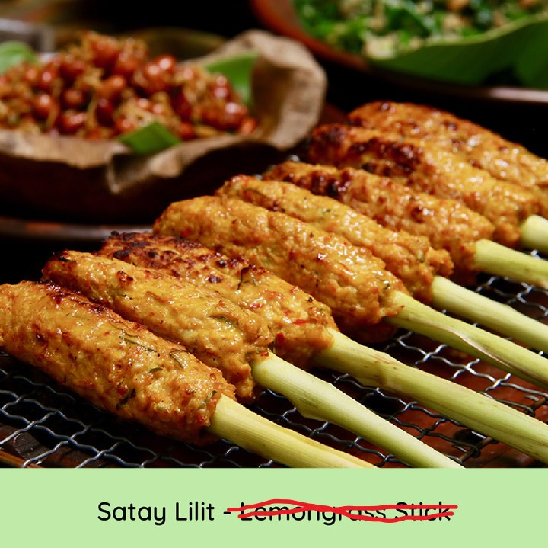
11.09 | Ohayogozaimasu! Enjoy all sorts of Japanese fare such as takoyaki, oden, tamagoyaki and some sweet fusion treats as well like cendol matcha cake or uji matcha with pearl!  Don't miss our unique solitary ramen dining experience inspired by Ichiran Ramen. Dig into a bowl of Japanese ramen with tonkotsu broth as you sit alone in a cubicle known as a 'flavor concentration booth'.  Meet us at Penang Asian Food & Culture Festival this 13-15 September and let's have a feast!  #PAFCF #ExperiencePenangTasteAsia #Japan #penang | Ohayogozaimasu! Enjoy all sorts of Japanese fare like takoyaki, oden, and tamagoyaki and treat yourself to sweet, fusion treats like cendol matcha cake and uji matcha with pearl!  Don't miss our unique solitary ramen dining experience inspired by Ichiran Ramen. Dig into a bowl of Japanese ramen with tonkotsu broth as you sit alone in a cubicle known as a 'flavor concentration booth'.  Meet us at Penang Asian Food & Culture Festival this 13-15 September and let's have a feast!  #PAFCF #ExperiencePenangTasteAsia #Japan #penang | No change
 | Look forward to these Chinese delicacies when you visit the Penang Asian Food & Culture Festival this weekend!  Experience an authentic Chinese tea tasting, indulge in the unique salted egg and pomelo cake or if you're feeling adventurous, we dare you to try out the Penang Asam Laksa ice blended drink!  We have all these treats and more waiting for you this 13-15 September so mark your calendars and see you there!  #PAFCF #ExperiencePenangTasteAsia #chinesefood #penang | From famous Chinese eats like Mala hotpot and dim sum to fusion treats, including Penang assam laksa ice blended drink and salted egg yolk ice cream, you’ll find plenty to keep you satisfied as you sample China’s best bites at the Penang Asian Food & Culture Festival this weekend!  #PAFCF #ExperiencePenangTasteAsia #chinesefood #penang | No change
 | Stick with us and you'll get to try mango sticky rice along with some other sweet treats from Thailand.  We have amazing Thai dishes waiting for you at Penang Asian Food & Culture Festival so bring your appetites when you get here this 13-15 September!  #PAFCF #ExperiencePenangTasteAsia #Thailand #penang | Load up on authentic Thai pandan chicken and green curry chicken rice, stick with us for the best mango sticky rice – and for the curious foodies, the Peranakan mango kerabu is guaranteed to leave you tongue-‘thai’-ed!  All these and more only at Penang Asian Food & Culture Festival, happening from 13-15 September!  #PAFCF #ExperiencePenangTasteAsia #Thailand #penang | No change
11.09 | Have you tried any of these and found one or all of them to be your favorite Chinese dish? Now you can join our Chinese cooking workshop and learn to make them at home!  #PAFCF #ExperiencePenangTasteAsia #China #ChineseFood #penang | Unleash your inner chef and whip up some tasty Chinese eats when you join our ‘Cook With China’ cooking workshop!  Head on to Gurney Plaza this 13-15 September and you’ll be cheffing it up in no time!  #PAFCF #ExperiencePenangTasteAsia #China #ChineseFood #penang | The video’s main title says it’s The Great China Dishing Out Demo, which i believe is a plating competition?  - 0.08 there’s a picture of vietnamese spring rolls. It’s not Chinese food, right?  - 0.11 pasta with prawn salad sounds italian.
11.09 | Join our cooking workshop and learn to make lontong, gado gado, satay balut and other authentic Indonesian foods!  #PAFCF #ExperiencePenangTasteAsia #Indonesia #penang | Need a hand in the kitchen? Join our ‘Cook With Indonesia’ cooking workshop and learn to make lontong, gado gado, satay balut and other authentic Indonesian foods!  #PAFCF #ExperiencePenangTasteAsia #Indonesia #penang | No change
11.09 | Learn to make your favorite Japanese dishes right here at our Japanese cooking workshop!  Head over to Gurney Paragon mall at these times and get your chef hats on. It's time to cook [emoji]  #PAFCF #ExperiencePenangTasteAsia #Japan #penang | Take a deeper dive into Japanese cuisine with our ‘Cook with Japan’ cooking workshop!  Head over to Gurney Paragon mall at these times and get your chef hats on. It's time to cook [emoji]  #PAFCF #ExperiencePenangTasteAsia #Japan #penang | Video subtitle is ‘workshop’. Please standardise to ‘Cook With Japan’
11.09 | You don't have to go to Korea to learn to make kimchi. Just come to Penang Asian Food & Culture Festival and join our 'Cook with South Korea'!  This workshop and cooking demo will teach you how to make South Korea's most popular and favorite dishes, as seen on K-dramas (and maybe a few Kpop videos)  #PAFCF #ExperiencePenangTasteAsia #SouthKorea #penang | You don't have to go to Korea to learn to make kimchi. Just come to Penang Asian Food & Culture Festival and join our 'Cook with South Korea' cooking workshop!  This workshop will teach you how to make South Korea's popular dishes often seen on Mukbang videos and K-dramas!  #PAFCF #ExperiencePenangTasteAsia #SouthKorea #penang | No change
11.09 | Take part in our Thai cooking workshop and then impress your friends over dinner after you learn to make exotic Thai dishes like deep fried coconut shrimp with palm sugar spicy sauce.  Come to 1st Avenue this 13-15 September and give it a Thai.  #PAFCF #ExperiencePenangTasteAsia #Thailand #penang | Give our ‘Cook With Thailand’ cooking workshop a ‘thai’!  Learn to make exotic Thai dishes like Thai chicken salad and deep fried coconut shrimp and impress your friends with your new culinary skills over dinner!  Head over to 1st Avenue this 13-15 September.  #PAFCF #ExperiencePenangTasteAsia #Thailand #penang | Mark 0.03, please change Thai Chicken Salad Hold with Crispy Wan Tan Cup to Thai Chicken Salan in Crispy Wonton Cup  Mark 0.06, reword to:  - Thai Golden Chicken Meatball  - Thai Crunchy Crab Cake
11.09 | Prepare your travel checklist because Klook has exclusive deals for you!  Grab up to 50% off on different travel deals when you visit each mall at Penang Asian Food & Culture Festival!  More info at www.penangafcf.com  *All visuals: Deals available in limited quantities. T&Cs apply.  #PAFCF #ExperiencePenangTasteAsia | Prepare your travel checklist because Klook has exclusive deals for you!  Grab up to 50% off on different travel deals when you visit each mall at Penang Asian Food & Culture Festival!  More info at www.penangafcf.com  #PAFCF #ExperiencePenangTasteAsia | 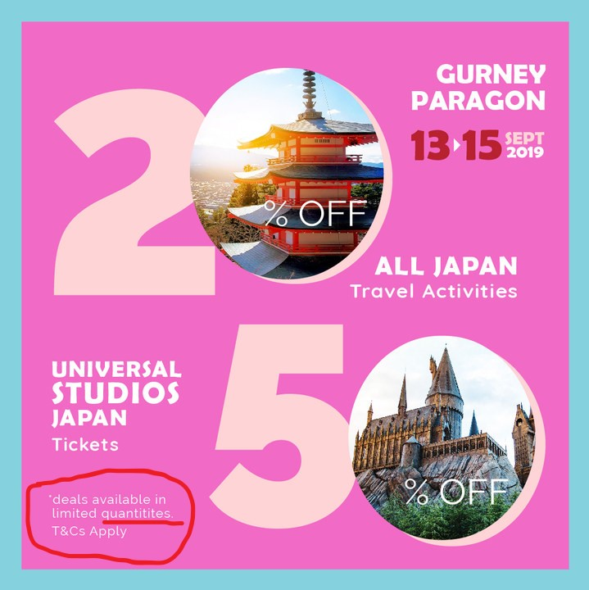  Reword to:  Deals available in limited quantities. T&Cs apply.  Please make sure this edit is implemented across all visuals in this post.
12.09 | Yay to 50% off your favourite theme parks!  Drop by Klook's booth at the festival’s participating malls to unlock exclusive deals from Klook.  Promo is only available during the Penang Asian Food & Culture Festival happening on 13 - 15 September.  Visit www.penangafcf.com for more information.  #Klook #PAFCF #ExperiencePenangTasteAsia #AsianFoodCulture #Penang | Yay to 50% off your favourite theme parks!  Drop by Klook's booth at the festival’s participating malls to unlock exclusive deals from Klook.  Promo is only available during the Penang Asian Food & Culture Festival happening on 13 - 15 September.  Visit www.penangafcf.com for more information.  #Klook #PAFCF #ExperiencePenangTasteAsia #AsianFoodCulture #Penang | Please change Universal Studio, Japan to Universal Studios, Japan at mark 0.05.  Must have an ‘S’ for the studio.
12.09 | Give your taste buds the royal treatment as Royaltea serves up the freshest, most creative beverages only at Penang Asian Food & Culture Festival.  Don't miss out on crazy good concoctions like Royal Cheese Sakura Oolong tea and Jujube Longan milk tea!  For more information, check out our website: www.penangafcf.com  #PAFCF #Royaltea #milktea #ExperiencePenangTasteAsia | Give your taste buds the royal treatment as Royaltea serves up the freshest, most creative beverages only at Penang Asian Food & Culture Festival.  Don't miss out on crazy cool concoctions like Royal Cheese Sakura Oolong tea and Jujube Longan milk tea!  For more information, check out our website: www.penangafcf.com  #PAFCF #Royaltea #milktea #ExperiencePenangTasteAsia | No change
12.09 | Ever wondered what laksa japchae tastes like? Or maybe kimchi popiah?  KOTA will be serving up a unique fusion cuisine only at Penang Asian Food & Culture festival this 13-15 September!  Mark your calendars and bring your appetites and see you there!  Find out more at: www.penangafcf.com  #PAFCF #ExperiencePenangTasteAsia #fusionfood #KOTA | If you're a fan of Korean fusion, then Penang Asian Food & Culture festival is a real treat.  KOTA is serving up unique fusion dishes like laksa japchae and kimchi popiah this 13-15 September!  Bring your appetites and see you there!  Find out more at: www.penangafcf.com  #PAFCF #ExperiencePenangTasteAsia #fusionfood #KOTA | No change
12.09 | Use your phone as your wallet at Penang Asian Food and Culture Festival and Boost all the way to enjoy great food as well as greater cashbacks!  #PenangAsianFoodandCultureFestival #PenangAFCF #Boost | Pay with your phone at Penang Asian Food and Culture Festival and Boost your way to great food and great cashbacks!  #PenangAsianFoodandCultureFestival #PenangAFCF #Boost | No change
 | Different nation, different ice-cream. Are you ready to try them all?  #PAFCF #ExperiencePenangTasteAsia | Different countries, different ice creams. Are you ready to try them all?  #PAFCF #ExperiencePenangTasteAsia | No change
 | In supporting our festival's initiative to save the environment, we are selling these awesome tote bags at these selected malls! Get them at ONLY RM10 each when you visit Penang Asian Food & Culture Festival on 13-15 September 2019.  Limited stocks only so be sure to come early!  #PAFCF #ExperiencePenangTasteAsia | Help us save the planet, one bag at a time!  Collect all five Penang Asian Food & Culture Festival tote bags available at these selected malls!  Limited stocks only so be sure to come early!  #PAFCF #ExperiencePenangTasteAsia | No change
 | You don't have to ask "Konichi-where" to go. Just refer to this directory when you visit Japan in Gurney Paragon Mall!  #PAFCF #ExperiencePenangTasteAsia | Konichi-‘where’?  Let us ‘shoyu’ the way to seriously delicious Japanese eats with this complete directory!  #PAFCF #ExperiencePenangTasteAsia | No change
 | Don't just dim sum, make sure you visit all zones to experience China in Penang at Gurney Plaza this 13-15 September!  #PAFCF #ExperiencePenangTasteAsia | Penang Asian Food & Culture Festival is set to heat things up this weekend! ‘Wok’ your way around Gurney Plaza with this complete directory!  #PAFCF #ExperiencePenangTasteAsia
 | Things are less hazy when you have our directory to explore Indonesia in Sunway Carnival Mall!  #PAFCF #ExperiencePenangTasteAsia | Find your way to the best Indonesian delights in Sunway Carnival Mall with this complete directory!  #PAFCF #ExperiencePenangTasteAsia
 | Don't forget to check out all our zones in 1st Avenue to get the most Tom Yummy experience from 13-15 September 2019!  #PAFCF #ExperiencePenangTasteAsia | Here’s your cheat sheet to appe-‘thai’-sing flavours at 1st Avenue from 13-15 September 2019!  #PAFCF #ExperiencePenangTasteAsia
 | Here's a huge bibim-map for you to tick your boxes as you experience Korea in Queensbay Mall!  #PAFCF #ExperiencePenangTasteAsia | Right this way to a ‘Seoul’-searching event at Queensbay Mall you'll never forget!  #PAFCF #ExperiencePenangTasteAsia
12.09 | Can't get enough of Klook deals at our festival? Keep looking and get local as well as international holiday deals at Klook Travel Fest on 28 - 29 September at MITEC Kuala Lumpur! Check them out now. | Can't get enough of Klook travel deals at our festival? Grab local and international holiday deals at Klook Travel Fest on 28 - 29 September at MITEC Kuala Lumpur! Check them out now. | No change

