August Socmed

Date | Original text | Change to | Graphic Edits
1.8 | Asian food always keeps things spicy! Here's how hot Asian condiments can get  How high up the scoville scale can you go? Find out at Penang Asian Food & Culture Festival this 13-15 September 2019!  #PAFCF #ExperiencePenangTasteAsia #SpicyFood  Editor’s comment: Green curry, laksa, and tom yam are not condiments. | Asian food always keeps things spicy. Here's how hot Asian food can get!  How high up the Scoville scale can you go? Find out at Penang Asian Food & Culture Festival this 13-15 September 2019!  #PAFCF #ExperiencePenangTasteAsia #SpicyFood | 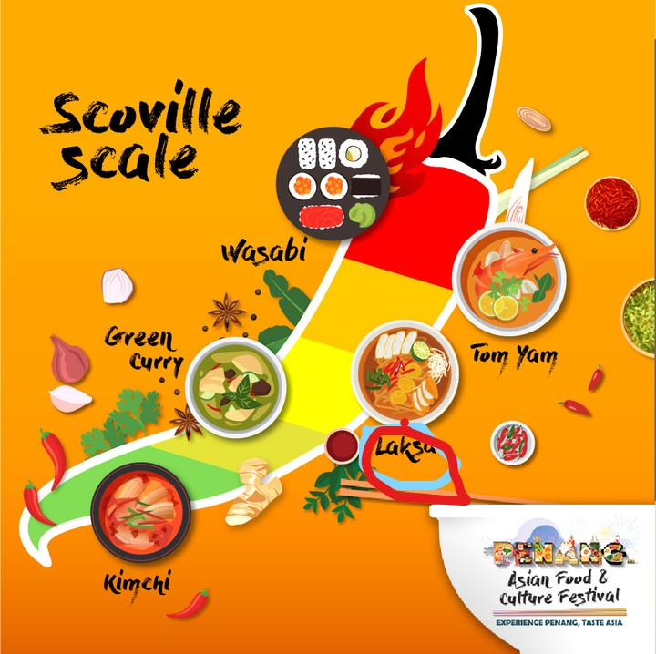  Editor’s comment: Laksa can be sarawak laksa or johor laksa. Best to clarify it as Assam Laksa?
6.8 | Food quiz using FB poll  Question: What does dim sum translate to?  Choices: Touch the heart/Bite-sized food | How well do you know your dim sum? Take this poll and find out!  Question: What does dim sum translate to?  Choices: Touch the heart/Bite-sized food | 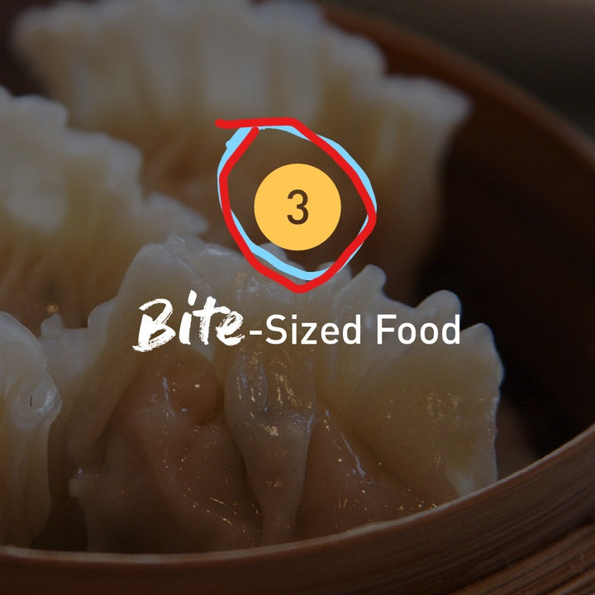  Editor’s note: The number should be 2, not 3.
10.8 | Fly to one place, eat from 5 countries. We're serving up the best eats from all around Asia in Penang this 13-15 September!  #PAFCF #ExperiencePenangTasteAsia #AsianFood #Foodie | Fly to one place, eat from five countries. We're serving up the best eats from all around Asia in Penang this 13-15 September!  #PAFCF #ExperiencePenangTasteAsia #AsianFood #Foodie | NIL
14.8 | [Food quote]  "Ask not what you can do for your country. Ask what's for lunch" - Orson Welles | We [heart icon] this quote from the late Anthony Bourdain!  Editor’s comment: This Orson Welles quote has a negative historical background to it.  Suggest to use this quote by Anthony Bourdain instead.  “You learn a lot about someone when you share a meal together.” - Anthony Bourdain | NIL
23.8 | Try out Ichiran Ramen at Penang Asian Food & Culture Festival. The solitary experience is meant to let you focus on your delectable bowl of ramen so you can savor the taste!  #PAFCF #IchiranRamen #ExperiencePenangTasteAsia | No face-to-face interaction with servers or neighbours? Say no more!  Try out Ichiran Ramen at Penang Asian Food & Culture Festival. While the Aji-shuchu counter isolates you, the solitary experience is meant to let you focus on your delectable bowl of ramen so you can savour the taste!  #PAFCF #IchiranRamen #ExperiencePenangTasteAsia | No change
26.8 | Only 20 days to go to all the glorious Asian food you can eat! Penang Asian Food & Culture Festival is near so get your appetites ready  #PAFCF #ExperiencePenangTasteAsia #AsianFood | NIL | Please edit out the chicken bit and the chilli in front number 20. They take the focus away from the number.
30.8 | Thailand's culture of strange foods may not be for everyone, but if you have the stomach for an authentic Thai street food experience then we challenge you to eat a bowl of bugs!  Crickets, grasshoppers, ants and silk worms are just some of the choices you have. Get your grubs this 13-15 September 2019 at Penang Asian Food & Culture Festival  #PAFCF #ExperiencePenangTasteAsia #AsianFood | Thailand's culture of strange foods may not be for everyone, but if you have the stomach for crickets, grasshoppers, ants and silkworms, then get these grubs at Penang Asian Food & Culture Festival this 13-15 September 2019!  #PAFCF #ExperiencePenangTasteAsia #AsianFood | No change

