Murals of Air Itam

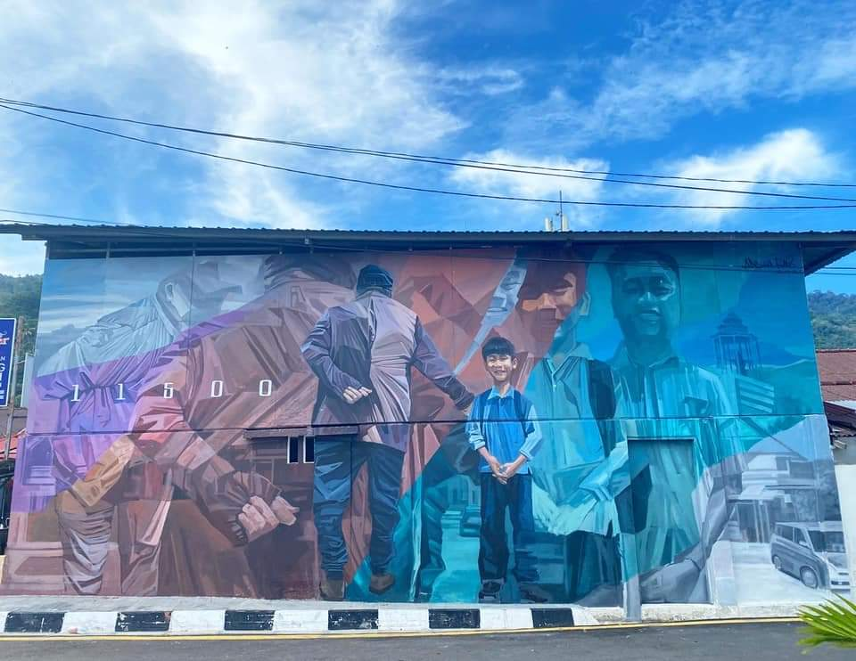

The artist who created Generation to Generation is Amir Andhar (commonly known as Andharas) from Malacca. Andharas is a mural art and graffiti practitioner. As Air Itam was one of the first suburbs developed when Penang was founded in 1786, generations past worked here, settled down, and families burgeoned. Generation after generation continued to live here. However, despite a reduction in younger generation members today, a lively environment remains, especially during festive seasons. The bustling activities in the marketplace and roadside stalls in the morning make Air Itam definitely worth a visit to experience the authentic life of old Penang.
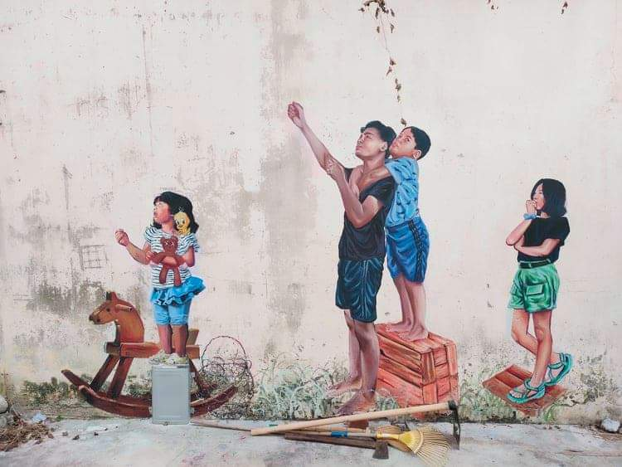
Creating Kites Got Stuck are Dana Ng and Nur Hana Tan. Dana is a young artist, specialising in illustration and game art design, while Hana is an established figurative artist. The Air Itam of today is filled with residents of the older generation and we see heritage, cultures, and traditions of old still celebrated. Kite flying was once a fun activity for children, depicted here nostalgically in this mural. On windy afternoons, children from various ethnic groups would play and mingle together as one big family in the playground. It is hope that this engaging mural will bring back childhood memories for those visiting Air Itam.

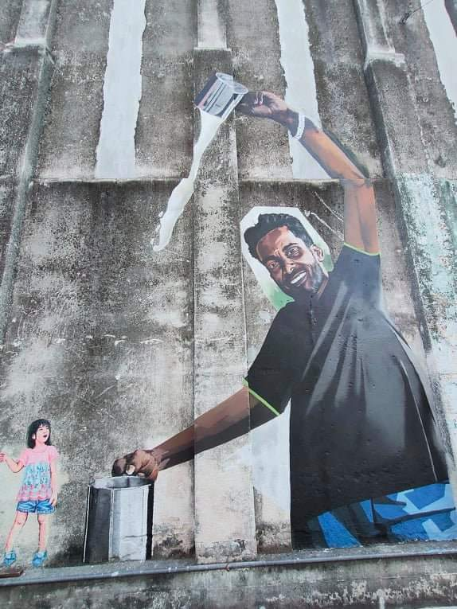
Khow Zew Wey, popularly known as Bibichun, created Susu Tarik (translated as ‘pulled milk’). Bibichun enjoys reaching out to the community by presenting his creations on public walls. Mr Kathiravelu, depicted here in this mural, began serving nutritious fresh pulled milk at the age of 20. Today, his iconic street stall 32 years on, continues to do so every evening. An addition of raw eggs is optional. Kathiravelu’s process of pulling the milk is definitely one of its kind, and thus, it is a must-try for food hunters. To those who worry about communication issue, his ability to speak fluent Hokkien, a commonly spoken dialect in Penang, will definitely ease their worries.

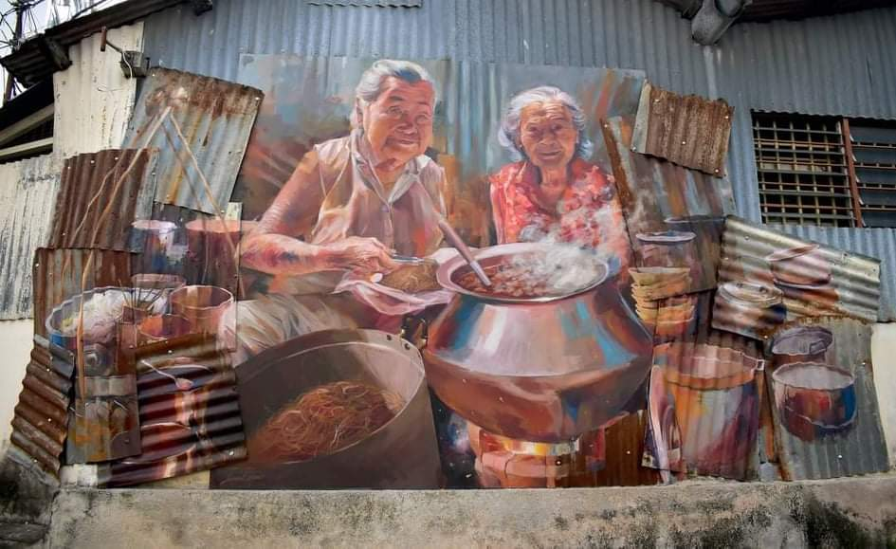
Curry Mee Ah Ma has been created by Leonard Siaw from Sarawak. Leonard is a self-taught mural artist, specialising in painting human figures, animals, and portraits. These two famous Siamese sisters, curry noodle hawkers, are 87-year old Madam Lim Kooi Lye (left) and 89-year old Madam Lim Kooi Heang (right). Both sisters are widely known among Penangites. Migrating from Thailand, the sisters assisted their mother at her curry noodle stall after their father passed away. The first bowl of curry noodles was sold at 5 cents. After World War II, the sisters continued operating the stall every day for seven decades. Their authentic Siamese recipe of noodles served in rich, fragrant curry-flavoured soup has long captivated the taste buds of many. Neither sisters ever married, but they are living happily with their godchild’s family. This mural reflects the Siamese sisters’ hardship of life where they persistently served the community over the years to earn a living.

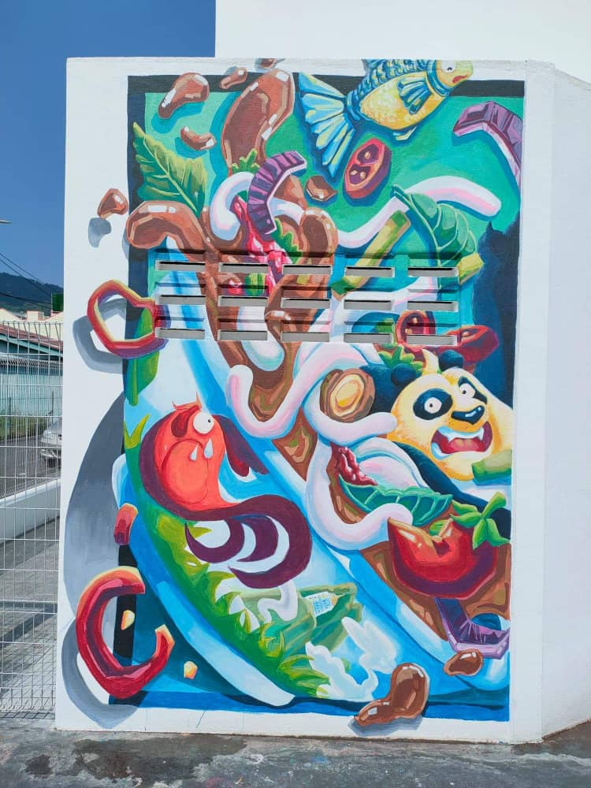
Laksa has been created by Dana Ng, who enjoys integrating fun characters and food culture into her art. Laksa is thick wheat noodles served in spicy fish-based sour broth. It is popular among the locals and Air Itam is home to two long-established Laksa stalls. The one in the market is run by a brother, deaf from birth, and assisted by his sister, while the one opposite the market is a family business run over generations since 1955. This pop culture mural serves as a memoir of the beloved dish that is also an icon of Air Itam.

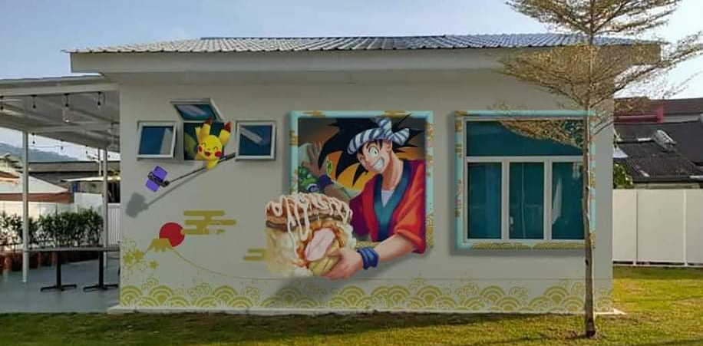
Dana Ng also created Trendiness! Pop cultural murals aim to be witty yet thought provoking, as demonstrated in Trendiness! Popular activities for today’s young people are spending time on social media, enjoying Japanese, Korean, and Western cuisine, and taking selfies with friends. This mural captures such activities – Goku, an anime male character, is seen showing off his huge, delicious, 3D tuna sushi, while Pikachu, the most well-known species of Pokémon, is performing a selfie with his camera phone attached to a selfie stick. This piece of ‘trendy’ creation is hoped to bring something to which the young ones visiting Air Itam can relate.

