3. Communications - Reported by D’Yani Ramoo

July - November 2020
Report Overview
Events’ promotion:
All state supported events were postponed due to the Covid-19 pandemic. The main annual festivals that happen in the months of July and August such as George Town Festival, George Town Heritage Celebrations, Penang Hill Festival, Penang Bon Odori, were all cancelled. Hence, all planned A&P were cancelled too. However, we have been promoting TechFest Live, a state event, that’s mainly held virtually via our social media platform. The ad was boosted to: Malaysia, Singapore, HK, Japan, S. Korea, Australia, Taipei, Thailand, Indonesia, Philippines, UK, Vietnam. From the boosting, the total reach was 1,042,392 and Link Clicks were 13,071.

International campaigns:
Under Comms, no international campaigns were undertaken during this period, from July to November 2020. However, there was only one print ad in the inflight magazine of Gateway for August issue completed. All other inflight magazines have been suspended due to the Covid-19 outbreak. Hence, ads booked in SilverKris, Silkwinds, Emirates and Travel360 are all void now.

We are now updating our remaining Lightbox ad which is part of the OOH campaign in Taiwan, in Ximen MRT Station, for three months - December 2020 to February 2021.

Domestic campaign:
The ongoing outdoor advertising campaign on Covered Walkways continues at the KL’s city centre at Jalan Sultan Ismail and Jalan Raja Chulan located in front of Wisma Genting and Wisma Cosway. However, with regards to TechFest Live, we have submitted two TV commercials that will appear on selected ASTRO TV channel. The TVCs were 20secs each and they were on Penang Accolades and The Other Side Of The Island – Teluk Bahang and Balik Pulau.

New videos were recently completed with an aim to target the domestic market via social media however we’re yet to launch it due to the high number of positive Covid cases in Penang. The new completed videos were The Other Side Of The Island – Teluk Bahang and Balik Pulau, The Opposite Side Of The Island Seberang Perai, Why Travel Elsewhere, Experience It All In Penang and Penang Through The Lens.

From the wake of the pandemic, PGT has been focusing more on promoting Penang via social media, to ensure Penang remains in the minds of potential visitors especially when travel bans are lifted. PGT has also been regularly boosting posts on its Facebook page, targeted especially towards the domestic market. In the following pages of this report, you’ll find that there has been more effort put into social media and lesser of outdoor advertising of bus wraps and billboards which had been used to promote events that are now all currently on hold in Penang.

3.1 Accomplished from July to November 2020

3.1.1 Print ads
- China Southern Airlines’ inflight magazine (Gateway) in Aug 2020 issue – the featured ad is on Penang Responsible Tourism:
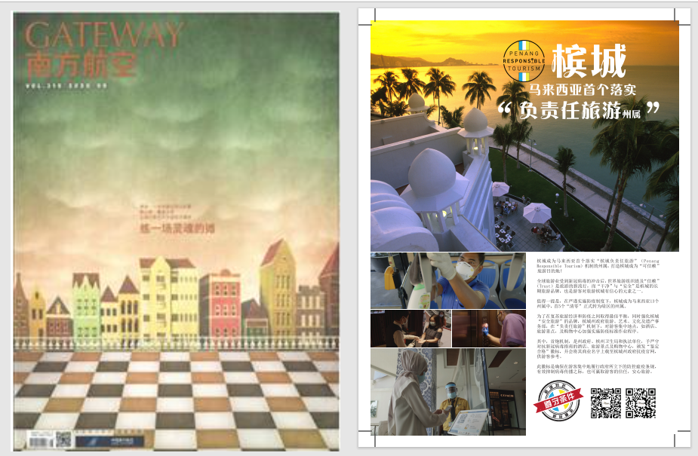
Magazine Cover: Advertorial:

3.1.2 Promo CUBEs at Airport & TIC – the four sides of the CUBEs were updated to mainly feature our current Jom Experience Penang campaign as well as the Thank You Frontliners and Penang International Container Art Festival.

Airport CUBE:
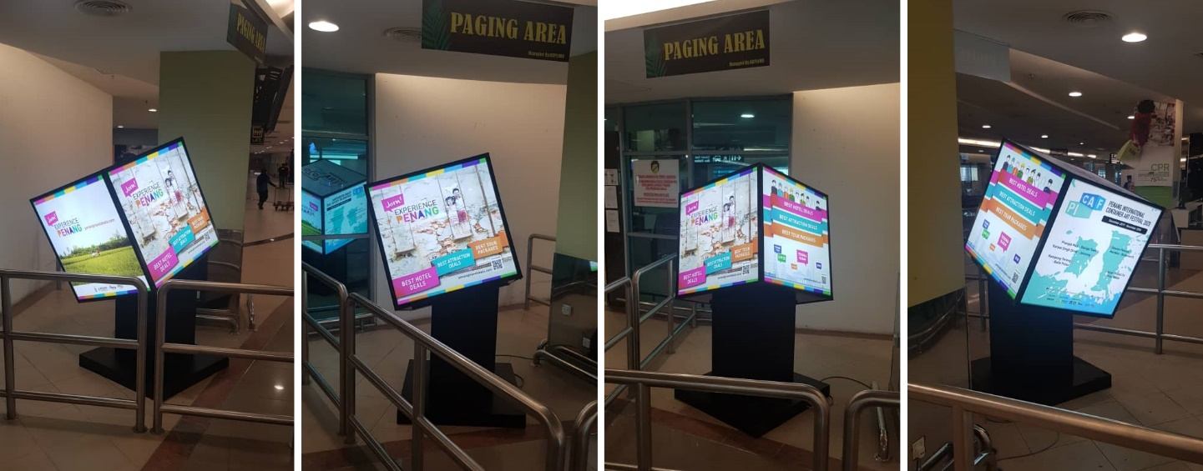

TIC CUBE:
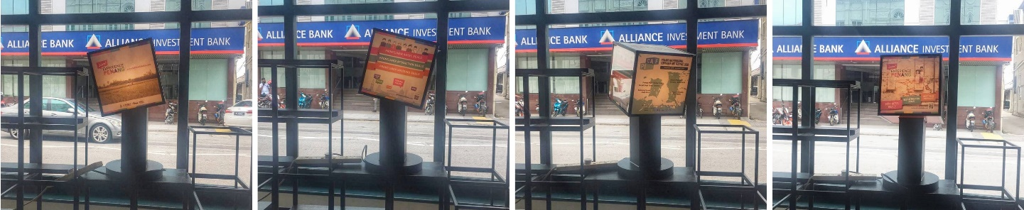

In Nov, we replaced one of the Penang Travel Deals ads on Airport and TIC CUBEs with Penang Responsible Tourism. Here’s a snapshot of the ad as follows:
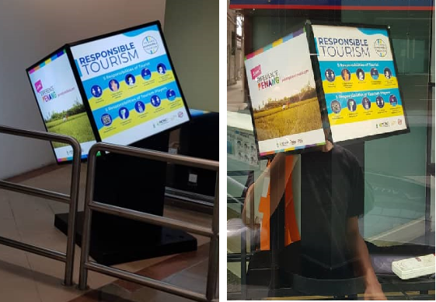

3.1.3 Billboard Ads - PGT has been advertising EPY2020 on the billboards at IJM and Penang Turf Club mainly this year as most major events were cancelled due to Covid-19. However, recently in Nov, we have printed and installed the Penang Responsible Tourism on both billboards, as follows:

IJM Billboard | Penang Turf Club Billboard
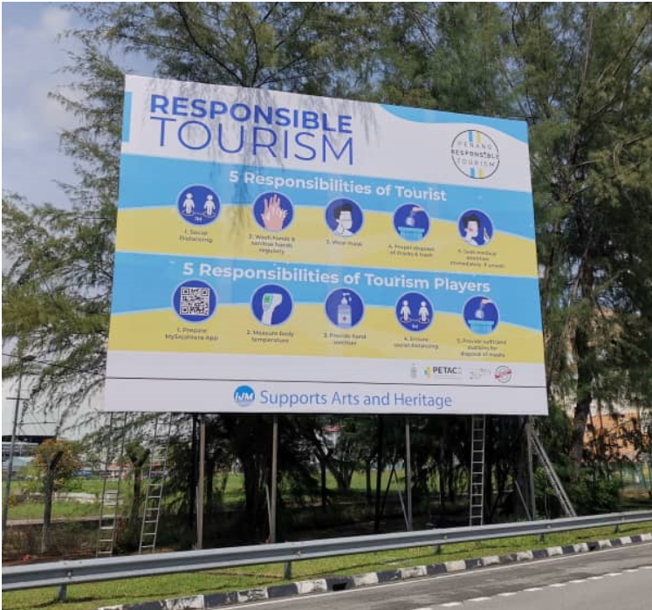 | 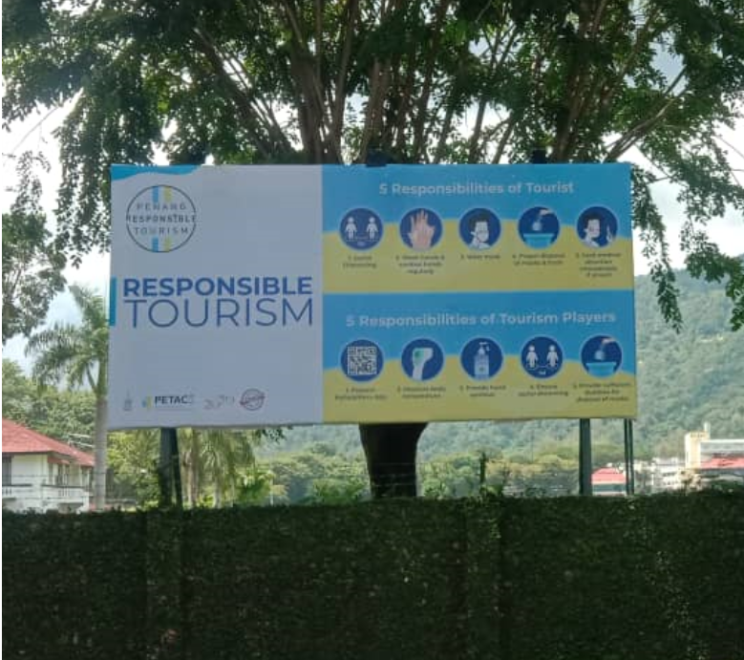

3.1.4 Rapid Bus Wrap - PGT obtained approval from MBPP to wrap two CAT buses for Penang Responsible Tourism from Dec onwards. The approval is however valid till end January 2021 only. Snapshots of the fully wrapped buses are as follows together with its respective bus number plate details.

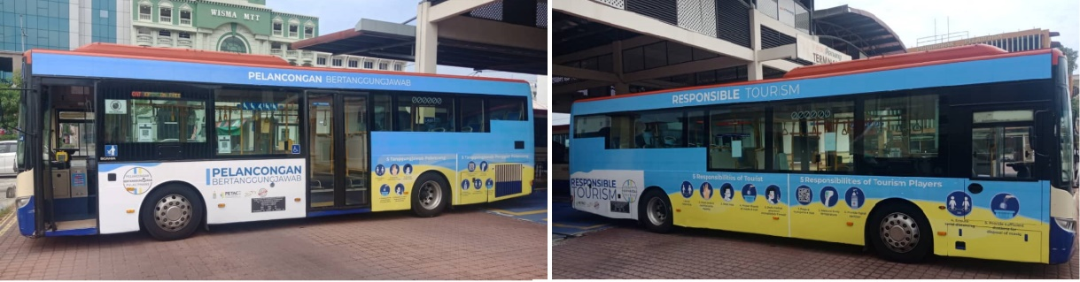
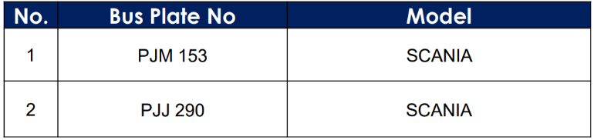

3.1.5 Armenian Street Poster – Penang Responsible Tourism was also put up on one of the Armenian Street Posters in Nov as follows:
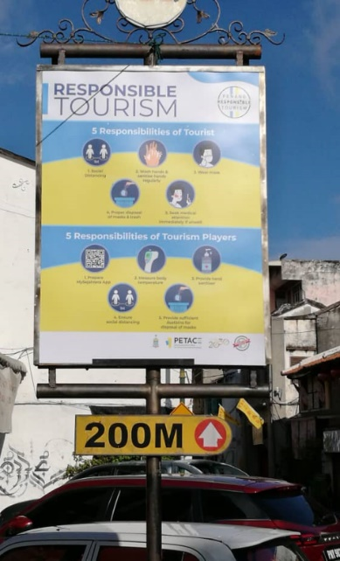

3.1.6 LED board – Anson Road (by Optimal Media)
Penang Travel Deals –  Jom! Experience Penang campaign  20 June – current | 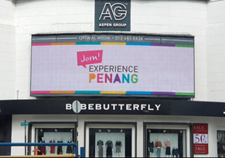
Penang International Container Art Festival  23 July – current | 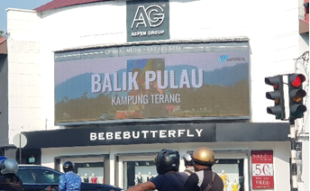
Thank You Frontliners  6 August – current | 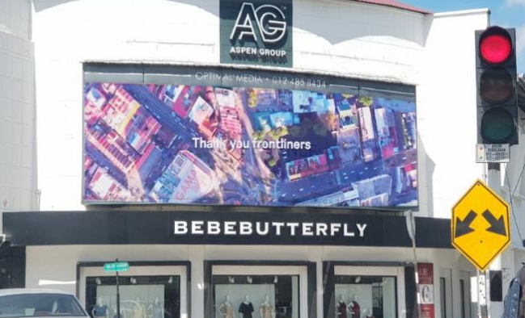
CAT Bridge – by Rapid Penang  8 September – current | 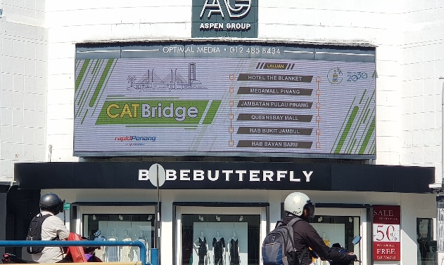
Techfest Live  5 October – current | 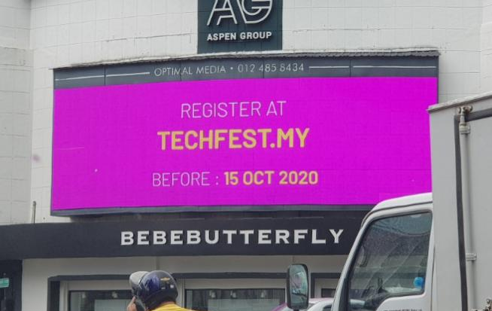
Penang Travel Deals (updated) - video  30 October – current | 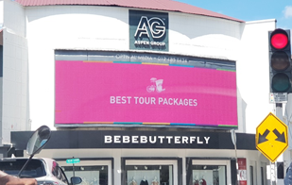
Penang Responsible Tourism  13 November - current | 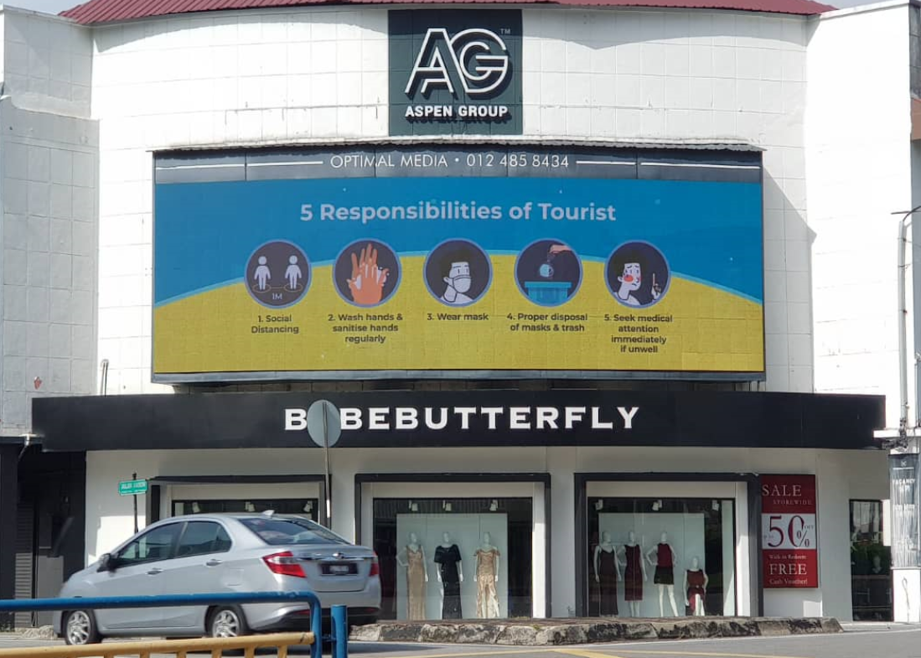

3.1.7 LED boards – AutoCity, Queensbay, Gurney Plaza and Nibong Tebal (by Performance Plus)
Penang Travel Deals –  Jom! Experience Penang campaign  20 June – current | 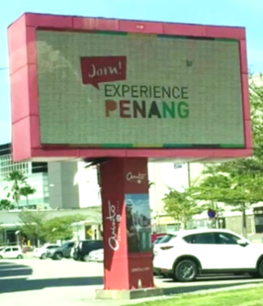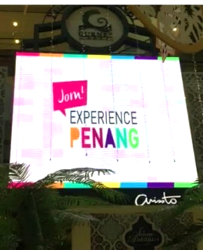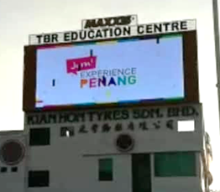
Penang International Container Art Festival  23 July – current | 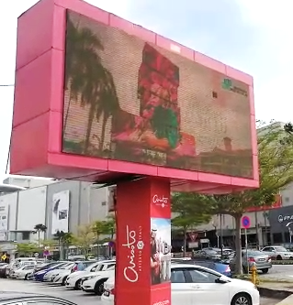  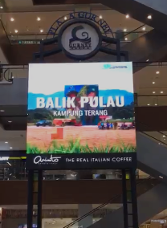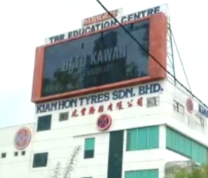

Thank You Frontliners  6 August – current | 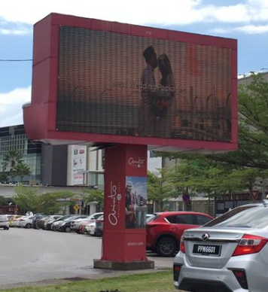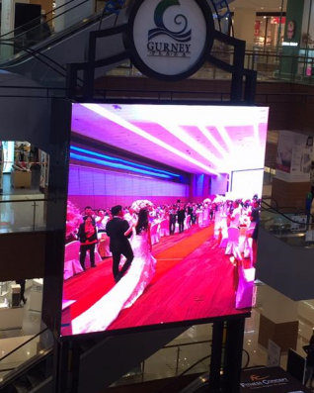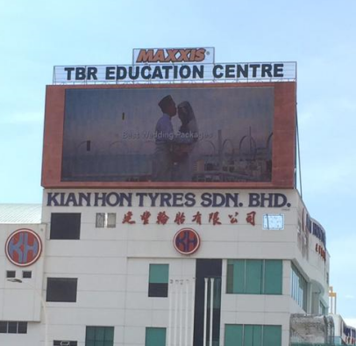
CAT Bridge – by Rapid Penang  8 September – current | 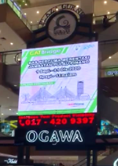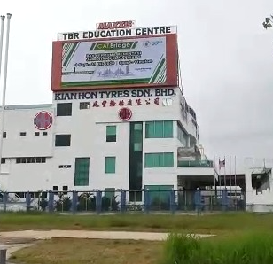
Techfest Live  5 October – current | 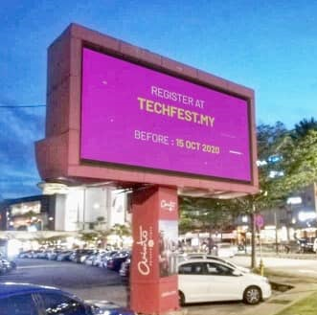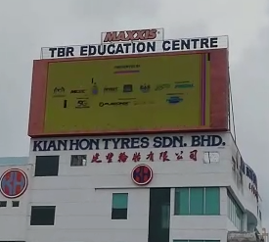
Penang Travel Deals (updated) - video  30 October – current | 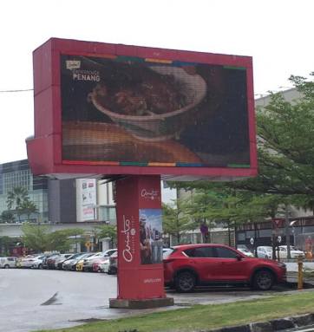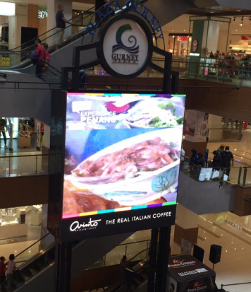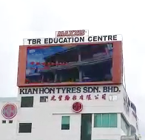
Penang Responsible Tourism  13 November - current | 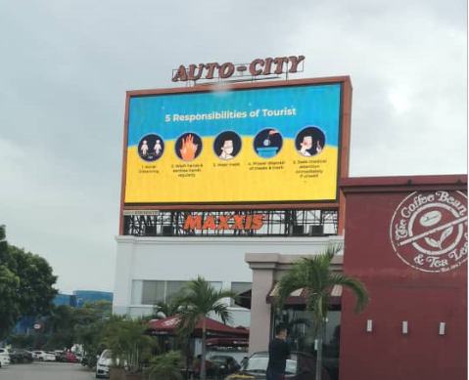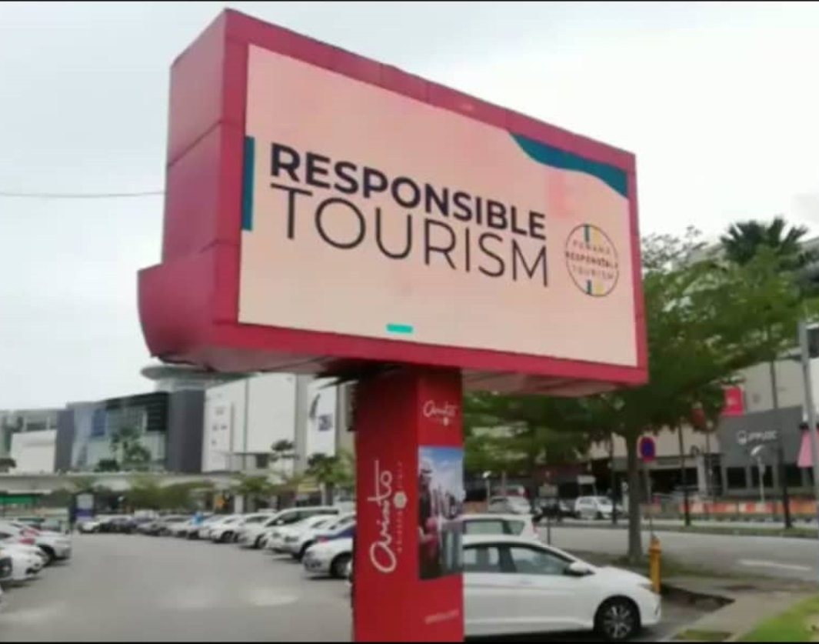  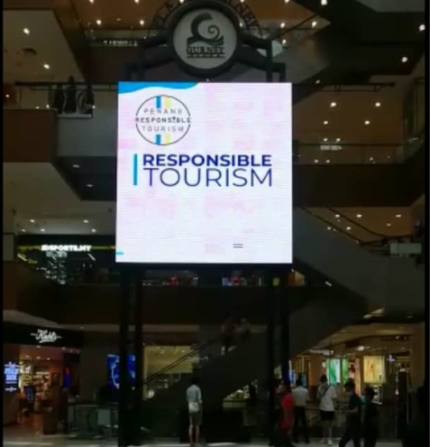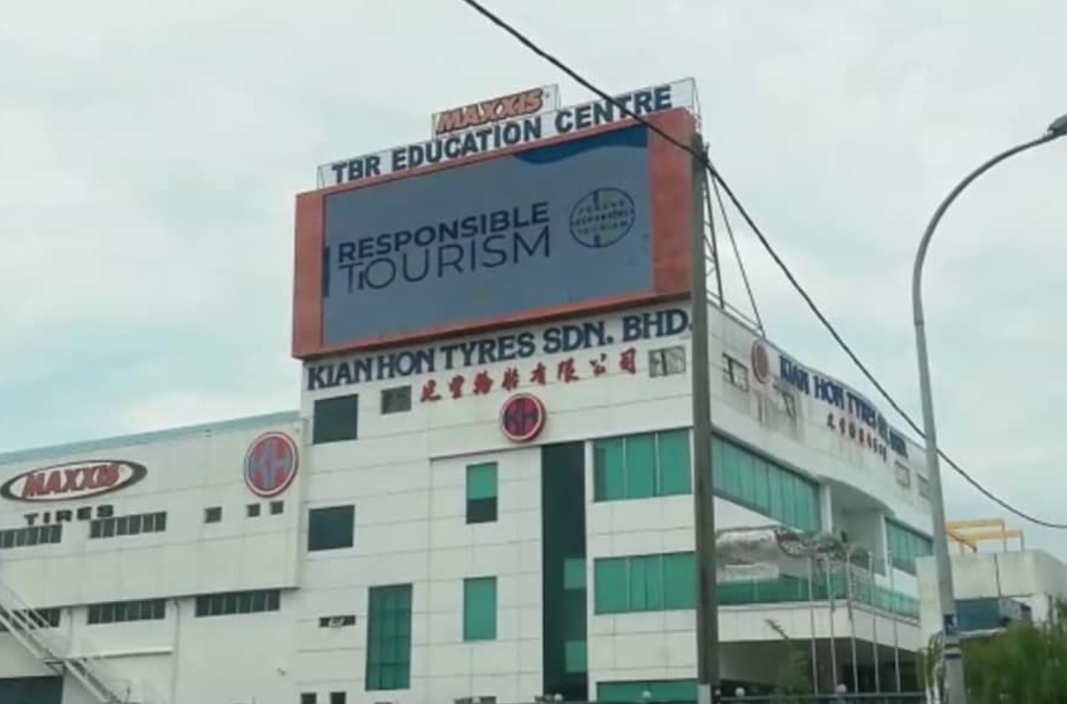

3.1.8 New Logo for Upcoming Communication Materials
In replacement of the EPY2020, the design/logo without 2020 for following years has been finalised. We will start incorporating the new logo onto all our promo materials for next year onwards. We are also designing the cover pages of our brochures for a different branding from EPY2020. We are targeting to launch the "Other Side Of The Island" and "Opposite Side Of The Island" in mid-Jan 2021 with the new cover design and logo. The new finalized logo design is as follows:


3.1.9 Calendar of Events (COE) for 2021 – Website Listing
We have just published a list of events and festivals on PGT’s official website for year 2021. The initial compilation had been a little challenging due to this uncertain period of time where most organisers are doubtful on whether or not their events will take place. However, we have clearly included on the event web page as well as on each event listing a notice for people’s awareness such as: In light of the COVID-19 pandemic, kindly check the status of the event closer to the date. Physical events taking place will adhere to the Standard Operating Procedures (SOPs) set by the government. Here’s a screenshot of one of the events listing:
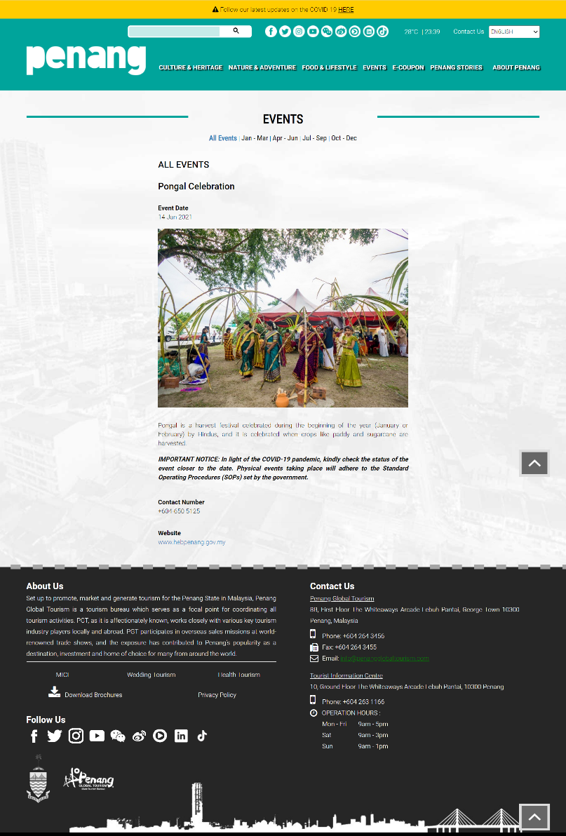
3.1.10 Penang Travel Deals – New Category on Food & Lifestyle
Penang Travel Deals, our new website was developed to feature the best deals in Penang offered by hotels, attractions and tour operators and it currently promotes our domestic campaign called Jom! Experience Penang. Aside from the initial categories that were launched earlier such as the Best Hotel Deals, Best Attraction Deals, Best Tour Packages and a Thank You Frontliners’ campaign, we now have added a new category called Best Food & Lifestyle Deals that mainly offers F&B deals as well as other lifestyle related offers.

Here is a screenshot of the updated penangtraveldeals.com homepage:
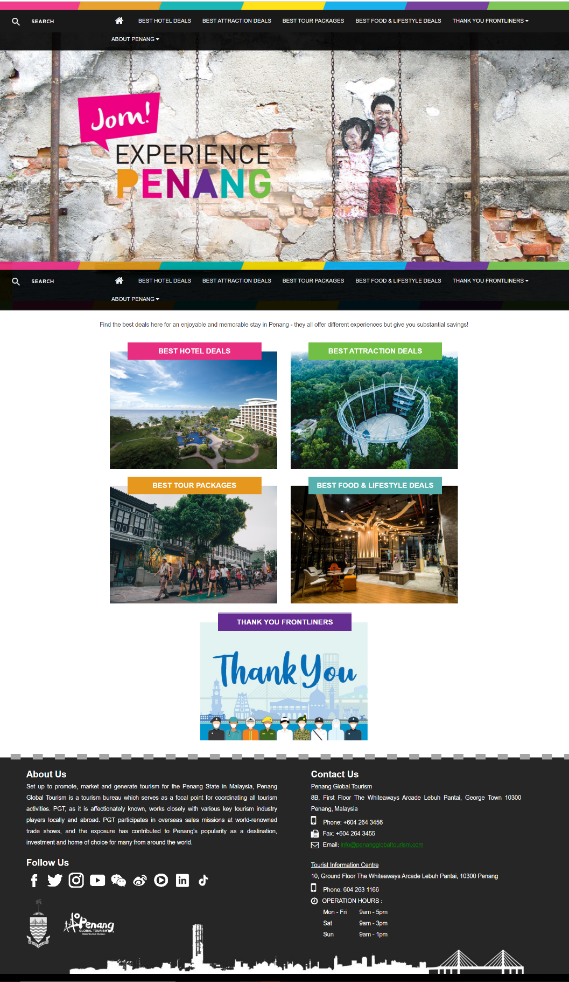
3.1.11 New Videos

Penang Travel Deals Video
A short TVC for mainly online and LED advertising was produced to highlight the various categories or deals featured in the Penang Travel Deals website. Here are screenshots of the completed video:


Experience It All In Penang
Mainly aimed at targeting the domestic market, PGT came up with this video concept to highlight to visitors that they have so much to explore here, right at their own backyard and need not look elsewhere. It showcases that Penang has amazing attractions very much similar to other parts in the world. Hence, the split screen comparison is made in this fast paced video. This video is also produced in Malay and Chinese languages. Here are screenshots of the completed video, yet to be launched:
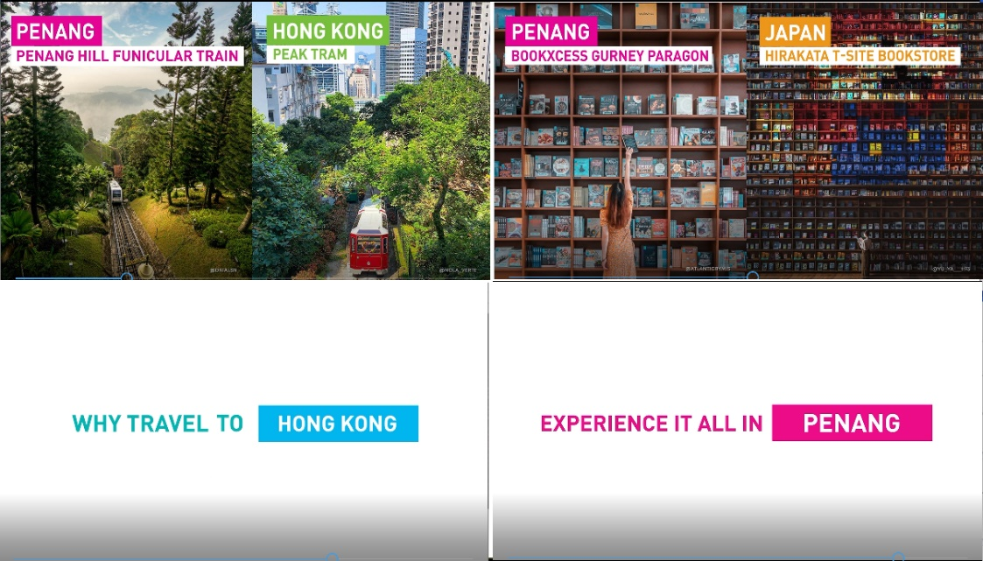

Penang Through The Lens
Also, mainly targeting the domestic market, this video was produced to highlight Penang’s many Insta-worthy spots on the island as well as the mainland. IG shots are mainly used in the video where PGT has in fact featured on its social media as well. Penang Through The Lens basically showcases people’s creativity in capturing their beautiful experiences in Penang where PGT has compiled and presented in this video. This video is also produced in Malay and Chinese languages. Here are screenshots of the completed video, yet to be launched:
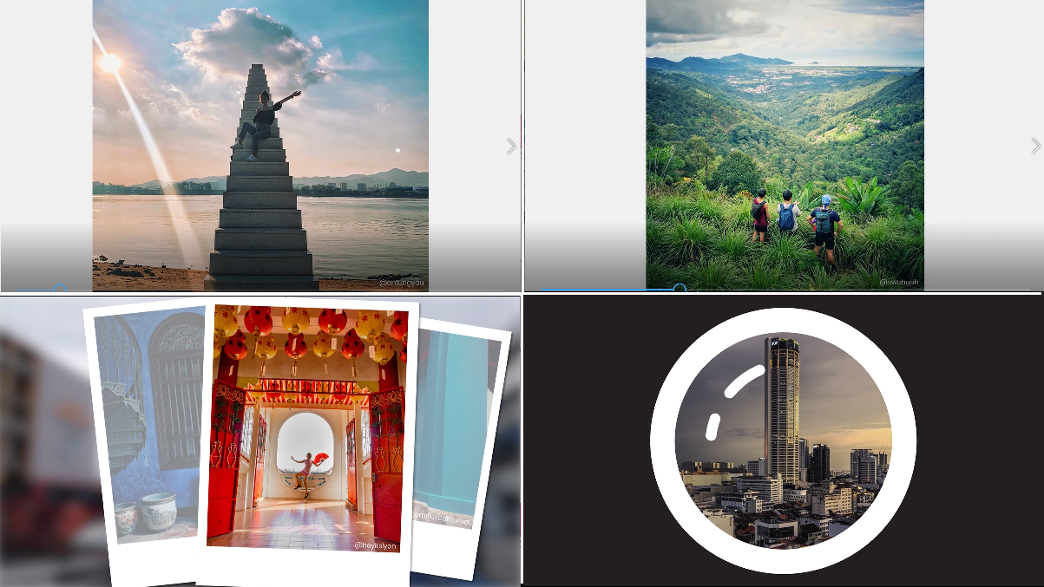

The Other Side Of The Island – Teluk Bahang & Balik Pulau
In this video, attractions located on the other side of the island which are at Teluk Bahang and Balik Pulau are featured. Teluk Bahang showcases main attractions such as Escape Theme Park, Tropical Spice Garden, Entopia and even Boulder Valley Glamping. Whereas Balik Pulau highlights what it’s famously known for such as Durian orchards, nutmeg, farms and scenic paddy fields. The objective of this video is to also promote other than our George Town UNESCO World Heritage Site. This video is also produced in Malay and Chinese languages. Here are screenshots of the completed video, yet to be launched:
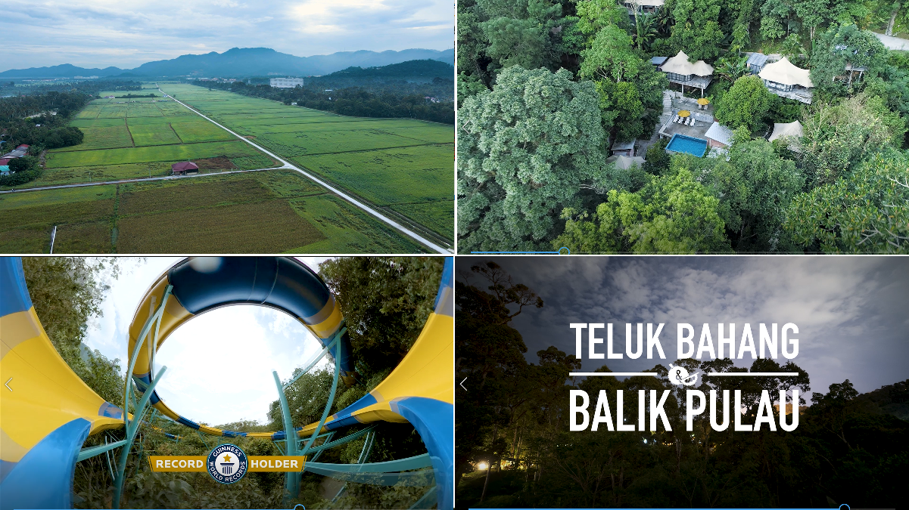

The Opposite Side Of The Island – Seberang Perai
In addition to promoting the other side of the island, the focus is also to promote the opposite side of the island, which is Seberang Perai. Hence this video was produced as one of our main marketing tools to showcase places of interests that are also hidden gems or lesser known to even our locals. Trending Insta-spots such as Frog Hill and Kampung Agong are included in this video. This video is also produced in Malay and Chinese languages. Here are screenshots of the completed video, yet to be launched:
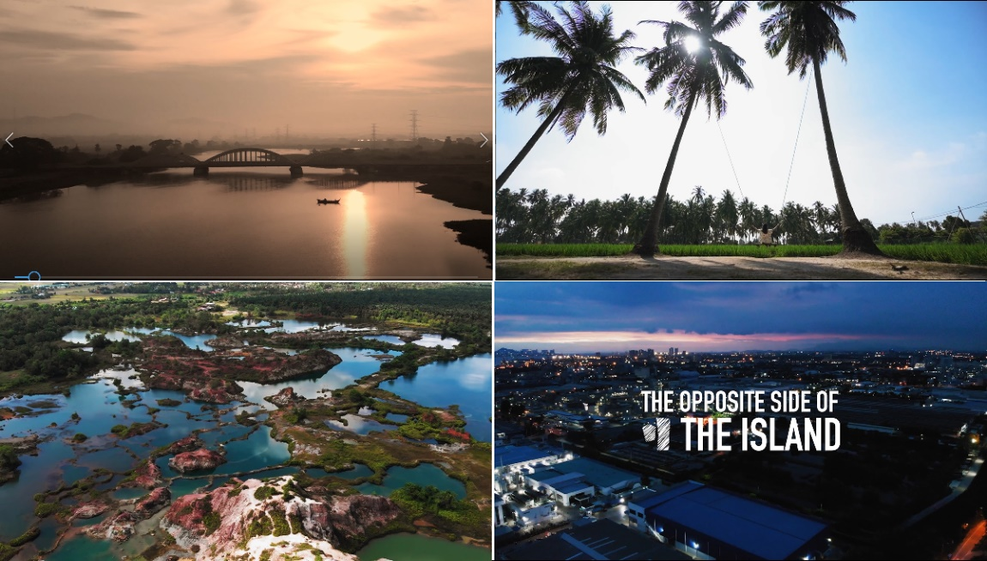

3.2 Updates

3.2.1 Gateway – December ‘20 issue
We had initially booked 12 issues in Gateway - China Southern Airlines’ (CSA) inflight magazine, to promote EPY2020. Subsequently, CSA suspended its inflight publication when the outbreak of the virus started from February onwards. It resumed in May 2020 however, PGT reduced the advertorials from 12 to only 3 issues. Hence, we advertised in January 2020, August 2020 and finally, December 2020. The following is the ad visual prepared by PETACE office via an outsourced agency:
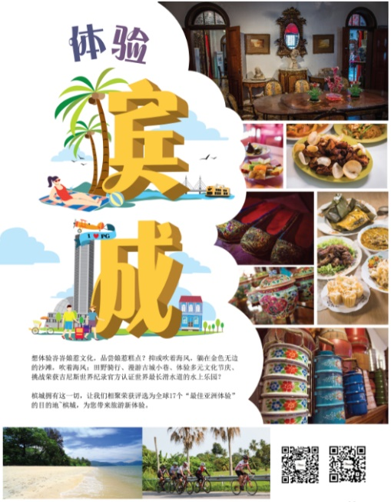

3.2.2 Lightbox Ad in Ximen MRT Station
The Lightbox ad in Ximen MRT Station is part of the OOH campaign in Taiwan and it will be undertaken for three months starting December 2020 to February 2021. The entire advertising campaign in Taipei’s Ximen MRT station started in December 2019 with 10 fully wrapped buses ending in June 2020 and just after the New Year of 2020, a “U” Shaped Escalator Wall ad was up until end of March 2020. Ximen MRT station has the highest footfall, being a highly used transit station by commuters where its footfall/traffic was approximately 4.8 million people every month (as per prior data). Due to the Covid-19 pandemic, our final ad, i.e., the Lightbox has been postponed from June to December 2020. Our ad visual has also been updated as follows (EPY2020 replaced with Jom! Experience Penang logo):
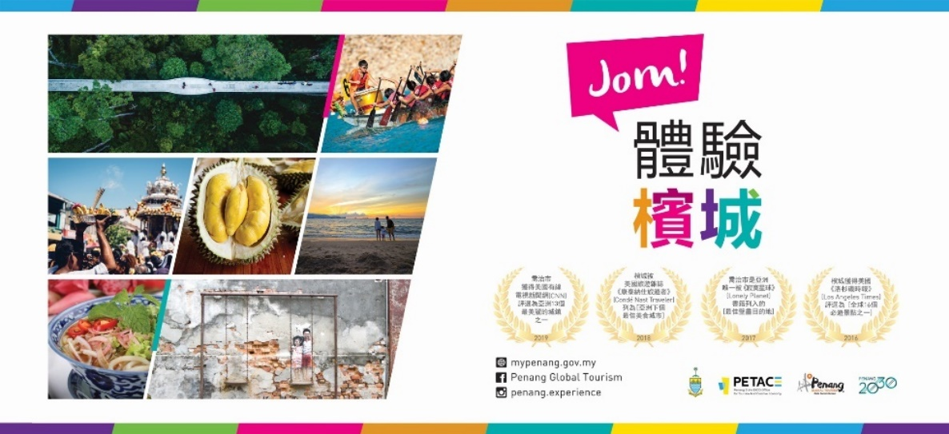

3.2.3 SIA Online Advertising (singaporeair.com)
Many airlines have also ceased publishing inflight magazines due to hygiene concerns and instead shifting their focus on digital or online platforms. Singapore Airlines (SIA) that has been publishing its inflight magazines - SilverKris and Silkwinds has now embarked on a new advertising avenue after it ceased publishing its inflight magazines due to Covid-19. Thus, SIA offered PGT the opportunity to communicate with potential travellers to Penang through storytelling (on SilverKris.com); associate our brand with SIA for further brand positioning and credibility; plus access SIA’s exclusive audience/database, who are affluent and can spend money in Penang, through “retargeting”, i.e., from the use of its Navigator database system.

PGT’s has engaged SIA’s official media agency, Ink Global to undertake on serving ads online targeting the most current audience captured via its database system – customers with the intention to travel, who’ve visited singaporeair.com. Once they’ve entered the site, they are already tagged and would start to see our ads whenever they’re on Google, Facebook and Instagram. Upon clicking on our ad, they will then be directed to a landing page on silverkris.com with our advertorial on Penang. This is when their interest is further reinforced which in turn will persuade them to book a flight to Penang. The package deal offered by Ink Global (Ink Publishing Pte Ltd) includes the branded content/advertorial for the landing page on silverkris.com at SGD5,000 and 1 million impressions (online ads served) to be utilized by end of 2021 at SGD20,000.

Here’s part of a screenshot of our online advertorial / landing page on silverkris.com that has just been completed. It features 8 eco-sites in Penang that covers mainland too. We opted to have this story angle done because of current times where people would prefer more nature based places that are less crowded, widely spaced and promotes health.  At the end of this article, we have also included our official website link that leads to a more extensive write-up of the 8 eco-sites informing visitors how to get there plus also includes other nearby attractions that would make their trip worthwhile for a visit. | 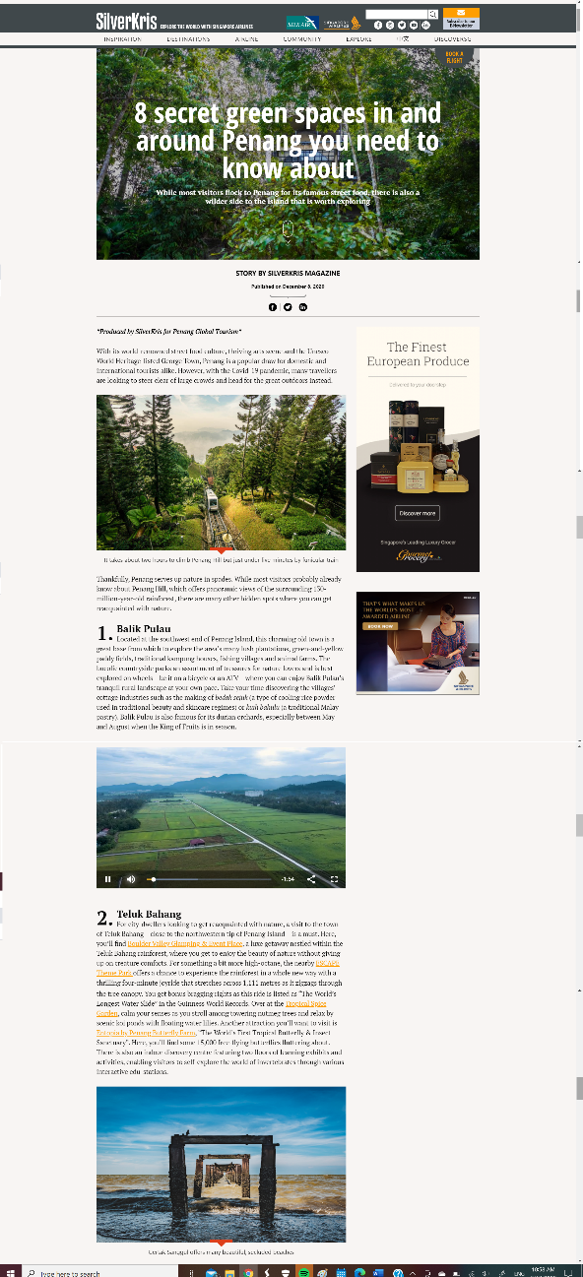

3.2.4 Billboard Advertising In Brunei
D’ Sunlit Sdn Bhd, the sole media owner of billboards in Brunei Darussalam recently presented a proposal for billboard advertising in Brunei. In its survey, Sunlit highlighted that advertising on billboards in Brunei is more worthwhile in comparison with other advertising mediums such as TV commercial, newspaper, magazine and radio. As our plan is to firstly target regional markets when international travel reopens early next year, Brunei is certainly a potential market to be looked into.

D’ Sunlit proposed to PGT various billboards across eight locations in Brunei. The billboard located at Gadong Wet Market was the best option as it is a high traffic spot not only for passing traffic but pedestrians as well. The market is a well-constructed building and is a gathering place for street food, fruits, vegetables and meat. Hence, advertising on this billboard is quite ideal for targeting the locals who congregate at the location daily. It is also 10 minutes from a popular shopping place in Brunei, the Gadong Mall. Gadong is a commercial area in Bandar Seri Begawan, the capital of Brunei. The billboard at Gadong Wet Market has an average of over 1.7mil viewers a month.

We are targeting to have the billboard up by end of this December for 12 months. The total cost of the 47ft x 18ft billboard is B$ 51,880.40. The ad visual which we are getting approval now (with Jawi wordings) is as follows:


3.2.5 Family Mart Retail Advertising
PGT will undertake retail advertising in all FamilyMart stores across Malaysia. This will be a new media platform that PGT wishes to explore to promote domestic tourism. Penang will be the first state in the country to advertise a tourism campaign in all FamilyMart stores in Malaysia. FamilyMart is drawing the highest number of patrons to its stores compared to other convenient retail networks in Malaysia. FamilyMart stores in Malaysia, to date totaling 200+ stores achieve approximately 200,000 transactions per day / an average of 1,000 transactions per store per day. FamilyMart stores are located at major transit hubs, universities & colleges, commercial & business districts, etc. and continues to expand rapidly.

YTL Info Screen Sdn Bhd (InfoScreen) is the appointed agency of QL Resources Bhd that owns FamilyMart Malaysia. FamilyMart is Japan’s 2nd largest convenience store chain after 7-Eleven. InfoScreen approached PGT to advertise in FamilyMart stores proposing several in-store media spaces. Out of these, we prefer advertising on its counter-top TV screens situated above the payment counter, between the menu screen. This is a more cost-effective option than the others as it does not incur production cost. Also, due to the current “norm”, customers spend more time waiting in line adhering to physical distancing when making payment. Hence, there’s more visibility for a TVC that’s being advertised. The TVC is played every 5 minutes. There are 20 slots of TVC in total, where 8 are reserved for FamilyMart’s internal promotions. InfoScreen quoted PGT to advertise across all 200+ stores (full network) in Malaysia at RM57,271.80 for 3 months from December 2020 to February 2021. This advertising is targeted to begin this December. We are now preparing three 15-sec TVCs for the campaign which are 7 World Wonders of Penang, Experience It All In Penang (comparison video) and The Other Side Of The Island (Teluk Bahang & Balik Pulau).

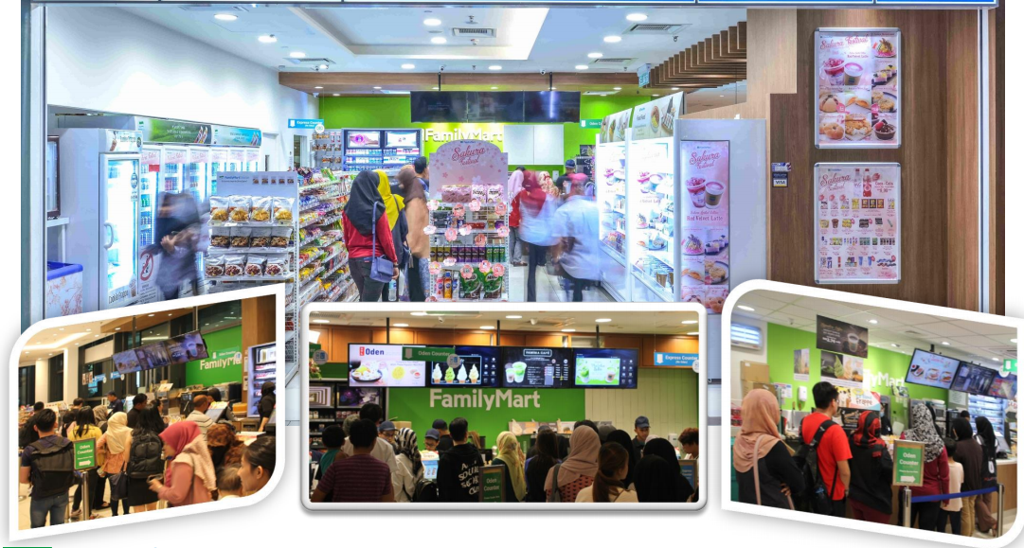
Shots of FamilyMart Counter Top Advertising:

3.2.6 Social Media Advertising – IMedia Brands
PGT is always looking into exploring new and potential advertising platforms and partners to gain more branding exposure. Thus, PGT will explore working with a digital media company to undertake social media advertising targeting the millennial audience of the domestic market.

We are now working with iMedia via its brand partners to promote domestic tourism. iMedia is a digital media company that sells media advertising solutions for popular local language sites, social influencer platforms and mobile apps. PGT was approached by iMedia to run an advertising campaign via its brand partners, namely OH!MEDIA (Malay language), GOODY25 (Chinese language) plus 8 influencers under ITTIFY (2 macro + 6 micro influencers).

An overview of these brands’ reach are as follows:
Brand | Website | Facebook | Instagram
OH! MEDIA  (Malay language) | 1.5mil  Unique users | 3.6mil  Followers | 280k  Followers
GOODY25  (Chinese language) | 1.4mil  Unique users | 400k  Followers | 30k  Followers

iMedia’s RM40,000 package to PGT includes 1x branded article in OH! MEDIA and 1x branded article in GOODY25 covering both the Malay and Chinese language audience, where it guarantees 20,000 reads and 15,000 FB engagements per article. There is also 1x FB post in OH! MEDIA that estimates 100,000 reach and 1,000 FB engagements. Additionally, its ITTIFY package of 2 macro and 6 micro influencers estimates 160,000 impressions and 8,000 engagements where it can be targeted to a mix of different language audience. This advertising is targeted to begin this December.

3.2.7 New video production – 20 +1 Reasons To Visit Penang
Following a directive from your office, PGT pursued on getting proposals from various video production houses to produce a new promotional video for next year, to welcome 2021 and especially target domestic tourism. Hence the concept of the video entails 20 +1 (in line with the year 2021) reasons to Visit Penang. The video is aimed to highlight not only places of interest, but the focus will be on the “experiences” of visitors when in Penang. The video would also highlight Penang’s hospitality as the “finale” or 21st reason to visit Penang plus showcase YB as the spokesperson of the video. For production of this video, we had opted for Peanut Butter Creative Studios because their past video productions that they had shared with us were quite impressive and creatively executed plus their pricing was good as well.

3.2.8 Covered Walkways (Extension till 2021) in KL City Centre
An outdoor advertising campaign on EPY2020 was undertaken on Covered Walkways in February 2020. The advertising is for 12 months - located in KL’s city centre at Jalan Sultan Ismail and Jalan Raja Chulan located in front of Wisma Genting and Wisma Cosway respectively. In July 2020, we had changed our Covered Walkway visuals with two new Jom! Experience Penang ads featuring the campaign’s promotions and “7 World Wonders of Penang”, and it was officially unveiled by YB in front of Wisma Genting along Jalan Sultan Ismail then.

The advertising period should be ending in March 2021, however now, the media owner, Parisign Media has agreed to extend the campaign period till end of May 2021 due to the Covid-19 outbreak.

Parisign Media has also offered us a special value-added package at RM139,570.20 to continue advertising on the Covered Walkways till end of 2021, i.e. 7 months from June 2021. This includes rental free spaces as follows:
1) 3x units Covered Walkway ad panels in KL Golden Triangle (no media rental charges & *relocatable)
2) 5x units Bus Shelter advertising in Penang Island (no media rental charges & *relocatable)
* Relocatable means if the ad space is taken up by a new advertiser, Parisign Media will first notify Penang Global Tourism and propose the nearest alternative to be agreed for transfer. There will be no charges or workmanship charges for this relocation works.

Photo of our current ad on one of the Covered Walkways:
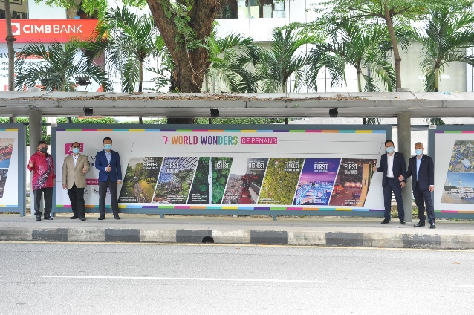

3.2.9 Giant Cube LED Advertising in KL City Centre
Apart from our advertising on Covered Walkways, for stronger presence of Penang’s promotion in the Golden Triangle of Kuala Lumpur, and to especially target the domestic market, we will advertise on the Giant Cube LED, located in front of Lot 10 Shopping Centre, right next to the MRT entrance.

PGT was offered a very special deal by the media owner, YTL Info Screen Sdn Bhd (InfoScreen). The package offered to PGT was for 5 months (to be utilised by end June 2021) and it includes complimentary spots on 9x TV plasma screens inside Lot 10. The gross value of the package is RM280,000 but the nett total cost to PGT is only RM53,000 for 5 months.

The iconic Giant Cube offers advertisers the visibility and exposure that effectively targets KL’s busiest arterial road – Jalan Bukit Bintang. InfoScreen reports that the Giant Cube attracts about 5 million pedestrians and 2.4 million vehicles on a monthly basis (based on prior data). Advertising on the Giant Cube covers all four sides of the 20’ x 20’ LED cube simultaneously when an ad is shown. The ad appears 20 times on every 60min loop or a total of 1,440 times from 7am to 1am (18hours). Also note that there will only be about four to a max of 10 advertisers at a time.

Photo of Giant Cube (in front of Lot 10)
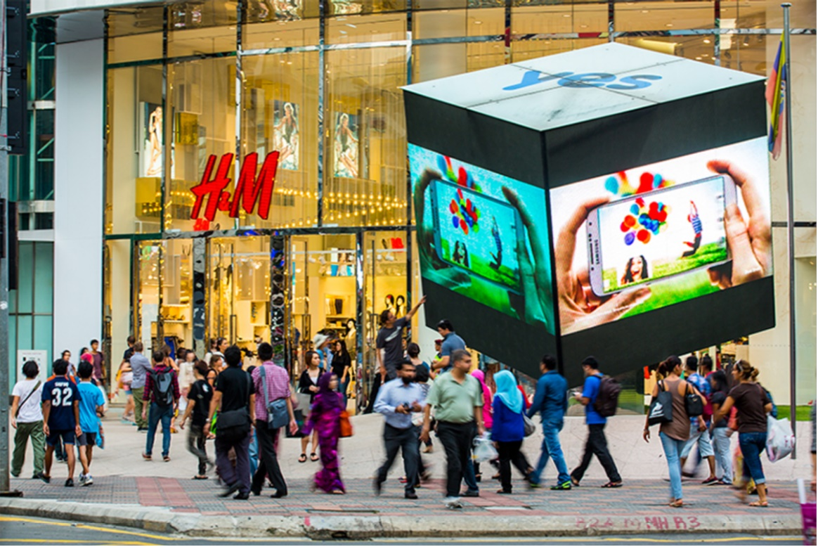

3.2.10 Penang Bus Shelters Advertising (2021)
Following the booking of Covered Walkways in KL City Centre with media owner Parisign Media Sdn Bhd, PGT was also given advertising space on 5 bus shelters in Penang, rental free as a package deal.

These 5 bus shelters that have been offered by Parisign are the ones with our Experience Penang 2020 (EPY2020) campaign currently which were launched on 2nd July 2019. The bus shelters are located at the following 5 locations:
1) Lebuh Light
2) Pengkalan Weld
3) Lebuh Farquhar
4) Air Itam
5) Lebuhraya Tun Dr. Lim Chong Eu

All of the above 5 bus shelters are being provided to PGT to continue advertising rental free for the whole year of 2021. However, to advertise, it involves production cost comprising metal framing and printing plus installation. Also note that, Parisign has the right to relocate our ad should a new advertiser take up the bus shelter. Parisign Media will first notify Penang Global Tourism and propose the nearest alternative to be agreed for transfer. There will be no charges imposed by Parisign but VCreate will have to impose labour charges for relocation at RM424 per bus shelter. The total production cost for all 5 bus shelters amounts to RM10,494 and it will be undertaken by VCreate Sdn Bhd, the appointed vendor of Parisign Media Sdn Bhd.

Photos of our current EPY ad on Bus Shelter:
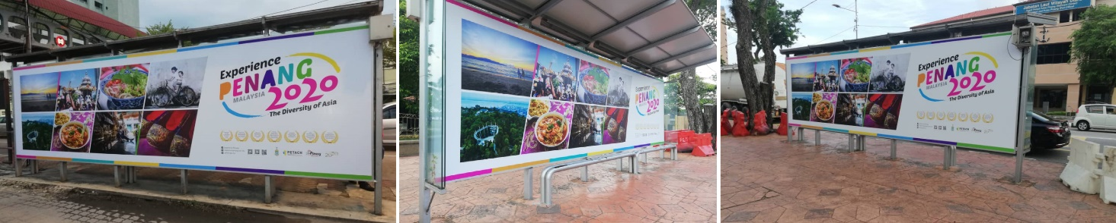

3.2.11 Festivals in A Box and Other Videos (1 July – 30 November 2020)
The festival in a box videos are used on an ongoing basis to promote the year-round festivals happening in Penang. Apart from festivals, other promo videos are also used. It is an effective way to promote Penang as it’s more visually driven and gives a good preview of what Penang has to offer. Our videos are also produced in multiple languages to target specific markets locally. The videos posted on Facebook are also aimed to drive visitors to our official mypenang website and our other event or campaign websites for more details.

Videos shared on PGT’s Facebook page from 1 July - 30 November 2020:
No. | Videos | Total Views as at 30 Nov ‘20 | Date Published
1 | Mid-Autumn Festival  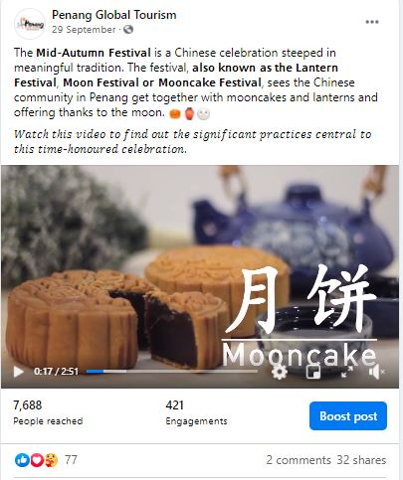 | 1.7k | 29 Sept 2020
2 | Tarikan Terkini Pulau Pinang  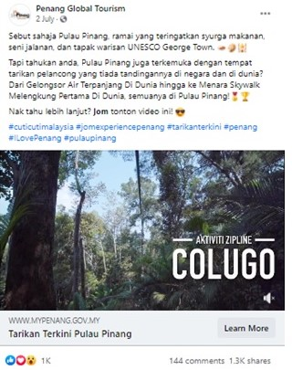 | 141.3k | 2 July 2020

No. | Videos | Total Views as at 30 Nov ‘20 | Date  Published
3 | 20 Pengalaman Unik di Pulau Pinang   | 268.2k | 9 July 2020
4 | 20 Aktiviti Percuma di Pulau Pinang   | 143k | 16 July 2020

No. | Videos | Total Views as at 30 Nov ‘20 | Date  Published
5 | Paper kite butterfly encounter at Entopia  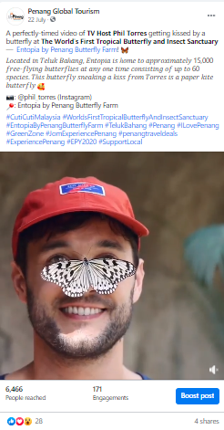 | 1.2k | 22 July2020

No. | Videos | Total Views as at 30 Nov ‘20 | Date  Published
6 | 20 Makanan Mesra Muslim Terbaik di Pulau Pinang   | 272.2k | 23 July 2020
7 | Peranakan Heritage & Customs  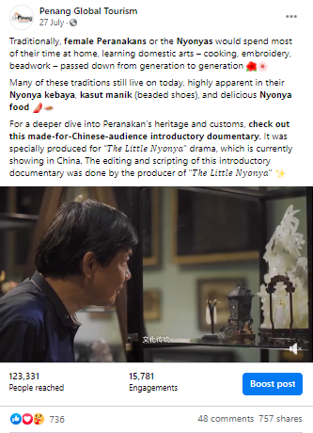 | 45.4k | 27 July 2020

No. | Videos | Total Views as at 30 Nov ‘20 | Date Published
8 | 20 Lokasi Insta di Pulau Pinang   | 229.8k | 30 July 2020
9 | Penang International Container Art Festival  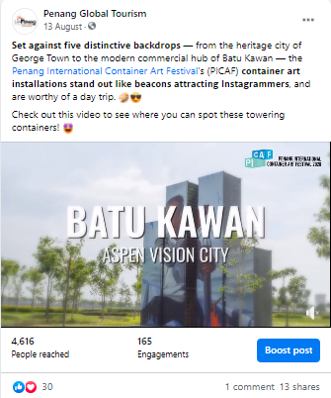 | 949 | 13 Aug 2020

No. | Videos | Total Views as at 30 Nov ‘20 | Date Published
10 | 20 Nasi Kandar Terbaik di Pulau Pinang  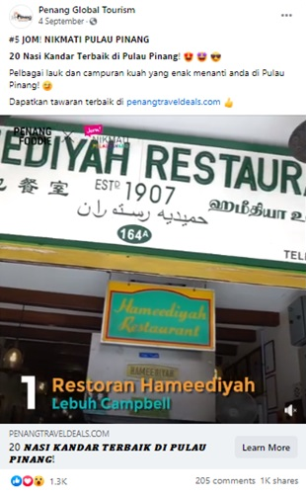 | 167.1k | 4 Sept 2020

No. | Videos | Total Views as at 30 Nov ‘20 | Date Published
11 | 20 Aktiviti Mesra Keluarga di Pulau Pinang   | 138.3k | 11 Sept 2020
12 | 20 Makanan Vegetarian Terbaik di P’ Pinang  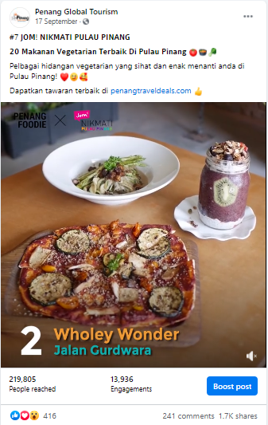 | 64.3k | 17 Sept 2020
No. | Videos | Total Views as at 30 Nov ‘20 | Date Published
13 | Instagram Filter Video  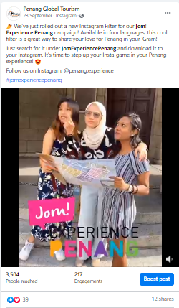 | 1.1k | 23 Sept 2020
14 | 20 Tempat Beribadat Cantik di Pulau Pinang  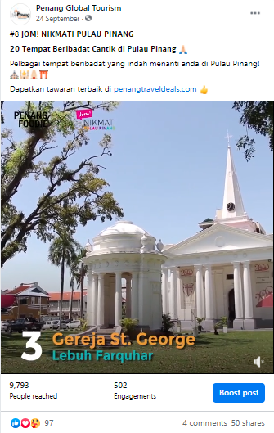 | 2.4k | 24 Sept 2020
No. | Videos | Total Views as at 30 Nov ‘20 | Date Published
15 | Kayu Nasi Kandar – Roti Tisu  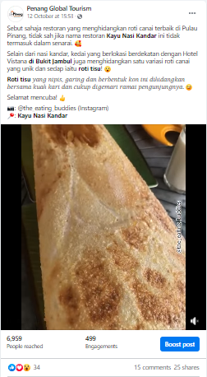 | 2.4k | 12 Oct 2020
16 | Ais Tingkap di Lebuh Tamil, George Town  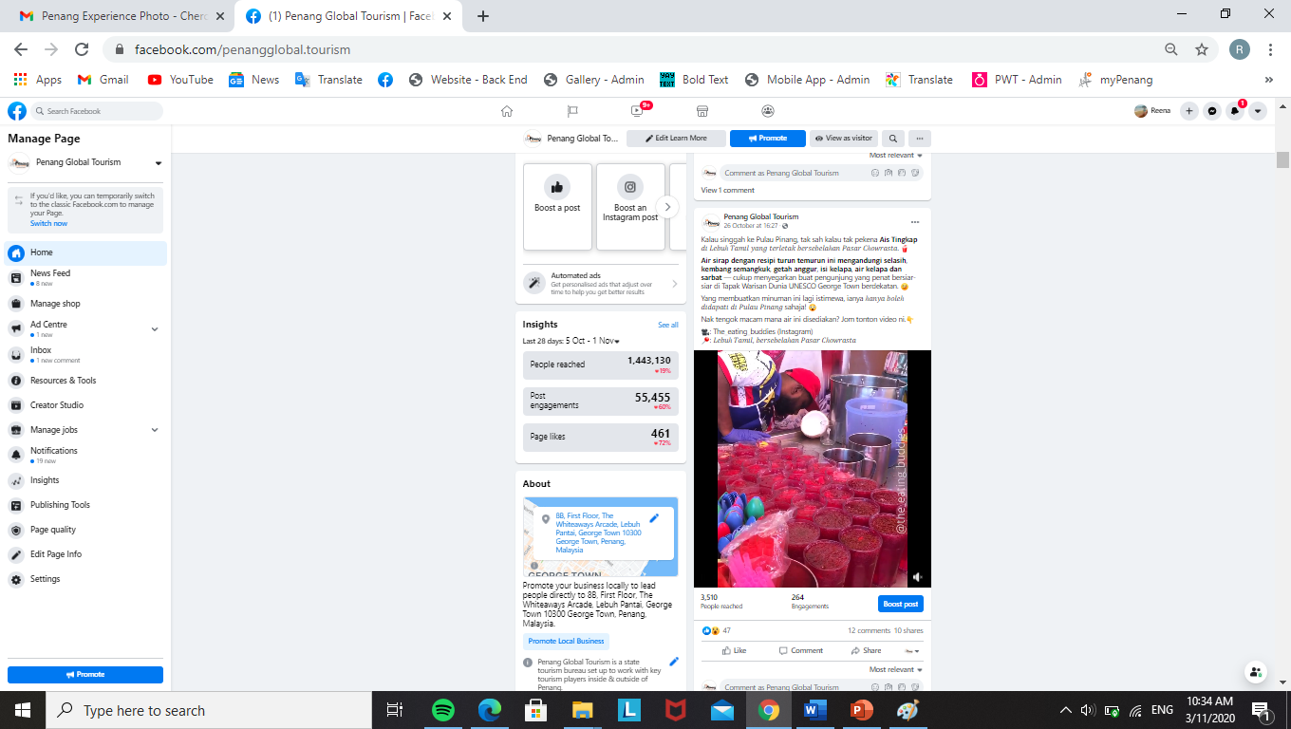 | 1.4k | 26 Oct 2020
No. | Videos | Total Views as at 30 Nov ‘20 | Date Published
17 | KOMTAR, George Town  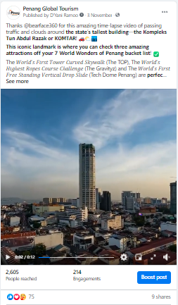 | 820 | 3 Nov 2020
18 | Penang House of Music  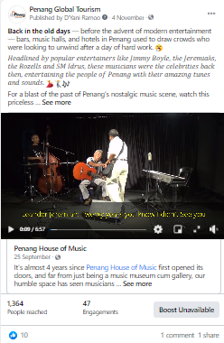 | 836 | 4 Nov 2020
No. | Videos | Total Views as at 30 Nov ‘20 | Date Published
19 | Guar Kepah, Seberang Perai  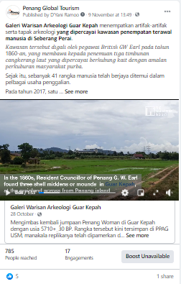 | 204 | 9 Nov 2020
20 | The Habitat, Penang Hill  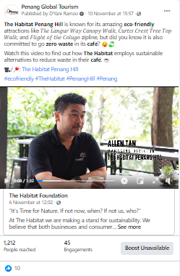 | 749 | 10 Nov 2020

No. | Videos | Total Views as at 30 Nov ‘20 | Date Published
21 | Various places, Penang  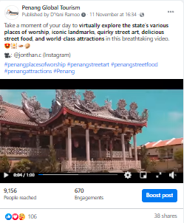 | 2.7k | 11 Nov 2020
22 | Kampung Terang, Balik Pulau  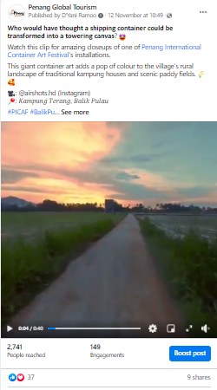 | 762 | 12 Nov 2020

No. | Videos | Total Views as at 30 Nov ‘20 | Date Published
23 | Penang Botanic Gardens  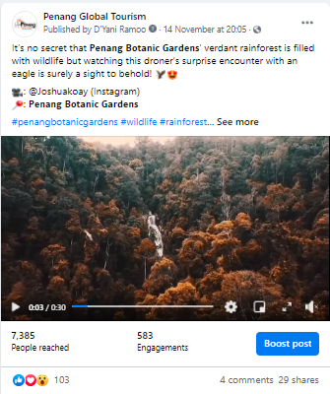 | 2.1k | 14 November
24 | Pantai Pasir Panjang, Balik Pulau  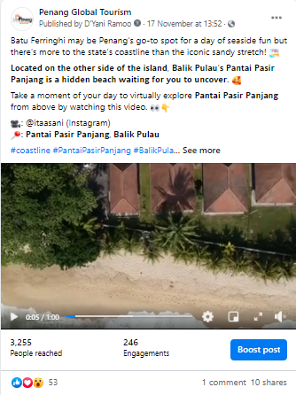 | 1.2k | 17 Nov 2020

No. | Videos | Total Views as at 30 Nov ‘20 | Date Published
25 | Teruna Dara Waterfall, Balik Pulau  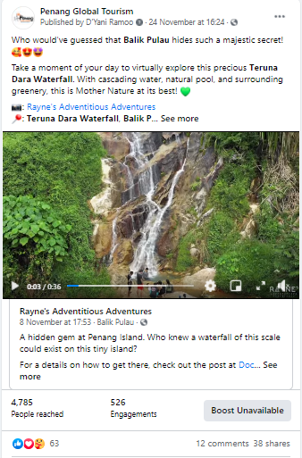 | 24.4k | 24 Nov

3.2.12 Results of Paid Advertising via Social Media
Boosted Posts on PGT Facebook Page from 1 July – 30 November 2020:
PGT’s Facebook Page
Post/ Advert | Target Market | Budget (RM) | Duration | Reach | Results
Tarikan Terkini Pulau Pinang | Johor Bahru  Alor Setar  Kota Bharu  Melaka  Seremban  Kuantan  Ipoh  Perlis  Kuching  Miri  Selangor  Terengganu  Kuala Lumpur  Labuan  Kota Kinabalu  Putrajaya | 800 | 2 - 6 July 2020 | 114,368 | 141k views  1.3k shares  1k reactions  144 comments
Traditional Trades – George Town Unesco World Heritage Site | Johor Bahru  Alor Setar  Kota Bharu  Melaka  Seremban  Kuantan  Ipoh  Perlis  Kuching  Miri  Selangor  Terengganu  Kuala Lumpur  Labuan  Kota Kinabalu  Putrajaya | 600 | 6 - 10 July 2020 | 170,944 | 1k shares  5.9k reactions  50 comments
“ | Penang | 400 | 5 - 9 July 2020 | 82,961 | -
20 Pengalaman Unik di Pulau Pinang | Johor Bahru  Alor Setar  Kota Bharu  Melaka  Seremban  Kuantan  Ipoh  Perlis  Kuching  Miri  Selangor  Terengganu  Kuala Lumpur  Labuan  Kota Kinabalu  Putrajaya | 800 | 9 - 13 July 2020 | 188,991 | 268k views  1.4k shares  1.7k reactions  161 comments
 | Johor Bahru  Alor Setar  Kota Bharu  Melaka  Seremban  Kuantan  Ipoh  Perlis  Kuching  Miri  Selangor  Terengganu  Kuala Lumpur  Labuan  Kota Kinabalu  Putrajaya | 800 | 26 - 30 Oct 2020 | 195,201
20 Aktiviti Percuma di Pulau Pinang | Johor Bahru  Alor Setar  Kota Bharu  Melaka  Seremban  Kuantan  Ipoh  Perlis  Kuching  Miri  Selangor  Terengganu  Kuala Lumpur  Labuan  Kota Kinabalu  Putrajaya | 800 | 16 - 20 July 2020 | 205,088 | 3.7k share  2.2k reactions  524 comments  142k views
20 Makanan Mesra Muslim Terbaik di Pulau Pinang | Johor Bahru  Alor Setar  Kota Bharu  Melaka  Seremban  Kuantan  Ipoh  Perlis  Kuching  Miri  Selangor  Terengganu  Kuala Lumpur  Labuan  Kota Kinabalu  Putrajaya | 800 | 23 - 27 July 2020 | 242,561 | 2.8k shares  2.1k reactions  410 comments  272k views
20 Lokasi Insta di Pulau Pinang | Johor Bahru  Alor Setar  Kota Bharu  Melaka  Seremban  Kuantan  Ipoh  Perlis  Kuching  Miri  Selangor  Terengganu  Kuala Lumpur  Labuan  Kota Kinabalu  Putrajaya | 800 | 30 July - 3 Aug 2020 | 339,456 | 3.4k shares  1.9k reactions  384 comments  229k views
Penang Travel Deals | Johor Bahru  Alor Setar  Kota Bharu  Melaka  Seremban  Kuantan  Ipoh  Perlis  Kuching  Miri  Selangor  Terengganu  Kuala Lumpur  Labuan  Kota Kinabalu  Putrajaya | 800 | 3 - 7 Aug 2020 | 40,448 | 10 shares  1.4k reactions  20 comment
20 Nasi Kandar Terbaik di Pulau Pinang | Johor Bahru  Alor Setar  Kota Bharu  Melaka  Seremban  Kuantan  Ipoh  Perlis  Kuching  Miri  Selangor  Terengganu  Kuala Lumpur  Labuan  Kota Kinabalu  Putrajaya | 800 | 4 - 9 Sept 2020 | 271,361 | 1k shares  1.3k reactions  205 comments  167k views
7 Keajaiban Dunia di Pulau Pinang | Johor Bahru  Alor Setar  Kota Bharu  Melaka  Seremban  Kuantan  Ipoh  Perlis  Kuching  Miri  Selangor  Terengganu  Kuala Lumpur  Labuan  Kota Kinabalu  Putrajaya | 800 | 9 - 13 Sept 2020 | 303,554 | 1.4k shares  1.9k reactions  383 comments
20 Aktiviti Mesra Keluarga di Pulau Pinang | Johor Bahru  Alor Setar  Kota Bharu  Melaka  Seremban  Kuantan  Ipoh  Perlis  Kuching  Miri  Selangor  Terengganu  Kuala Lumpur  Labuan  Kota Kinabalu  Putrajaya | 800 | 11 - 15 Sept 2020 | 209,918 | 1.1k shares  1k reactions  109 comments  138k views
Penang Stories - Best Rural Escapes: Exploring Kepala Batas, Penang | Johor Bahru  Alor Setar  Kota Bharu  Melaka  Seremban  Kuantan  Ipoh  Perlis  Kuching  Miri  Selangor  Terengganu  Kuala Lumpur  Labuan  Kota Kinabalu  Putrajaya | 800 | 25 - 29 Sept 2020 | 94,937 | 16 shares  1.2k reactions  8 comments  1,539 link clicks
Penang Stories – Menerokai Teluk Kumbar: Intan Yang Belum Diasah | Johor Bahru  Alor Setar  Kota Bharu  Melaka  Seremban  Kuantan  Ipoh  Perlis  Kuching  Miri  Selangor  Terengganu  Kuala Lumpur  Labuan  Kota Kinabalu  Putrajaya | 800 | 1 - 5 Oct 2020 | 189,926 | 54 shares  1.7k reactions  9 comments  965 link clicks
Techfest | Johor Bahru  Alor Setar  Kota Bharu  Melaka  Seremban  Kuantan  Ipoh  Perlis  Kuching  Miri  Selangor  Terengganu  Kuala Lumpur  Labuan  Kota Kinabalu  Putrajaya | 800 | 8 - 12 Oct 2020 | 6,504 | 3 shares  6.3k reactions  2 comments  491 link clicks
“ | Singapore | 1,000 | 12 - 17 Oct 2020 | 87,600 | 23 reactions  830 link clicks  853 engagement
“ | Japan | 500 | 14 - 19 Oct 2020 | 63,551 | 8 reactions  260 link clicks  270 engagement
“ | South Korea | 500 | 15 - 20 Oct 2020 | 41,055 | 7 reactions  267 link clicks  275 engagement
“ | Australia | 1,500 | 16 - 21 Oct 2020 | 58,849 | 17 reactions  621 link clicks  639 engagement
“ | Taipei | 1,000 | 22 - 27 Oct 2020 | 61,328 | 18 reactions  742 link clicks  763 engagement
“ | Indonesia | 500 | 23 - 28 Oct 2020 | 120.4k | 93 reactions  2,008 link clicks  2,104 engagement
“ | Philippines | 500 | 25 - 30 Oct 2020 | 64,576 | 68 reactions  2,096 link clicks  2,167 engagement
“ | United Kingdom | 1,500 | 26 - 31 Oct 2020 | 72,271 | 6 reactions  596 link clicks  605 engagement
“ | Hong Kong | 1,000 | 26 - 31 Oct 2020 | 68,303 | 17 reactions  578 link clicks  596 engagement
“ | Vietnam | 500 | 27 Oct - 1 Nov 2020 | 144.7k | 73 reactions  2,467 link clicks  2,545 engagement
“ | Thailand | 1,000 | 27 Oct - 1 Nov 2020 | 169.2k | 66 reactions  2,606 link clicks  2,676 engagement
Penang Stories - Bukit Tambun | Johor Bahru  Alor Setar  Kota Bharu  Melaka  Seremban  Kuantan  Ipoh  Perlis  Kuching  Miri  Selangor  Terengganu  Kuala Lumpur  Labuan  Kota Kinabalu  Putrajaya | 800 | 3 - 7 Nov 2020 | 89,377 | 7.3k reactions  9 comments  650 link clicks  10,716 engagement
Penang Stories – Khazanah Tersembunyi Bukit Tambun | Johor Bahru  Alor Setar  Kota Bharu  Melaka  Seremban  Kuantan  Ipoh  Perlis  Kuching  Miri  Selangor  Terengganu  Kuala Lumpur  Labuan  Kota Kinabalu  Putrajaya | 800 | 17 - 21 Nov 2020 | 87,360 | 13,795 reactions  10 comments  783 link clicks  14,860 engagement
7 Keajaiban Dunia di Pulau Pinang | Johor Bahru  Alor Setar  Kota Bharu  Melaka  Seremban  Kuantan  Ipoh  Perlis  Kuching  Miri  Selangor  Terengganu  Kuala Lumpur  Labuan  Kota Kinabalu  Putrajaya | 800 | 17 - 21 Nov 2020 | 309.2k | 1,549 reactions  185 comments  195 link clicks  26,449 engagement
Pulau Aman by Buletin Mutiara | Johor Bahru  Alor Setar  Kota Bharu  Melaka  Seremban  Kuantan  Ipoh  Perlis  Kuching  Miri  Selangor  Terengganu  Kuala Lumpur  Labuan  Kota Kinabalu  Putrajaya | 800 | 22 - 26 Nov 2020 | 222.1k | 5,600 reactions  81 comments  107 link clicks  22,213 engagement
20 Aktiviti Percuma di Pulau Pinang | Johor Bahru  Alor Setar  Kota Bharu  Melaka  Seremban  Kuantan  Ipoh  Perlis  Kuching  Miri  Selangor  Terengganu  Kuala Lumpur  Labuan  Kota Kinabalu  Putrajaya | 800 | 26 - 30 Nov 2020 | 179.7k | 534 reactions  28 comments  1,397 link clicks  75,025 engagement

The total amounts spent on PGT Facebook page from 1 July – 30 November 2020 is as follows:
Penang Global Tourism | RM 24,900

3.2.13 Facebook Posts (non-paid) from 1 July – 30 November 2020

Month: July 2020
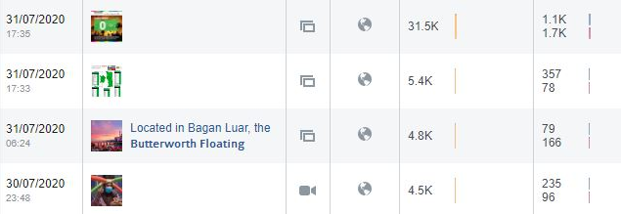
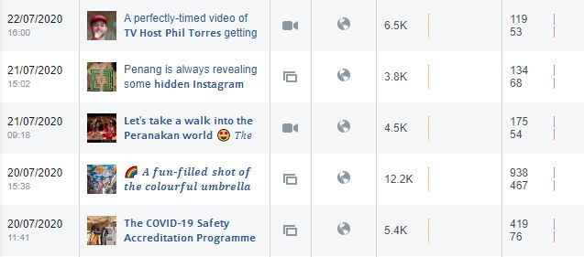
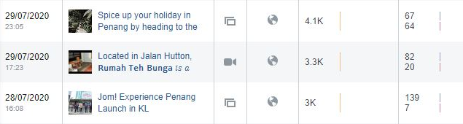
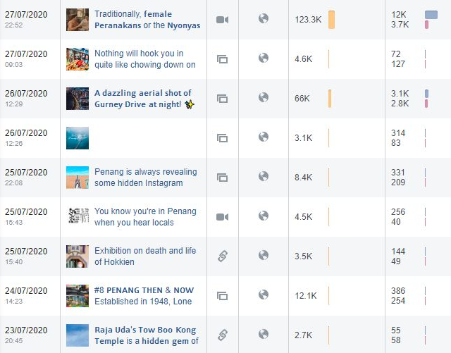

Month: July 2020
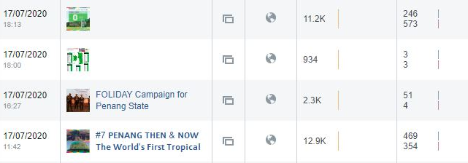
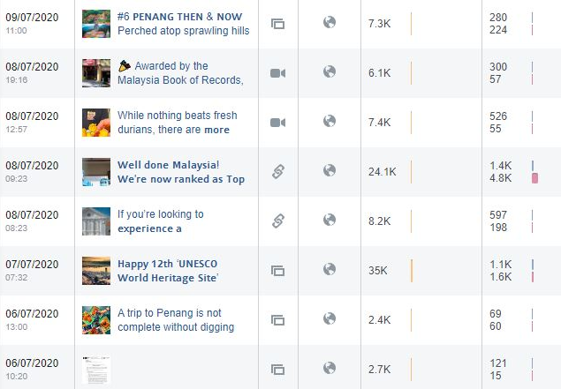
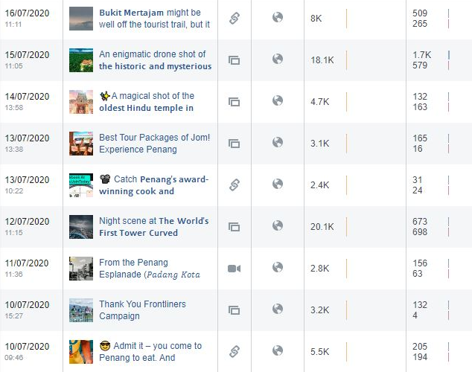

Month: July 2020
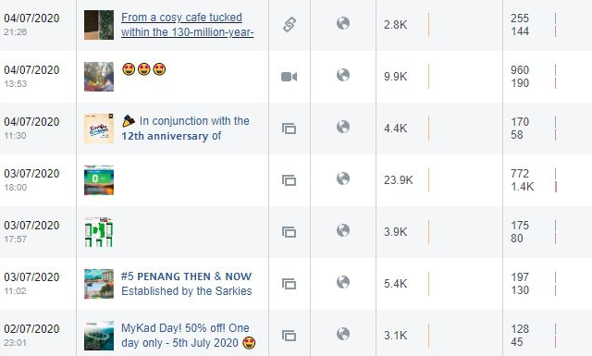
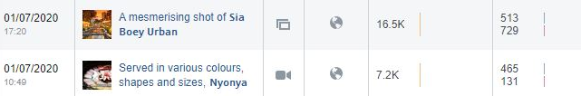
Total Post | Total Reach | Total Post Clicks | Total Reaction, Comments & Shares
51 | 582,734 | 33,002 | 22,965

Month: August 2020
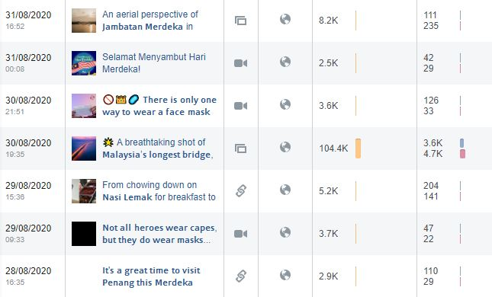

Month: August 2020
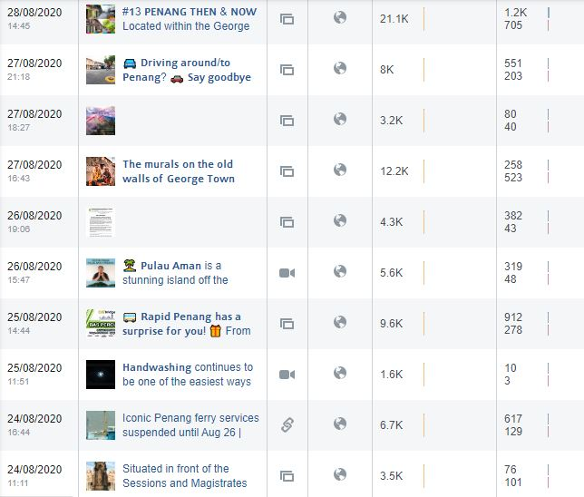
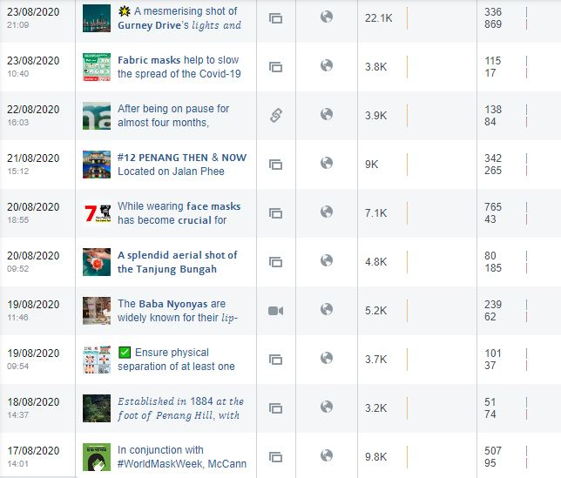

Month: August 2020
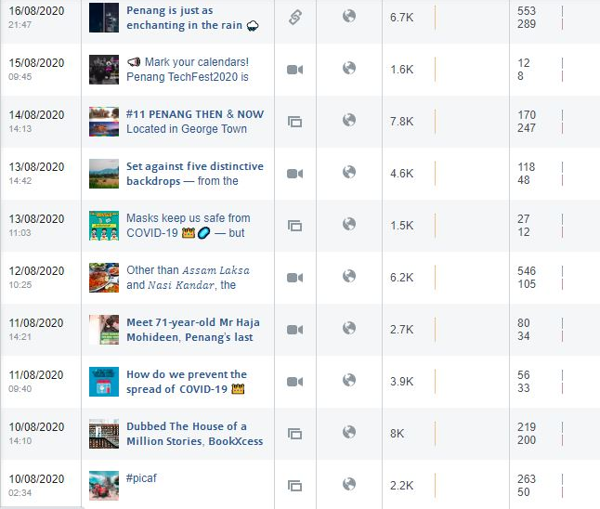
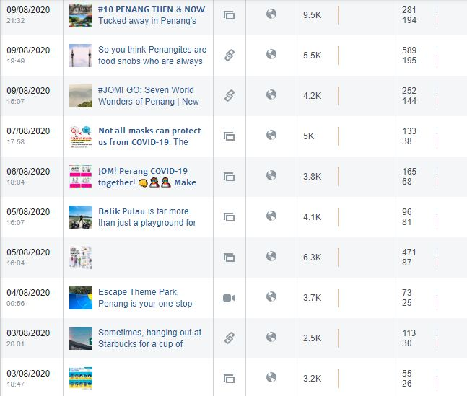

Month: August 2020
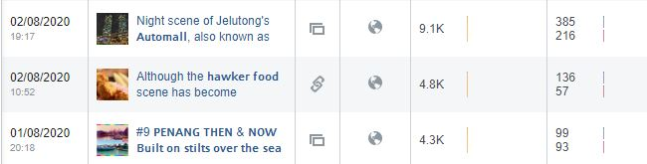
Total Post | Total Reach | Total Post Clicks | Total Reactions, Comments & Shares
50 | 390,100 | 16,211 | 11,273

Month: September 2020
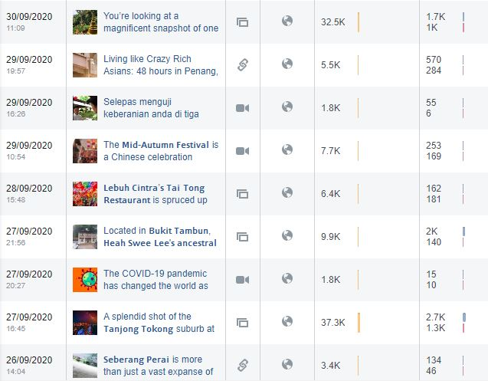
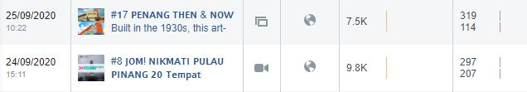

Month: September 2020
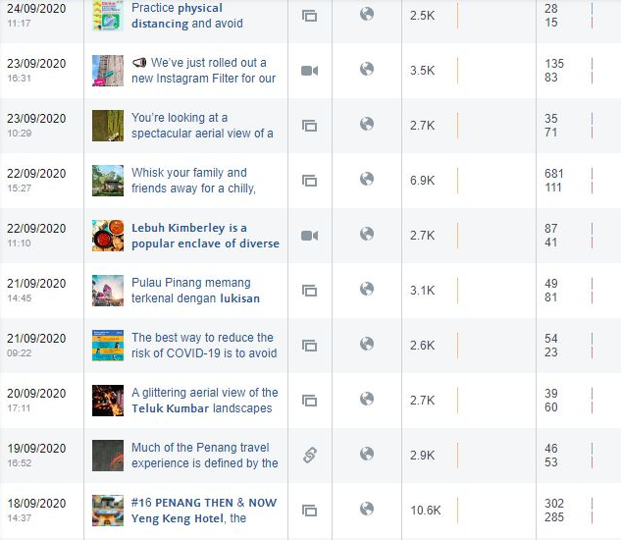
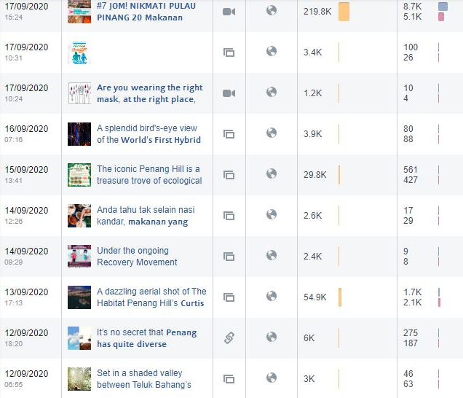

Month: September 2020
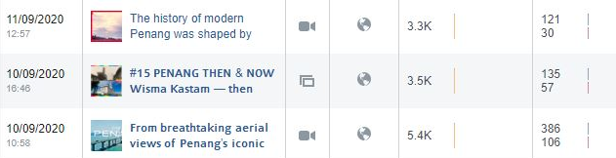
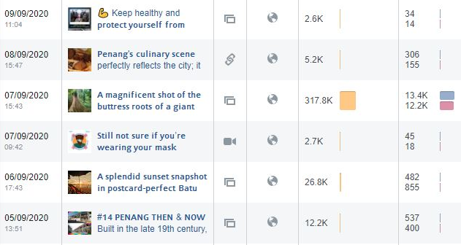
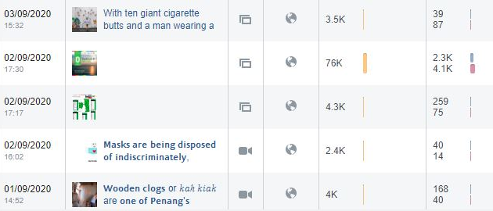
Total Post | Total Reach | Total Post Clicks | Total Reactions, Comments & Shares
45 | 960,500 | 39,411 | 30,463

Month: October 2020
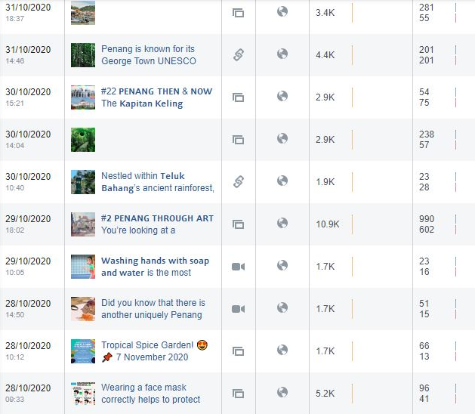
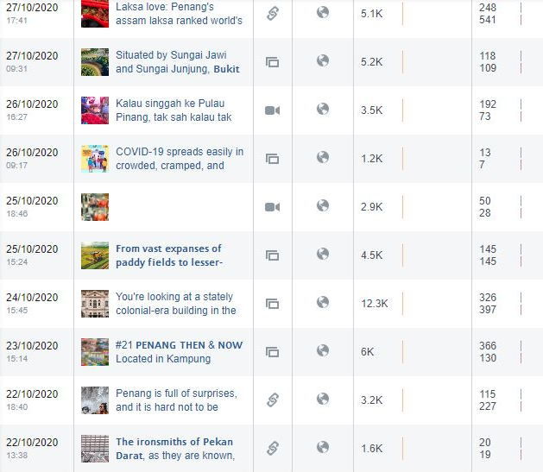

Month: October 2020
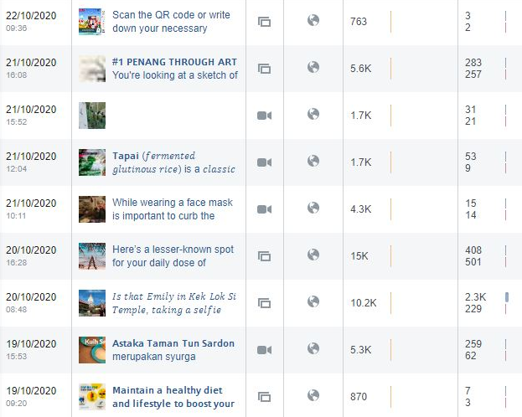
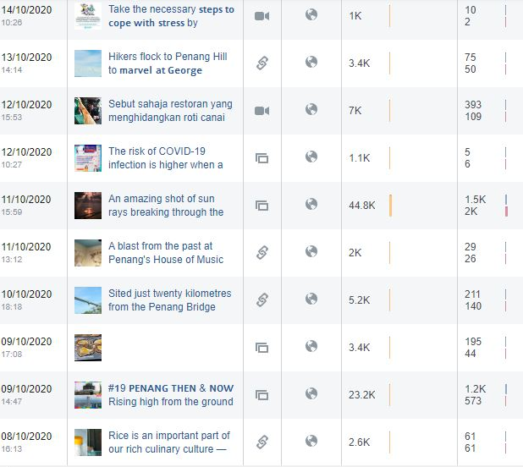

Month: October 2020
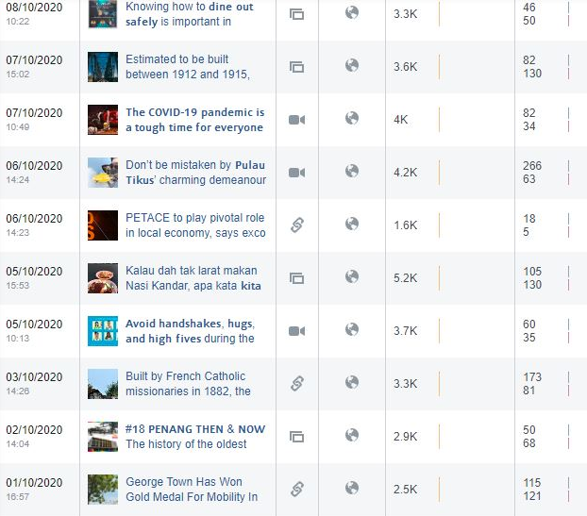
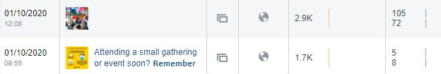
Total Post | Total Reach | Total Post Clicks | Total Reactions, Comments & Shares
61 | 315,733 | 13,668 | 9,494

Month: November 2020
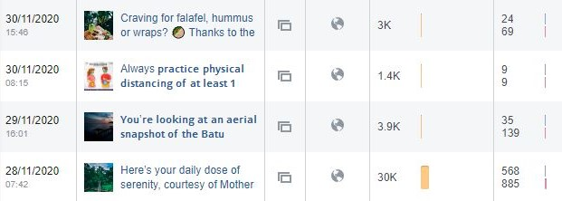

Month: November 2020
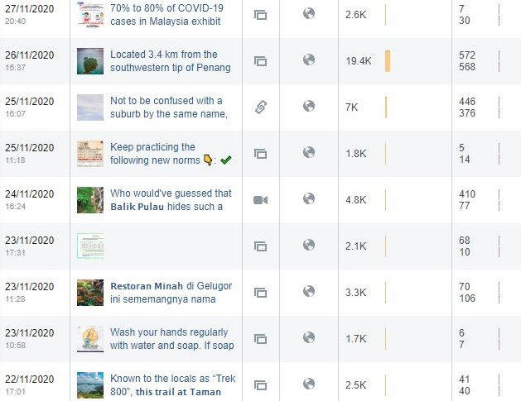
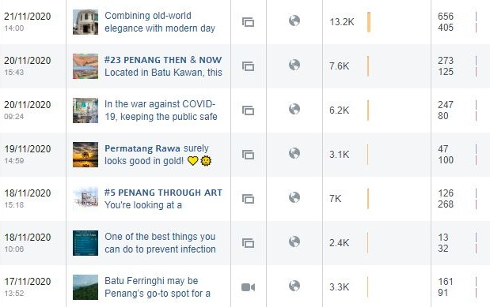

Month: November 2020
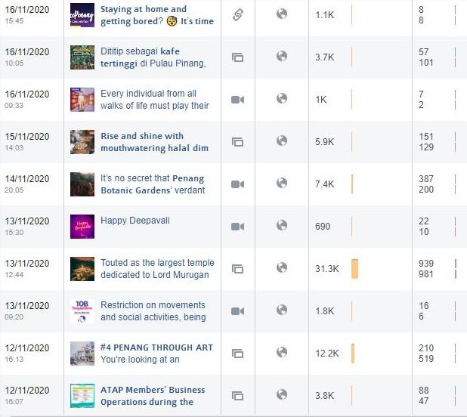
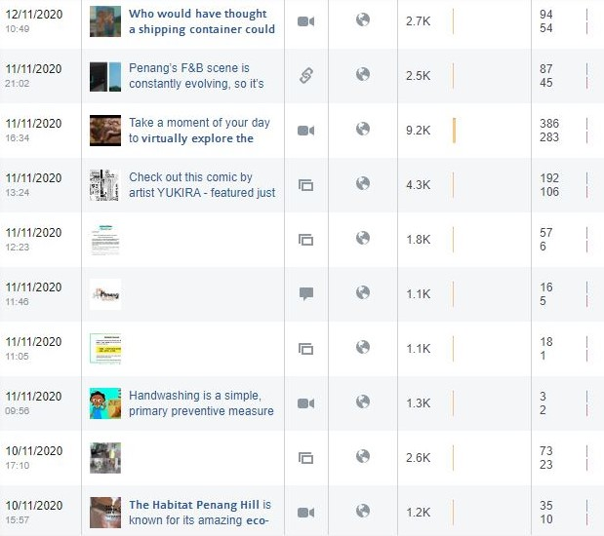

Month: November 2020
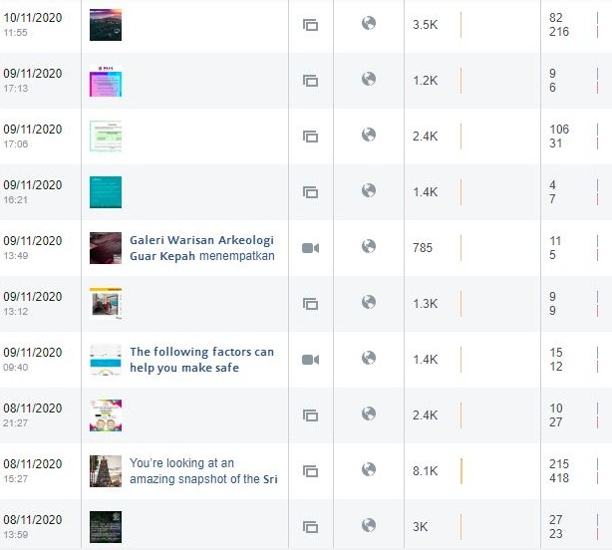
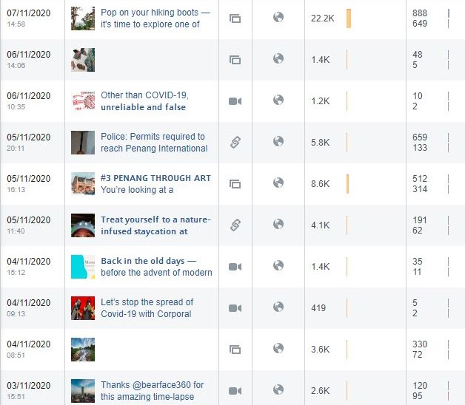

Month: November 2020
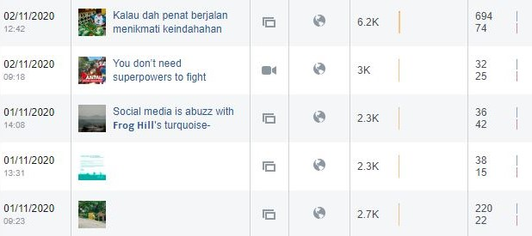
Total Post | Total Reach | Total Post Clicks | Total Reactions, Comments & Shares
66 | 317,195 | 10,989 | 8,274

Total post and reach for PGT’s Facebook Page from 1 July - 30 November 2020:
Month | Total Posts | Total Reach | Total Post Clicks | Total Reactions, Comments & Shares
July | 51 | 582,734 | 33,002 | 22,965
August | 50 | 390,100 | 16,211 | 11,273
September | 45 | 960,500 | 39,411 | 30,463
October | 61 | 315,733 | 13,668 | 9,494
November | 66 | 317,195 | 10,989 | 8,274
Total | 273 | 2,566,262 | 113,281 | 82,469

3.2.14 Facebook Posts on Seberang Perai (Mainland) from July to November 2020 are as follows:

July 2020 - Facebook Posts on Seberang Perai
No. | Posts | Total Reach | Total Engagement | Date Published
1 | The historic and mysterious 99-door mansion | 18,113 | 2,291 | 15 July 2020
2 | 19 Incredible things to do (and eat) in Bukit Mertajam by Penang Insider | 8,010 | 774 | 16 July 2020
3 | Tow Boo Kong Temple by Butterworth Guide | 2,745 | 113 | 23 July 2020
4 | Penang’s Hidden Food Gem – Pulau Aman | 4,560 | 199 | 27 July 2020
5 | Bagan Luar, Butterworth Floating Mosque | 4,764 | 245 | 31 July 2020

August 2020 - Facebook Posts on Seberang Perai
No. | Posts | Total Reach | Total Engagement | Date Published
1 | Video on Pulau Aman by ML Studios | 5,572 | 390 | 26 August 2020
2 | Instagram shot on Penang Second Bridge | 104,351 | 8,338 | 30 August 2020
3 | Instagram shot on Jambatan Merdeka | 8,186 | 346 | 31 August 2020

September 2020 - Facebook Posts on Seberang Perai
No. | Posts | Total Reach | Total Engagement | Date Published
1 | Instagram shot on big tree at Cherok Tokun | 317,811 | 25,620 | 7 Sept 2020
2 | Instagram shot – Seafood to try at Kepala Batas | 2,559 | 46 | 14 Sept 2020
3 | Instagram shot on PICAF at Dataran Merdeka | 3,103 | 130 | 21 Sept 2020
4 | Instagram shot on paddy field at Penaga | 2,738 | 106 | 23 Sept 2020
5 | Penang Stories: Exploring Kepala Batas | 99,383 | 3,282 | 25 Sept 2020
6 | The mysterious relic of Cherok Tokun by Butterworth Guide | 3,350 | 180 | 26 Sept 2020
7 | Heah Swee Lee’s ancestral mansion by Penang Hidden Gems | 9,941 | 2,097 | 27 Sept 2020

October 2020 - Facebook Posts on Seberang Perai
No. | Posts | Total Reach | Total Engagement | Date Published
1 | The ‘Notre Dame’ of Pagar Tras | 3,314 | 254 | 3 Oct 2020
2 | Nasi Lemak Permatang Rawa | 5,189 | 235 | 5 Oct 2020
3 | Instagram shot of Jambatan Keretapi Pinang Tunggal | 3,607 | 212 | 7 Oct 2020
4 | Air Hitam Dalam Educational Forest, Tasek Gelugor | 5,170 | 351 | 10 Oct 2020
5 | Instagram shot of Penang Second Bridge | 44,858 | 3,479 | 11 Oct 2020
6 | The idyllic countryside district of Penanti by Butterworth Guide | 2,401 | 65 | 15 Oct 2020
7 | Instagram shot of paddy field at Sungai Dua | 6,863 | 402 | 18 Oct 2020
8 | Video on Penang International Paddy Festival | 1,702 | 65 | 21 Oct 2020
9 | Penang Through Art – Bukit Mertajam’s town | 5,616 | 541 | 21 Oct 2020
10 | The ironsmiths of Pekan Darat by Butterworth Guide | 1,632 | 40 | 22 Oct 2020
11 | Penang Then & Now – Butterworth Digital Library | 5,963 | 496 | 23 Oct 2020
12 | Instagram shot on Seberang Perai Paddy Fields | 4,505 | 290 | 25 Oct 2020
13 | Instagram shot on Bukit Tambun Fishing Village | 5,277 | 227 | 27 Oct 2020

November 2020 - Facebook Posts on Seberang Perai
No. | Posts | Total Reach | Total Engagement | Date Published
1 | Instagram shot on Frog Hill | 2,261 | 78 | 1 Nov 2020
2 | Penang Stories – Bukit Tambun | 91,652 | 8,664 | 3 Nov 2020
3 | Instagram shot on Bukit Berapit | 22,192 | 1,537 | 7 Nov 2020
4 | Instagram shot on Sri Maha Mariamman Temple Butterworth | 8,142 | 633 | 8 Nov 2020
5 | Video by The Malaysian Insight on Galeri Warisan Arkeologi Guar Kepah | 789 | 17 | 9 Nov 2020
6 | Instagram Video on Penang | 9,210 | 671 | 11 Nov 2020
7 | Article on first Nasi Kandar drive-thru at Seberang Perai by Siakap Keli | 2,511 | 132 | 11 Nov 2020
8 | Penang Stories – Khazanah tersembunyi Bukit Tambun | 87,360 | 15,623 | 17 Nov 2020
9 | Instagram shot on Permatang Rawa | 3,081 | 147 | 19 Nov 2020
10 | #23 Penang Then & Now – Design Village Mall, Batu Kawan | 7,572 | 398 | 20 Nov 2020
11 | Pulau Aman by Buletin Mutiara | 239,490 | 38,584 | 22 Nov 2020
12 | Facebook post on Taman Rimba Bukit Mertajam | 2,480 | 81 | 22 Nov 2020
13 | Instagram shot on Air Hitam Dalam Educational Forest | 30,769 | 1,460 | 28 Nov 2020
14 | Pulau Aman aerial snapshot | 3,920 | 174 | 29 Nov 2020

Screenshots of July 2020 Facebook Posts on Seberang Perai:
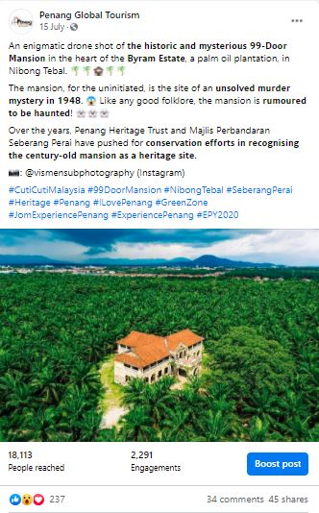 | 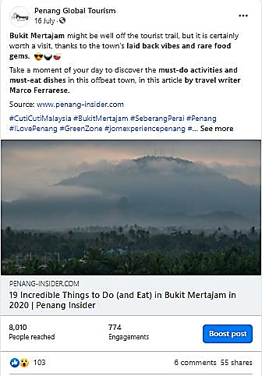

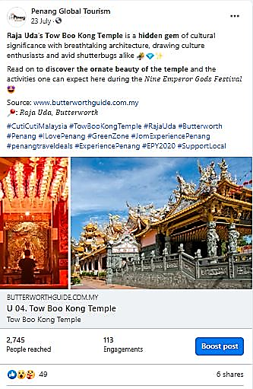 |  | 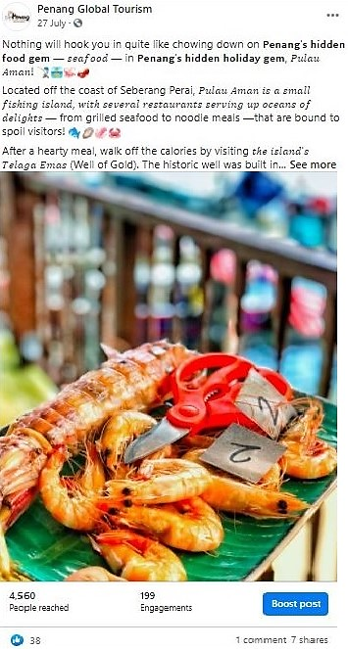
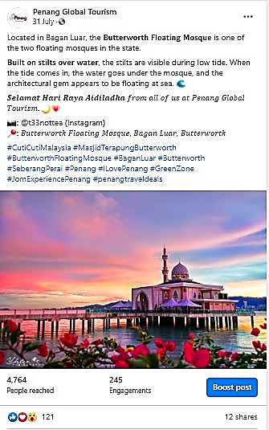

Total Post | Total Reach |  | Total Engagement
5 | 38, 192 |  | 3,622

Screenshots of August 2020 Facebook Posts on Seberang Perai:
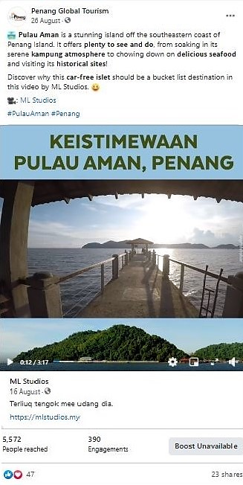 |  | 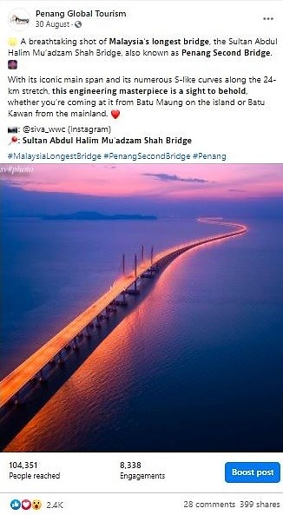
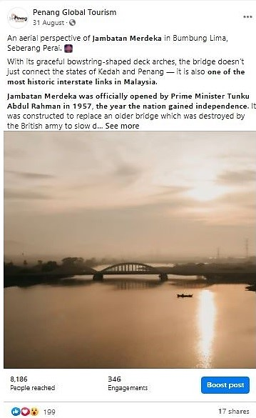

Total Post | Total Reach |  | Total Engagement
3 | 118,109 |  | 9,074

Screenshots of September 2020 Facebook Posts on Seberang Perai:
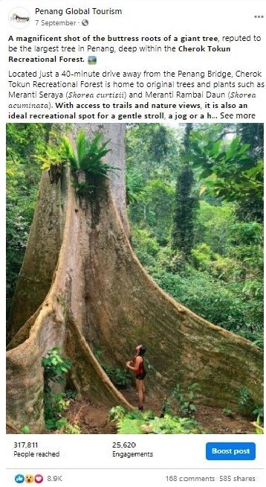 | 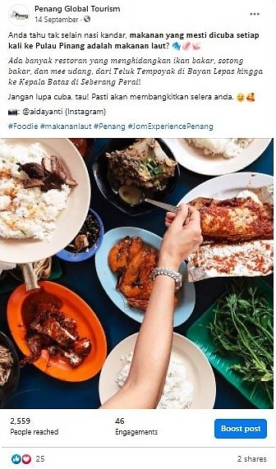
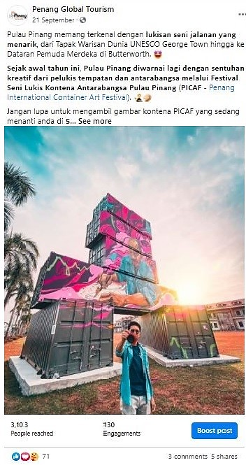 | 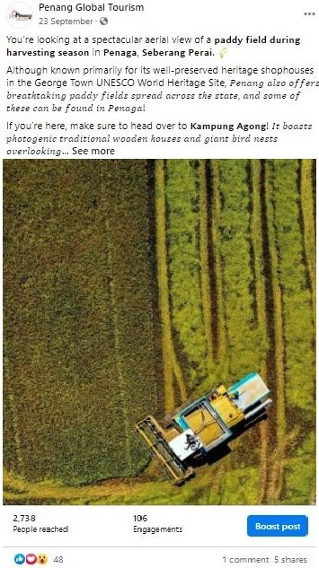

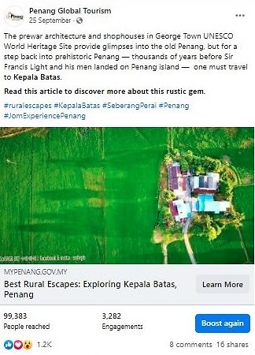 | 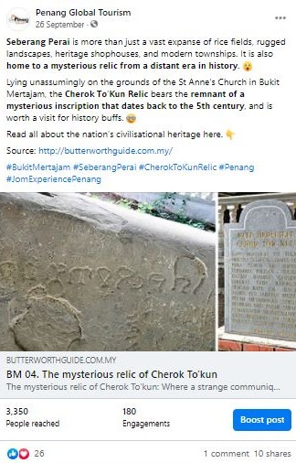

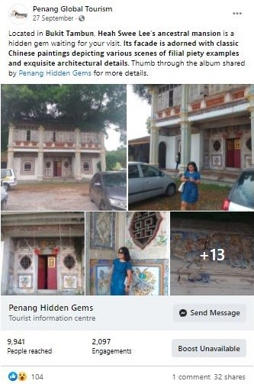

Total Post | Total Reach |  | Total Engagement
7 | 438,885 |  | 31,461

Screenshots of October 2020 Facebook Posts on Seberang Perai:
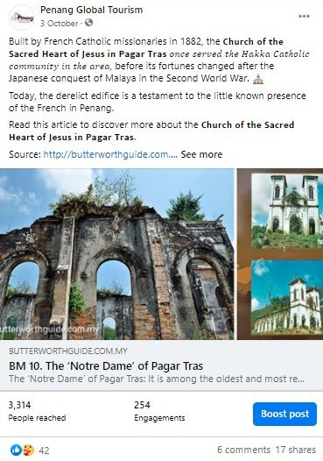 | 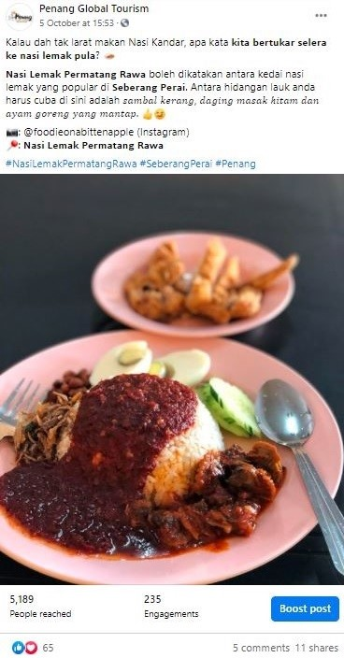
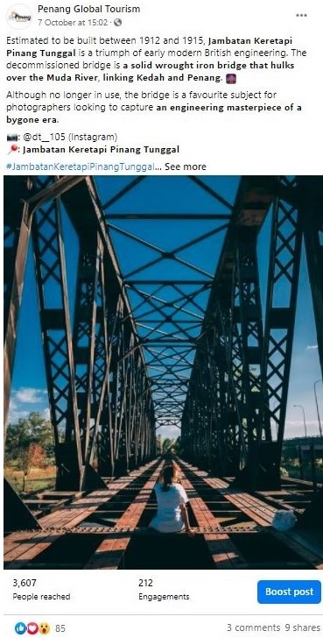 | 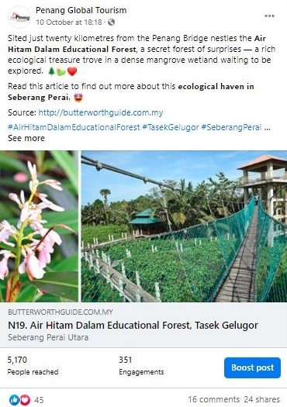

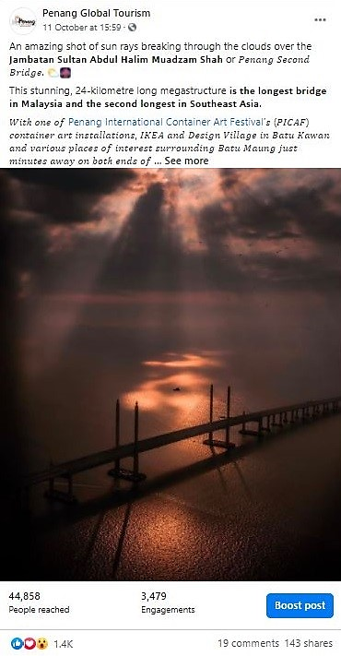 | 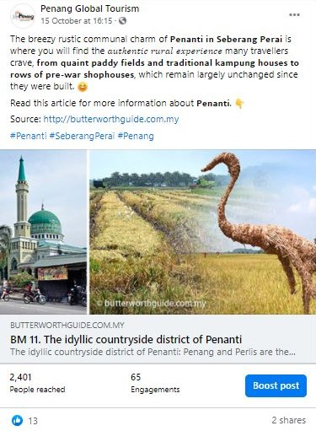

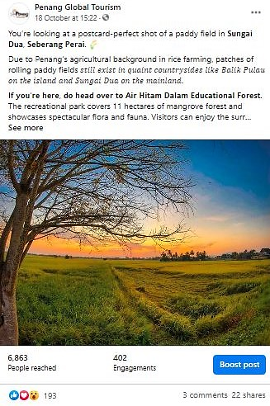 | 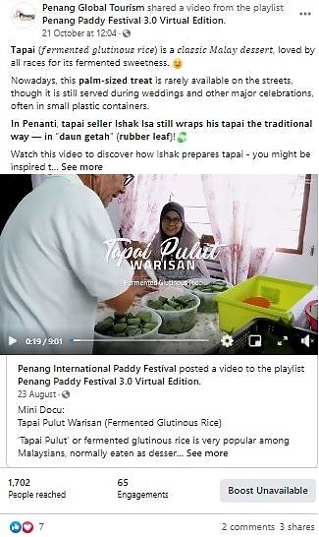

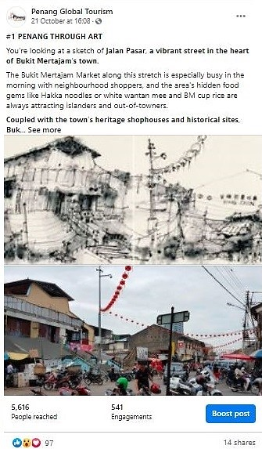 | 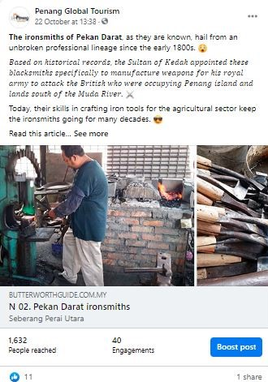

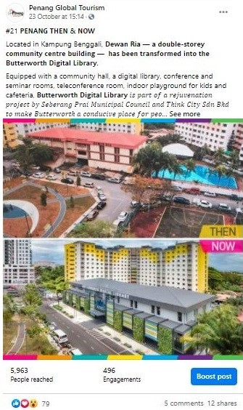 |  | 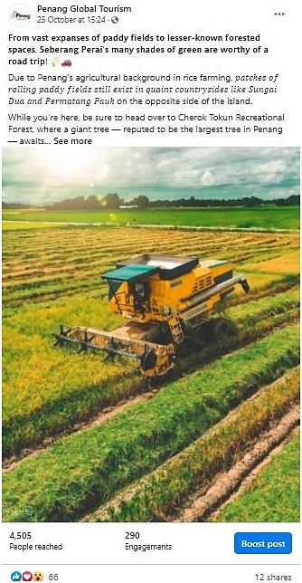
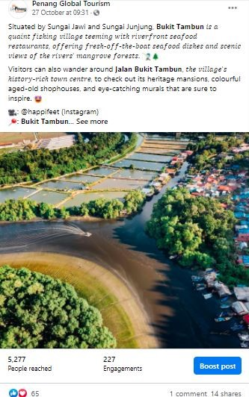

Total Post | Total Reach |  | Total Engagement
13 | 96,097 |  | 6,657

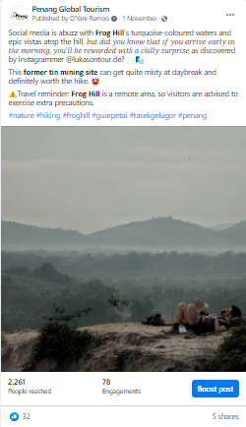 | 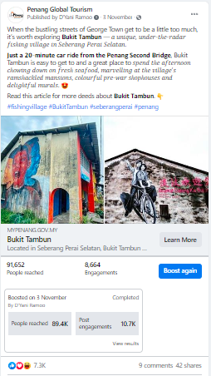

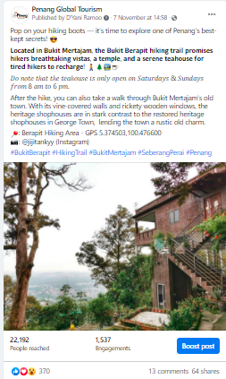 | 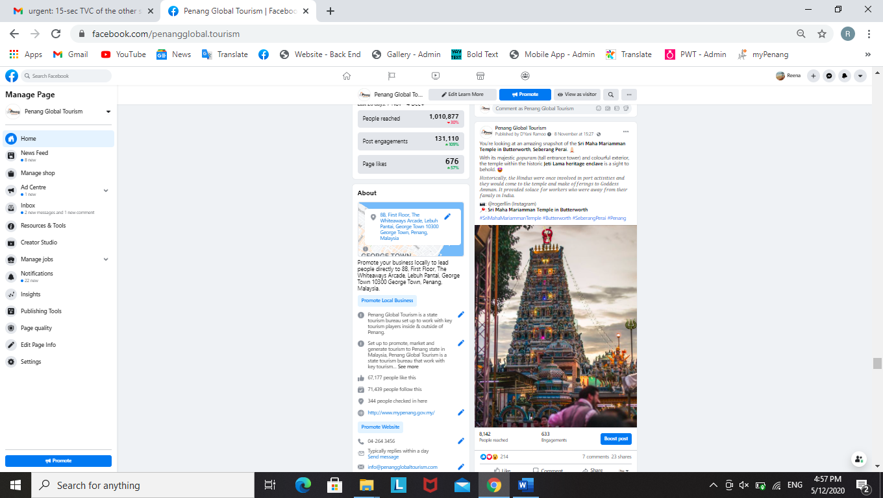
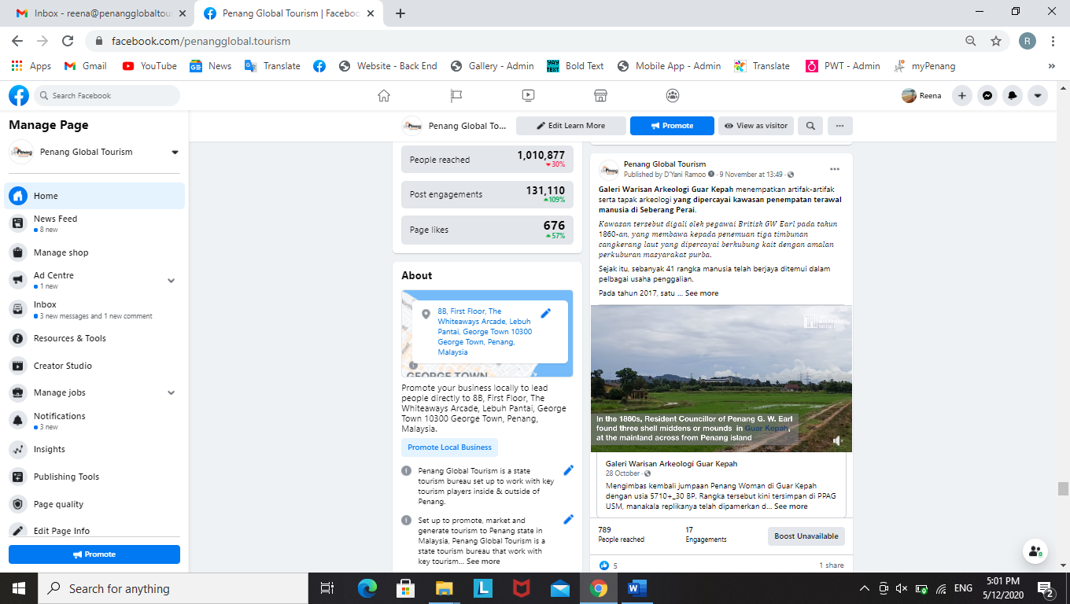 | 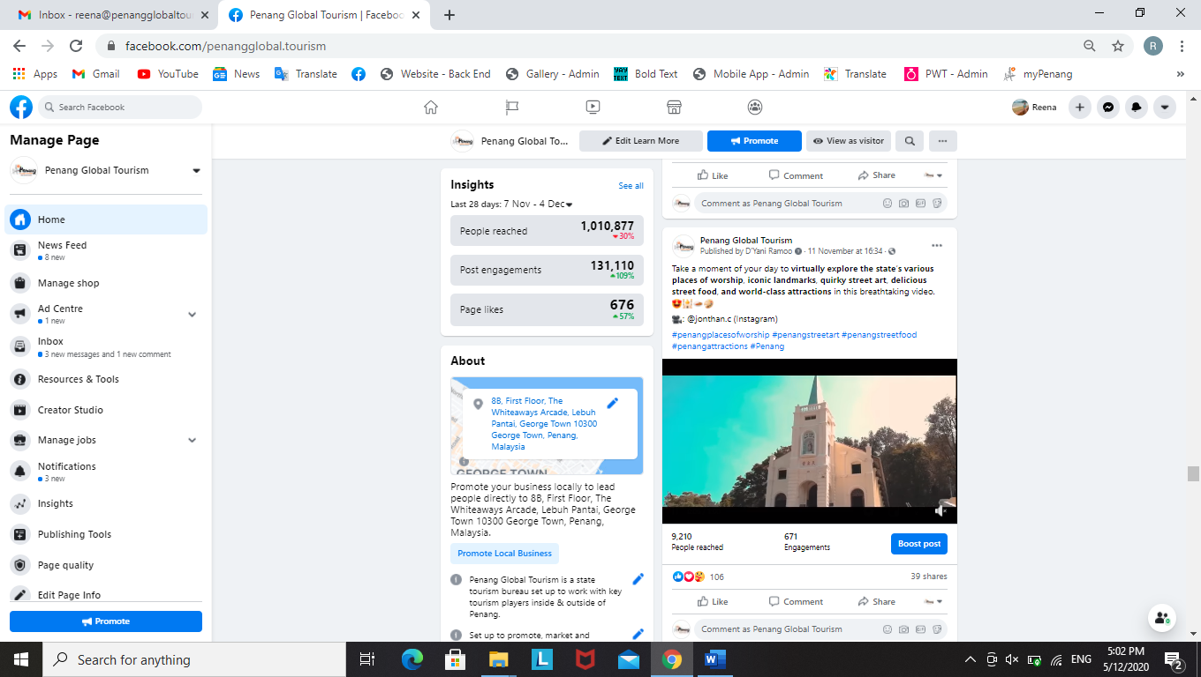

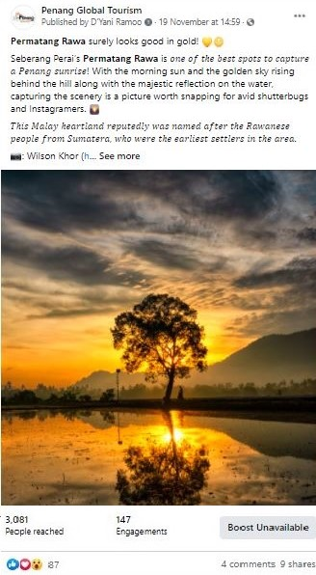 | 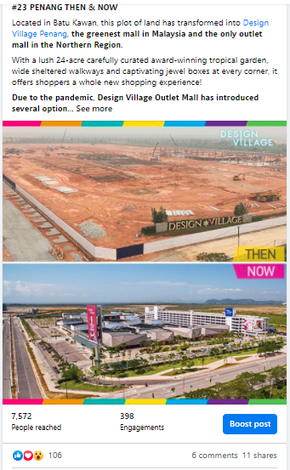

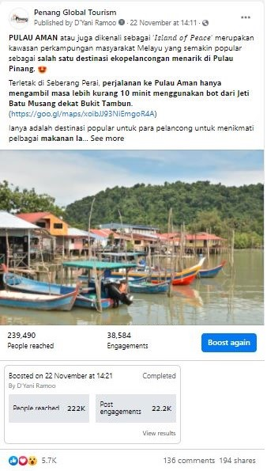 | 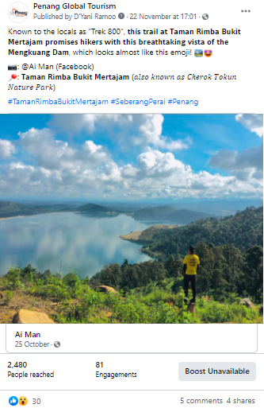

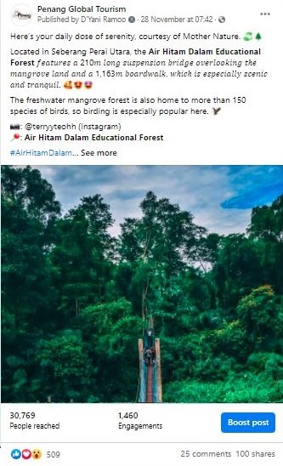 |  | 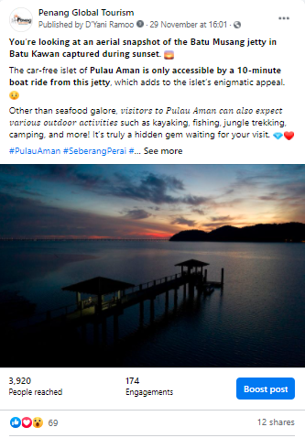
Total Post | Total Reach |  | Total Engagement
14 | 511,429 |  | 68,199

3.2.15 PGT’s Facebook Page Analytics
Based on the insights of PGT’s Facebook Page, there has been a pretty good increase in the number of Page Followers in comparison to the same period, a year before. The number of Page Followers recorded for current period of 1 July to 30 November 2020 was 63,046 and 69,579 whereas the number of Page Followers recorded on 1 July to 30 November 2019 was 55,600 and 58,641. Therefore, there’s a clear indication that the increase of Page Followers for current period is at a good pace.

Comparison of Page Followers:
YOY Comparison | Page Followers |  | Increased by | % Increase
1 July – 30 Nov 2019 | 55,600 | 58,641 | 3,041 | 5.47
1 July – 30 Nov 2020 | 63,046 | 69,579 | 6,533 | 10.36

Page Followers: 1 July to 30 November 2019
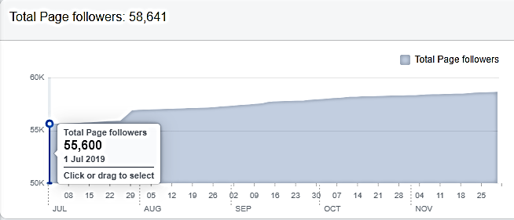

Page Followers: 1 July to 30 November 2020
,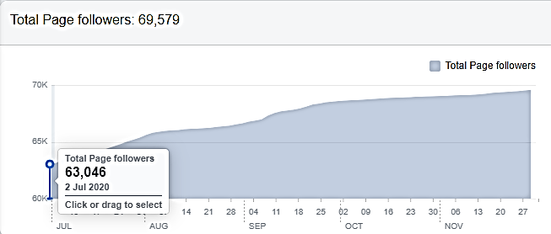

Each month from July to November 2020, the top posts on PGT’s FB Page, were as follows:
Month | Posts/Videos | Total Reach
July | #4 JOM! NIKMATI PULAU PINANG  – 20 Lokasi Insta di Pulau Pinang | Organic: 316,285  Paid: 335,134
August | Instagram Photo – Malaysia’s Longest Bridge, the Sultan Abdul Halim Mu’adzam Shah Bridge | Organic: 104,351  Paid: - n/a
September | 7 Keajaiban Dunia di Pulau Pinang! | Organic: 138,779  Paid: 301,677
October | Techfest Live | Organic: 2,071  Paid: 1,031,002
November | Pulau Aman by Buletin Mutiara | Organic: 18,216  Paid: 218,897

Facebook Posts Summary From 1 July - 30 November 2020

Total Posts & Total Reach of Facebook Posts – Boosted vs Non-Boosted:
 | Total Posts | % Total Posts | Total Reach
Boosted Posts | 273 | 89.80 | 4,495,788
Non-Boosted Posts | 31 | 10.20 | 2,566,262
Total | 304 | 100 | 7,062,050

Total Posts & Total Reach of Facebook Posts – Island vs Mainland:
 | Total Posts | % Total Posts | Total Reach
Island | 262 | 86.18 | 5,859,338
Mainland | 42 | 13.82 | 1,202,712
Total | 304 | 100 | 7,062,050

3.2.16 Website Google Analytics for mypenang.gov.my
The analytics report shows a year-on-year (YOY) comparison between two time periods – 1 July to 30 November 2020 and 1 July to 30 November 2019.

Website traffic
The Google Analytics Report shows a spike on 20 July 2020 with 554 users although in comparison to 20 July 2019, it had 3,785 users, which is higher than this year. There was also a spike on 21 October 2020 with 314 users and comparatively to the previous year on the same date, there were 2,244 users. Additionally, there was also a spike on 16 November 2020 with users in comparison to 16 November 2019, it had 1,656 users to the site, which is higher than this year.
The significant decrease of users to the website for July to November 2020 is likely due to the unforeseen circumstances of the Covid-19 pandemic. Based on previous reports, visitors head to the site mainly to know more on latest events and programmes. There were quite a number of visitors that were linked to our website, mypenang.gov.my via organic Google search, PGT’s Facebook Page, Penang state government’s website, Penang Sentral’s official website, www.penangsentral.com.my and via yahoo.com
According to the analytics report, majority of users to our mypenang.gov.my website was acquired organically via Google. There were also users who were linked to our website through Facebook posts, some organically and some through adverts.

The following is a list of the top 10 sites, mypenang.gov.my was accessed:
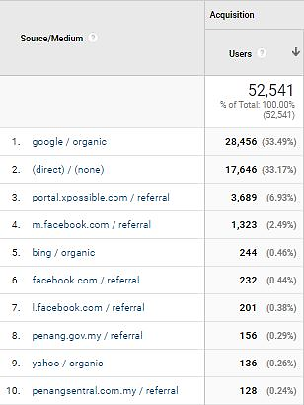

Comparison between 1 July – 30 November 2020 and 1 July – 30 November 2019
The comparison report shows a decrease of 59.57% in new users to the website. The number of sessions per user also recorded a slight decrease of 0.53%. However, there’s a decrease on the bounce rate which is at 5.18%

Top 5 countries visiting the site and most viewed pages
The top 5 countries visiting the site are Malaysia, United States, Singapore, China and Australia. Their most-viewed pages are mainly on Events, Culture & Heritage, Penang Stories, Directory and About Penang.
The following pages show the relevant charts and tables summarizing the Google analytics report as highlighted above.

Period: 1 July - 30 November 2020
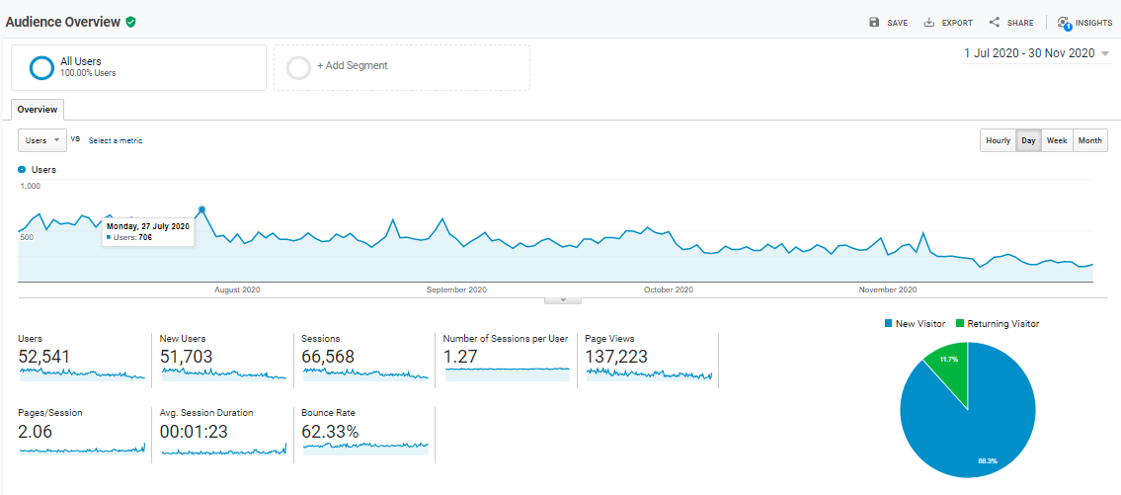

Period: 1 July - 30 November 2019
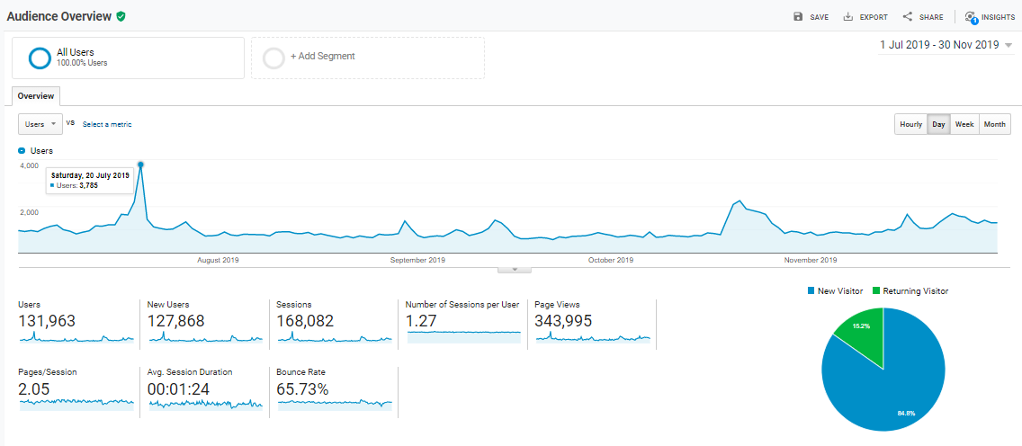

Comparison Chart of 1 July - 30 November 2020 and 1 July - 30 November 2019
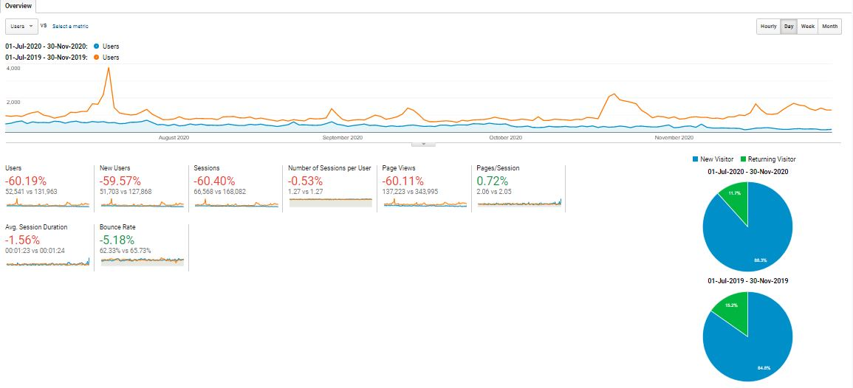

With reference to the above, visitors to the site, in comparison of the time periods:
Item | 1 July – 30 Nov 2020 | 1 July – 30 Nov 2019
Users | 52,541 | 131,963
Sessions | 66,568 | 168,082
Page Views | 137,223 | 343,995
Ave. Session Duration | 00:01:23 | 00:01:24
Bounce Rate | 62.33% | 65.73%

Current period’s Top 10 users by Country from 1 July – 30 November 2020:
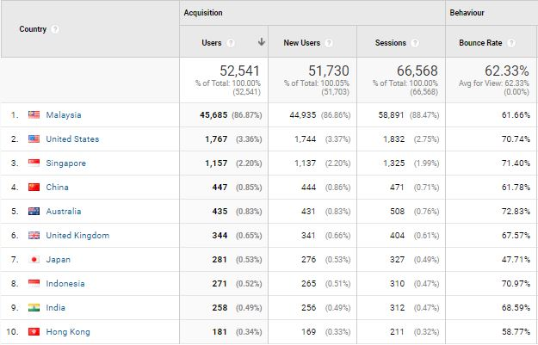

Comparison of the Top 10 users by Country: (1 July – 30 November 2020 and 1 July – 30 November 2019)
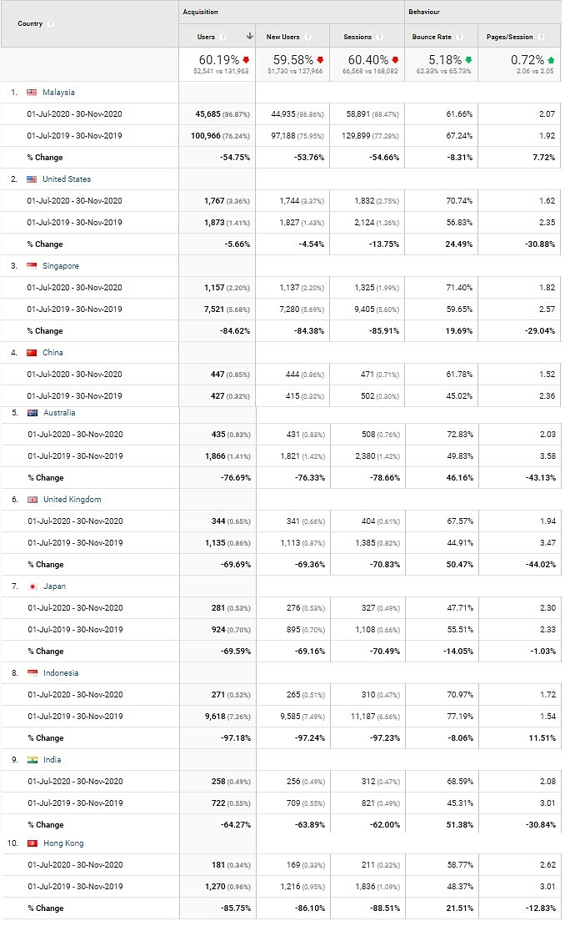
Most viewed pages by the Top 5 Countries visiting our website:
Country | Most viewed Pages
Malaysia | Events, Penang Stories, Culture and Heritage and Directory
United States | Penang Stories, Home page, Events
Singapore | Penang Stories, Culture and Heritage
China | Penang Stories
Australia | Penang Stories, Culture and Heritage

Top page views in the mypenang.gov.my website from 1 July – 30 November 2020:
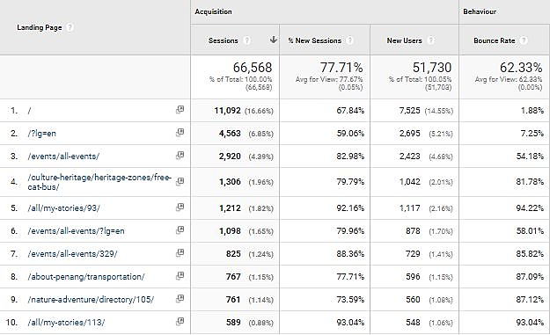

3.2.17 Website Google Analytics for Penang Travel Deals (penangtraveldeals.com)
The analytics report shows the time period of the website from the time it was launched on 15 June – 30 November 2020.

Website traffic
The Google Analytics Report shows a spike on 14 July 2020 with 2,530 users. There was also a spike on 17 July 2020 with 2,352 users.
The significant increase of users to the website in July 2020 could be brought by visitors searching for travel deals and it could be a driven crowd from Facebook posts (organically and through adverts). There were quite a number of visitors that were linked to our penangtraveldeals.com website via Facebook and there were also users that searched for the website directly. Besides that, the other source that directed users to the website are via organic google search, mstar (mstar.com.my) and news portal, Malay Mail (www.malaymail.com).

The following is a list of the top 10 sites, penangtraveldeals.com was accessed:
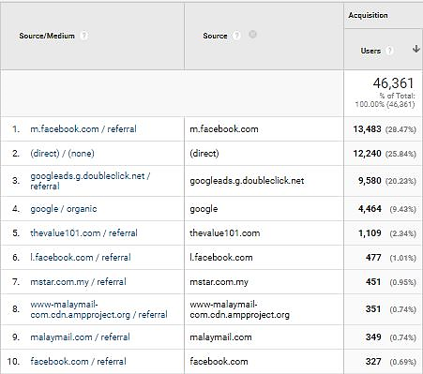

Top 5 countries visiting the site and most viewed pages
The top 5 countries visiting the site are Malaysia, United States, Singapore, China and Indonesia. Their most-viewed pages are mainly on Best Tour Packages, Best Attraction Deals and Best Hotel Deals.
The following pages show the relevant charts and tables summarizing the Google analytics report as highlighted above.

Period: 15 June – 30 November 2020
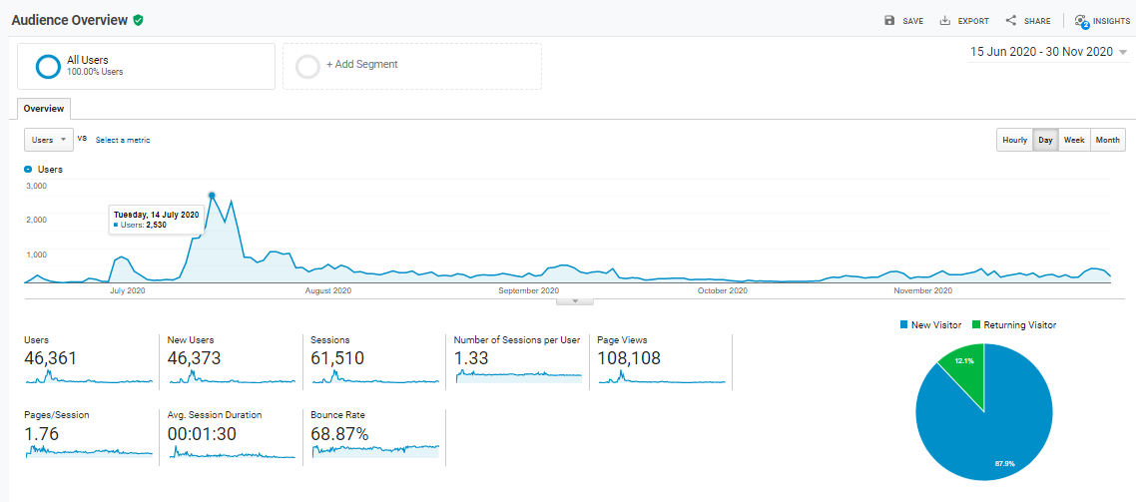

Current period’s Top 10 users by Country from 15 June – 30 November 2020:
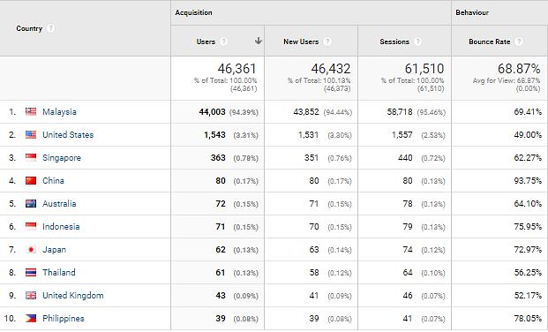

3.2.9 PGT’s Facebook Page Analytics
Based on the insights of PGT’s Facebook Page, there has been a pretty good increase in the number of Page Followers in comparison to the same period, a year before. The number of Page Followers recorded for current period of 1 Oct 2019 to 30 June 2020 was 57,957 and 62,990 whereas the number of Page Followers recorded on 1 Oct 2018 to 30 June 2019 was 52,393 and 55,594. Therefore, there’s a clear indication that the increase of Page Followers for the current period is at a good pace.

Comparison of Page Followers:
YOY Comparison | Page Followers |  | Increased by
1 Oct 2018 – 30 June 2019 | 52,393 | 55,594 | 3,201
1 Oct 2019 – 30 June 2020 | 57,957 | 62,990 | 5,033

Most viewed pages by the Top 5 Countries visiting our website:
Country | Most viewed Pages
Malaysia | Best Tour Packages, Frontliner Attraction Deals, Best Hotel Deals, Best Attraction Deals, Best Food & Lifestyle Deals
Singapore | Best Tour Packages, Best Attraction Deals, Frontliner Attraction Deals, Best Hotel Deals
United States | Home Page, Best Frontliner Deals, Best Tour Packages
China | Home Page, Best Attraction Deals
Australia | Best Tour Packages, Best Attraction Deals

Top page views in penangtraveldeals.com website from 15 June – 30 November 2020:
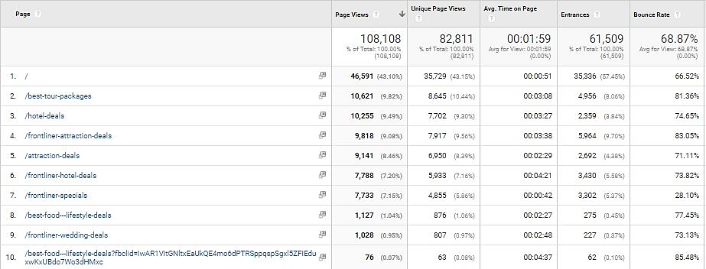

3.2.18 Penang Global Tourism Mobile App
Continuing from our last report, the following table shows the total number of downloads starting 1 July to 30 November 2020 on iOS and Android:
Domestic/In’tial | iOS |  | Android
Malaysia | 54 | 63.53 | 82 | 90.10
Overseas | 31 | 36.47 | 9 | 9.90
Total downloads | 85 | - | 91 | -

The total number of downloads (Malaysia and overseas) in the 5 months is 176. The top international countries for number of downloads on our mobile app are:
iOS: United States, Hong Kong, Japan, Singapore, Germany, China, France
Android: Indonesia, Thailand, Uzbekistan, Philippines, Korea, Germany

To be consistent with PGT’s website, updates are being done on PGT’s mobile app. For easier management, the backend CMS for e-coupon has been updated to enable further editing and amendments after item has been listed.

3.2.19 PGT’s E-Newsletter – Don’t Say Penang Bojio
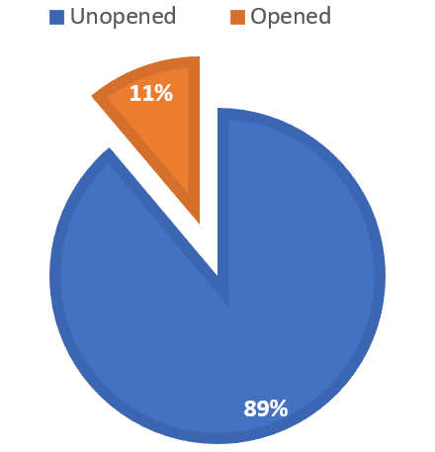
PGT’s e-newsletter, Don’t Say Penang Bojio highlights major events and upcoming events happening in the state, announces latest news and/or new openings on Penang’s tourism products, latest updates on direct flights to Penang, as well as latest special deals on PGT’s coupon.

Don’t Say Penang Bojio Issue #2 – October 2020
Item | Figure
Recipients | 3,234
Successfully Sent | 3,234
Opened This Campaign | 360 (11.13%)
Clicked A Link | 110 (3.40%)
Unsubscribed | 20 (0.62%)
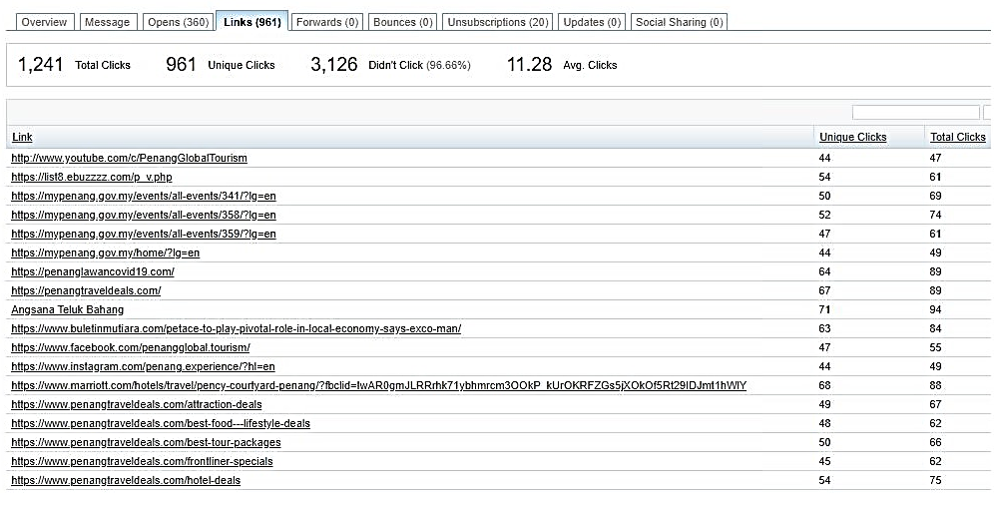

Summary:
- Percentage of recipients who opened the latest issue increased by 4.8%
- Percentage of link clicks increased by 2.5%. Most link clicks were to view Penang events, Penang Lawan Covid-19 and Penang Travel Deals.
- Percentage of recipients who unsubscribed in this issue is 0.44% higher compared to the previous issue.

The following is a screenshot of Don’t Say Penang Bojio #2 – October 2020:
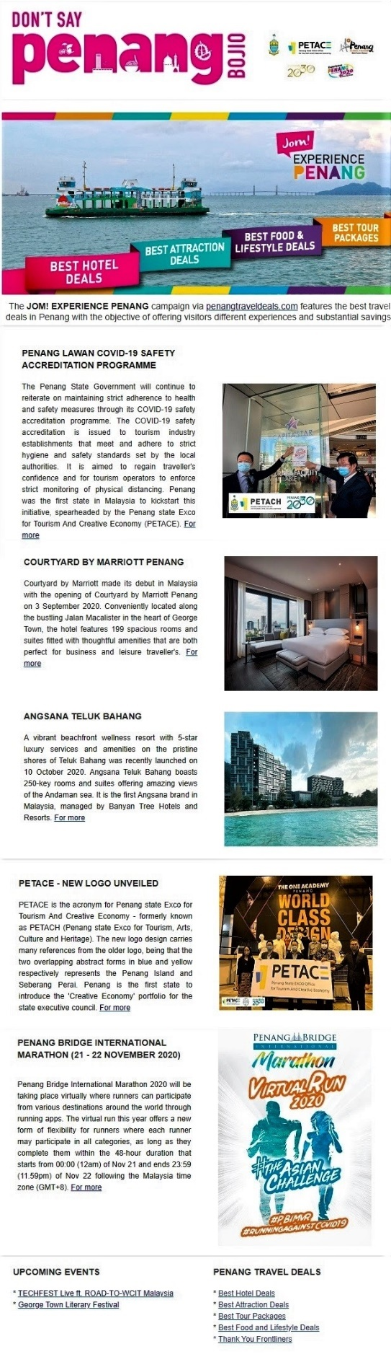
3.3 Recent Publicity (July - November 2020)

July 2020
Local
No | Name | Description | Type of Publication
1 | The Star | For just RM15 per person, anyone can now enjoy a full day’s tour of the best spots in Penang. | Online
2 | The Star | Penang covid-19 accreditation programme has seen 17 tourism players go the extra length to follow added standard operating procedures (SOP). | Online
3 | Tin Media | Penang tour package is expected to draw state revenue of RM1.54 million | Online
4 | Tin Media | Malaysian Chinese Inbound Association (MICA) is confident to attract 50,00 domestic tourists from July till the end of this year which targets to bring in RM 15 million of revenue. | Online
5 | Guang Ming Daily | 23 great value package discounts until the end of October starting RM 15 per person for major attractions in Penang. | Online
6 | Kwong Wah Yit Poh | Jom! Experience Penang RM 15 to take you on easy tour in Penang | Online
7 | Wartasaya.com | Penang launches Jom! Experience Campaign to woo local tourists | Online
8 | China Press Northern Region | Jom! Experience Penang Campaign launch calls domestic travellers to Penang. | Print
9 | Advertising + Marketing | Penang State Tourism unveils campaign hoping to capture domestic footfall | Online
10 | Weareunited.com | Jom! Experience Penang campaign launch to boost Penang’s tourism industry | Online
12 | Sin Chew Northern | YB Yeoh Soon Hin launches “Jom! Experience Penang” campaign | Print
13 | Oriental Daily News | Jom! Experience Penang features multiple discounts for domestic travellers travelling into Penang | Online
14 | RTM | News coverage on Jom! Experience Penang campaign launch | Television

July 2020
Foreign
No | Name | Description | Type of Publication
1 | TTG Asia | At The Habitat Penang Hill, an eco-tourism hotspot in Penang, visitor numbers have bounced back to “near normal”, with more than 90 per cent visitor ship comprising locals and expatriates living and working in Malaysia | Online

August 2020
Local
No | Name | Description | Type of Publication
1 | Where2lifestylemagazine | Penang promotes “Responsible Tourism” as it is among the longest recorded “Green Zones” in the country during the Covid-19 pandemic | Online
2 | New Straits Times | #JOM! GO: Seven World Wonders of Penang. The campaign is highlighting the seven World Wonders of Penang. | Online
3 | The Star | The Sia Boey Urban Archaeological Park is touted as the first of its kind in Malaysia. | Online
4 | Malay Mail | Rising occupancy rates at hotels here indicate the state’s tourism sector was gradually recovering from the Covid-19 pandemic | Online
5 | New Straits Times | Together with its Unesco World Heritage Site, seven world wonders, delicious local cuisine and a rich tapestry of culture, Penang State Exco for Tourism, Arts, Culture and Heritage wants visitors to know that the state is host to many other unique attractions. | Online
6 | The Edge Markets | The third edition of the Penang International Travel Exchange 2020 (PITE 2020) will be held virtually between Oct 14 and 16 due to the COVID-19 pandemic and international travel ban. | Online
7 | Malaysian Parenting | Jom! Experience Penang campaign launch | Online
8 | Lancareno.com | Pulau Pinang lokasi percutian antarabangsa | Online
9 | Isaactan.net | Blog post on Jom! Experience Penang campaign | Online
10 | Clefffairy.com | Blog post on Jom! Experience Penang campaign | Online

September 2020
Local
No | Name | Description | Type of Publication
1 | The Star | The Penang government has been tirelessly helping stakeholders to restore the state’s tourism industry to its former glory. | Online
2 | Buletin Mutiara | PENANG is expected to welcome more domestic tourists after the state has been declared free of Covid-19 by the Health Ministry. | Online
3 | Malay Mail | As the international borders remain barred, the Penang government aims to promote the state as the top domestic tourism destination in Malaysia. | Online
4 | Buletin Mutiara | PENANGITES as well as local and foreign tourists can look forward to knowing more about the footprints left by the French in the state through the French Heritage Trail initiative. | Online
5 | The Star | PENANG had a low-key celebration of annual World Tourism Day on 20th September 2020 as a string of programmes initially lined up has to cease due to the Covid-19 pandemic. | Online

September 2020
Foreign

No | Name | Description | Type of Publication
1 | Tour Hero | Living like in Crazy Rich Asians: 48 hours in Penang, Malaysia | Online
2 | Express – Home of the Daily and Sunday Express | The Singapore Grip drama series which was aired on ITV, a British commercial television network was filmed in George Town, Penang | Online

October 2020
Local
No | Name | Description | Type of Publication
1 | Buletin Mutiara | The Penang government has been actively carrying out promotional and marketing campaigns to develop domestic tourism in the state amid the Covid-19 pandemic. | Online
2 | Buletin Mutiara | The state government is embarking on initiatives to create new tourist attractions in Seberang Perai to ensure a balanced development between the island and the mainland. | Online
3 | Buletin Mutiara | Creative industries will help to boost Penang’s tourism image and transform existing cultural and heritage assets into revenue for the state in the long term | Online

October 2020
Foreign
No | Name | Description | Type of Publication
1 | CNN Travel | Penang’s Assam Laksa ranked world’s 7th best dish by CNN Travel | Online

November 2020
Local
No | Name | Description | Type of Publication
1 | The Edge Markets | To place heritage under sustainable development | Online
2 | Free Malaysia Today | George Town Development Plan to be business and heritage friendly | Online
3 | The Star | Invest in creative economy | Online
4 | Digital News Asia | Penang TECHFEST Live features Road-to-WCIT in hybrid series of events to drive inclusivity of tech for all | Online
5 | World of Buzz | Penang to have first drive-thru Nasi Kandar in Seberang Perai | Online
6 | The Star | Article on Penang War Museum | Online
7 | The Star | Hoteliers urge govt to allow tourism activities in green zones | Online
8 | Guang Ming | ATAP hopes that the government and the people will join forces to revive the tourism industry | Online
9 | Malay Mail | Penang asks Putrajaya for measures to safeguard tourism industry | Online
10 | Kwong Wah Yit Poh | Penang Airport Expansion plan postponed | Online
11 | Guang Ming | Penang Tourism Exco writes in to Tourism Minister on suggestion to alleviate the plight of the tourism industry | Online
12 | New Straits Times | #JOM! EAT: Vegan Laksa in Penang | Online
13 | Malay Mail | Penang extends hotel room fee exemption to June 2021 | Online
14 | The Star | First Penang Bridge International Marathon virtual run kicks off | Online

November 2020
Foreign
No | Name | Description | Type of Publication
1 | South China Morning Post | The Singapore Grip filmed in Penang and Kuala Lumpur | Online
2 | Travel Weekly | Article on lesser-known attractions in Penang and Kuala Lumpur | Online
3 | Think Advisor | 11 Best Islands for Retirement Abroad | Online

The following are the number of local and foreign news coverage based on what we have managed to monitor - mainly online, via Google Alerts and physical publications/magazines received through free subscriptions:

Month (2020) | Local News Coverage | Foreign News Coverage
July | 14 | 1
August | 10 | -
September | 5 | 2
October | 3 | 1
November | 14 | 3
Total | 46 | 7

