3.2.4 Festivals in A Box (1 July - 30 November 2020)
The festival in a box videos are used on an ongoing basis to promote the year-round festivals happening in Penang. It is an effective way to promote the events as it’s more visually driven and gives a good preview of what the festivals are all about. The videos posted on Facebook also drive visitors to our mypenang website for more details.

Festival in A Box videos shared on PGT’s Facebook page from 1 July – 30 November 2020:

No. | Videos | Total Views as at 30 November 2020 | Date Published
1 | Mid-Autumn Festival  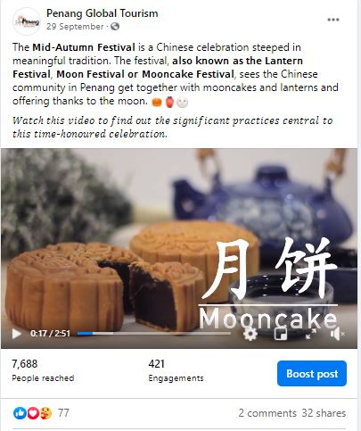 | 1.7k | 29 September 2020

Other Promotional Videos (1 July – 30 November 2020)
No. | Videos | Total Views as at 30 November 2020 | Date Published
1 | Tarikan Terkini Pulau Pinang  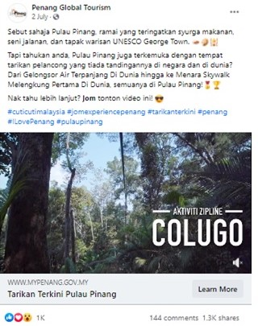 | 141.3k | 2 July 2020
2 | 20 Pengalaman Unik di Pulau Pinang   | 268.2k | 9 July 2020

No. | Videos | Total Views as at 30 November 2020 | Date Published
3 | 20 Aktiviti Percuma di Pulau Pinang   | 143k | 16 July 2020
4 | Paper kite butterfly encounter at Entopia  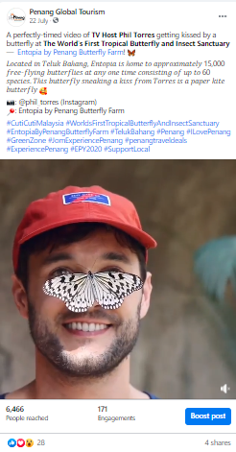 | 1.2k | 22 July2020

No. | Videos | Total Views as at 30 November 2020 | Date Published
5 | 20 Makanan Mesra Muslim Terbaik di Pulau Pinang   | 272.2k | 23 July 2020
6 | Peranakan Heritage & Customs  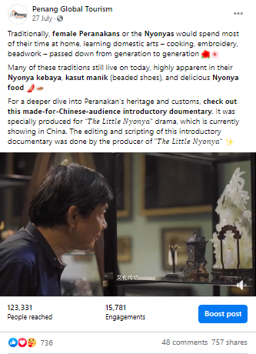 | 45.4k | 27 July 2020

No. | Videos | Total Views as at 30 November 2020 | Date Published
7 | 20 Lokasi Insta di Pulau Pinang   | 229.8k | 30 July 2020
8 | Penang International Container Art Festival  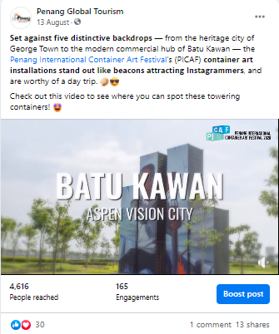 | 949 | 13 August 2020

No. | Videos | Total Views as at 30 November 2020 | Date Published
9 | 20 Nasi Kandar Terbaik di Pulau Pinang  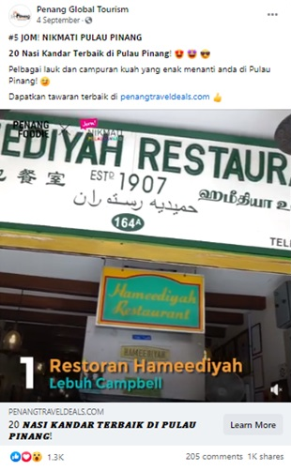 | 167.1k | 4 September 2020
10 | 20 Aktiviti Mesra Keluarga di Pulau Pinang   | 138.3k | 11 September 2020

No. | Videos | Total Views as at 30 November 2020 | Date Published
11 | 20 Makanan Vegetarian Terbaik di Pulau Pinang  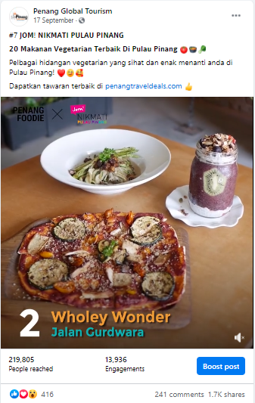 | 64.3k | 17 September 2020
12 | Instagram Filter Video  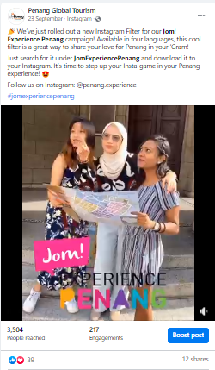 | 1.1k | 23 September 2020

No. | Videos | Total Views as at 30 November 2020 | Date Published
13 | 20 Tempat Beribadat Cantik di Pulau Pinang  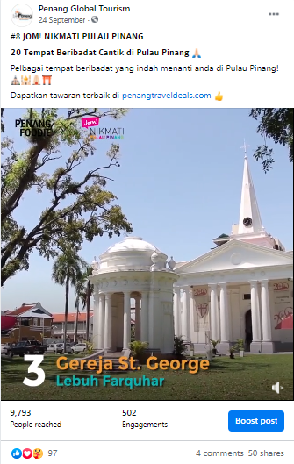 | 2.4k | 24 September 2020
14 | Kayu Nasi Kandar – Roti Tisu  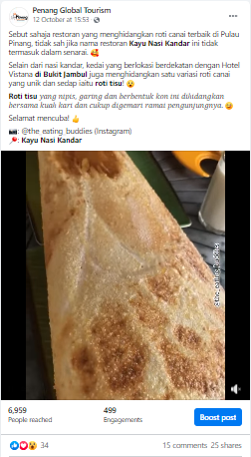 | 2.4k | 12 October 2020

No. | Videos | Total Views as at 30 November 2020 | Date Published
15 | Ais Tingkap di Lebuh Tamil, George Town  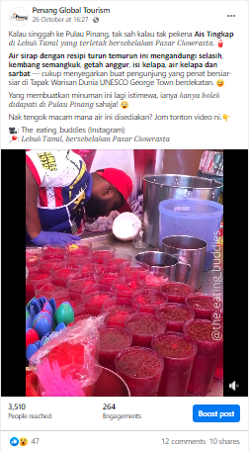 | 1.4k | 26 October 2020

3.2.5 Results of Paid Advertising via Social Media
Boosted Posts on PGT Facebook Page from 1 July 2020 – 31 October 2020:

PGT’s Facebook Page
Post/ Advert | Target Market | Budget (RM) | Duration | Reach | Results
Tarikan Terkini Pulau Pinang | Johor Bahru  Alor Setar  Kota Bharu  Melaka  Seremban  Kuantan  Ipoh  Perlis  Kuching  Miri  Selangor  Terengganu  Kuala Lumpur  Labuan  Kota Kinabalu  Putrajaya | 800 | 2 – 6 July 2020 | 114,368 | 141k views  1.3k shares  1k reactions  144 comments
Traditional Trades – George Town Unesco World Heritage Site | Johor Bahru  Alor Setar  Kota Bharu  Melaka  Seremban  Kuantan  Ipoh  Perlis  Kuching  Miri  Selangor  Terengganu  Kuala Lumpur  Labuan  Kota Kinabalu  Putrajaya | 600 | 6 – 10 July 2020 | 170,944 | 1k shares  5.9k reactions  50 comments
 | Penang | 400 | 5 - 9 July 2020 | 82,961 | -
20 Pengalaman Unik di Pulau Pinang | Johor Bahru  Alor Setar  Kota Bharu  Melaka  Seremban  Kuantan  Ipoh  Perlis  Kuching  Miri  Selangor  Terengganu  Kuala Lumpur  Labuan  Kota Kinabalu  Putrajaya | 800 | 9 – 13 July 2020 | 188,991 | 268k views  1.4k shares  1.7k reactions  161 comments
 | Johor Bahru  Alor Setar  Kota Bharu  Melaka  Seremban  Kuantan  Ipoh  Perlis  Kuching  Miri  Selangor  Terengganu  Kuala Lumpur  Labuan  Kota Kinabalu  Putrajaya | 800 | 26 – 30 October 2020 | 195,201
20 Aktiviti Percuma di Pulau Pinang | Johor Bahru  Alor Setar  Kota Bharu  Melaka  Seremban  Kuantan  Ipoh  Perlis  Kuching  Miri  Selangor  Terengganu  Kuala Lumpur  Labuan  Kota Kinabalu  Putrajaya | 800 | 16 – 20 July 2020 | 205,088 | 3.7k share  2.2k reactions  524 comments  142k views
20 Makanan Mesra Muslim Terbaik di Pulau Pinang | Johor Bahru  Alor Setar  Kota Bharu  Melaka  Seremban  Kuantan  Ipoh  Perlis  Kuching  Miri  Selangor  Terengganu  Kuala Lumpur  Labuan  Kota Kinabalu  Putrajaya | 800 | 23 – 27 July 2020 | 242,561 | 2.8k shares  2.1k reactions  410 comments  272k views
20 Lokasi Insta di Pulau Pinang | Johor Bahru  Alor Setar  Kota Bharu  Melaka  Seremban  Kuantan  Ipoh  Perlis  Kuching  Miri  Selangor  Terengganu  Kuala Lumpur  Labuan  Kota Kinabalu  Putrajaya | 800 | 30 July – 3 August 2020 | 339,456 | 3.4k shares  1.9k reactions  384 comments  229k views
Penang Travel Deals | Johor Bahru  Alor Setar  Kota Bharu  Melaka  Seremban  Kuantan  Ipoh  Perlis  Kuching  Miri  Selangor  Terengganu  Kuala Lumpur  Labuan  Kota Kinabalu  Putrajaya | 800 | 3 – 7 August 2020 | 40,448 | 10 shares  1.4k reactions  20 comment
20 Nasi Kandar Terbaik di Pulau Pinang | Johor Bahru  Alor Setar  Kota Bharu  Melaka  Seremban  Kuantan  Ipoh  Perlis  Kuching  Miri  Selangor  Terengganu  Kuala Lumpur  Labuan  Kota Kinabalu  Putrajaya | 800 | 4 – 9 September 2020 | 271,361 | 1k shares  1.3k reactions  205 comments  167k views
7 Keajaiban Dunia di Pulau Pinang | Johor Bahru  Alor Setar  Kota Bharu  Melaka  Seremban  Kuantan  Ipoh  Perlis  Kuching  Miri  Selangor  Terengganu  Kuala Lumpur  Labuan  Kota Kinabalu  Putrajaya | 800 | 9 – 13 September 2020 | 303,554 | 1.4k shares  1.9k reactions  383 comments
20 Aktiviti Mesra Keluarga di Pulau Pinang | Johor Bahru  Alor Setar  Kota Bharu  Melaka  Seremban  Kuantan  Ipoh  Perlis  Kuching  Miri  Selangor  Terengganu  Kuala Lumpur  Labuan  Kota Kinabalu  Putrajaya | 800 | 11 – 15 September 2020 | 209,918 | 1.1k shares  1k reactions  109 comments  138k views
Penang Stories - Best Rural Escapes: Exploring Kepala Batas, Penang | Johor Bahru  Alor Setar  Kota Bharu  Melaka  Seremban  Kuantan  Ipoh  Perlis  Kuching  Miri  Selangor  Terengganu  Kuala Lumpur  Labuan  Kota Kinabalu  Putrajaya | 800 | 25 – 29 September 2020 | 94,937 | 16 shares  1.2k reactions  8 comments  1,539 link clicks
Penang Stories – Menerokai Teluk Kumbar: Intan Yang Belum Diasah | Johor Bahru  Alor Setar  Kota Bharu  Melaka  Seremban  Kuantan  Ipoh  Perlis  Kuching  Miri  Selangor  Terengganu  Kuala Lumpur  Labuan  Kota Kinabalu  Putrajaya | 800 | 1 – 5 October 2020 | 189,926 | 54 shares  1.7k reactions  9 comments  965 link clicks
Techfest | Johor Bahru  Alor Setar  Kota Bharu  Melaka  Seremban  Kuantan  Ipoh  Perlis  Kuching  Miri  Selangor  Terengganu  Kuala Lumpur  Labuan  Kota Kinabalu  Putrajaya | 800 | 8 – 12 October 2020 | 6,504 | 3 shares  6.3k reactions  2 comments  491 link clicks
 | Singapore | 1,000 | 12 – 17 October 2020 | 87,600 | 23 reactions  830 link clicks  853 engagement
 | Japan | 500 | 14 – 19 October 2020 | 63,551 | 8 reactions  260 link clicks  270 engagement
 | South Korea | 500 | 15 – 20 October 2020 | 41,055 | 7 reactions  267 link clicks  275 engagement
 | Australia | 1,500 | 16 – 21 October 2020 | 58,849 | 17 reactions  621 link clicks  639 engagement
 | Taipei | 1,000 | 22 – 27 October 2020 | 61,328 | 18 reactions  742 link clicks  763 engagement
 | Indonesia | 500 | 23 – 28 October 2020 | 120.4k | 93 reactions  2,008 link clicks  2,104 engagement
 | Philippines | 500 | 25 – 30 October 2020 | 64,576 | 68 reactions  2,096 link clicks  2,167 engagement
 | United Kingdom | 1,500 | 26 – 31 October 2020 | 72,271 | 6 reactions  596 link clicks  605 engagement
 | Hong Kong | 1,000 | 26 – 31 October 2020 | 68,303 | 17 reactions  578 link clicks  596 engagement
 | Vietnam | 500 | 27 October – 1 November 2020 | 144.7k | 73 reactions  2,467 link clicks  2,545 engagement
 | Thailand | 1,000 | 27 October –  1 November 2020 | 169.2k | 66 reactions  2,606 link clicks  2,676 engagement

The total amounts spent on PGT Facebook page from 1 July – 31 October 2020 is as follows:
Penang Global Tourism | RM 20,900

3.2.6 Facebook Posts from 1 July – 31 October 2020
Period: July 2020
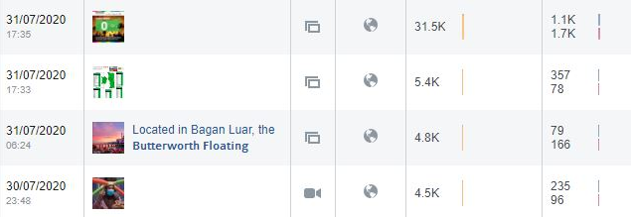
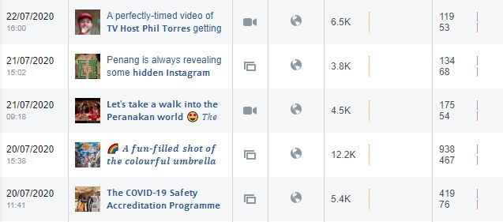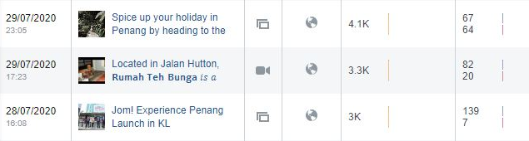
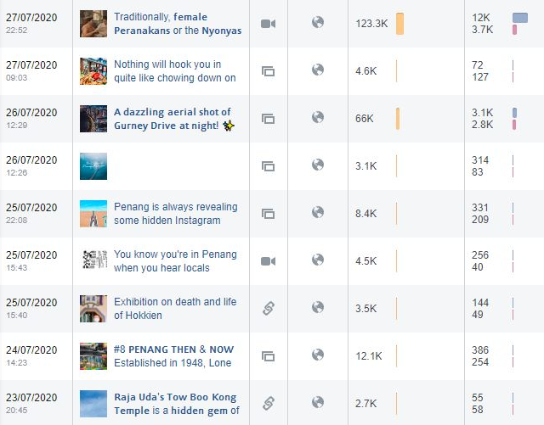

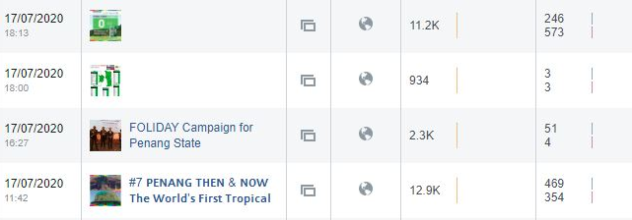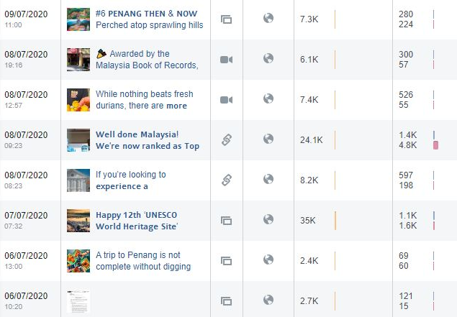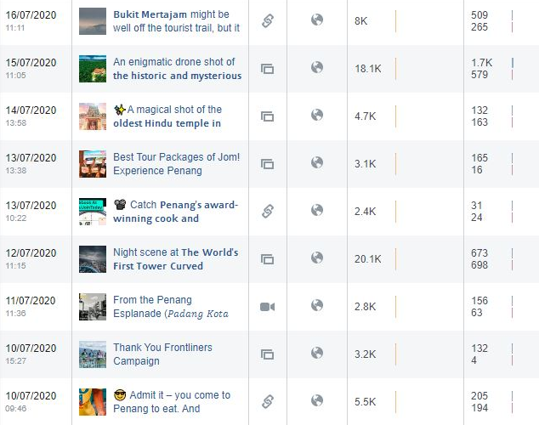

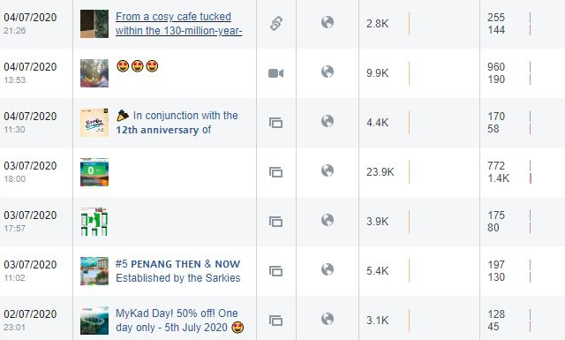
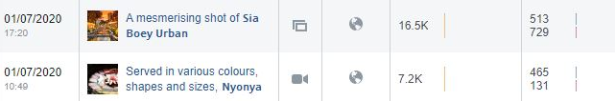
Total Post | Total Reach | Total Post Clicks | Total Reaction, Comments & Shares
51 | 582,734 | 33,002 | 22,965

Period: August 2020
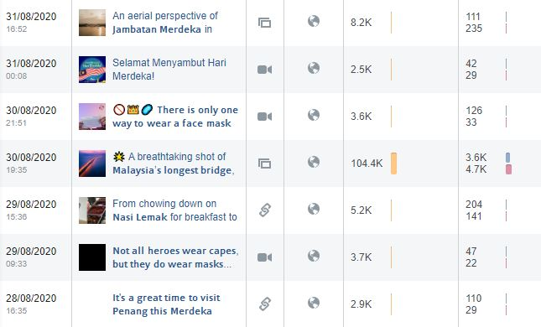

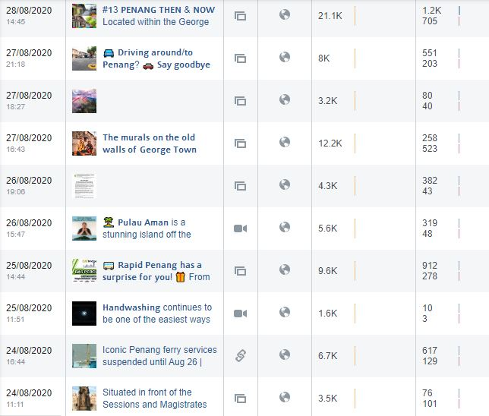
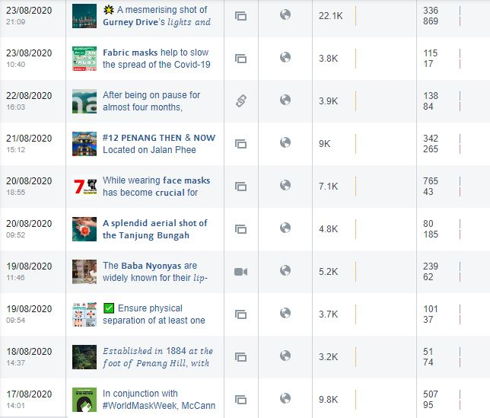

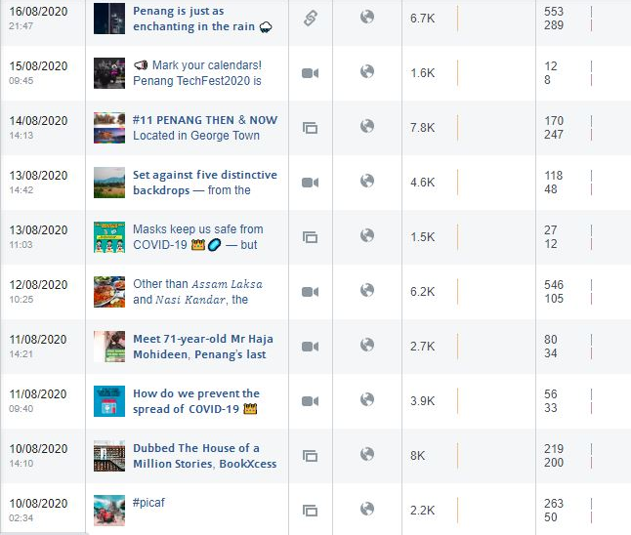
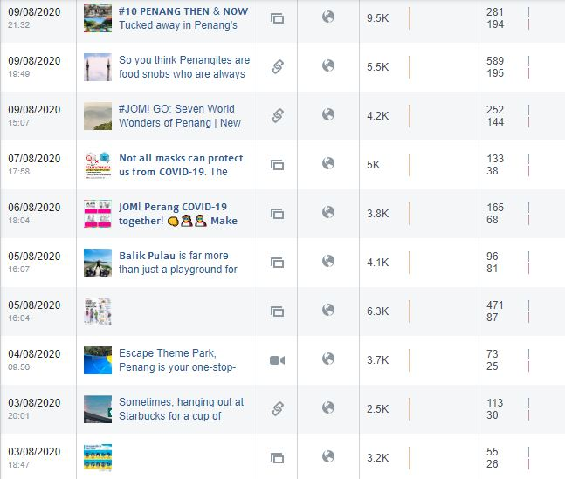

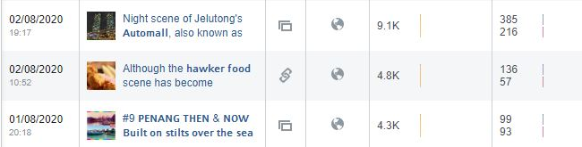
Total Post | Total Reach | Total Post Clicks | Total Reactions, Comments & Shares
50 | 390,100 | 16,211 | 11,273

Period: September 2020
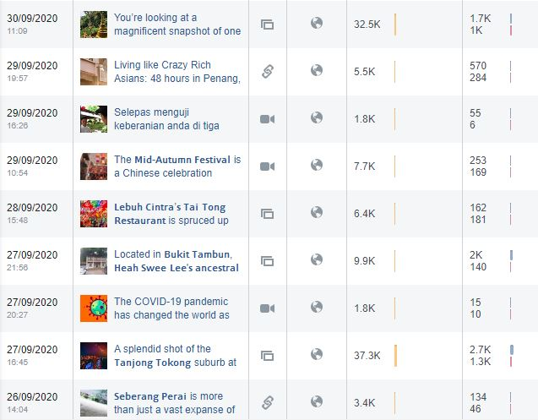
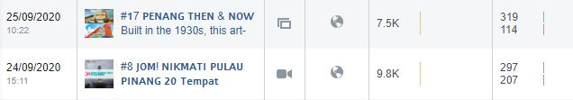

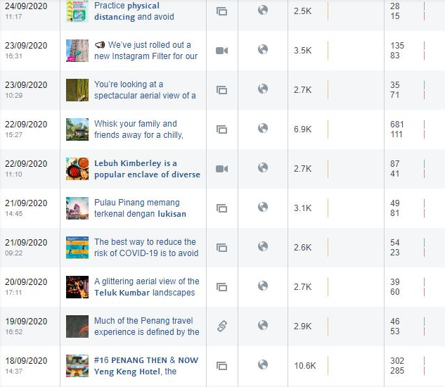
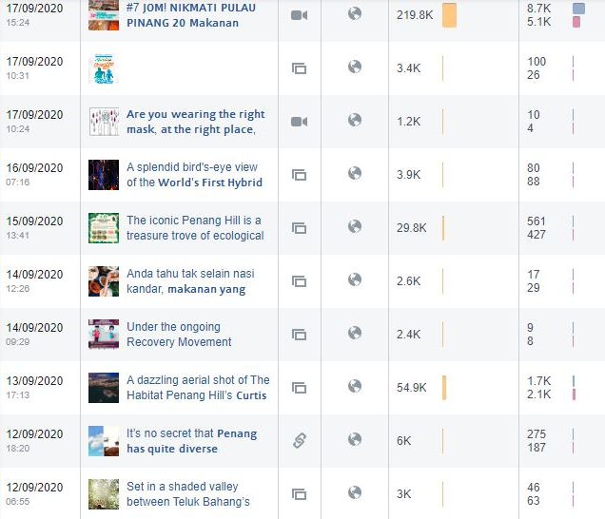
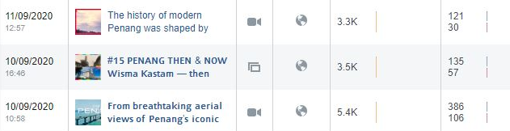
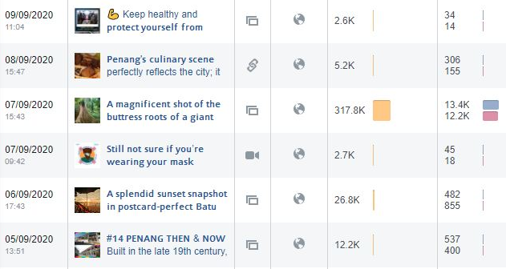
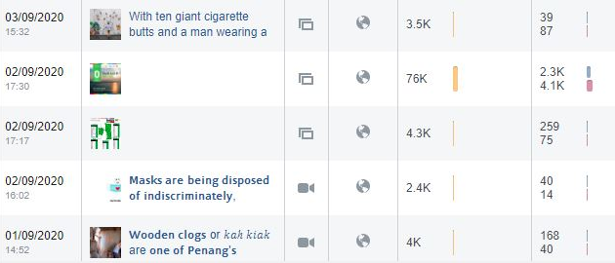
Total Post | Total Reach | Total Post Clicks | Total Reactions, Comments & Shares
45 | 960,500 | 39,411 | 30,463

Period: October 2020
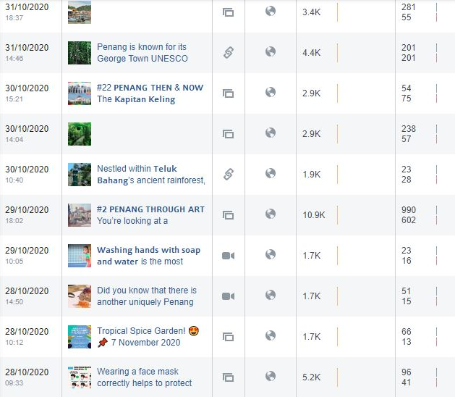

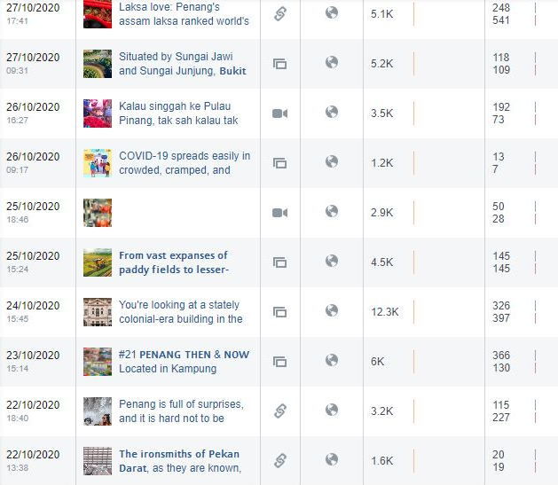
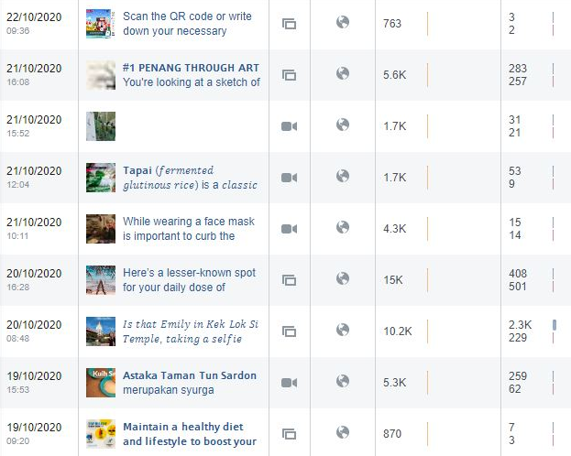

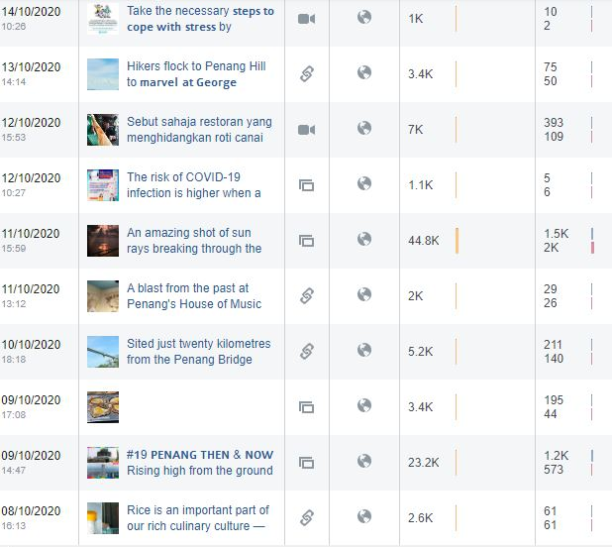
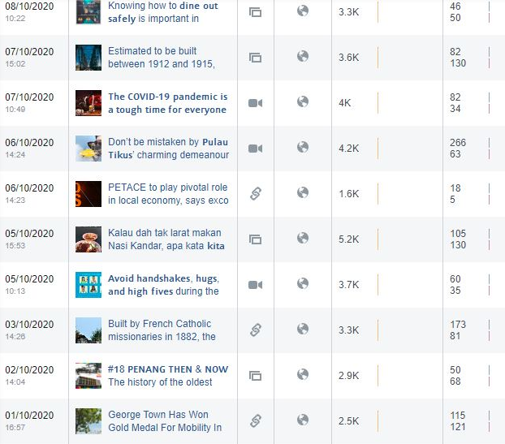
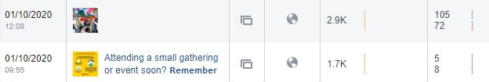
Total Post | Total Reach | Total Post Clicks | Total Reactions, Comments & Shares
61 | 315,733 | 13,668 | 9,494

Total post and reach for PGT’s Facebook Page from 1 July – 31 October 2020 are as follows:
Month | Posts | Reach | Post Clicks | Reactions, Comments & Shares
July | 51 | 582,734 | 33,002 | 22,965
August | 50 | 390,100 | 16,211 | 11,273
September | 45 | 960,500 | 39,411 | 30,463
October | 61 | 315,733 | 13,668 | 9,494
Total | 207 | 2,249,067 | 102,292 | 74,195

3.2.7 Facebook Posts on Seberang Perai (Mainland) from July to October 2020 are as follows:

July 2020
No. | Posts | Total Reach | Total Engagement | Date Published
1 | The historic and mysterious 99-door mansion | 18,113 | 2,291 | 15 July 2020
2 | 19 Incredible things to do (and eat) in Bukit Mertajam by Penang Insider | 8,010 | 774 | 16 July 2020
3 | Tow Boo Kong Temple by Butterworth Guide | 2,745 | 113 | 23 July 2020
4 | Penang’s Hidden Food Gem – Pulau Aman | 4,560 | 199 | 27 July 2020
5 | Bagan Luar, Butterworth Floating Mosque | 4,764 | 245 | 31 July 2020
August 2020
No. | Posts | Total Reach | Total Engagement | Date Published
1 | Video on Pulau Aman by ML Studios | 5,572 | 390 | 26 August 2020
2 | Instagram shot on Penang Second Bridge | 104,351 | 8,338 | 30 August 2020
3 | Instagram shot on Jambatan Merdeka | 8,186 | 346 | 31 August 2020
September 2020
No. | Posts | Total Reach | Total Engagement | Date Published
1 | Instagram shot on big tree at Cherok Tokun | 317,811 | 25,620 | 7 Sept 2020
2 | Instagram shot – Seafood to try at Kepala Batas | 2,559 | 46 | 14 Sept 2020
3 | Instagram shot on PICAF at Dataran Merdeka | 3,103 | 130 | 21 Sept 2020
4 | Instagram shot on paddy field at Penaga | 2,738 | 106 | 23 Sept 2020
5 | Penang Stories: Exploring Kepala Batas | 99,383 | 3,282 | 25 Sept 2020
6 | The mysterious relic of Cherok Tokun by Butterworth Guide | 3,350 | 180 | 26 Sept 2020
7 | Heah Swee Lee’s ancestral mansion by Penang Hidden Gems | 9,941 | 2,097 | 27 Sept 2020
October 2020
No. | Posts | Total Reach | Total Engagement | Date Published
1 | The ‘Notre Dame’ of Pagar Tras | 3,314 | 254 | 3 Oct 2020
2 | Nasi Lemak Permatang Rawa | 5,189 | 235 | 5 Oct 2020
3 | Instagram shot of Jambatan Keretapi Pinang Tunggal | 3,607 | 212 | 7 Oct 2020
4 | Air Hitam Dalam Educational Forest, Tasek Gelugor | 5,170 | 351 | 10 Oct 2020
5 | Instagram shot of Penang Second Bridge | 44,858 | 3,479 | 11 Oct 2020
6 | The idyllic countryside district of Penanti by Butterworth Guide | 2,401 | 65 | 15 Oct 2020
7 | Instagram shot of paddy field at Sungai Dua | 6,863 | 402 | 18 Oct 2020
8 | Video on Penang International Paddy Festival | 1,702 | 65 | 21 Oct 2020
9 | Penang Through Art – Bukit Mertajam’s town | 5,616 | 541 | 21 Oct 2020
10 | The ironsmiths of Pekan Darat by Butterworth Guide | 1,632 | 40 | 22 Oct 2020
11 | Penang Then & Now – Butterworth Digital Library | 5,963 | 496 | 23 Oct 2020
12 | Instagram shot on Seberang Perai Paddy Fields | 4,505 | 290 | 25 Oct 2020
13 | Instagram shot on Bukit Tambun Fishing Village | 5,277 | 227 | 27 Oct 2020

Period: July 2020
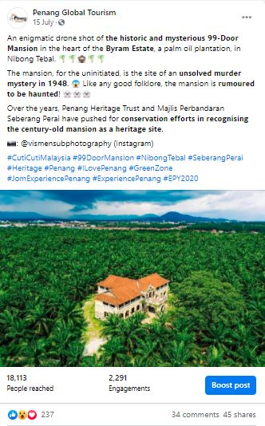 | 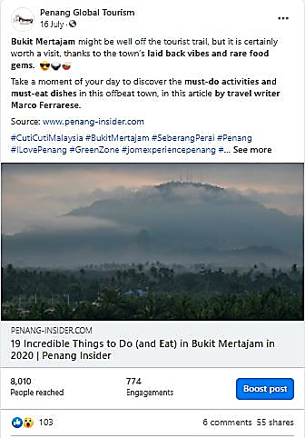

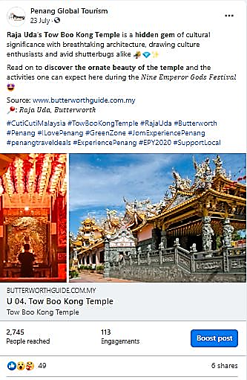 |  | 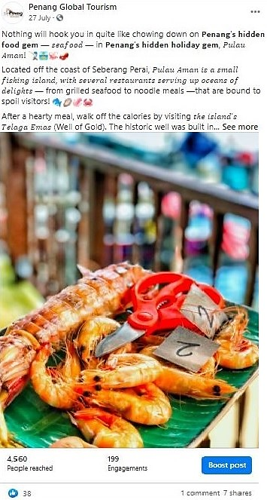
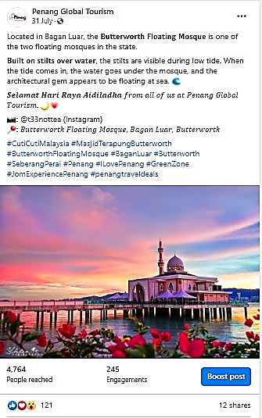

Total Post | Total Reach |  | Total Engagement
5 | 38, 192 |  | 3,622

Period: August 2020
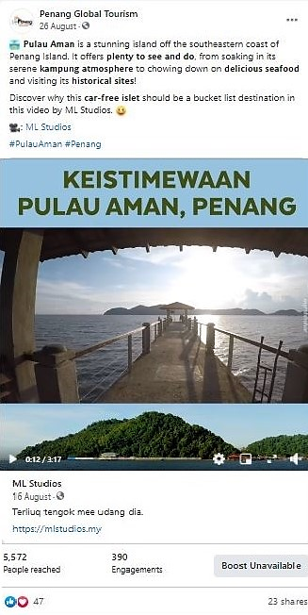 |  | 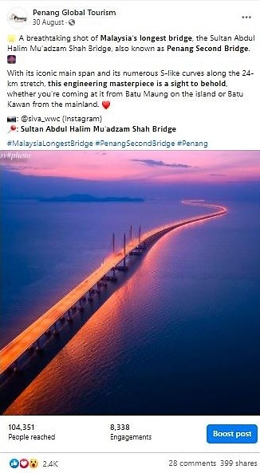
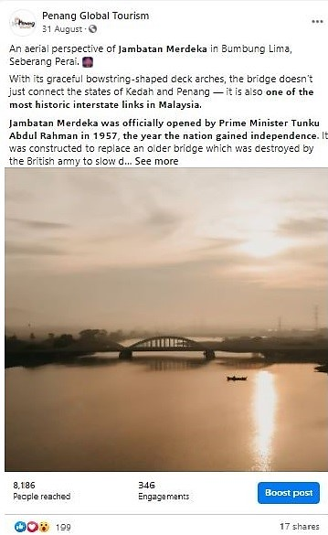

Total Post | Total Reach |  | Total Engagement
3 | 118,109 |  | 9,074

Period: September 2020
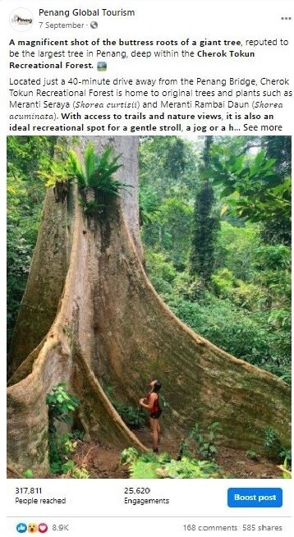 |  | 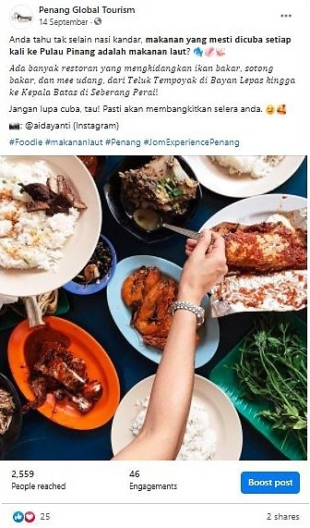
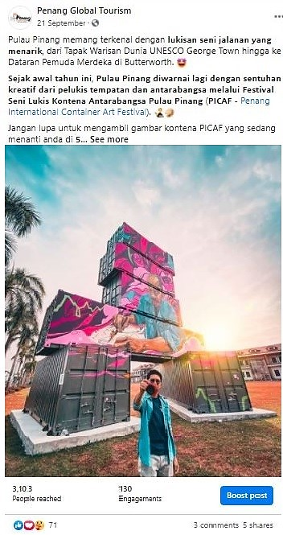 |  | 
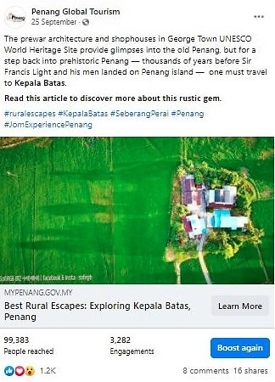 |  | 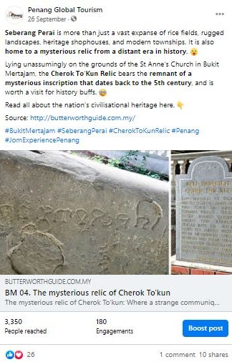
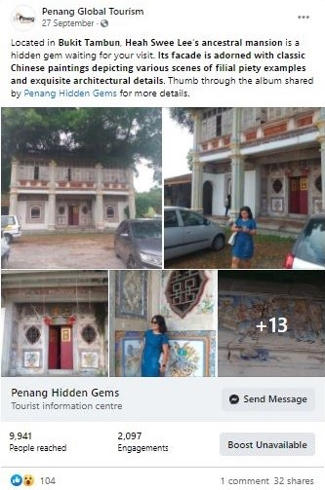

Total Post | Total Reach |  | Total Engagement
7 | 438,885 |  | 31,461

Period: October 2020
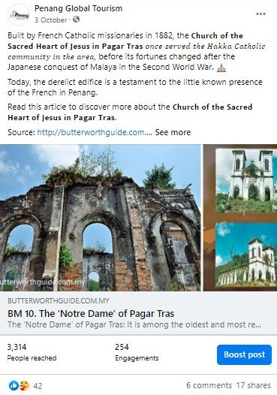 | 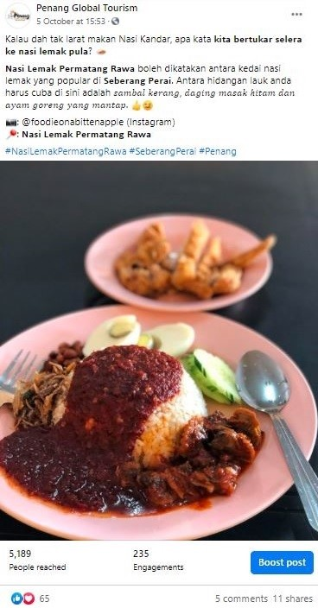
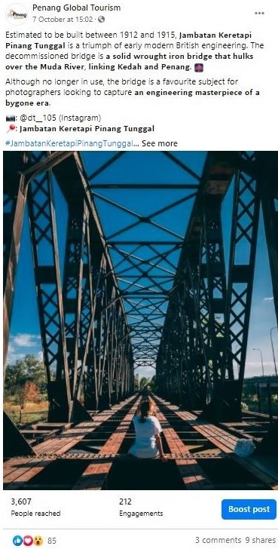 | 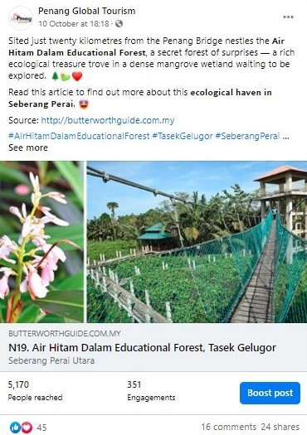

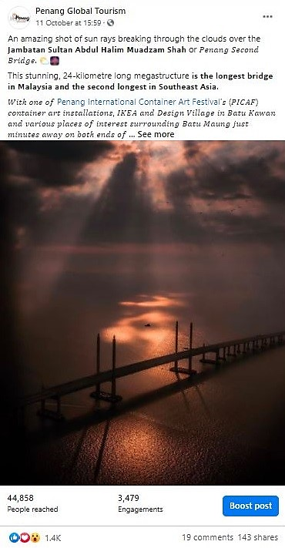 | 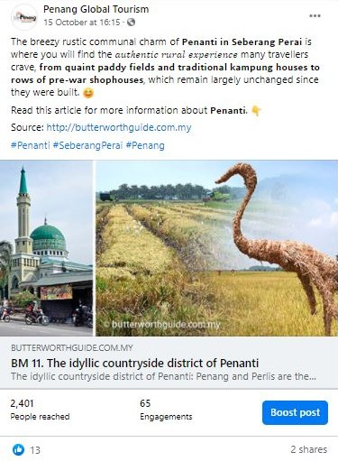
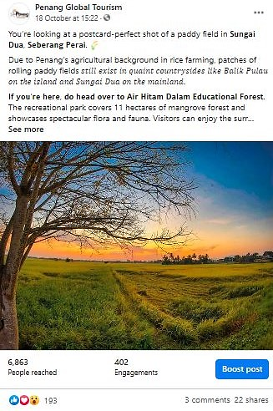 | 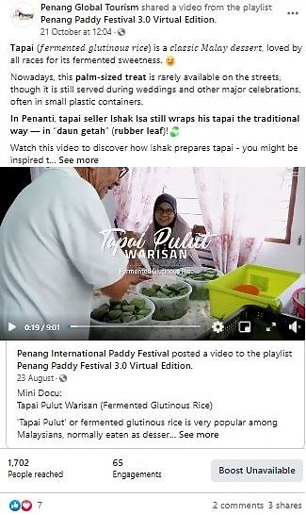
 | 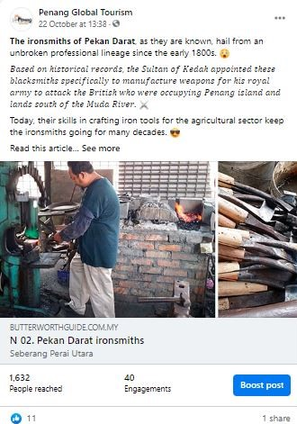

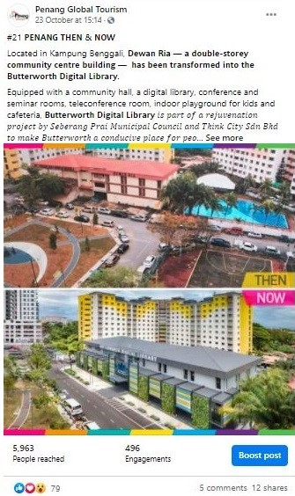 |  | 
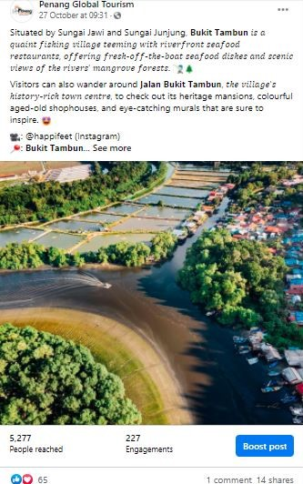
Total Post | Total Reach |  | Total Engagement
13 | 96,097 |  | 6,657

3.2.8 PGT’s Facebook Page Analytics
Based on the insights of PGT’s Facebook Page, there has been a pretty good increase in the number of Page Followers in comparison to the same period, a year before. The number of Page Followers recorded for current period of 1 July to 31 October 2020 was 63,024 and 69,027 whereas the number of Page Followers recorded on 1 July to 31 October 2019 was 55,600 and 58,337. Therefore, there’s a clear indication that the increase of Page Followers for current period is at a good pace.

Comparison of Page Followers:
YOY Comparison | Page Followers |  | Increased by
1 July – 31 October 2019 | 55,600 | 58,337 | 2,737
1 July – 31 October 2020 | 63,024 | 69,027 | 6,003

Page Followers: 1 July to 31 October 2019
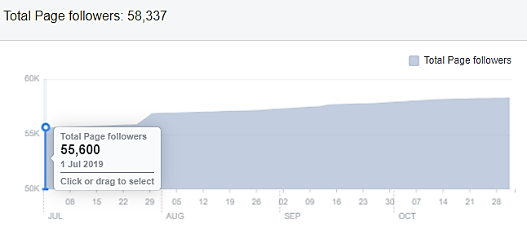

Page Followers: 1 July to 31 October 2020
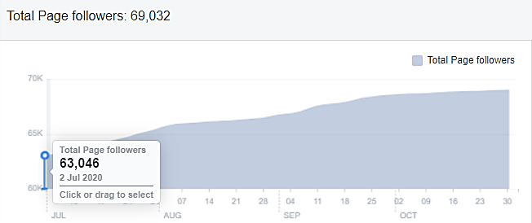

Each month from July to October 2020, the top posts on PGT’s FB Page, are as follows:
Month | Posts/Videos | Total Reach
July | #4 JOM! NIKMATI PULAU PINANG – 20 Lokasi Insta di Pulau Pinang | Organic: 316,285  Paid: 335,134
August | Instagram Photo – Malaysia’s Longest Bridge, the Sultan Abdul Halim Mu’adzam Shah Bridge | Organic: 104,351  Paid: -
September | 7 Keajaiban Dunia di Pulau Pinang! | Organic: 138,779  Paid: 301,677
October | Techfest | Organic: 2,071  Paid: 1,031,002

From July to October 2020, the top 10, by Country and City – People Reached, are as follows:
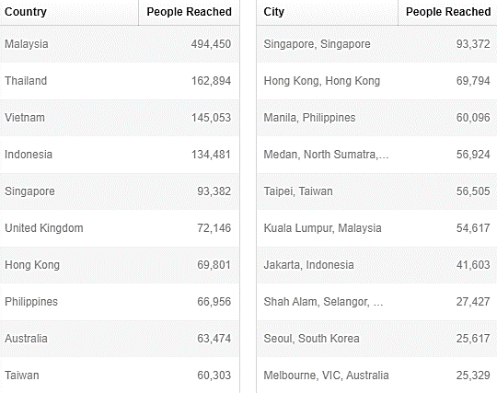

3.2.9 Website Google Analytics for mypenang.gov.my
The analytics report shows a year-on-year (YOY) comparison between two time periods –
1 July - 31 October 2020 and 1 July - 31 October 2019.

Website traffic
The Google Analytics Report shows a spike on 27 July 2020 with 706 users although in comparison to 21 July 2019, it had 1,338 users, which is higher than this year. There was also a spike on 23 August 2020 with 607 users and comparatively to the previous year on the same date, there were 739 users. Additionally, there was also a spike on 30 August 2020 with 617 users in comparison to 30 August 2019, it had 1,377 users to the site, which is higher than this year.
The significant decrease of users to the website for July to October 2020 could be due to the unforeseen circumstances of the Covid-19 pandemic. Based on previous reports, visitors head to the site mainly to know more on latest events and programmes. There were quite a number of visitors that were linked to our website, mypenang.gov.my via organic google search, PGT’s Facebook Page, Penang state government’s website, Penang Sentral’s official website, www.penangsentral.com.my and our latest Penang Travel Deals website at www.penangtraveldeals.com
According to the analytics report, majority of users to our mypenang.gov.my website was acquired organically via Google. There were also users who were linked to our website through Facebook posts, some organically and some through adverts.

The following is a list of the top 10 sites, mypenang.gov.my was accessed:
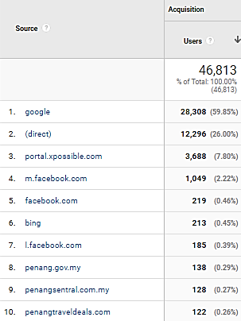

Comparison between 1 July – 31 October 2020 and 1 July – 31 October 2019
The comparison report shows a decrease of 53.85% in new users to the website. The number of sessions per user also recorded a slight decrease of 0.73%. However, there’s an increase on the bounce rate which is at 7.72%

Top 5 countries visiting the site and most viewed pages
The top 5 countries visiting the site are Malaysia, United States, Singapore, Australia and China. Their most-viewed pages are mainly on Events, Culture & Heritage, Penang Stories and About Penang.
The following pages show the relevant charts and tables summarizing the Google analytics report as highlighted above.

Period: 1 July - 31 October 2020
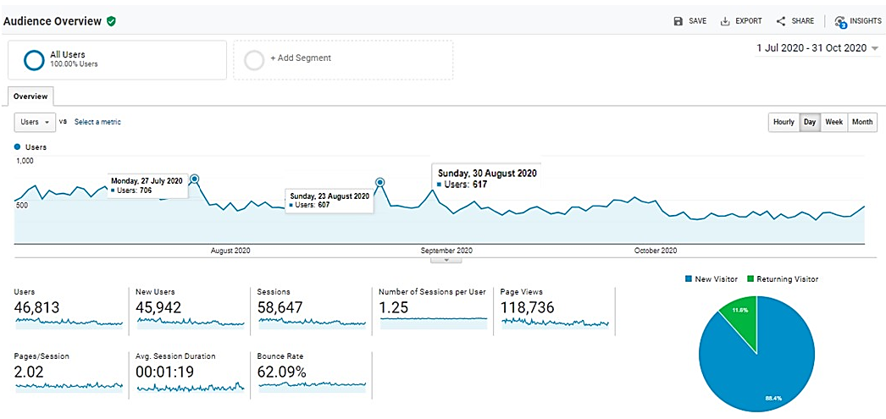

Period: 1 July – 31 October 2019
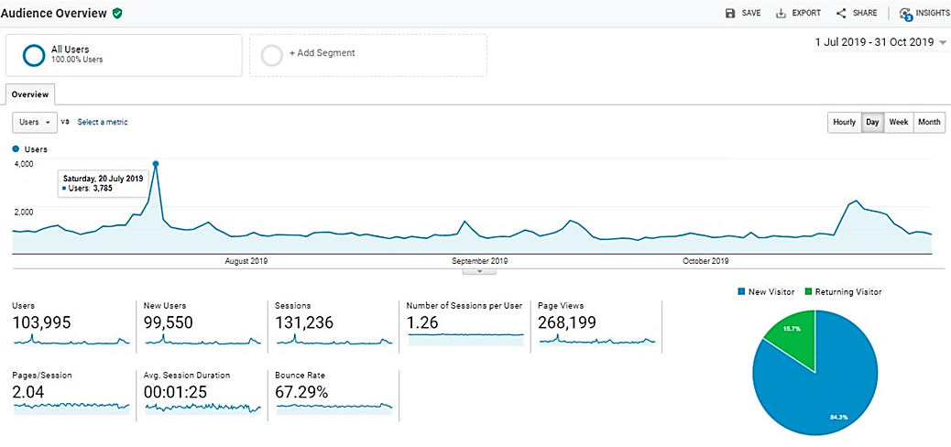

Comparison Chart of 1 July – 30 October 2020 and 1 July – 31 October 2019
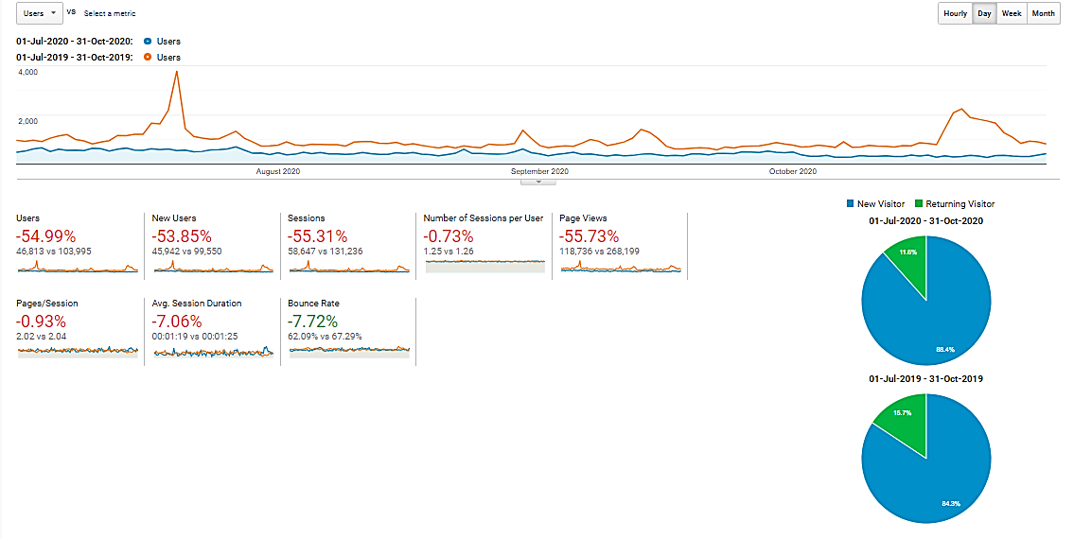

With reference to the above, visitors to the site, in comparison of the time periods:
Item | 1 July – 31 October 2020 | 1 July – 31 October 2019
Users | 46,813 | 103,995
Sessions | 58,647 | 131,236
Page Views | 118,736 | 268,119
Ave. Session Duration | 00:01:19 | 00:01:25
Bounce Rate | 62.09% | 67.29%

Current period’s Top 10 users by Country from 1 July – 31 October 2020:
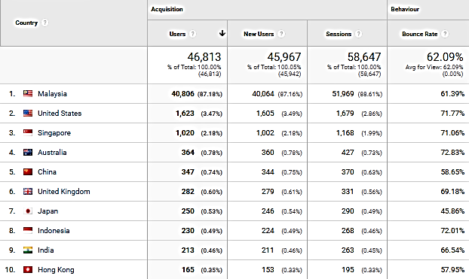

Comparison of the Top 10 users by Country:
(1 July – 31 October 2020 and 1 July – 31 October 2019)
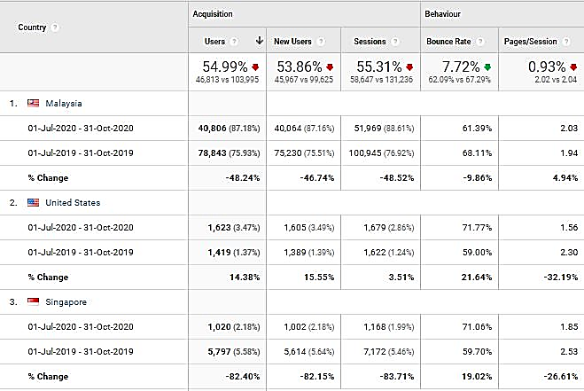
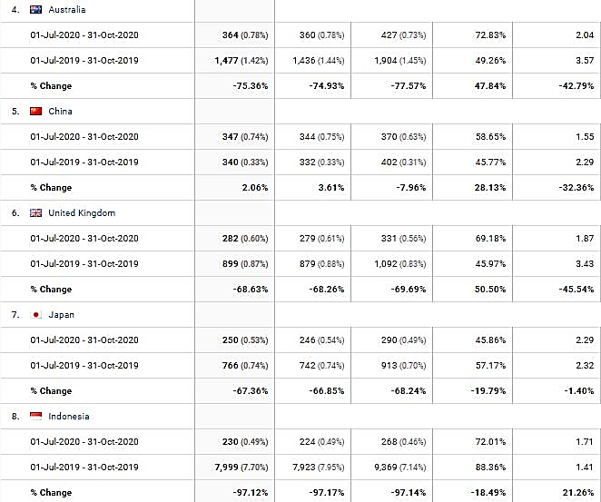
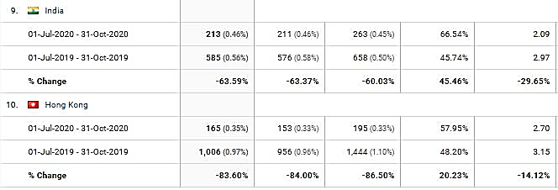

Most viewed pages by the Top 5 Countries visiting our website:
Country | Most viewed Pages
Malaysia | Events, Penang Stories, Culture and Heritage and Directory
Singapore | Penang Stories, Events
United States | Events, Culture and Heritage, About Penang, Nature and Adventure, Food and Lifestyle
Australia | Penang Stories,
Canada | Culture and Heritage

Top page views in the mypenang.gov.my website from 1 July – 31 October 2020:
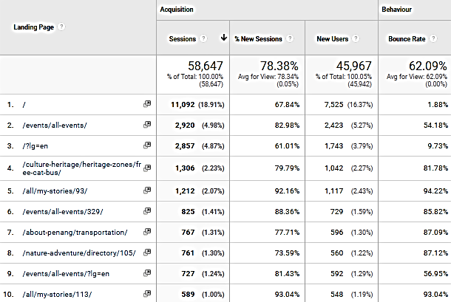

3.2.10 Website Google Analytics for Penang Travel Deals (penangtraveldeals.com)
The analytics report shows the time period of the website from the time it was launched on
15 June – 31 October 2020.

Website traffic
The Google Analytics Report shows a spike on 14 July 2020 with 2,530 users. There was also a spike on 17 July 2020 with 2,352 users.
The significant increase of users to the website in July 2020 could be brought by visitors searching for travel deals and it could be a driven crowd from Facebook posts (organically and through adverts). There were quite a number of visitors that were linked to our penangtraveldeals.com website via Facebook and there were also users that searched for the website directly. Besides that, the other source that directed users to the website are via organic google search, mstar (mstar.com.my) and news portal, Malay Mail (www.malaymail.com).

The following is a list of the top 10 sites, penangtraveldeals.com was accessed:
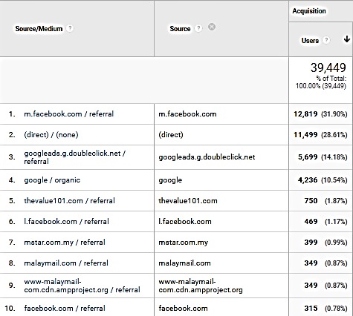

Top 5 countries visiting the site and most viewed pages
The top 5 countries visiting the site are Malaysia, United States, Singapore, Australia and China. Their most-viewed pages are mainly on Best Tour Packages, Best Hotel Deals and Thankyou Frontliner Deals.
The following pages show the relevant charts and tables summarizing the Google analytics report as highlighted above.

Period: 15 June – 31 October 2020
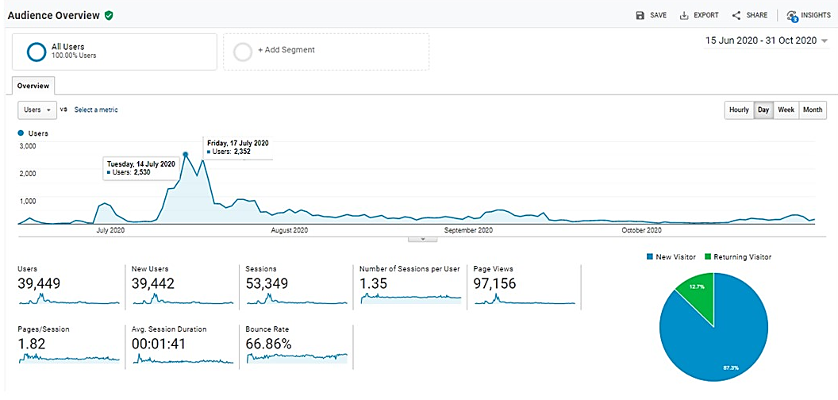

Current period’s Top 10 users by Country from 15 June – 31 October 2020:
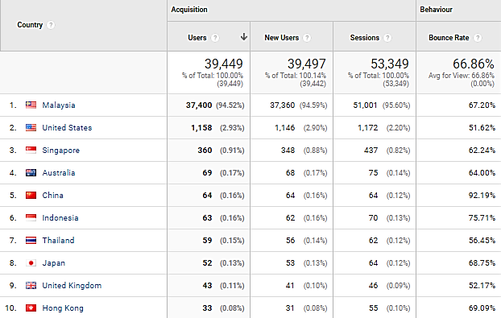

Most viewed pages by the Top 5 Countries visiting our website:
Country | Most viewed Pages
Malaysia | Best Tour Packages, Frontliner Attraction Deals, Best Hotel Deals, Best Attraction Deals, Frontliner Wedding Deals
Singapore | Best Tour Packages, Best Attraction Deals, Best Hotel Deals, Frontliner Attraction Deals, Best Food & Lifestyle Deals
United States | Best Hotel Deals, Frontliner Deals,
Thailand | Best Hotel Deals, Best Attraction Deals
Japan | Best Hotel Deals, Best Tour Packages

Top page views in penangtraveldeals.com website from 15 June – 31 October 2020:
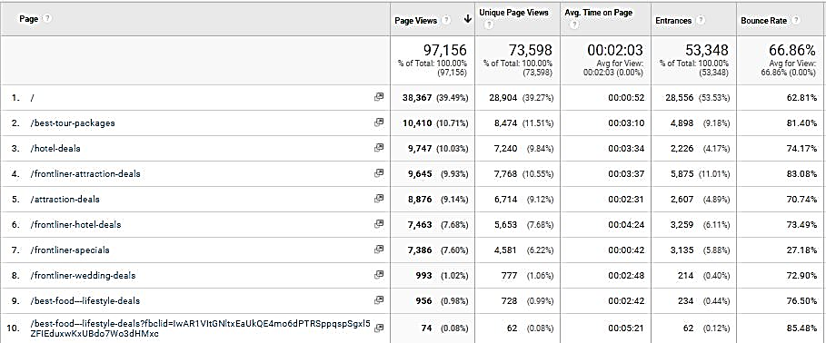

3.2.11 Penang Global Tourism Mobile App
Continuing from our last report, the following table shows the total number of downloads starting 1 July to 31 October 2020 on iOS and Android:
Domestic/In’tial | iOS |  | Android
Malaysia | 50 | 64.10% | 76 | 89.41%
Overseas | 28 | 35.90% | 9 | 10.59%
Total downloads | 78 | - | 85 | -

The total number of downloads (Malaysia and overseas) in the 4 months is 163.

The top 5 international countries for number of downloads on our mobile app are as follows:

iOS:
1. United States - 5
2. Hong Kong - 3
3. Singapore - 2
4. Germany - 2
5. China - 2
6. Japan - 2
7. France - 2

Android:
1. Indonesia - 4
2. Thailand - 1
3. Uzbekistan - 1
4. Philippines - 1
5. Korea - 1
6. Germany - 1

To be consistent with PGT’s website, updates are being done on PGT’s mobile app. For easier management, the backend CMS for e-coupon has been updated to enable further editing and amendments after item has been listed.

3.2.12 PGT’s E-Newsletter – Don’t Say Penang Bojio
PGT’s e-newsletter, Don’t Say Penang Bojio highlights major events and upcoming events happening in the state, announces latest news and/or new openings on Penang’s tourism products, latest updates on direct flights to Penang, as well as latest special deals on PGT’s coupon.

Don’t Say Penang Bojio Issue #2 – October 2020
Item | Figure
Recipients | 3,234
Successfully Sent | 3,234
Opened This Campaign | 360 (11.13%)
Clicked A Link | 110 (3.40%)
Unsubscribed | 20 (0.62%)

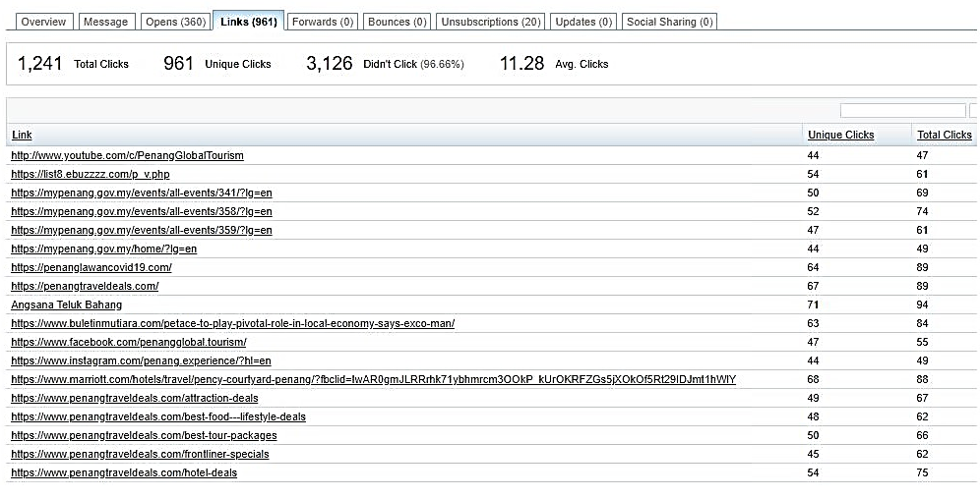

Summary:
- Percentage of recipients who opened the latest issue increased by 4.8%
- Percentage of link clicks increased by 2.5%. Most link clicks were to view Penang events, Penang Lawan Covid-19 and Penang Travel Deals.
- Percentage of recipients who unsubscribed in this issue is 0.44% higher compared to the previous issue.

The following is a screenshot of Don’t Say Penang Bojio #2 – October 2020:


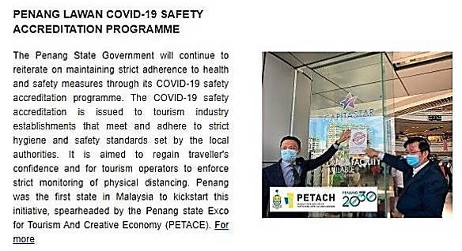
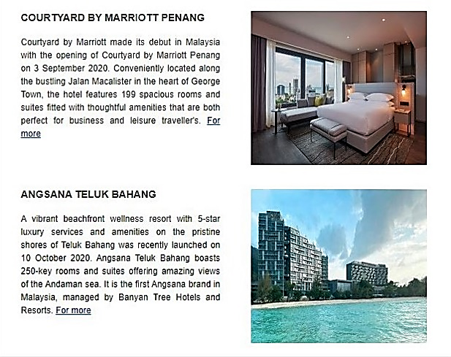


3.3 Recent Publicity (July - October 2020)

July 2020
Local
No | Name | Description | Type of Publication
1 | The Star | For just RM15 per person, anyone can now enjoy a full day’s tour of the best spots in Penang. | Online
2 | The Star | Penang covid-19 accreditation programme has seen 17 tourism players go the extra length to follow added standard operating procedures (SOP). | Online
3 | Tin Media | Penang tour package is expected to draw state revenue of RM1.54 million | Online
4 | Tin Media | Malaysian Chinese Inbound Association (MICA) is confident to attract 50,00 domestic tourists from July till the end of this year which targets to bring in RM 15 million of revenue. | Online
5 | Guang Ming Daily | 23 great value package discounts until the end of October starting RM 15 per person for major attractions in Penang. | Online
6 | Kwong Wah Yit Poh | Jom! Experience Penang RM 15 to take you on easy tour in Penang | Online
7 | Wartasaya.com | Penang launches Jom! Experience Campaign to woo local tourists | Online
8 | China Press Northern Region | Jom! Experience Penang Campaign launch calls domestic travellers to Penang. | Print
9 | Advertising + Marketing | Penang State Tourism unveils campaign hoping to capture domestic footfall | Online
10 | Weareunited.com | Jom! Experience Penang campaign launch to boost Penang’s tourism industry | Online
12 | Sin Chew Northern | YB Yeoh Soon Hin launches “Jom! Experience Penang” campaign | Print
13 | Oriental Daily News | Jom! Experience Penang features multiple discounts for domestic travellers travelling into Penang | Online
14 | RTM | News coverage on Jom! Experience Penang campaign launch | Television

July 2020
Foreign
No | Name | Description | Type of Publication
1 | TTG Asia | At The Habitat Penang Hill, an eco-tourism hotspot in Penang, visitor numbers have bounced back to “near normal”, with more than 90 per cent visitor ship comprising locals and expatriates living and working in Malaysia | Online

August 2020
Local
No | Name | Description | Type of Publication
1 | Where2lifestylemagazine | Penang promotes “Responsible Tourism” as it is among the longest recorded “Green Zones” in the country during the Covid-19 pandemic | Online
2 | New Straits Times | #JOM! GO: Seven World Wonders of Penang. The campaign is highlighting the seven World Wonders of Penang. | Online
3 | The Star | The Sia Boey Urban Archaeological Park is touted as the first of its kind in Malaysia. | Online
4 | Malay Mail | Rising occupancy rates at hotels here indicate the state’s tourism sector was gradually recovering from the Covid-19 pandemic | Online
5 | New Straits Times | Together with its Unesco World Heritage Site, seven world wonders, delicious local cuisine and a rich tapestry of culture, Penang State Exco for Tourism, Arts, Culture and Heritage wants visitors to know that the state is host to many other unique attractions. | Online
6 | The Edge Markets | The third edition of the Penang International Travel Exchange 2020 (PITE 2020) will be held virtually between Oct 14 and 16 due to the COVID-19 pandemic and international travel ban. | Online
7 | Malaysian Parenting | Jom! Experience Penang campaign launch | Online
8 | Lancareno.com | Pulau Pinang lokasi percutian antarabangsa | Online
9 | Isaactan.net | Blog post on Jom! Experience Penang campaign | Online
10 | Clefffairy.com | Blog post on Jom! Experience Penang campaign | Online

September 2020
Local
No | Name | Description | Type of Publication
1 | The Star | The Penang government has been tirelessly helping stakeholders to restore the state’s tourism industry to its former glory. | Online
2 | Buletin Mutiara | PENANG is expected to welcome more domestic tourists after the state has been declared free of Covid-19 by the Health Ministry. | Online
3 | Malay Mail | As the international borders remain barred, the Penang government aims to promote the state as the top domestic tourism destination in Malaysia. | Online
4 | Buletin Mutiara | PENANGITES as well as local and foreign tourists can look forward to knowing more about the footprints left by the French in the state through the French Heritage Trail initiative. | Online
5 | The Star | PENANG had a low-key celebration of annual World Tourism Day on 20th September 2020 as a string of programmes initially lined up has to cease due to the Covid-19 pandemic. | Online
September 2020
Foreign

No | Name | Description | Type of Publication
1 | Tour Hero | Living like in Crazy Rich Asians: 48 hours in Penang, Malaysia | Online
2 | Express – Home of the Daily and Sunday Express | The Singapore Grip drama series which was aired on ITV, a British commercial television network was filmed in George Town, Penang | Online

October 2020
Local
No | Name | Description | Type of Publication
1 | Buletin Mutiara | The Penang government has been actively carrying out promotional and marketing campaigns to develop domestic tourism in the state amid the Covid-19 pandemic. | Online
2 | Buletin Mutiara | The state government is embarking on initiatives to create new tourist attractions in Seberang Perai to ensure a balanced development between the island and the mainland. | Online
3 | Buletin Mutiara | Creative industries will help to boost Penang’s tourism image and transform existing cultural and heritage assets into revenue for the state in the long term | Online

October 2020
Foreign
No | Name | Description | Type of Publication
1 | CNN Travel | Penang’s Assam Laksa ranked world’s 7th best dish by CNN Travel | Online

The following are the number of local and foreign news coverage based on what we have managed to monitor - mainly online, via Google Alerts and physical publications/magazines received through free subscriptions:

Month (2020) | Local News Coverage | Foreign News Coverage
July | 14 | 1
August | 10 | -
September | 5 | 2
October | 3 | 1
Total | 32 | 4

