Itinerary for Air Asia Online Travelogue Shooting

29th January 2012
Lunch at New World Park
Chinese New Year Cultural & Heritage Celebration
Pulau Tikus hawker food
Batu Feringghi Night Market
30th January 2012
Met Cititel Public Relation and shoot at Cititel Lobby
Breakfast at Toh Soon Cafe
Antiques shops at Chulia Street and 2nd hand bookstore at Chowrasta Market
Lunch – Tek Sen Restaurant
Campbell House
Ferry Ride
Dinner – Street burgers
Weld Quay CNY Celebration
31st January 2012
Sunrise, Chew Jetty
Breakfast Roti Canai at Teluk Bahang
Kuala Sungai Pinang, Pantai Keracut, Meromictic Lake, Turtle Conservation Centre
Batu Ferringhi Beach
Dinner at Macalister Road
1st February 2012
Chew Jetty Homestay
Lunch at CF Coffee Shop
Khoo Kongsi
Ghee Hiang & Dragon Ball Shop
Penang Visitor Centre

Summary of Air Asia Online Travelogue Shooting Trip

Air Asia from Kuala Lumpur came to Penang on 29th January to 1st February 2012 to shoot the very first online travelogue in Penang. Air Asia is the most popular and influential airline in the world on social networking sites and the website attracts 20 million unique visitors per month. This is a good platform to showcase and promote Penang as a travel destination. The online travelogue will be in mandarin to target Chinese speaking market. The team will be shooting another online travelogue in English by this year.

Below are the expenses throughout the shooting

Descriptions | Sponsored by PGT (RM) | Sponsored by others (RM)
Air Tickets KUL-PEN-KUL for 5 pax – Paid by Air Asia |  | 755.00
Hotel Accommodation for 3 rooms/3nights – Sponsored by Cititel Hotel (RM 195 per room per night) |  | 1,755.00
Transportation – 10 seaters van for 4 days | 2,000.00
Meals for the Air Asia Team | 394.50
1 day Nature tour – Boat ride along mangroves system, Pantau Keracut, Meromictic Lake and Turtle Conservation Centre | 450.00
Rental for shooting at Chew Jetty Homestay | 50.00
Khoo Kongsi’s entrance fee for 7 pax – Waived by Khoo Kongsi |  | 70.00
Total | 2,894.50 | 2,580.00

Pictures during the shooting
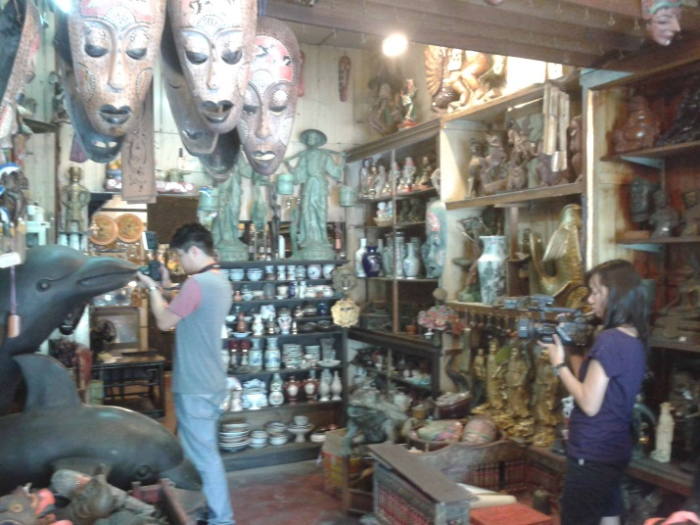
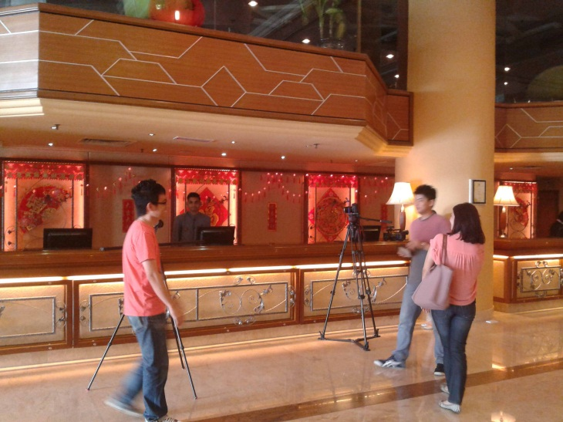

Cititel Hotel Antique Shop at Chulia Street

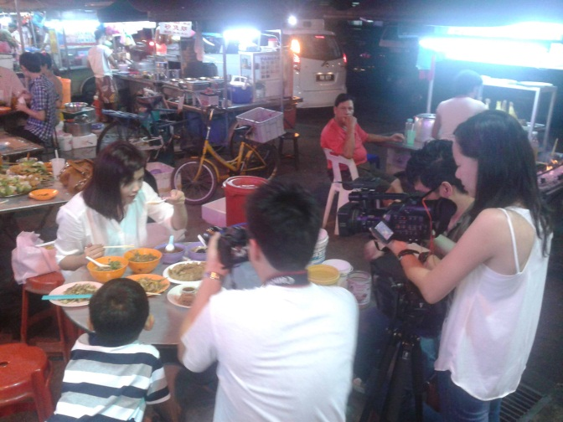
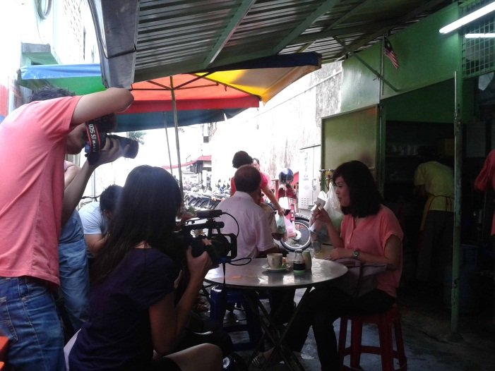

Hawker Food at Pulau Tikus Toh Soon Cafe

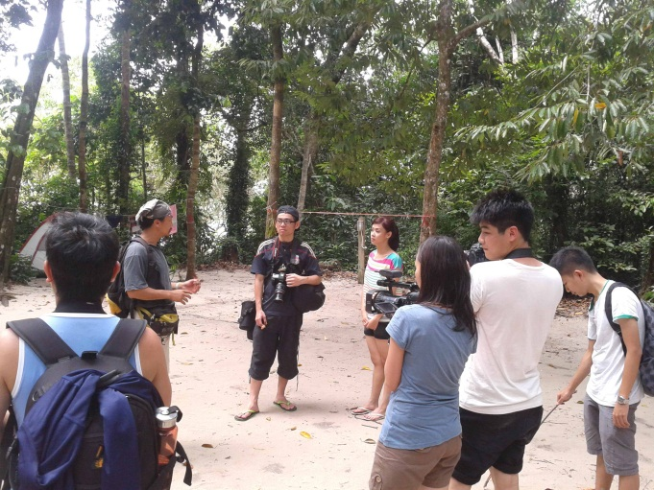
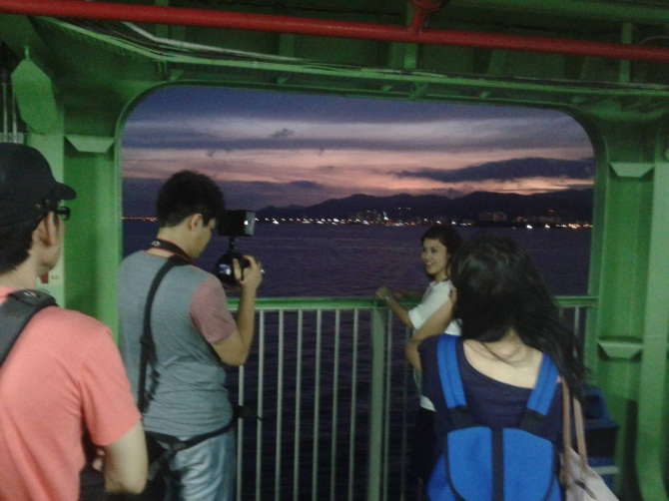

Ferry Ride Pantai Keracut

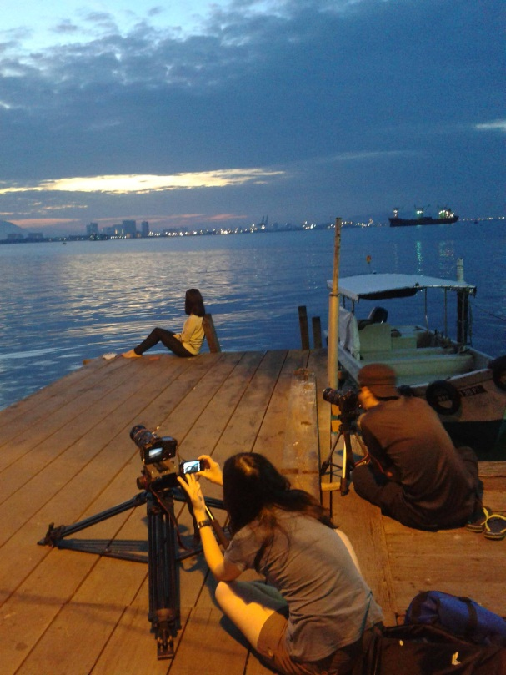
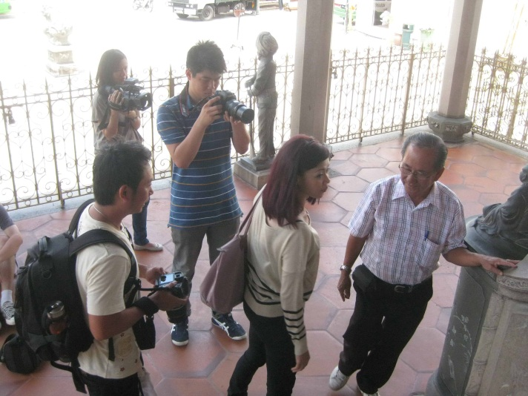
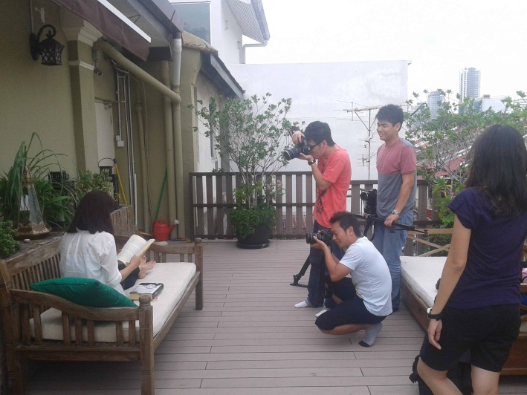
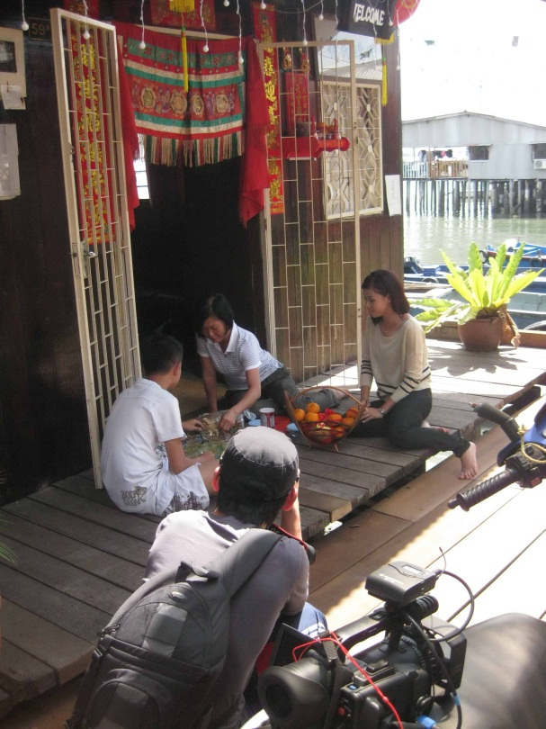

Chew Jetty Homestay Sunrise at Chew Jetty

Campbell House Khoo Kongsi

