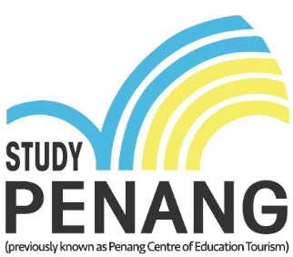

REPORT ON THE ACTIVITIES OF STUDYPENANG
APR - Sep 2019

1.0 Membership Update
StudyPENANG Membership as at 31st September 2019 is 17 (15 colleges and 2 associate).

Ordinary Members:
- CAC Academy
- Disted College
- Equator College
- Golden Chef Culinary Academy
- Han Chiang University College of Communication
- Inti International College Penang
- IPK College
- KDU Penang University College
- Olympia College
- Penang Medical College
- SEGI College Penang
- SENTRAL College Penang
- Stradford International College
- Tunku Abdul Rahman University College
- Peninsula College

Associate Members
- PhoenixAsia Academy of Technology
- Clinical Hypnotherapy Practitioners

2.0 Activities Apr – Sep 2019
2.1 Indonesia International Education EXPO by Q Study

StudyPENANG members attended the Indonesia International Education Expo organised by QStudy with the collaboration of Education Malaysia Global Services (EMGS). This project was approved with subsidy of RM500 per city for each college that participation in this fair.

Cities that covered by StudyPENANG members during this event are:

22 April – Surabaya (KDU Penang)
26 & 27 April – Jakarta (IPK, KDU)
28 April – Bandung (KDU)
12 May – Medan (IPK, KDU)
Feedback from the members:
The fair organised by Q Study has better quality lead compare to the other fairs, those that visited the fair came along with their parents. The potential is quite high for certain city like Medan and Jakarta. In overall, StudyPENANG can consider to join next year.

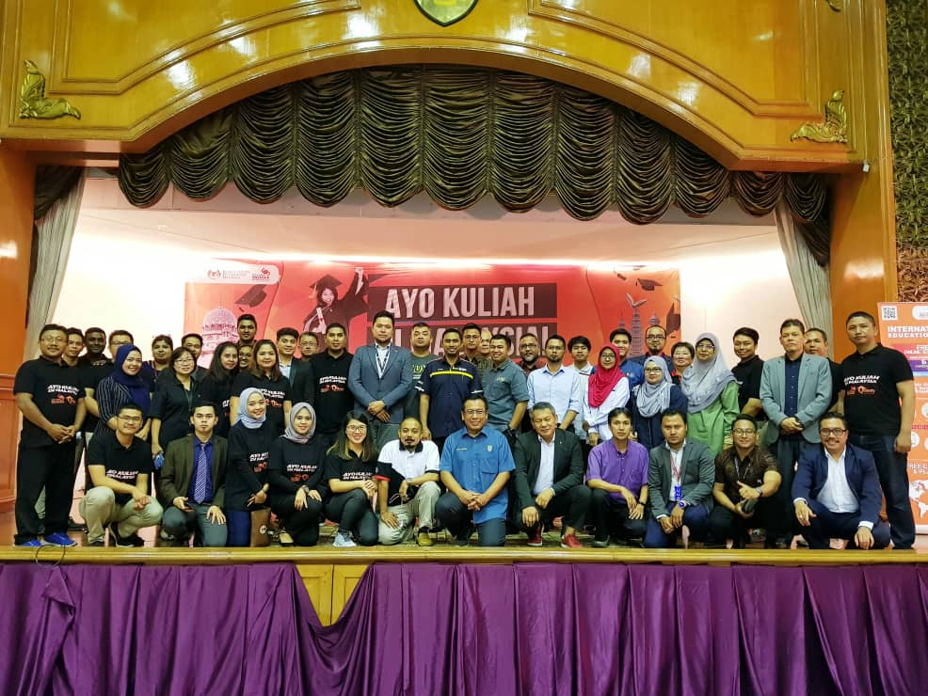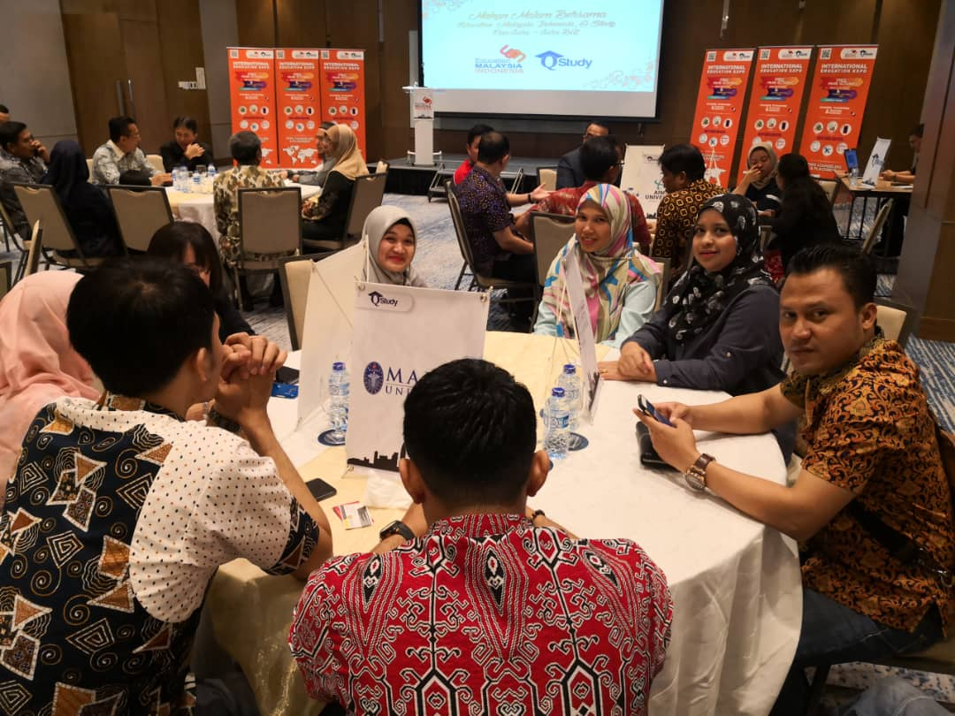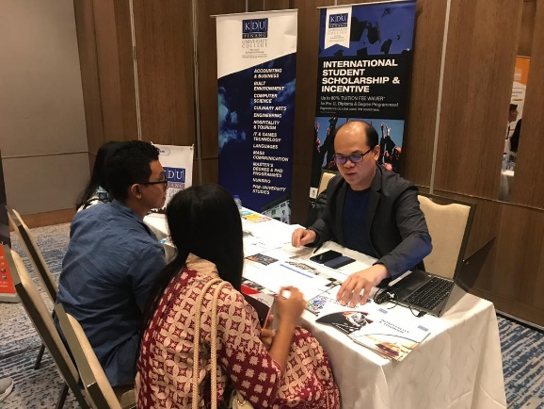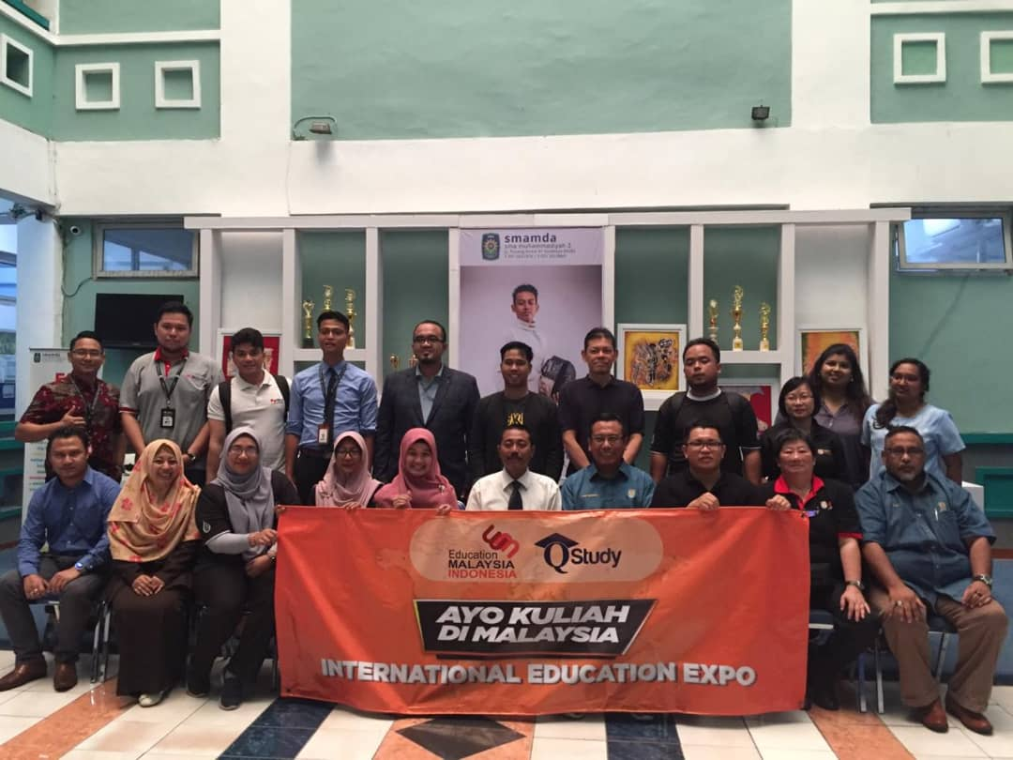

2.2 2019 ASEAN – China (Guiyang) Belt and Road Culture and Tourism Exchange Week
Penang Global Tourism was invited together with PETACH office to participate in the 2019 ASEAN – China (Guiyang) Belt and Road Culture and Tourism Exchange Week. Lead by YB Yeoh Soon Hin, Exco of Tourism, Art, Culture and Heritage, StudyPENANG also attended the event to support the good cause as well as promote Education Tourism in Penang.

ASEAN – China Centre (ACC) is an inter-governmental organization co-established by 10 ASEAN Member States and China. ACC was officially launched at the Commemorative Summit marking the 20th anniversary of ASEAN-China dialogue relations on 18 November 2011. ACC is committed to promote friendly echanges and practical cooperation between ASEAN and China in various fields including trade, investment, education, culture, tourism, information and media.

2019 ASEAN – China (Guiyang) Belt and Road Culture and Tourism Exchange Week will enhance information interconnection and exchange between both sides and innovate media cooperation forms, enabling Guizhou Province and ASEAN countries to establish a stable exchange mechanism and expand cooperation field. It will build high-end culture, tourism, exonomy & trade cooperation platforms in the form of conference and exhibition. The event details are as below:
Event Date:
27 Aug – 31 Aug 2019

Venue:
2/F of Guiyang International Eco-Conference Centre

Organiser:
ASEAN-Guizhou (Guiyang) Tourism Culture Promotion Centre, Guiyang Municipal People’s Government, Guizhou Provincial and Tourism Department, Foreign Affairs Office of Guizhou Province.

Participating StudyPENANG members are:

1. IPK College
2. SEGi College Penang
3. GCCA
4. Sentral College

Feedback from the members:
This event is more to creating awareness about the state of Penang, as Guiyang is far away in terms of distance and it does not have a direct flight to Penang, therefore, it is hard to have any achievement through this fair.

The crowd is slow during the event, where there were not much of public crowd or agents / buyers attending, it could be cause by the poor publicity as well as last minute confirmation from the organiser.

As a conclusion, StudyPENANG members will support the initiative by the State Government in promoting Penang.
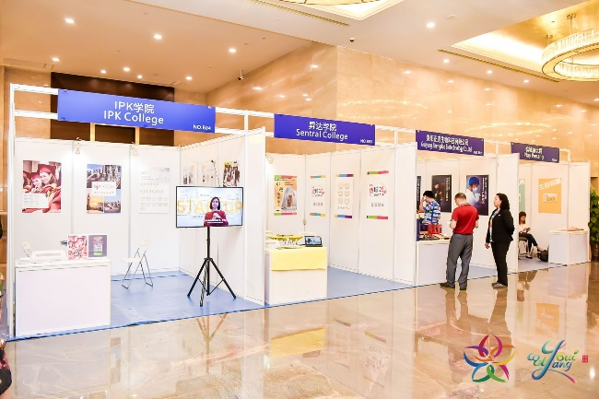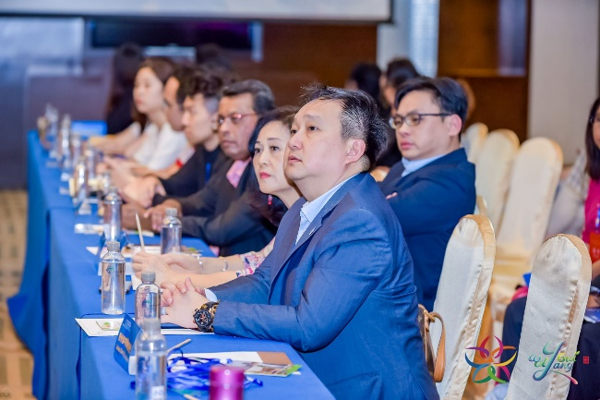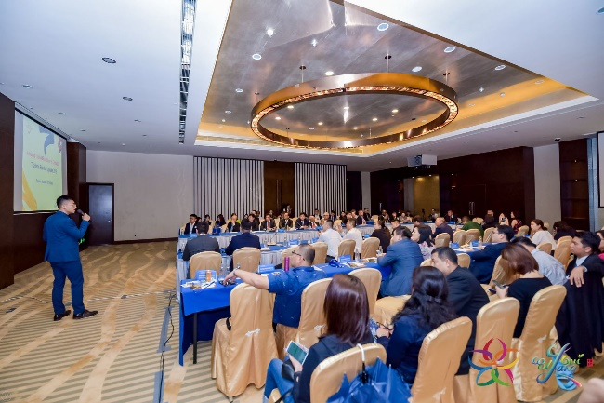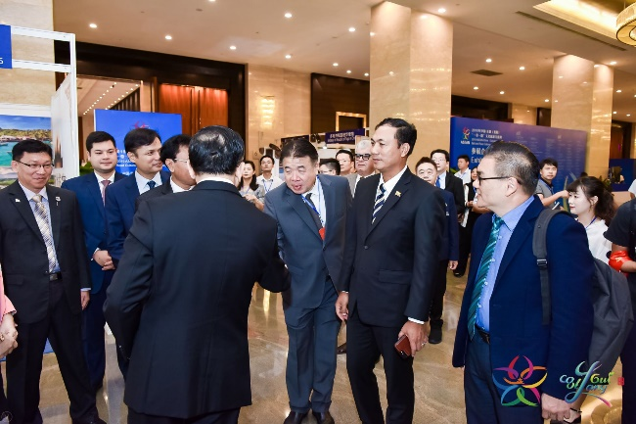
2.3 World Education Expos Indonesia 2019 (WEEI)

World Education Expo Indonesia 2019 (WEEI 2019) is an annual Education Exhibition that aimed to be the gateway for Indonesian students to further their higher education. WEEI is in its 8th annual event and is one of the education exhibitions with the participation of universal education institutions from over 20 countries. WEEI 2018 guarantees an audience of more than 10,000 students from over 150 national high schools and universities across four cities. The event details as below:

Medan, Adimulia Hotel
Date: 26th September 2019
Time: 1pm – 6pm
Venue: Medan, Adimulia Hotel
Target number of students: 1,500

Jakarta
Date: 27th – 28th September 2019
Time: 10am – 5pm
Venue: Jakarta Convention Center Merak Room
Target number of Students: 5,000 – 7,000

4 colleges have confirmed their participants on both destinations as below:
1. DISTED
2. IPK
3. INTI
4. SENTRAL

Feedback from the members:
WEEI fair is similar with Star Education Fair in Penang, there are crowds visited the event however follow up are required. Being distance away from Jakarta, it is rather difficult for the salesperson to do so. Follow up has been taken in place to all the possible leads that collected during the fair. So far there is no result yet as the Grace 12 students met during the fair will only complete their studies next year.

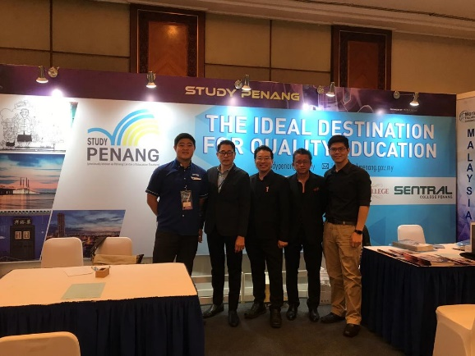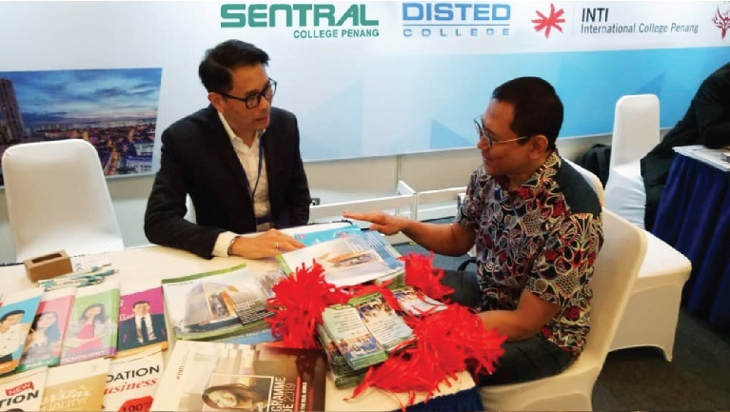
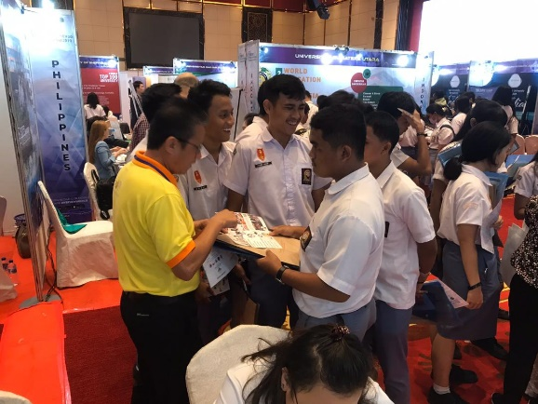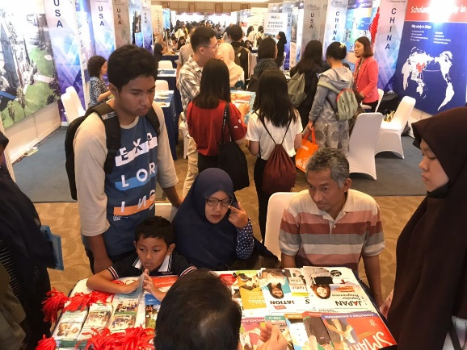

2.4 Monthly Meeting
Monthly meetings were held in April – September 2019

3.0 Other Matters
3.1 Budget StudyPENANG 2020

StudyPENANG budget will be remained at RM150,000 for 2020.

 | Items | Budget
a | Website Maintenance & Hosting / Write up | 3,000
b | Roadshow (Vietnam - HCMC/Hanoi, Myanmar -Mandalay,Thailand (Southern Thailand & Bangkok), Indonesia-Medan/Jakarta/Surabaya) | 90,000
c | Printing of promotional materials, souvenirs | 10,000
d | Advertisement | 20,000
e | ED's Honorarium and travelling expenses | 20,000
f | Misc. | 7,000
 | Total | 150,000

Prepared by: Darren Ng
Assistant Manager
Penang Global Tourism
(On behalf of StudyPENANG)

