Justice League Run Penang
Date: 30 August 2015
Time: 6.00am - 12.00pm
Venue: Esplanade, Penang
Route: 3km & 8km
Fee: RM100
Supported by: Penang State Government
Organiser: Penang Global Tourism
Programming partner: ActifeStyle
Sponsors & Partners: Tourism Malaysia, FlyFm, oneFM, BSN, Gurney Paragon Mall, Penang Hop On Hop Off, Penang Amazing World Studios
Licensing agent & Licensee: Pacific Licensing Studio, DC Comics Super Heroes & I2 Promotions

Supported by Penang State Government and organised by Penang Global Tourism with ActifeStyle as programming partner, Justice League Run was held in Penang on 30 August 2015. The run is the first in Malaysia and was not held at the capital city of the country as compare to the other countries such as Philippines, Taiwan, and Singapore. This is also an event for everyone during August holiday season as well as part of branding exercise for Visit Penang Year 2015.

Taking example of annual fun run in Penang such as Delta Eco Night Run and Rock to Rock Run by Hard Rock which recorded 1700 runners and 2500 runners this year, Justice League Run Penang are the largest number of registration fun run in Penang for 2015. Justice League Run Penang faced a intense competition in August 2015 as the spending power of Malaysian fun runners are not high, they tend to join only one event that happen on the same period of time. There are a total of 7 fun runs is happening in Malaysia:

No. | Fun Run | Date | Distance | Fee (RM)
1. | Larian Sehati Sejiwa - Kuala Lumpur | 23 Aug 2015 | 10km, 5km, & 3km | 20 - 45
2. | Save the Bornean Elephant Charity Run 2015 - Kota Kinabalu | 23 Aug 2015 | 11km | 60 - 100
3. | Helping Steps Charity Run 2015 - Shah Alam | 29 Aug 2015 | 5km | 25
4. | DELTA Eco Night Run 2015  - Youth Park, Penang | 30 Aug 2015 | 8km & 3.5km | 45
5. | Electric Run 2015 - Selangor Turf Club | 30 Aug 2015 | 5 km | 88
6. | Justice League Run Singapore | 30 Aug 2015 | 5km | $50 - 70
7. | Johor Run @ Johor Bahru 2015 | 31 Aug 2015 | 4km | 20

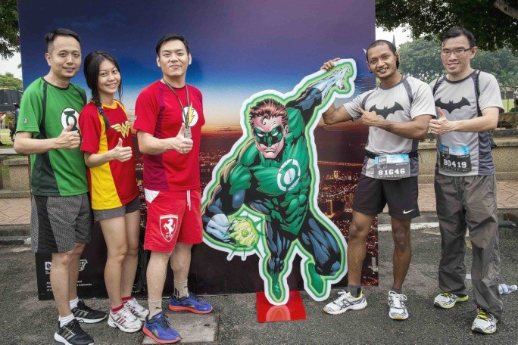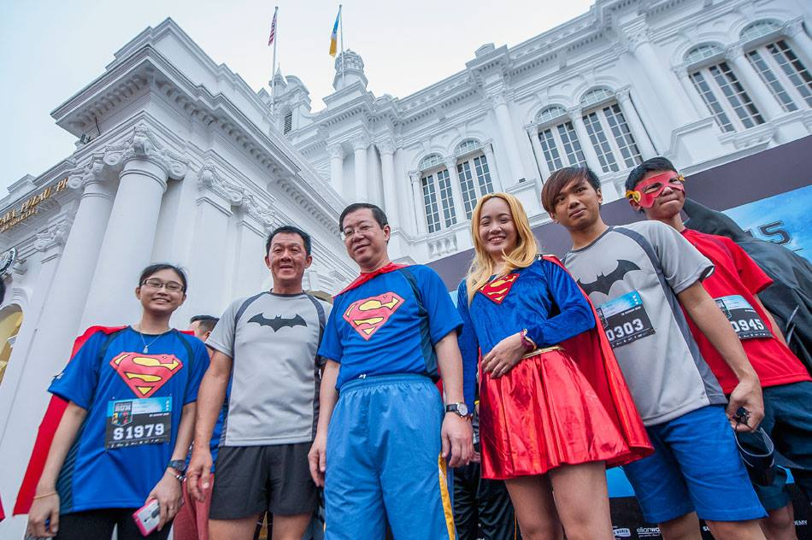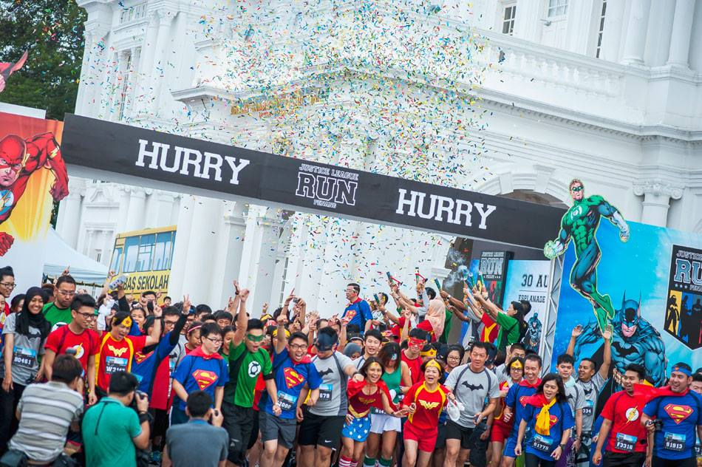

Number of runners & visitors
Justice League Run Penang successfully recorded a number of 3220 registrants on 30 August 2015, and as well 229,000 visitors at Gurney Paragon Mall (GPM) during Justice League Weekend in Penang from 27 - 31 Aug 2015.

Income: Sponsorship & Sales
As a support to the event, Penang Global Tourism received sponsorship of RM50, 000 from BSN, RM8, 000 from Tourism Malaysia and RM2, 000 from Gurney Paragon Mall.

The breakdown for the collected registrant fees is as below:

Detail | Amount
Per Person Per ticket | RM100.00
3220 participants (3220 x RM100) | RM322,000
Howei charges (6%) | (RM19,320)
Refund for 3 participants | (RM294.40)
Nett income | 302,385.60

Justice League Weekend in Penang
Justice League Weekend in Pennag was organised to utilize the copyright fee of RM350, 000 and to build up the excitement before and after the run. The weekend is for non-runner, targeting the public by working together with other parties such as Gurney Paragon Mall, Penang Hop on Hop off (HOHO) & Penang Amazing World Studio to fill up Penang as Justice League Weekend in Penang. The target audiences for Justice League Weekend are:
- Family and friends
- Teenagers
- DC Comics Fans
- Children
- Non-runners

Below are the programmes happening during the long weekend:
Super Heroes Treat at Gurney Paragon Mall
A. Race Entry Pack Collection Point
B. Exclusive retail promotions at Gurney Paragon Mall by wearing Superhero Tshirt
C. Special Car Parking Rates for Super Heroes (Park & Ride to the Penang Esplanade)
D. The One Academy Paper Model Exhibition
E. Penang Amazing World Studios Trick Art Display
F. DC Comics Super Heroes Cosplay Showcase
G. DC Comics Wayang Kulit Exhibition
H. DC Comics Collectibles Exhibition
I. Card acquisition and spending campaign by BSN
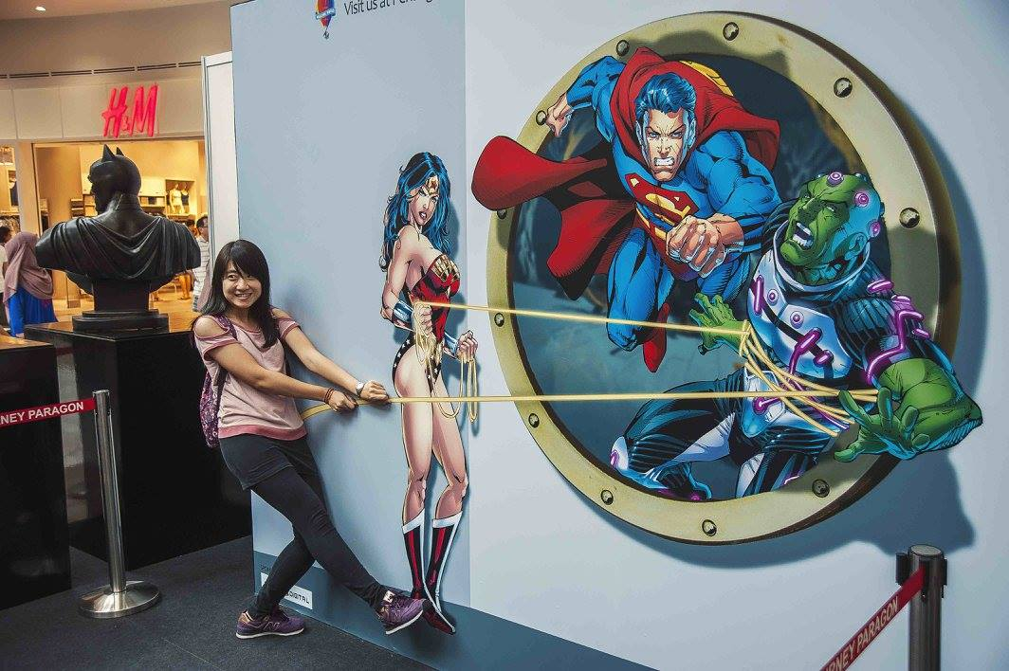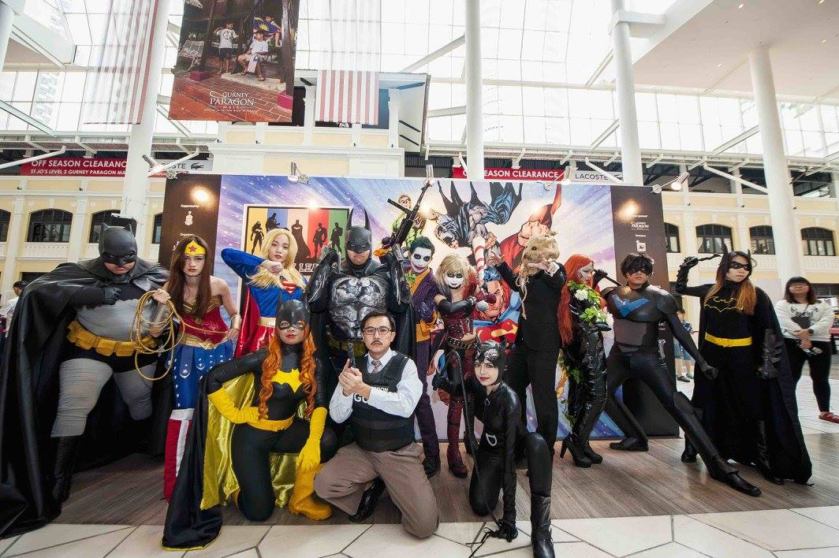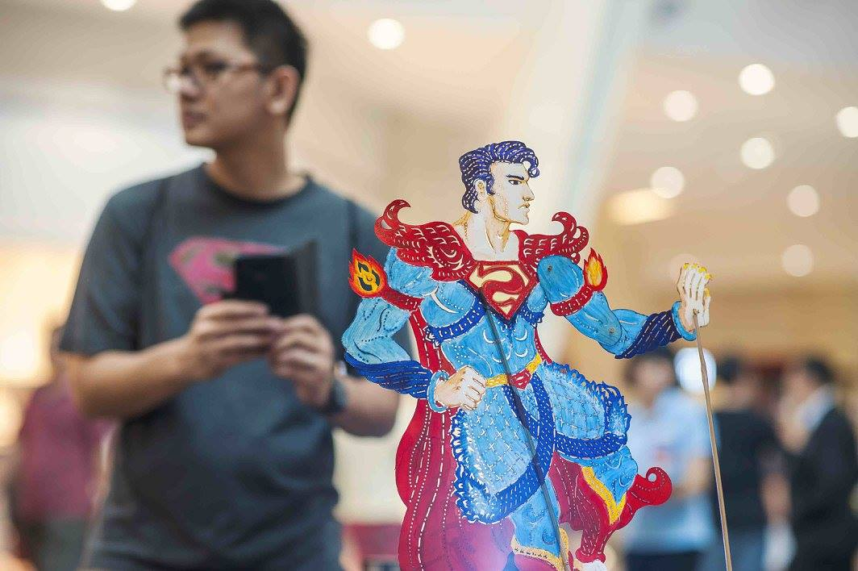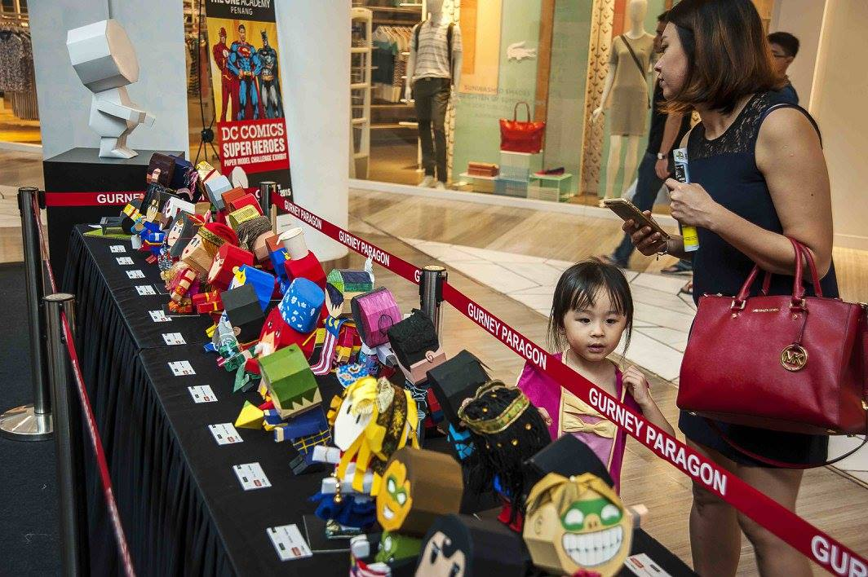

229,000 visitors were recorded at Gurney Paragon Mall (GPM) during Justice League Weekend in Penang from 27 - 31 Aug 2015. Comparison of the number of visitors for 2014 & 2015 at GPM are as below:

2014 |  | 2015
Wed, 27 Aug 2014 | 23,000 | Thurs, 27 Aug 2015 | 27,000
Thurs, 28 Aug 2014 | 23,000 | Fri, 28 Aug 2015 | 33,000
Fri, 29 Aug 2014 | 29,000 | Sat, 29 Aug 2015 | 50,000
Sat, 30 Aug 2014 | 42,000 | Sun, 30 Aug 2015 | 60,000
Sun, 31 Aug 2014 | 62,000 | Mon, 31 Aug 2015 | 59,000

Super Heroes ride around Penang
A. Special discounts on HOHO 24-hour ticket
B. Free Shuttle for Super Heroes

To encourage more runners to Park & Ride during the event days, free shuttle buses were provided for the public from Gurney Paragon Mall to Convent Light Street. In additional to the HOHO bus we engaged 2 Rapid Penang to increase the frequency as below:

GPM - Convent Light Street | Convent Light Street - GPM
5.30am  6.00am  6.15am  6.30am  7.00am  7.15am  7.30am | 10.30am  10.45am  11.15am  11.30am  11.45am  12.15pm  12.30am  12.45pm

For the shuttle service, we managed to record a number of 180 people took the bus service to Esplanade, and there is only 26 car by the runners parked at Gurney Paragon Mall.
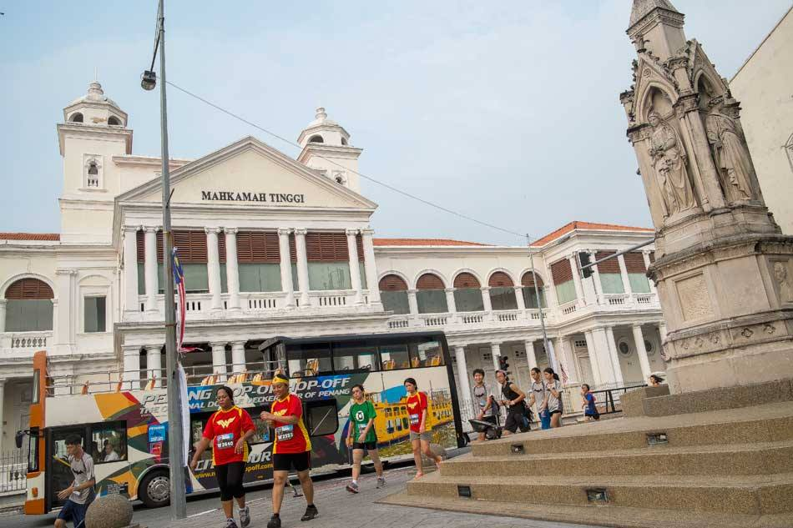

Effectiveness of radio advertising by FlyFm, oneFM
We engaged FlyFM & oneFM as the Official Radio Stations for Justice League Run Penang. Analysis for the radios is as below:

 | FlyFm | oneFM
Ranking | No 2 English Radio Station in Malaysia :  440000 listener per week | No 2 Chinese Radio Station in Malaysia :  900,000 listener per week
Social media platform | 80% | 60%
Facebook | 258,262++ Page likes | 614,300 page likes
Twitter | 179,391++ Followers | 8,427++ Followers
Instagram | 18,684++ Followers | 23,055++ Followers
Youtube | 32,989++ Subscribers | 10,738++ Followers
Line | 267,913++ Followers | 345,000++ Followers
Weibo |  | 49,562++ Followers
Online Streaming
Unique users average in a month | 711,288 | 517,359
Listening hours average in a month | 2,899,864 | 1,841,187

Below are the number of post created by flyFM & oneFM on their social medias to promote Justice League Run Penang and Justice League Weekend in Penang:

 | FlyFM | oneFM
Webpage highlighting Justice League Run Penang | 1446 view | 1001 view
Instagram | 17 post by flyfm958 & cowbear  Total likes: 4410 | 13 post by onefmyin, onefmnicholas & onefm881  Total likes: 11762
Facebook | 1 post  18283 reached | 3 post  Total likes: 3260 likes  Total shares: 163

Example of posting by FlyFM & oneFM:
