- Log in : https://www.cimb.bizchannel.com.my (Must type in full )
- Key in Company ID : 004997, User ID : SUZANA, User Password : ??? click log in button
- Press A & B to switch ON the token, then key in PIN number
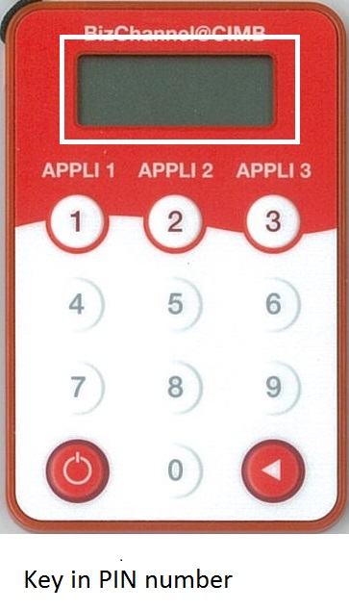
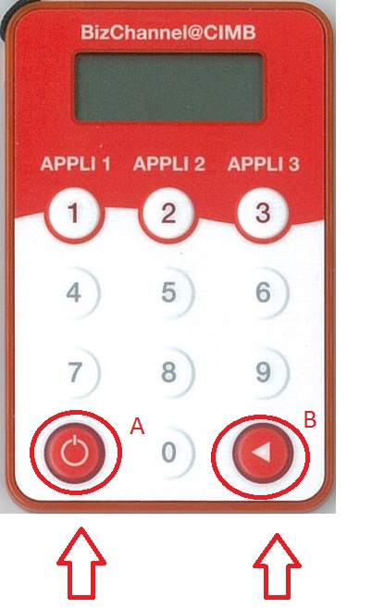

- Press APPLI1 for OTP number
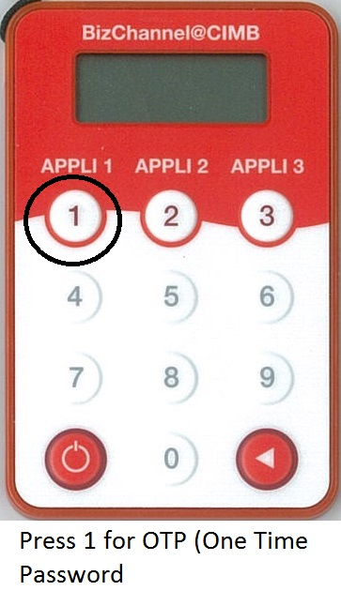

- After logged in to CIMB Bizchannel interface, go to Pending Task
To approve the task, press APPLI2, then key in the challenge number shown in bizchannel into token, then key in the response number shown in token.
