4.3.2 MATTA Travel Exchange (MTEX) in-conjunction with the FATA Convention 2019
Organiser : MATTA
Date : 27th – 28th April 2019
Venue : The Everly, Putrajaya
Partner : MATTA, Tourism Malaysia, Penang Global Tourism

Event details:

- The Malaysian Association of Tour and Travel Agents (MATTA) have invited Federation of ASEAN Travel Associations (FATA) delegation to Malaysia in conjunction with the FATA Convention 2019, The event as expecting 225 buyers from Thailand, Myanmar, Philippines, Cambodia, Singapore, Indonesia, Brunei and India. Penang Global Tourism has been invited to promote the tourism segment display and promotion of products/destination.
- In conjunction with the event, MATTA organised a B2B session for both local buyer with Federation of ASEAN Travel Associations (FATA) delegate. This two-day trade event where brings together Malaysian sellers of travel and tourism products and services to interact with ASEAN counterparts to establish business networking and partnerships.
- The MTEX 2019 is featuring 82 Malaysian travel industry players consisting of 49 travel agents, 17 hotels, 11 product owners and 5 State Tourism Organisations showcasing the wide range of attractive variety of tourism products and services to over 150 buyers from ASEAN countries.
- Purpose of participating this event is to encourage MATTA members to sell Penang packages to the 200 ASEAN Buyers and their existing customers
- To develop special packages with MATTA on Experience Penang Year 2020
- To showcase Penang’s products to the ASEAN Buyers
- To network and explore marketing opportunity with the travel agent’s association in ASEAN countries including India
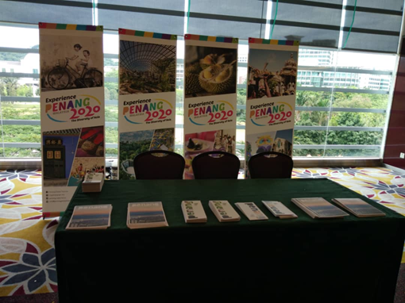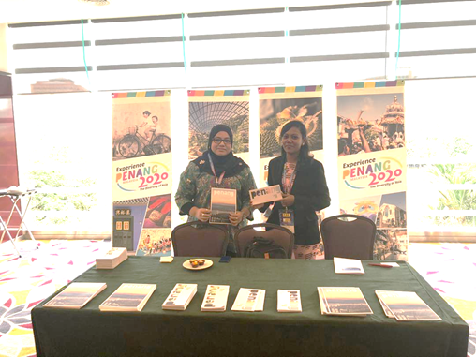
< table for display and promotion of products/destination>
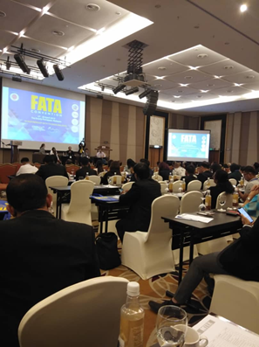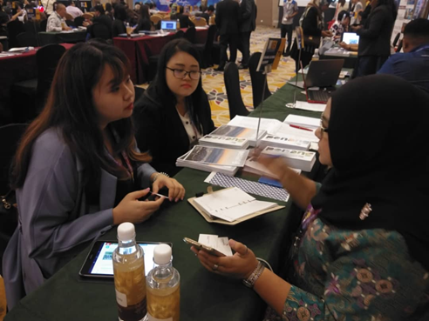
< FATA Convention and the B2B sessions first day >

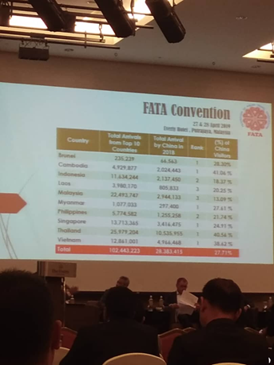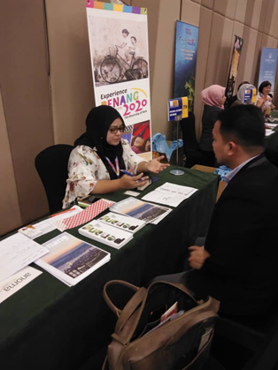
< FATA Convention and the B2B sessions second day >

