MATTA Travel Exchange (MTEX) in-conjunction with the FATA Convention 2019

Organiser : MATTA Travel Exchange (MTEX)
Date : 27th – 28th April 2019
Venue : The Everly, Putrajaya
Partner : Penang Development Corporation, PERDA, Penang
International Halal Hub MARA, Penang Global Tourism, Invest Penang

Event details:

- Penang Pekan Raya Sumatara Udara is the biggest exhibition in the north Sumatera region. As Penang is the sister city of Medan, Penang has been invited annually to be one of the exhibitors during event. Penang State Government has gathered different state agencies to exhibitor different product offers in Penang, as a promotional activity to the local people in Medan. Penang has been participated in this event for 35th times, since year 1984.
- Three vendors have been invited to sell Laksa, Roti Canai and Fried Koay Teow at Penang Pavilion.
- Penang Global Tourism has been invited to promote the tourism segment, which include medical tourism and education tourism.
- In conjunction with the event, Penang Development Corporation has organized a B2B session for both local buyer and Penang entrepreneurs.
- The delegation is led by PDC, where PDC invited different state agencies and Penang entrepreneurs to participate the event. There are 100 participants from Medan to have business matching with Penang delegates.

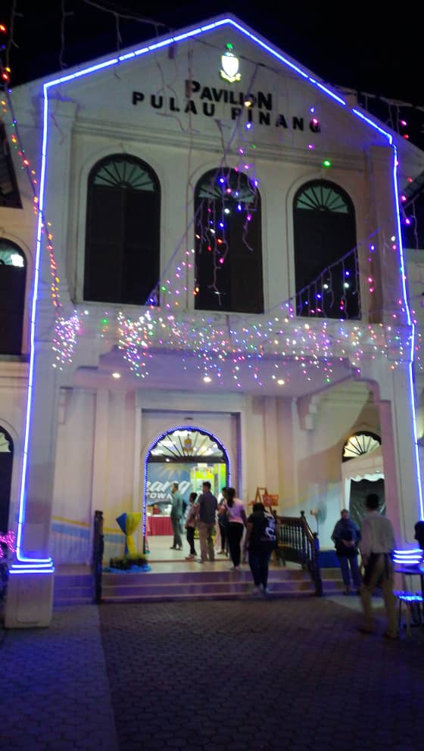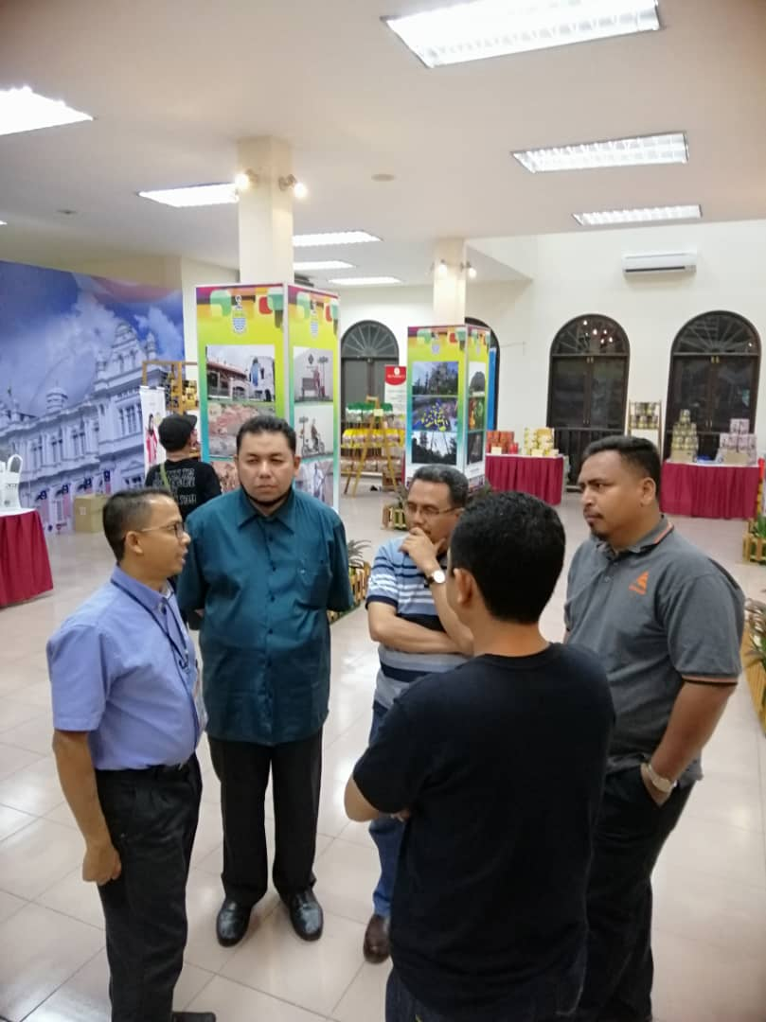
Visit Penang Pavilion during Medan Fair 2019
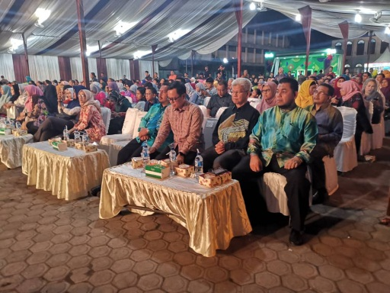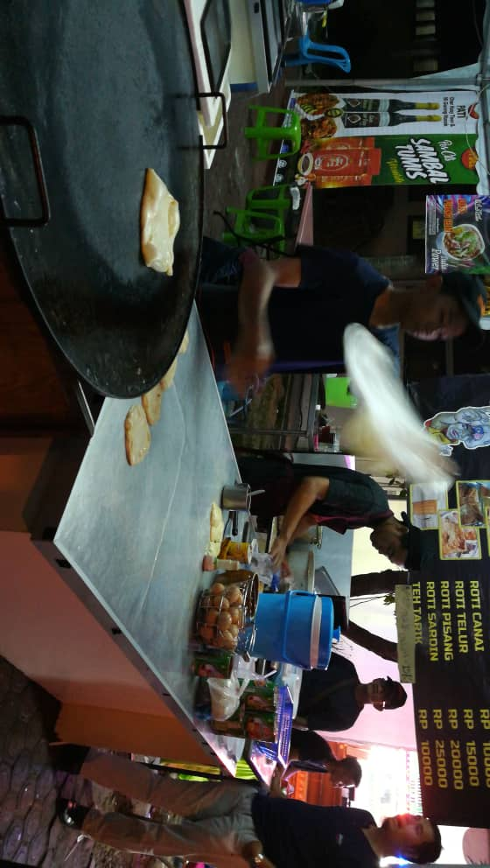
Launching of Medan Fair participated by PDC, few vendors has been invited to join the event where one of the vendor is Roti Canai.

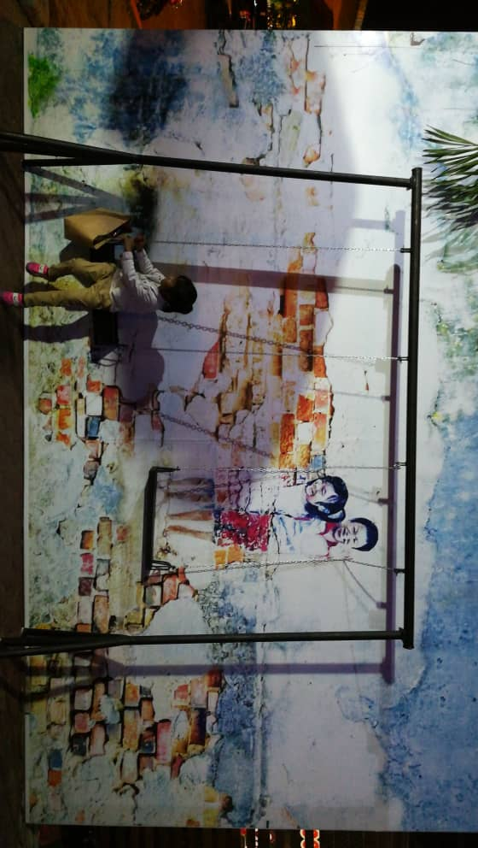
One backdrop has been set up to increase public engagement by attract public to take photo with the photo opt.
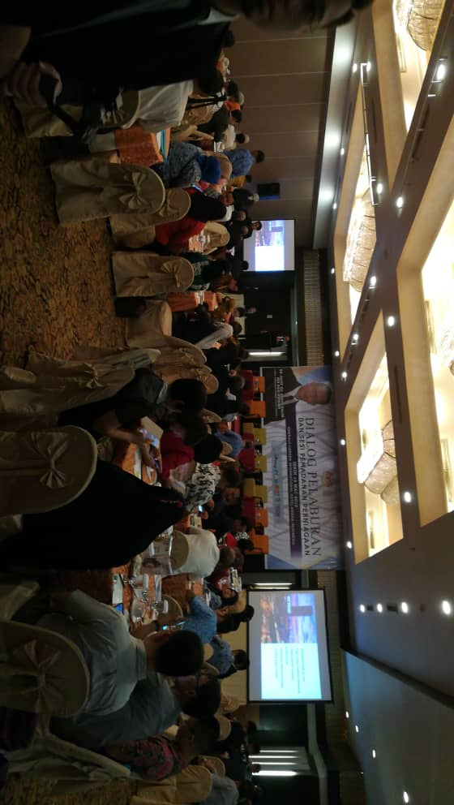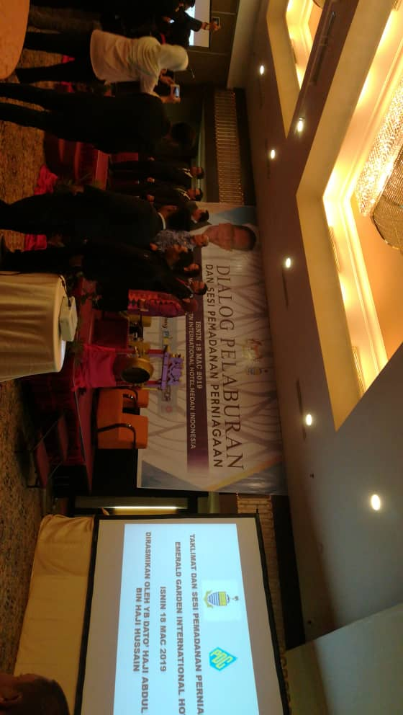
B2B session has been organised in conjunction with Medan Fair, in Grand Emerald Hotel.
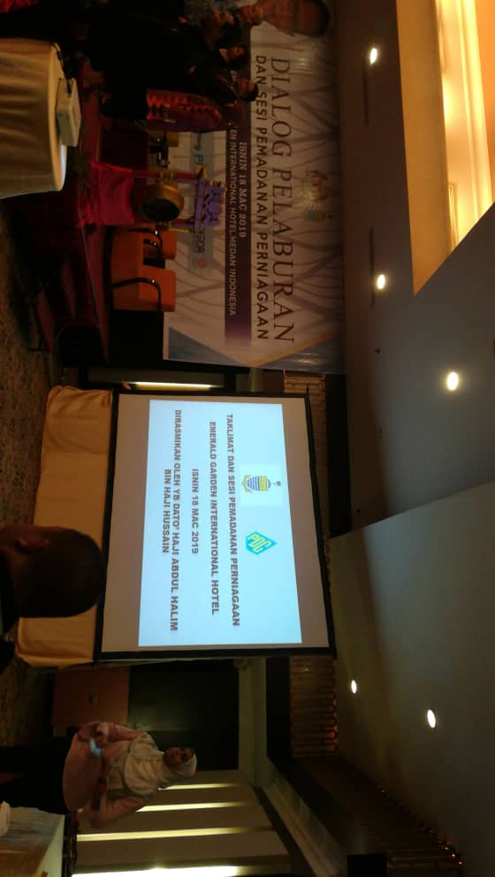
Opening ceremony by YB. Dato Haji Abdul Halim Bin Haji Hussain

