4. Marketing and Promotions

4.3 B2B / Events (June 2020 to November 2020)
No | Event Date | Venue | B2B / Events | Images
1 | 17 July 2020 | The Wembley St Giles | MICA B2B SESSION  Penang Global Tourism collaborated with the Malaysia Inbound Chinese Association (MICA) by arranging a networking session with Penang Tourism players promoted Cuti-Cuti Malaysia packages.  This has stimulated the domestic tourism concurrently, MICA is actively promoting Malaysia Inbound tourism to the Chinese market globally, with major focus on China, Taiwan and Hong Kong.  The B2B session has been held to create more Penang packages and to build more networking with tour operators and tourism-related industry members. A total of 80 Tour operator from different states such as Johor, Melaka, Kuala Lumpur and Perak meets with 67 Penang industry members from the Hotel and attraction. | 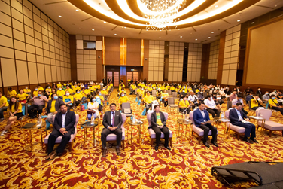  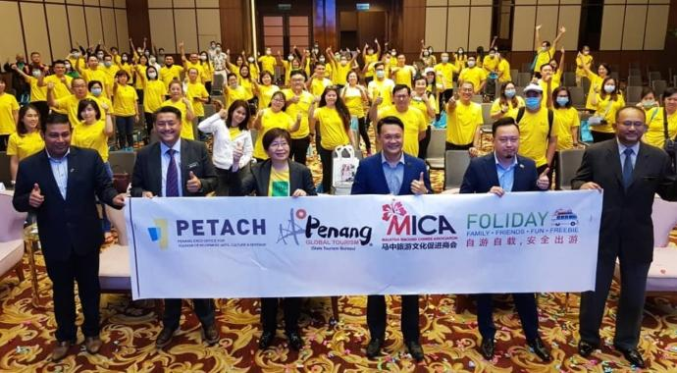  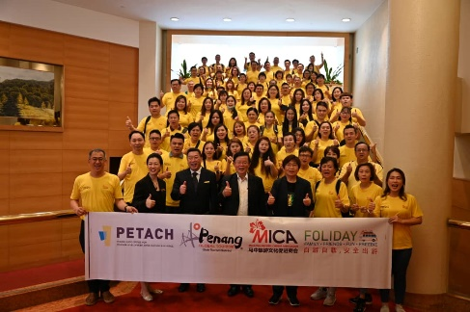
2 | 13 July 2020 | The Wembley St Giles | MCTA Travel Agent B2B  Penang Global Tourism collaborated with Malaysia Chinese Travel Association (MCTA) Penang Chapter by arranging a networking session with Penang Tourism players promoted Penang packages.  This B2B was held in Penang from 2nd to 4th September 2020. A total of 40 travel agents from Perak, Kuala Lumpur, Negeri Sembilan and Johor joined the networking session with 52 Tourism industry players from Penang. The networking session builds a confident to Agent to create more packages include historical & cultural furthermore its help to get to know the incredible history of Penang.  The best tour packages will desire the domestic travelers to travel more and experience Penang historical and cultural heritage with a peace of mind and at the same time reviving Penang Travel industry. | 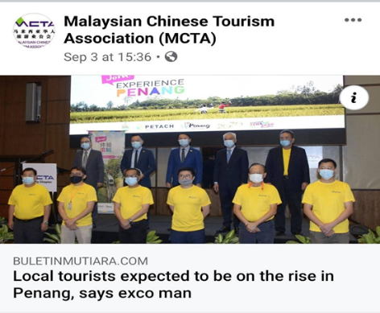  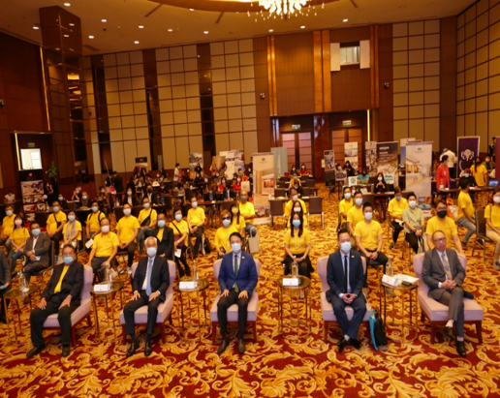
3 | 23 July & 13 August 2020 | Cititel / Evergreen Hotel | PETERAB/MATTA B2B  Penang Tourism Economy Recovery Advisory Board (PETERAB) collaborated with Penang Global Tourism arranged a networking session with Penang Tourism Players and a Townhall session with YB Yeoh Soon Hin, the state EXCO for Tourism, Arts, Culture and Heritage.  There are 2 groups involved which is bumiputras and non-bumiputras group followed by TV2 and TTG media. Around 55 Tourism players from hotel and attraction side involved in a B2B networking session.  The objective of this B2B to reactive Penang Tourism and encourage people to explore Penang with more new travelling packages and support domestic market. | 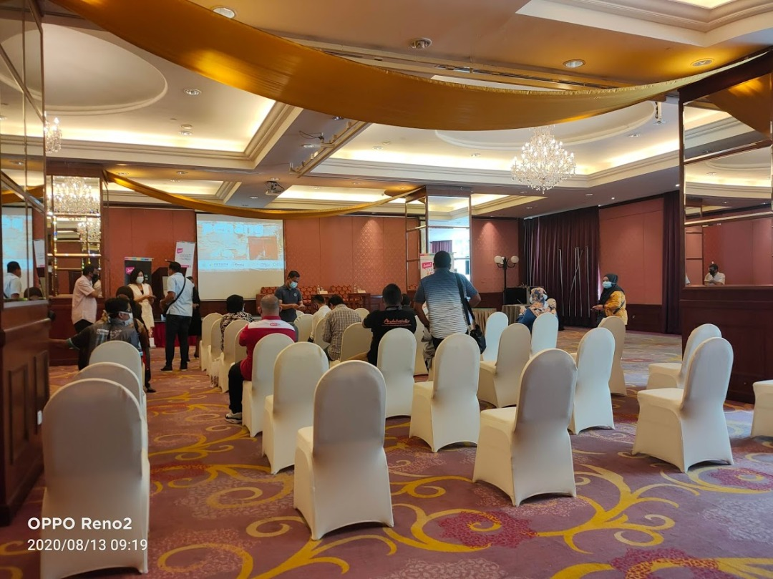  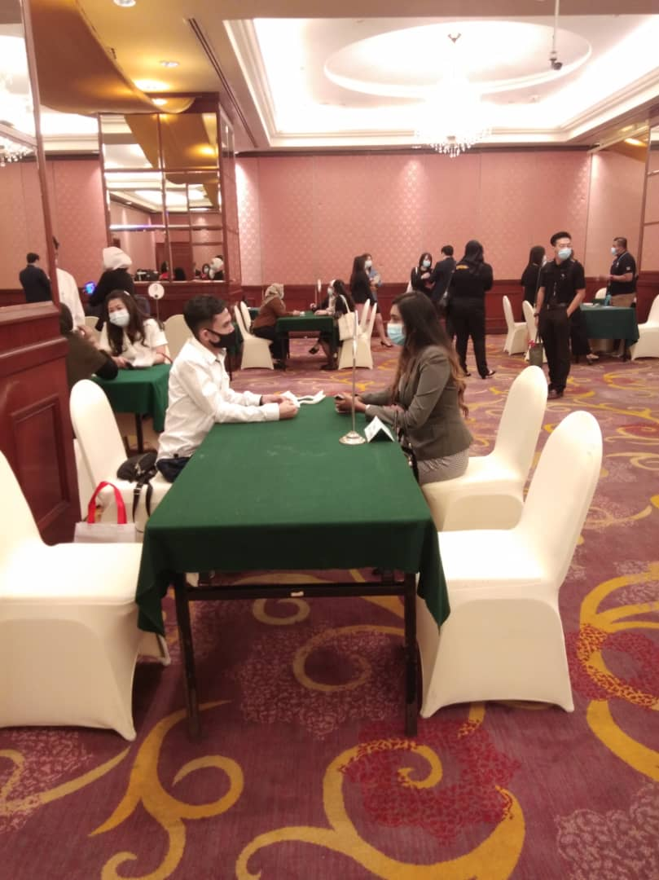  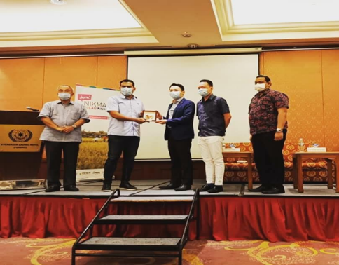
4 | 22 October 2020 | Webinar | PENANG DESTINATION WEBINAR – SRI LANKA TRAVEL AGENTS  Penang Global Tourism collaborated with the Ministry of Tourism by arranging 1-hour webinar with Sri Lanka Travel Agents to showcase Penang Uniqueness and to promote Penang Tourism.  The Webinar session has been participates around 20 Travel agents. The session begins with Mr Ooi Chok Yan (CEO of Penang Global Tourism) presentation. He explained on Penang products and uniqueness, followed by Mr Kenny (Marketing Manager) presentation regarding The Top Penang.  End of Presentation the agents asked few questions such as the status of Malaysia border opening date and the current situation for Tourism and Hospitality in Penang. | 