ITB ASIA 2019

Organiser : Messe Berlin (Singapore) Pte Ltd
Date : 16 -18 October 2019
Venue : Marina Bay Sands Convention Centre Partner : ACTE Global, BestCities Global Alliance, CrescentRating,
Corporate Travel Management, Cruise Lines International
Association, Future Leaders and Islamic Tourism Centre

Event details:
- ITB Asia is the biggest Asia’s hybrid show, bringing more than 13,000 show attendees from MICE, Corporate, and Leisure sectors
- Celebrating twelfth year in Singapore, ITB Asia taking place at Marina Bay Sands. It is organised by Messe Berlin (Singapore) Pte Ltd and supported by the Singapore Exhibition & Convention Bureau.
- ITB Asia which include international exhibitors of all sectors within the travel-value chain commerce, and Asia Pacific’s leading travel companies and emerging small and medium-sized enterprises to meet with top international buyers from the MICE, Leisure and Corporate Travel markets.
- Penang has been joining annually to be one of the exhibitors during event.
- Total eleven partners have been joined Penang Pavilion which is The Habitat, The Northam All Suites Hotel, Tour Incentive Travel, Lone Pine Hotel, Shangri La Rasa Sayang, Holiday Inn Resort, Pacific world destination, Royale Chulan Penang, The prestige Hotel, Discovery Overland, Iconic Hotel and PCEB.
- In conjunction with the event, B2B session arranged to connect with over 1,250 pre-qualified buyers

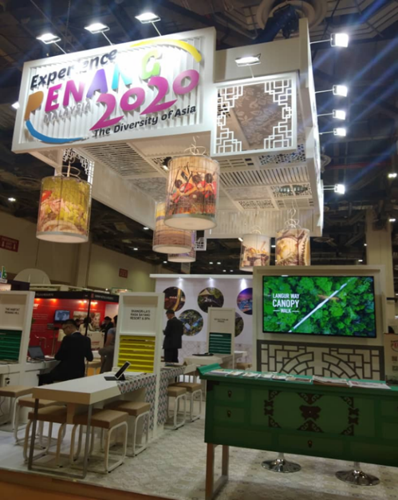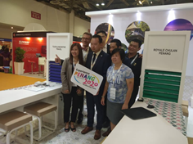
Visit Penang Pavilion during ITB ASIA 2019

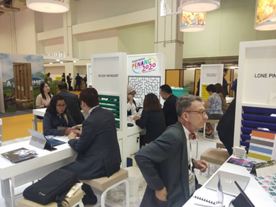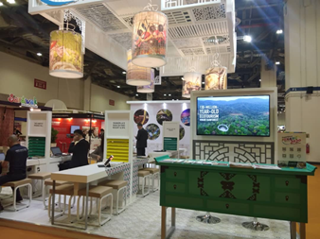
B2B session has been organised with seller and ASEAN TOURISM FORUM (ATF) delegate

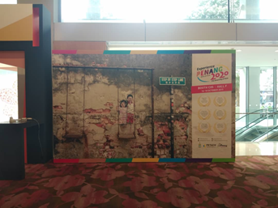
ITB Asia B2 Escalator Backdrop to increase delegate engagement to take photo

