  - Film Tourism
The total shooting recorded by Penang Film Tourism Unit from October 2019 to February 2020 is only 2 productions. There were no submitted budgets spent in Penang from the production house.

    - Summary
Same as previous months, the Unit captured lesser productions despite the consistent sharing by MBPP. Same advice from established production houses and experienced producers, many production houses are well-versed of the application processes and they are liaising directly with the respective parties bypassing MBPP should the case of shootings are not interrupting daily operations of public.

    - Special Productions Highlight
- AirAsia China <Brand New Experience in Malaysia> Penang Video Shooting.
AirAsia China is sending members of AirAsia Creator Club and Travel Intelligence to Penang for content creation. In accordance with Penang traveling feature, the content will be created in 3 angles – Culture / Wonder / Food, under this year’s big theme of 从未浪过的大马 (Brand New Experience in Malaysia).

The shooting date is from 2-7 November 2019 and AirAsia is sending 4 crew members for this shooting in Penang - 2 members of creator club for video shooting 1 long video clip (within 3mins) + 3 short clips (30s), 1 member of Travel intelligence for Travelogue and photo shooting - 1 travelogue + 30 selected photos and 1 AirAsia staff to coordinate onsite.

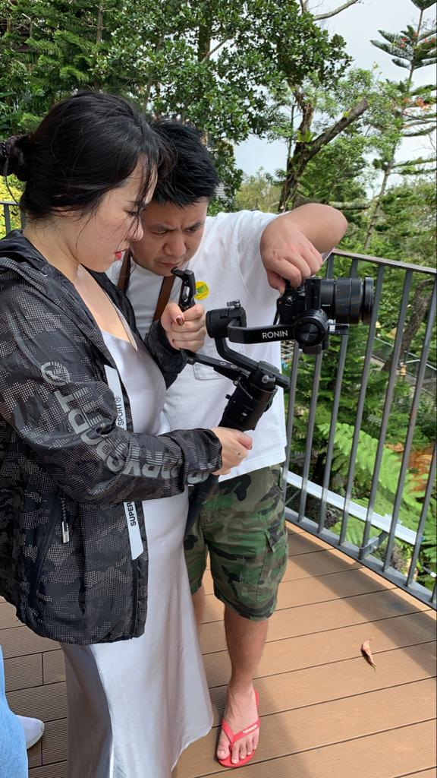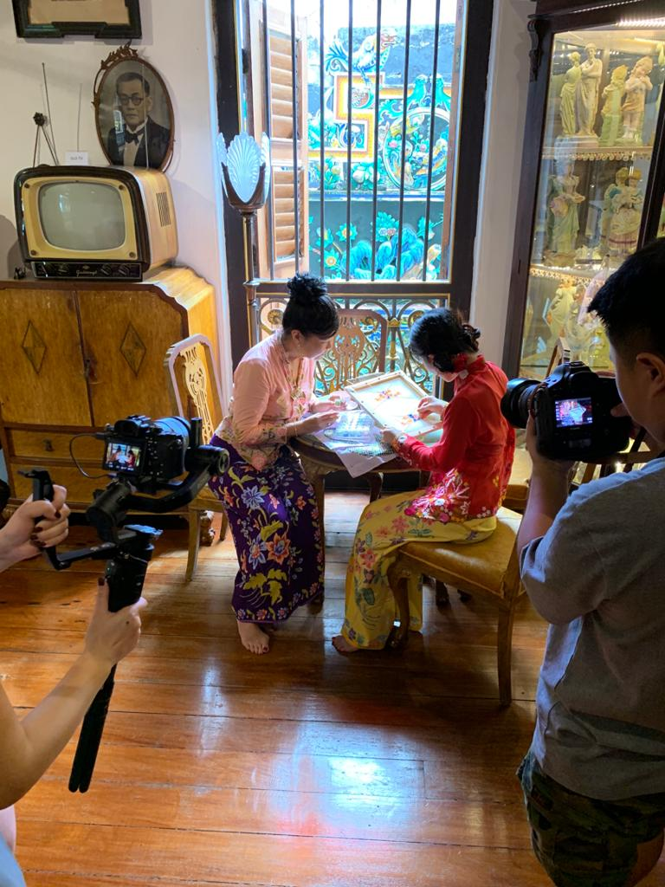

- AirAsia Video Shooting <Experience Penang 2020>
Penang Global Tourism is partnering with AirAsia to organize a familiarization tour for their production crews to shoot a new angle of Experience Penang 2020 in Penang. The video shooting date is from 11-14 December 2019.

The video production is focusing on George Town, Jerejak Island and Balik Pulau as a return Geotag and credit will be mentioned for the sponsors inside the content. The output of the shooting will be shared across all AirAsia Network Countries to promote Penang in 2020. The group consists of 3 production crews, 2 talents and 1 AirAsia staff.

