4. Marketing and Promotions

4.2 Familiarization Trip / Official Visit (October 2019 to January 2020)
No | Project Date | Type | Country | Familiarization Trip/Official Visit | Media Exposure
1 | 14 - 21 October 2019 | Media | Sweden | COMMUNINATION SWEDEN CONTENT MARKETING FAM  CommuniNation from Sweden will be creating tailor-made travel content of Penang to reach out to the right targeted group in Scandinavia. CommuniNation will raise Scandinavian awareness about Penang. They will be in Penang start from 14 October 2019 until 21 October 2019.  For your information, CommuniNation have produced more than 150 newspapers and magazine, contributed with articles and features to another hundred, travelled to over sixty countries, held a large number of photographic exhibitions, as well as held highly visited lecturers regarding travels.  Media list as follows:  1) Elisabet Garcia Dahlback - CEO / Editor-in-Chief  2) Binge Eliasson - Senior Creator / Lecturer  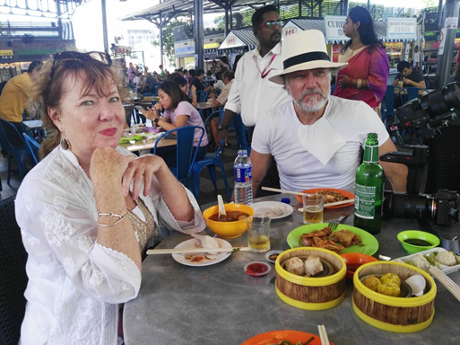
2 | 17 -19 October 2019 | Media | Germany | Qatar Airways / Urlaubsguru and TM Frankfurt FAM 17-19 October 2019  Qatar Airways and Tourism Malaysia Frankfurt in Germany are organizing a familiarization tour. Urlaubsguru is one of the leading travel brands in Germany. Their website publishes articles about travelling, as well as bookable offers. Additionally, they have their own booking engine with products of several of the largest tour operators in Germany. On social media, they have a large number of followers.  Media participating are as follows:  - Ms. Olivia Pudysz – Presenter, Editor  - Mr. Patrick Gillitzer – Cameraman  The objective is to showcase and promote Malaysia especially Langkawi and Penang to the German Market in additional to further strengthen the Visit Malaysia 2020 Campaign.  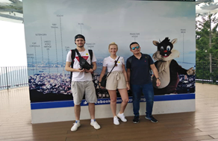  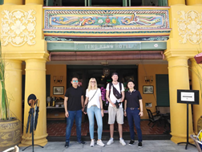 | The website https://www.urlaubsguru.de/ gets about 5.7 million views per month on average. Facebook page has 1.9 million fans and Instagram account has 342,000 followers.
3 | 17 – 20 October 2019 | Media | Hawaii | Hawaii Media FAM 17-20 October 2019  A veteran Hawaii radio personality, comedian, actor and a television host Mr. Lanai Tabura who in recent years dedicated to syndicated TV shows that currently air in Hawaii and nationally on the Lifestyle Network, Direct TV and Time-Warner Cable in 7 countries is visiting Penang from 17-20 October 2019.  Media list are as follows:  - Mr. Grant Tabura  - Mr. Sean Keoni Ah Yen    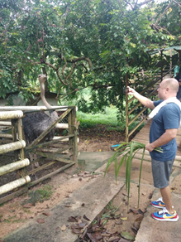 | Followers:  77,000 Followers  https://www.facebook.com/CookingHawaiianStyle/  30,000 Followers  https://www.facebook.com/AlohaPlateLunchPage/  20,000 Followers  https://www.instagram.com/cookinghawaiianstyle/  8,500 Followers  https://www.instagram.com/alohaplate/?hl=en
4 | 29 October – 2 November 2019 | Agent | China | Qingdao Airlines Travel Agents FAM Trip 29 October – 2 November 2019  Qingdao Airlines is flying direct from Changsha/Quanzhou to Penang on 29 October 2019 with two flights per week. This route is also the maiden voyage of China Qingdao Airlines to Malaysia. There will be more flights from various cities in China to Penang in Future.  With that, Qingdao Airlines is bringing 29 pax of travel agents from Changsha and Quanzhou for Penang familiarization trip. This FAM trip will help the agents on product development as well as understand Penang tourism products better. PGT organizes a networking session with Penang local travel agencies as well for more business collaborations.  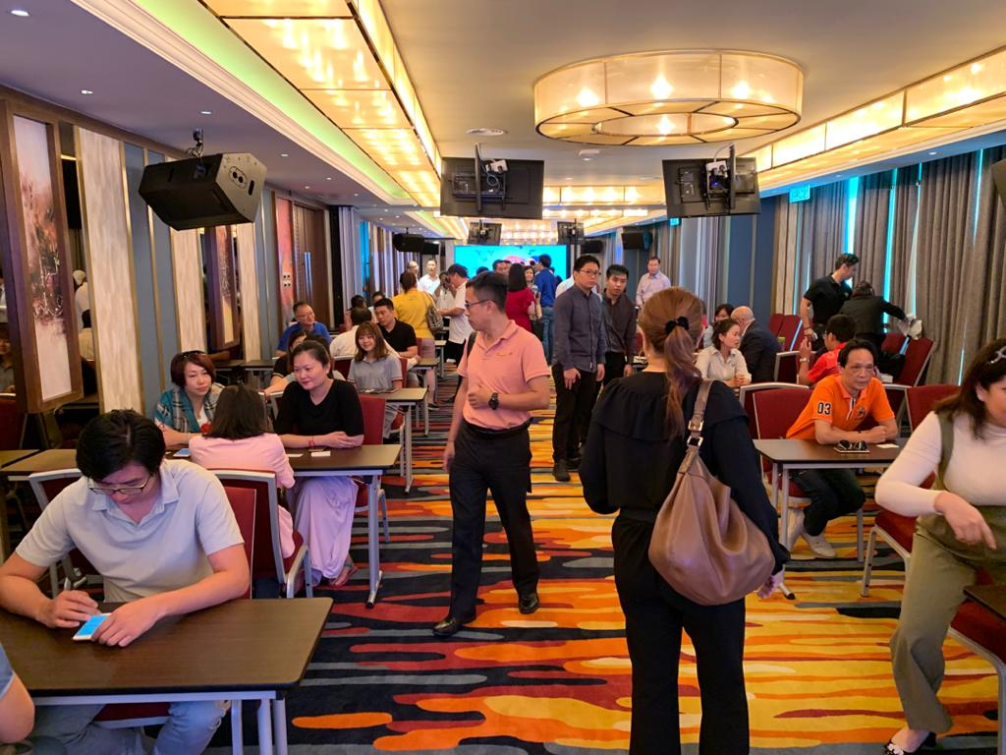
5 | 5 November 2019 | Agents | Hungary | Singapore Airlines Hungary Agents Cruise FAM 5 November 2019  Singapore Airlines Netherlands is developing Hungarian Market which has a strong potential to grow our business. One of the segments they are working on is premium leisure and MICE.  Singapore Airlines is organizing a FAM trip from Budapest to Singapore on 2 November and the agents is joining RCL for a short cruise to Penang on the 5 November. PGT is hosting the 6 hours excursion trip and dinner for the 14 pax agents in Penang.
6 | 6 - 12 November 2019 | Chefs | United  Kingdom | MALAYSIA AIRLINES TASTE TOUR CHEFS TOUR  Malaysia Airlines is organizing a familiarization tour for the chefs from United Kingdom to Penang. This group will be in Penang from 8 November 2019 to 12 November 2019. The group of 4 pax consists of; 2 pax Chefs, 1 PR and 1 Film crew.  The name list are as follows:  1) Mr William George Salvin Bowlby (Chef)  2) Mr Richard Andrew Campbell (Chef)  3) Mr Philip Graham Savage (PR)  4) Mr Steven William Bollschweiler (Film crew)  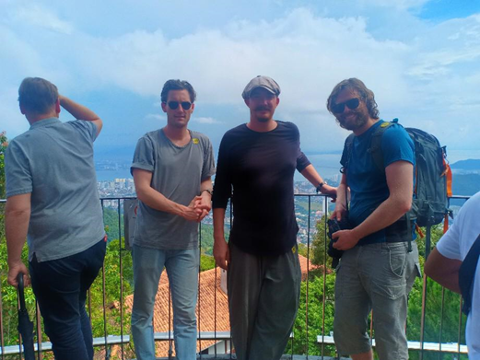
7 | 8-11 November 2019 | Media | Denmark | TV Vest Sjaelland Media FAM 8-11 November 2019  Singapore Airlines is organizing a familiarization Media Trip for TV Vestsjaelland Media, TV Vestsjaelland is the leading TV Channel in the Southern part of Denmark. All the material will be shown at prime time and several times during a month around 50 plus in South of Denmark as well as 30 plus via YouTube and other medias. The trip is to show how Penang made it back to the top 10 destinations in Asia ad to drive holiday traffic to Penang.  The media consists of 2 representatives:  - Mr. Svend Skjold Christensen  - Ms. Kavitha Sandakumaran  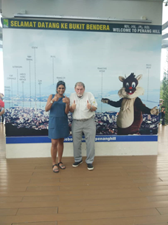  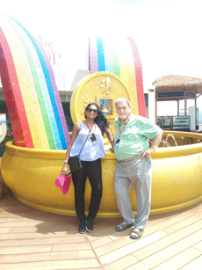
8 | 10-12 November 2019 | Agents | China | Guangzhou Wholesalers Travel Agents FAM 10-12 November 2019  GLZ International Travel Services Limited Guangzhou together with Tongyan Travel is bringing 20 top travel agents from their 40 branches around China. China is one of our focus markets especially the new direct flight from Changsha/Quanzhou and the upcoming Shezhen to Penang. This trip is important in order to educate the travel agents on the new products in Penang as well as building their confidence in selling Penang packages.
9 | 16-18 November 2019 | Agents | Japan | Osaka Agents FAM 16-18 November 2019  Malaysia Airlines and Tourism Malaysia Japan are organizing a FAM tour for top travel agents from Japan to Penang. This FAM trip is to promote Penang to thee Japanese citizens and also to promote Visit Malaysia 2020. The group consists of 7 pax travel agents, 1 Tourism Malaysia Officer and 1 Malaysia Airlines Officer.  The agent list is as follows:  - Hankyu Travel International Co., Ltd  - JTB Media Retailing Corp  - HIS  - ST world. Inc  - JTB Corp  - Nippon Travel Agency  - White Bare Family  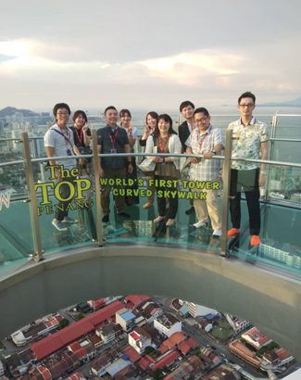  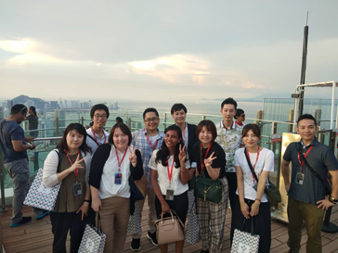
10 | 16-19 November 2019 | Agents | Taiwan | Taiwan Wholesalers and Agents FAM Trip 16-19 November 2019  China Airlines is co-organizing a familiarization trip to Penang with MyPassion Travel. Last year, MyPAssion Travel handled over 3,000 Taiwanese tourists into Penang. A total of 17 wholesalers and agents are traveling to Penang with China Airlines directly from Taipei. This FAM trip is essential to encourage the wholesalers and agents to promote Penang packages as well as developing new packages for Penang.  The agent list is as follows:  - Lion Travel  - SET Tour  - Phoenix Tour  - Star Travel  - Cola Tour  - Life Tour  - Best Tour  - Richmond  - MPT  - Kashme Tour  - Star Travel  - Ace Tours
11 | 15-19 November 2019 | Media | Australia & Europe | AirAsia and Kiwi.com Europe and Australia Media FAM 15-19 November 2019  AirAsia and Kiwi.com are planning for media FAM trip for Europe and Australia. A total of 7 pax – 1 Spanish media, 2 Czech Republic media, 1 Australian media, 2 representatives from kiwi.com and 1 representative from AirAsia.  The media list is as follows:  - Jose Ramon Valero Fernandes  - Milam Mikulka  - Jiri Liebreich  - John Maurice Burfitt  - Liang Jian Zhang  - Elena Sokolnikova  - Gan Xiang Ling | Aviation Magazine with 65,000 readers monthky
12 | 15-20 November 2019 | Students | Japan | JATA and Japan Tourism Agency Special Project of Promoting Outbound Travel Among Japanese Young People from 15-20 November 2019  Tourism Malaysia Japan is working with Japan Tourism Agency (JATA) in promoting outbound travel among Japanese university students. There were over 1,000 applications and 10 students were selected to join the tour to Penang. This program focuses on Education Tourism and homestay program in Malaysia. This program features a few tourist attractions in Penang, Homestay Mengkuang Titi and presentation by Japanese university students on their visit to Penang. Japan Tourism Agency under the Ministry of Land, Infrastructure, Transport and Tourism also agreed to fully backup the program in terms of publicity and relevant, the feedbacks will be made widely by various channels including social media, websites, newspapers and magazines.  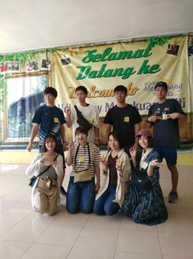  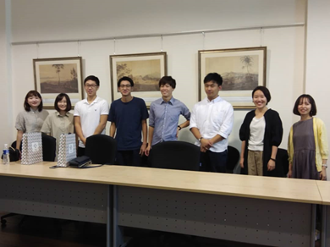
13 | 16 - 23 November 2019 | Travel  Agents | Norway | TOURISM MALAYSIA & QATAR AIRWAYS NORWAY FAM TRIP  Tourism Malaysia with Qatar Airways is organizing a familiarization trip for 7 travel agents from Norway starting 16 - 23 November 2019 in Malaysia.  The FAM trip falls mainly to promote the Penang / Langkawi flight. These group of agents consists of top producing and potential agents in Norway. They will be in Penang from 17 - 19 November 2019. The group of 7 pax consists of; 5 pax travel agents, 1 pax Qatar Airways officer and 1 pax Malaysia Tourism Promotion Board officer.  Agents participating are as follows:  1) Mr Askekjær Nils  (Senior Sales Executive, Qatar Airways)  2) Ms Eriksson Karin Anette Helen  (Consultant, Malaysia Tourism Promotion Board)  3) Ms Randmæl Bente  (Travel Consultant, Orkideekspressen)  4) Ms Ehde-Eliassen Charlotte  (Managing Director, Jomfrureiser)  5) Ms Bergerud Thea  (Social Media Manager, Ving)  6) Ms Rivera Beatriz Jaquotot  (Head of PR and Communication, Apollo)  7) Ms Høyme Carina  (Digital Content Manager, Berg Hansen)  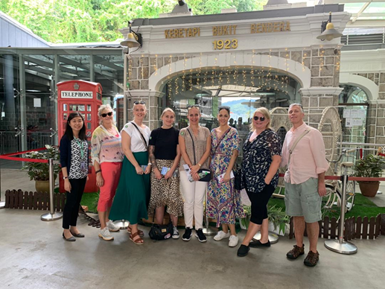
14 | 18-20 November 2019 | Vlogger | Singapore | Vlogger Singapore Airlines FAM 18-20 November 2019  Singapore Airlines Benelux is making plans to expand the Asia Trails vlogger campaign which they launched last year. They have highlighted Laos and Thailand last year and they would like to focus on the diversity of Malaysia.   | The campaign had an open rate of 42.4% and a click through rate of 11.1%. The vloggers pushed the campaign on their own social medias and websites as well.
15 | 19-21 November 2019 | Agents | Philippines & Indonesia | Tourism Malaysia ASEANMEET 2019 Post Tour FAM Trip to Penang 19-21 November 2019  Tourism Malaysia under International Promotion Division (Southeast Asia) is organizing ASEANMEET 2019 on the 17-22 November 2019 at Melaka. This program is involving 60 travel agents and 8 medias from ASEAN region with the objective of promoting Malaysia as preferred and top destination. A total of 11 travel agents and 1 Tourism Malaysia officer come to Penang as the post tour of the program.  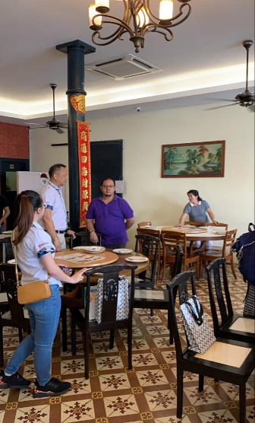
16 | 22-24 November 2019 | Agents | UK | Malaysia Airlines Tourism Malaysia UK Top Agents FAM 22-24 November 2019  Malaysia Airlines and Tourism Malaysia are organizing a FAM tour for top travel agents from UK to Penang. The group of 16 pax consists of 14 pax travel agents, 1 Tourism Malaysia Officer and 1 Malaysia Airlines Officer.  The Travel Agency list is as follows:  - Aviate  - Travel Counsellors  - Clarity  - Ian Allan Travel Limited  - Kenwood  - BestAT Travel  - Elegant Resorts  - Flight Centre  - Trailfinders  - Travelbag  - Premier Holidays  - News Travel  - Audley  - THG Holidays  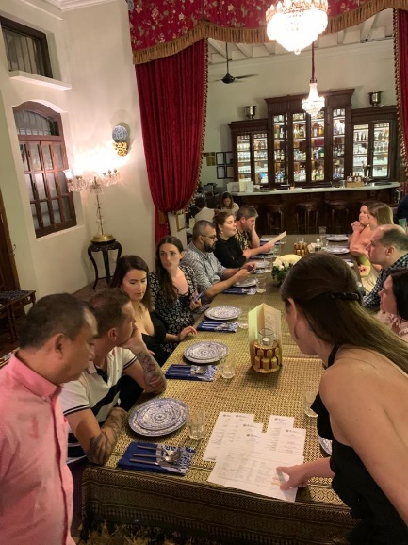
17 | 23-24 November 2019 | Media | Switzerland | TM/Qatar Airways Switzerland Media FAM 23-23 November 2019  Tourism Malaysia Frankfurt and Qatar Airways Switzerland are organizing a FAM tour for top media agencies, journalist and editor from Switzerland to Penang. The FAM trip is a part of series of tactical campaigns between Tourism Malaysia and Qatar Airways, the purpose of this trip is to promote the direct flight of Qatar Airways from Doha to Penang. The group consists of 8 media representatives, 1 Qatar Airways Officer and 1 Tourism Malaysia Officer.  The media list is as follows:  - Travel Inside  - 20 Minute  - Seesicht Magazine  - Globesession  - Zurcher Tagblatt  - Skippers Magazine  - 20 Minute Friday  - Ou Magazine  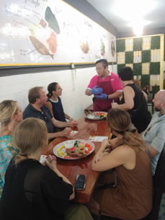  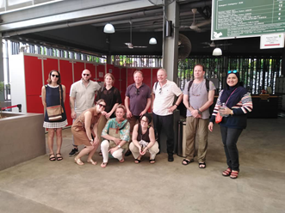 | Approximately 10,000,000 readers reached.
18 | 22-25 November 2019 | Media | UK | Culturetrip.com Media FAM 22-25 November 2019  Mr. John Bruton, a freelance journalist, is commissioned by Culturetrip.com to write an article on traditional trades in Penang. Mr. John Bruton has written several articles about Penang for major publications such as The Guardian and The Lonely Planet. | Culturetrip.com has over 7.2 million followers on Facebook.
19 | 29 November – 3 December 2019 | Agents | China | China Travel Agents Familiarization Trip 29 November – 3 December 2019  Zhuhai Ramda International Travel Services Co Ltd is organizing travel agents FAM trip that will bring agents from Guangdong, Guangzhou, Zhaoqing, Foshan, Jiangmen, Zhongshan, Zhuhai, Shenzhen, Dongguan, Huizhou, Hong Kong and Macau from China to Penang. The total population of these areas will be 66 million and with the most outbound tourists.  With the increase of direct flights from Guangzhou and new direct flight from Shenzhen to Penang, it is important to educate the China travel agencies about the tourism products of Penang.  A total of 32 travel agents are participating in the FAM trip.  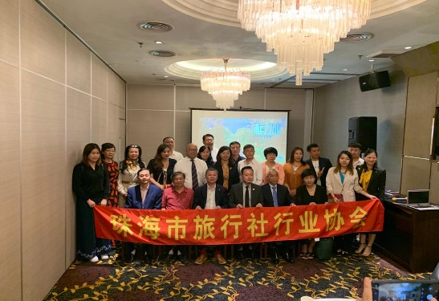
20 | 1-3 December 2019 | Media | Germany | TM / Qatar Airways Germany Media FAM 1-3 December 2019  Tourism Malaysia Frankfurt and Qatar Airways Germany are organizing a FAM tour for top media agencies, journalist and editor from Germany to Penang. The FAM trip is a part of series of tactical campaigns between Tourism Malaysia and Qatar Airways, the purpose of this trip is to promote the direct flight of Qatar Airways from Doha to Penang. The group consists of 8 media representatives, 1 Qatar Airways Officer and 1 Tourism Malaysia Officer.  The media list is as follows:  - Reisen Exklusiv Magazine  - Die neue Reiselust Travel Magazine  - Madsack Mediengruppe  - Neue Westfalische  - Luxusinsider  - Nordsee Zeitung  - Der Allgemeinarzt  - Freelance  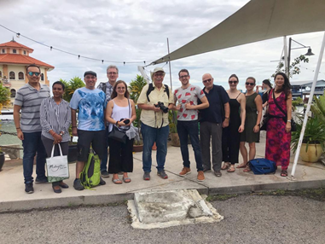  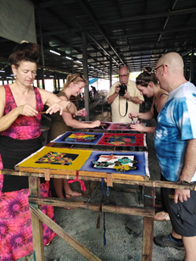 | Appeoximately 10,000,000 readers reached.
21 | 4-7 December 2019 | Agents | Hong Kong | Lotus Tours Hong Kong Agents FAM 4-7 December 2019  PST Travel and Lotus Tours Hong Kong brought in 24 retail agents from Hong Kong to Penang for FAM trip. Lotus Tours is one of the largest and most experienced travel management companies in Hong Kong. Hong Kong outbound has grown in July for 2.3% and 3% in September. Hong Kong remains as an important market for Penang.
22 | 10-14 December 2019 | Agents | China | Qingdao Airlines Fujian China Agents FAM 10-14 December 2019  Penang Global Tourism is collaborating with Qingdao Airlines in organizing a familiarization trip for travel agents from Fujian Province of China to Penang. There is a total of 14 travel agents coming from Haicang District, Quanzhou District and Zhangzhou District with the newly launched direct flight from Qingdao to Penang via Quanzhou offered by Qingdao Airlines.  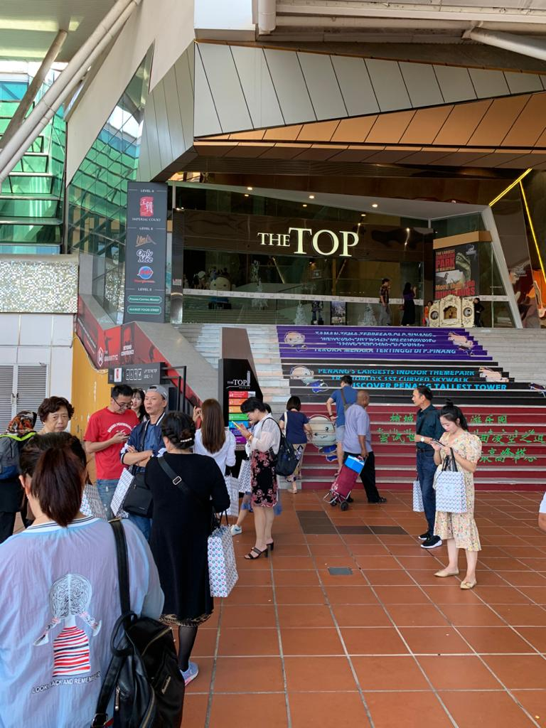  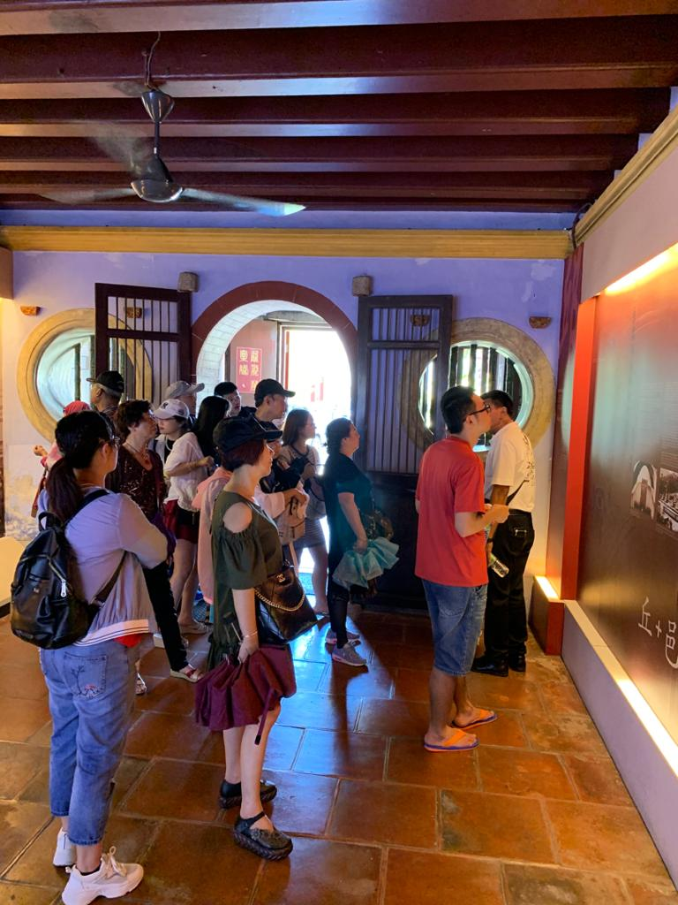
23 | 4 - 5 January 2020 | Media | Australia | AUSTRALIAN MEDIA "GOOD FOOD MAGAZINE”  Deputy editor Ms Roslyn Grundy from Good Food Magazine. She stories writing is on heritage and food. She will be visiting Penang from 4 - 5 January 2020.  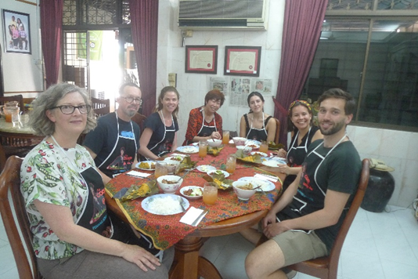
24 | 3 - 6 January 2020 | Travel  Agents | Shenzhen,China | SHENZHEN AIRLINES AGENTS FAM  Shenzhen Airlines is organizing a familiarization tour for travel agents from Shenzhen to Penang from  3 January 2020 to 6 January 2020.  The group of 19 pax consists of; 18 travel agents and  Shenzhen Airlines officer.  Travel agents participating are as follows:  1 深圳航空游侠责任公司  2 深圳市航空国际旅行社有限公司  3 深圳华侨城国际旅行社有限公司  4 国旅（深圳）国际旅行社有限公司  5 深圳国旅新景界  6 深圳中华龙旅游集团有限公司  7 东莞市国际旅行社有限公司  8 柏菲假期  9 携程国际合作  10 深圳市华正商旅国际旅行有限公司  11 深圳市招商国旅  12 万顺通  13 深圳市中源航空服务有限公司  14 深圳市尊尚汇商务代理有限公司  15 广州美亚电子商务国际旅行社有限公司  16 深圳市天泰国际航空旅行社有限公司  17 深圳市特航航空服务有限公司  18 慧通商旅  19 深圳航空  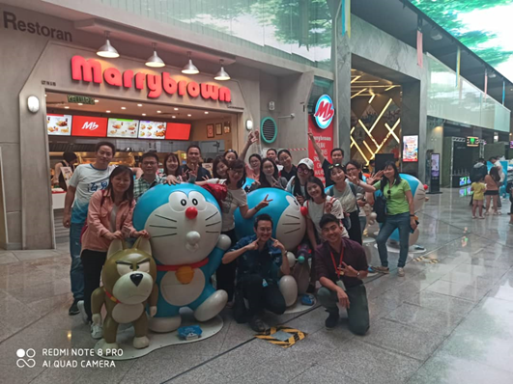
25 | 11-14 February 2020 | Media | Sweden | QATAR AIRWAYS NORDIC MEDIA FAM  Qatar Airways is organizing a familiarization tour for Svenska Dagbladet newspaper and TT News Agency which ranked as one of Europe's most profitable news agencies. The tour focusing on travel, food and lifestyle. This Media Trip feature most exclusive and luxurious places for accommodation, spa, shopping, dining and sightseeing in Penang.  The media list is as follows:  1. Ms. Kristiina Raitala- Senior editor  2. Ms. Jenna Vehviläinen- public broadcaster  3. Mr. Alexandra Saetran- freelance journalist  4. Mr. Björn Moholdt - Travel journalist  5. Mr. Jakob Steen Olsson – Editor  6. Mr. Jesper Moller- freelance journalist  