ASEAN TOURISM FORUM (ATF) 2020

Organiser : ASEAN TOURISM FORUM (ATF)
Date : 14th – 16th January 2020
Venue : BRIDEX International Conference Centre, Brunei
Partner : ASEAN NTO, ministerial delegates, association boards and tourism group

Event details:

- ATF 2020 TRAVEX, between top travel and tourism suppliers across all 10 ASEAN destinations Brunei Darussalam, Cambodia, Indonesia, Lao PDR, Malaysia, Myanmar, Philippines, Singapore, Thailand and Viet Nam, India and global buyers.
- Penang has been invited annually to be one of the exhibitors and has gathered hotels and travel agents to join ATF Brunei.
- Penang Global Tourism has been invited to promote attraction, hotels and Penang products.
- In conjunction with the event, ASEAN TOURISM FORUM (ATF) organized a B2B session for Seller with delegates.
- All exhibitors and buyers able to schedule up to 100% of their appointments prior to arriving in Brunei.

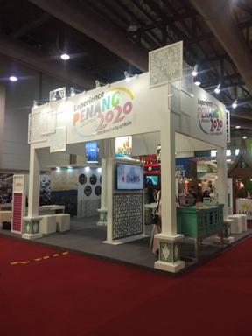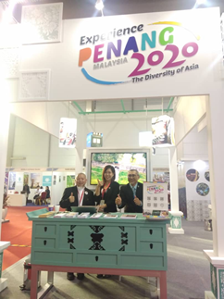
Visit Penang Pavilion during ATF BRUNEI 2020

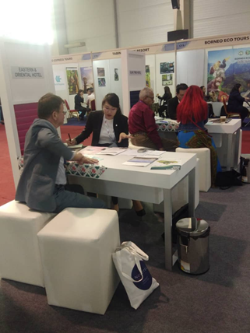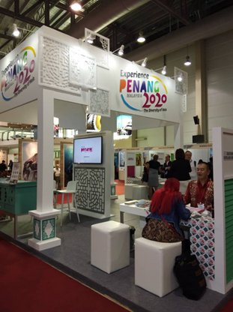
B2B session has been organised with seller and ASEAN TOURISM FORUM (ATF) delegate

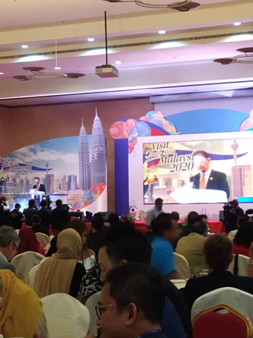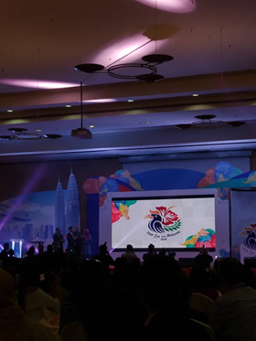
Launching of Visit Malaysia Campaign 2020 by YB Minister of Tourism, Arts & Culture, Datuk Mohamaddin bin Ketapi

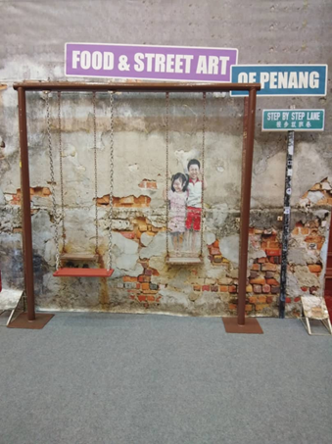
One of backdrop has been set up to increase public engagement by attract public to take photo with the photo opt.

