4. Marketing and Promotions

4.2 Familiarization Trip/Official Visit (April 2019 to September 2019)
No | Project Date | Type | Country | Familiarization Trip/Official Visit | Media Exposure
1 | 14 -19 April 2019 | Wedding Planners | China | PENANG WEDDING TOURISM CHINS BUYERS FAMILIARIZATION FAM  -Penang Global Tourism is supporting wedding  Planner familiarization trip organized by Kuang Yee Bridal.  -Kuang Yee bridal has invited more than 40 personnel of wedding planners from different region from China.  - Penang Global Tourism will support in terms of welcome reception, goodies bag, translator and emcee their ground arrangements such as transportations, tours, and meals for group.  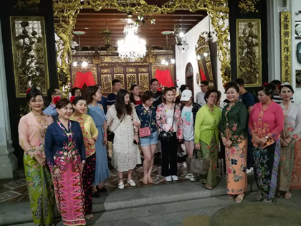  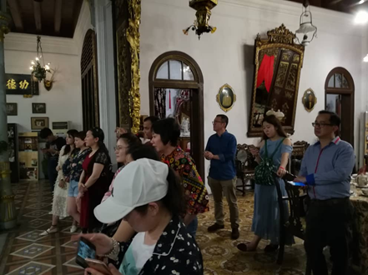
2 | 14 – 19 April 2019 | Media | China | AIRASIA CHINA MEDIA FAMMILIARIZATION TRIP IN CONJUSTION WITH PENANG INTERNATIONAL FOOD FESTIVAL  -Penang Global Tourism will be collaborating with AirAsia China and Tourism Malaysia China to organize a familiarization trip for media from China.  -Penang Global Tourism hosted their ground arrangements such as transportations, tours, and meals for group  -The objective is to promote tourism product in Penang and Participate in Penang International  Food Festival 2019.  Details as below:  Date: 14-19 Aril 2019 (10 pax KOL/Influencer)  Media list as below:  - Ms. Yan Xiaonan (KOL)  - Ms. Liu Xiaohui (KOL)  - Ms.Guo Wenjie (KOL)  - Mr. Shen Rui (KOL)  - Mr. Liu Yong (KOL)  - Ms. Li Jiayu (KOL)  - Ms. Li Xin (KOL)  - Ms. Hu Didei (Zaker App / News App)  - Mr.Tam Waikin (KOL)  - Ms. Yang Chuang (KOL)  - Ms. Lin Liyun (AirAsia Guangzhou)  - Ms. Zhou Dan (Tourism Malaysia Beijing)  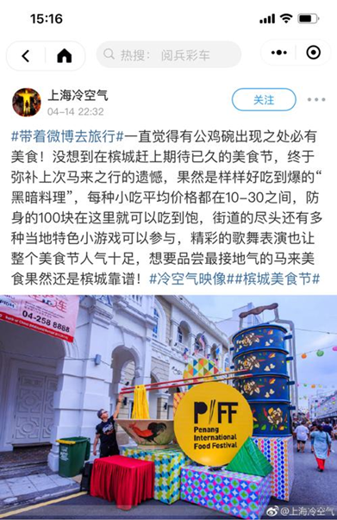  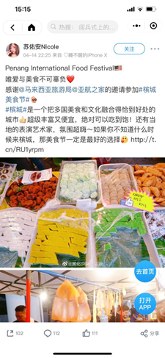
3 | 22-25 May 2019 | Agent | Seoul | SEOUL TOP TRAVEL AGENTS & AIRLINE FAM  - After Experience Penang 2020 Roadshow in South Korea, the travel agents are interested to explore charter flights to Penang. Penang State is also offering direct flights and charter flights incentive programmed for the airlines and charterers on 22-25 May2019  -Penang Global Tourism will be hosting the ground arrangement  Such as transportation, tours, and meals throughout their stay here  -The purpose of this familiarization trip is to promoted second biggest outbound travelers’ market.  Agents participating are as follows:  1. Mr Kim Chang Hun, General Manager of Hana Tour  2. Mr. Kang Min Kwan, General Manager of Mode Tour  3. Mr.Choi Yun Soo, CEO of HotelnAir  4. Mr.Kim Hue, CEO of Uniholiday  5. Mr. Kim Sang Wook, General Manager of Easter jet
4 | 3 May 2019 | Airlines | Japan | JAPAN AIRLINES INSPECTION FAM  -Japan Airlines from Singapore office organizing a market study tour in Penang to explore new route for the airlines.  - Penang Global Tourism will be supporting this program 1.30pm to 7pm.  Agent participating are as follows:  - Mr. Hatakeyamana Takahisa (Senior Vice President  - Mr. Akihide Yoguchi (Vice President)  - Mr. Sakaguchi Tomohiro (Regional Manager of Malaysia  - Ms. Chen Zhuowen (Director of passenger sales  - Mr. Wilson See (Assistant Manager)
5 | 24-26 May 2019 | Agents | Busan | BUSAN TRAVEL AGENTS & AIRLINE FAM  -Penang Global Tourism and AirAsia after Experience  Penang Roadshow in Busan decided to aggressively produce new group demand for Penang in Busan and Jeju. Flight from Busan and Jeju have been increased and develop a tour packages consisting of 2 nights stay and has been uploaded on local Travel agents’ packages sales list. However, the sales team not familiar with Penang product hence AirAsia organize a familiarization tour to Penang on 24-26 May 2019  -Penang Global Tourism will be hosting the ground arrangement such as transportation, tours, and meals throughout their stay here  Agents participating are as follows:  - Mr. Hur Gi Nam – Lion Tour@Golf  - Mr. Kim Ki Joon – Online Tour  - Mr. Ha Sung Hyun – Jayu Tour  - Ms. Yang Mi Kyung – Hanjin Travel  - Mr. Seo Dong Geun – VIP Tour  - Ms. Choi Ji Young – Touris Tour  - Ms. Oh Hye Lin- Latte Tour  - Mr. Kwack Kyoung Kwen - Landplus  - Mr. Yun Seong Han - Landplus  - Mr. Kang In Chul – Tourist info service  - Mr. Park Hwi Jin – I Tour  - Mr. Hwang Jung Gyu – E Joeun Tour  - Ms. So Se In – Seokyoung Tour  - Ms. Go Kyung Jin – Ruby Tour  - Mr. Kim Ki Chui - Airasia  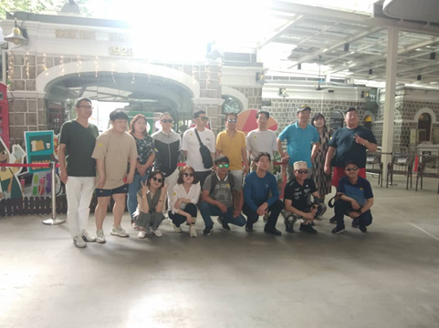
6 | 24 -29 June 2019 | Media | China | MALAYSIA AIRLINES CHINA & SINA WEIBO KOLs CAMPAIGN  -China most popular social media, Sina Weibo has lauched the ‘READ CITY’ Plan in 2018. They invite key opinion Leaders (KOLs) to travel worldwide to introduce different culture and history.  - The purpose of this familiarization trip is to focus on the history, multicultural activities in Penang.  - Penang Global Tourism will be hosting the ground arrangement such as transportation, tours, and meals throughout their stay here  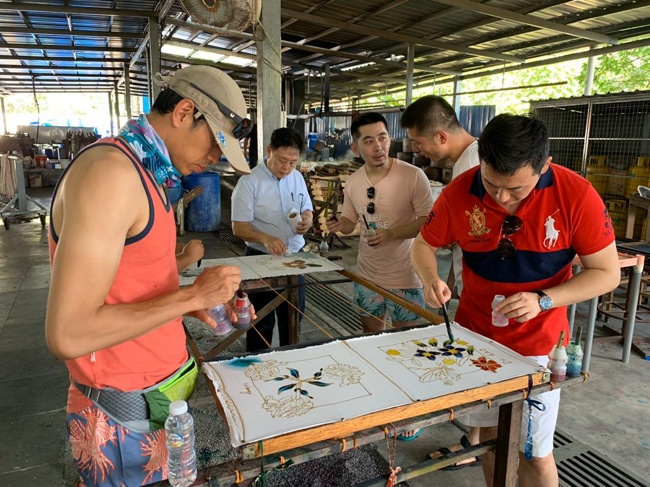  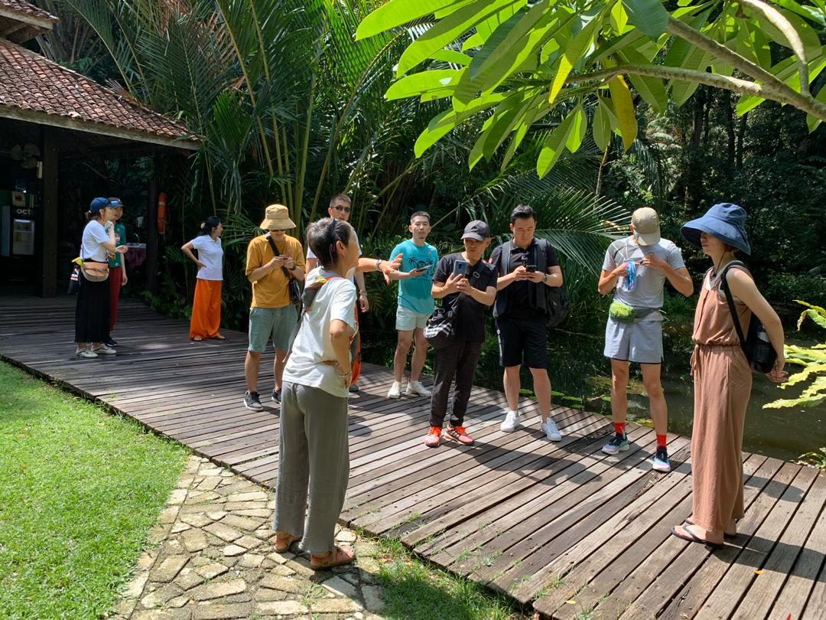 | Social Media Platform and Followers/likes  -358 million followers  -500 million followers  - 786 million followers  -560 million followers  - 395 million followers  -246 million followers  -110 million followers  - 720 million followers  - 376 million followers  -829 million followers
7 | 23 – 26 June 2019 | Media | New Zealand | NEW ZEALAND ‘CORPORATE TRAVELLER MAGAZINE’ FAM  - Tourism Malaysia Auckland office will be collaborating with Penang Global Tourism by organizing a familiarization Media Trip for Corporate Travel Magazine, Publishing Editor Mr. Bruce Laybourn. He will be in Penang start from 23 June until 26 June 2019.  - New Zealand Corporate Traveller Magazine is the premier business travel magazine of New Zealand and specially designed for leisure, food and business.  -The accommodation is hosted by ParkRoyal hotel Penang, Penang Global Tourism will be hosting the ground arrangement  -Such as transportation, tours, and meals throughout their stay here.  Media participating are as follows:  - Bruce Laybourn - Publishing Editor of Corporate Traveller Magazine  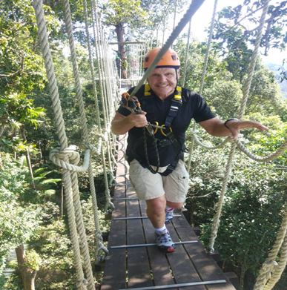  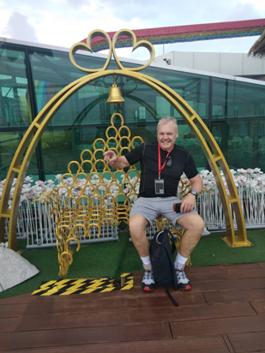 | Return from the Magazine:  -Amounts to more than NZ$75,000 in promotional space.  -Cover photo & headline  -Cover Story plus minimum 20 pages of editorial (this could grow substantially depending on regional/specialist attrition involvement)  - 200 print magazine delivered to one Auckland address  - Unlimited access to the identical online digital edition
8 | 12 July – 3 August 2019 | Agents | Taiwan | MEGA FAMILIARIZATION TRIP FOR TAIWAN WHOLESALERS  -Penang Global Tourism is collaborating with China Airlines and Taiwan Wholesalers to bring in Travel agents to Penang for product update in conjunction of Experience Penang 2020 campaign. Five main wholesalers in Taiwan will invite 40 pax of travel agents with special return ticket rates by China Airlines. A total of 200pax of travel agents will be visiting Penang from 12 to 3 August 2019. This the first time Penang is hosting a mega familiarization from Taiwan.  - The purpose of this familiarization trip is to promote and update Penang products as well as education tourism and wedding tourism  -Taiwan being a focus market that consistently one of the Top ten nationalities of international arrival into Penang  - To push Experience Penang packages in Taiwan market  -PGT collaborate with local industry players to co-host the mega familiarization trip from Taiwan in term of accommodations, transportation, tours, and meals.
9 | 12-16 July 2019 | Media | Australia | AUSTRALIA BLOGEER/INFLUENCER MEDIA FAM  - Tourism Malaysia Sydney office will be collaborating with Penang Global Tourism by organizing a familiarization Media Trip for Australia influencers, with positive numbers of followers Edward James and Sally Grace. They will be in Penang start from 12 July until 16 July 2019.  -The accommodation is hosted by Double Tree Resort Penang and Penang Global Tourism will be hosting the ground arrangement  -Such as transportation, tours, and meals throughout their stay here.  Media list as follows:  1. Mr. Edward James  2. Ms. Sally Grace  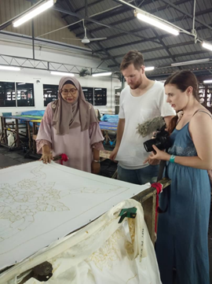  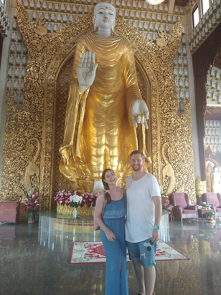 | Social Media Platform and Followers/likes  -Youtube: 7,706+  -Facebook: 235+  -Twitter: 1,263+  -Instagram: 5,500+  Publish link  https://www.youtube.com/watch?v=LiZErxL6Qqk  https://www.youtube.com/watch?v=2nOIA2Iy3K8
10 | 19 – 22 July 2019 | Students | Seoul and SMK Bukit Jambul | DAEWON KOREA STUDENT GROUP  -Student exchange programmes between Daewon International Middle School in Seoul and SMK Bukit Jambul has mutually agreed to develop this programme were initiated by Mr.Kang Chan Sik, the president of N Tour.  -The purpose of this trip to support the initiative of developing student exchange programme.  -Penang Global Tourism will be hosting the ground arrangement  -Such as transportation and meals during their trip in Penang.
 | 1-3 August 2019 | IMT – GT Partners | Indonesia  Thailand | HOSTING TECHNICAL VISIT FOR THE 12th IMT -GT WORKING GROUP  -MOTAC will be organizing the 12th IMT – GT working group meeting in Penang.  -The meeting will be attended by at least 50 delegates from Indonesia, Thailand and Malaysia which consists of government officers from district, state as well as federal level to discuss the coloration in term of marketing and development of Tourism products in IMT-GT.  -Penang Global Tourism will be supporting the event by hosting a technical visit to Penang Hill, Habitat and The Top.  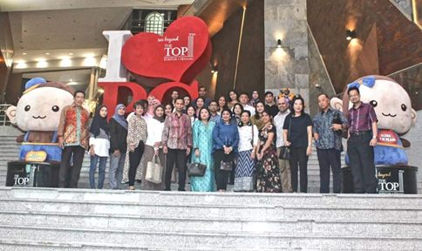  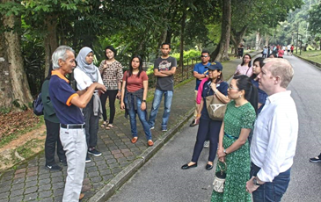
7 | 05 – 10  August 2019 | Media | China | CTRIP KOL FAM  -Penang Global Tourism partnership with Ctrip is organizing a familiarization Media Trip for bringing on a KOL from China to feature Penang as well as create new contents, with 1.01million followers.  - Katherine will be in Penang start from 05 August 2019 until 10 August 2019.  -The accommodation is hosted by Eastern Oriental Hotel and Penang Global Tourism will be hosting the ground arrangement  -Such as transportation, tours, and meals throughout she stays here.  Media list as follows:  - Katherine  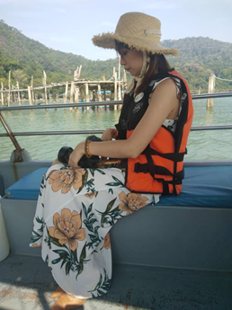  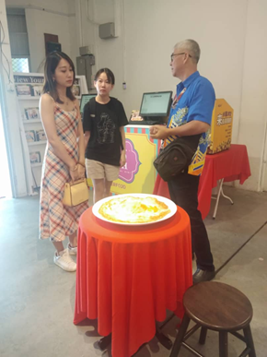 | Social Media Platform and Followers/fans  -Weibo 1.01million  (https://www.weibo.com/babykkk?is_hot=1)  -Ctrip 3,574  (https://you.ctrip.com/members/E23E50FD854646D09D9252F07EF7FC16)  -Ma Feng Wang 10,785  (http://www.mafengwo.cn/u/45974285.html)  -Yi Zi Bo 115,713  (http://www.yizhibo.com/member/personel/user_info?memberid=28941937&jumpbrowser=1&nest_url=)  -Douyin 17,342  http://v.douyin.com/kbKRyu/  -Xiao Hong Shu 51,000  https://www.xiaohongshu.com/user/profile/58354f725e87e70ef5ad92e1?xhsshare=CopyLink&appuid=551d6a32d39ea242f3f24b6c&apptime=1563270831
9 | 28-31 August 2019 | Media | Istanbul | ISTANBUL ‘INTERNATIONAL TOURISM MAGAZINE’ MEDIA FAM  -Tourism Malaysia Istanbul office will be collaborating with Penang Global Tourism by organizing a familiarization Media Trip for International Tourism Magazine.  -International Tourism Magazine will join familiarization tour focusing on Spa, wellness and medical tourism.  -This Media Trip feature most exclusive and luxurious places for accommodation, spa, health, shopping, dining and sightseeing in Penang.  -They will be in Penang start from 28 August until 31 August 2019.  -Penang Global Tourism will be hosting the accommodations and ground arrangement such as transportation, tours, and meals throughout their stay here.  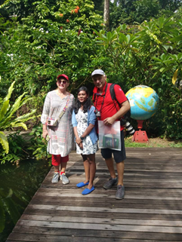  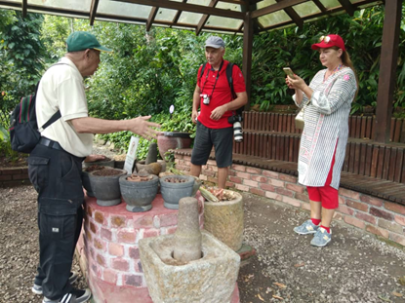 | Return from the Magazine:  -Publish Penang article in international Tourism Magazine-Spa, Wellness and Medical that will be published on 1 February 2020  -A total of 6 pages where 4 pages about destinations and 2 pages for hotel.
 | 6-9 September 2019 | Agent | China | MALIND0 AIR CHINA AGENTS FAM  - Penang Global Tourism is collaborating with Malindo Air planning the agent FAM trip from Guangzhou, Shenzhen, Zhengzhou and Chengdu to Penang.  - The purpose of this trip not only focused on leisure tourism but also medical tourism as a new product.  Agent participating are as follows:  - Guangdong Sunshine Holiday  - GZL International Travel Service Ltd  - Comfort International Travel Service  - China International Travel Service  - Shangpin Tour Shenzhen  - Henan Citic International Travel  - China Comford Travel Henan  - Le Pont International  - Chengdu International Travel  - Sichuan New Oriental International Travel  - Malindo Air China Offices  - Penang Global Tourism will be hosting the accommodations and ground arrangement such as transportation, tours, and meals throughout their stay here.
 | 2-7 September 2019 | Media | Malaysia | TOURISM MALAYSIA MEGA FAM TOUR -ITS SUMMER TIME IN MALAYSIA PERAK &PENANG  -Tourism Malaysia is organizing Mega FAM programme VM2020 Edition.  -A total of 33 media from 13 countries will be taking part in this programme and will separated in 3 groups to major beach/islands destination.  -Penang Global Tourism will be sponsoring the farewell dinner for the group at the Prestige Hotel.
10 | 12-13 September 2019 | Media | India | FOODOMANIA INDIAN PUBLICATION MEDIA FAM  - Blogger (Kavitha) Founder of the Indian Publication - Foodomania.com have been writing about food, recipes, and travel (revolving around food and culture) for the past 7 years  -Kavitha have over 200K subscribers across various social media platforms.  -The website also attracts a lot of working Asian and American readers (to the tune of ~250K views a month) who enjoy exploring new cultures.  -She also writes for the Parade Magazine where receive anywhere between 300K to 800K views in a month.  -Kavitha will be visiting Penang from 12 -13 September 2019.  -Penang Global Tourism will be hosting the 1-day guided tour with ground arrangement such as transportation, tours, and meals.  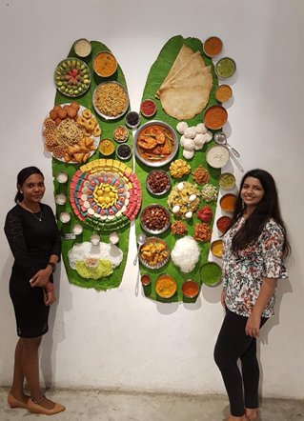  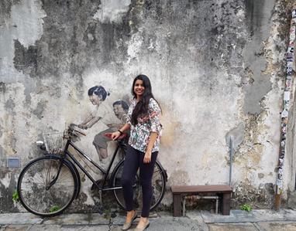 | Return from Kavitha for overall trip:  - A blog post on the food and culture in Penang  - 10-20 Instagram Stories featuring the city and its offerings  - Instagram, Facebook, and Twitter posts - 4 each, tagging the handle  - A video of my experience at the hotel (focusing mainly on the chefs, food, and drinks, but also highlighting the city.) - posted on IGTV and YouTube
 | 7 September 2019 | Media | USA | ARCHITECTURAL DIGEST MEDIA FAM  -Liza Weisstuch, a journalist from USA will be visiting Penang to write an article for Architectural Digest, a Conde Nast Magazine, about George Town and Heritage Hotels.  -Penang Global Tourism will be hosting the 9am to 2pm guided tour with ground arrangement such as transportation, tours, and meals.
11 | 27-29 September 2019 | Media | USA & Australia | EXPEDIA KOLS FAM TRIP  -Tourism Malaysia and Expedia Group will be organizing the KOLs Fam Trip from 24th September till 2nd October 2019 in Malaysia and they will visit Penang start from 27 September 2019 until 29 September 2019.  -This trip is a collaboration program between the Tourism Malaysia and Expedia Group in order to promote Visit Malaysia specifically for USA & AUS markets.  - This trip involves three KOLs and one producer from the USA and Australia  -Flamingo Hotel and transport will be provided by Expedia.  -Penang Global Tourism will be hosting the ground arrangement such as tour guide, tours, and meals throughout their stays here.  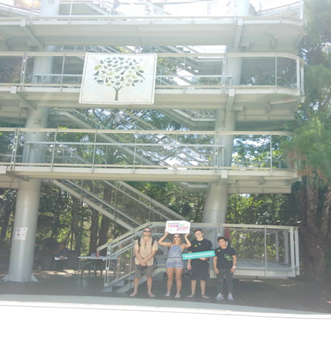  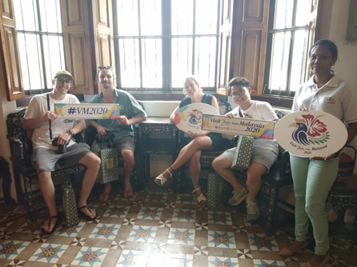 | In return, KOLs will promote the destinations on their social media accounts and the content will also be broadcast on Tourism Malaysia's social media.  Social Media Platform and Followers/fans:  -Instagram: Mitch Cox and Cleo Cohen  https://www.instagram.com/mitch.cox/  https://www.instagram.com/cleocohen/  Followers: 115k and 142k  Location: Sydney  -Instagram: Ty Newcomb  https://www.instagram.com/eye.of.ty/  Followers: 166k  Location: US

