Contents

AIRASIA PR TRIP 3 – 6 JANUARY 2019………………………………………………………2-3
QATAR AIRWAYS ROMANIA FAM 26-31 JANUARY 2019…………………………………3-4
QATAR AIRWAYS KUWAIT TRAVEL AGENT FAM …………………………………………..5-6
31 JANUARY- 03FEBRUARY 2019

BONE MAGAZINE MEDIA FAM………………………………………………………………………6-7

4. Marketing and Promotions

4.2 Familiarization Trip/Official Visit (January 2019 to April 2019)
No | Project Date | Type | Country | Familiarization Trip/Official Visit
1 | 3 – 6 January 2019. | Media | Singapore | AIRASIA PR TRIP  -Penang Global Tourism will be collaborating with AirAsia Singapore to do PR trip for 2 groups which will be media and KOL/influencer group.  -Penang Global Tourism hosted their ground arrangements such as transportations, tours, and meals for both group  -The objective is to showcase to Singaporeans that a short, fulfilling getaway is possible for travel frequently to Penang.  Details as below:  Date: 3-4 January 2019 (10 pax media)  Date: 5-6 January 2019 (10 pax KOL/Influencer)  Media list as below:  - Channel News Asia Lifestyle  - Lifestyle Asia  - Coconuts Singapore  - Weekender  - 8 Days  - SethLui.com  - City Nomads  - Straits Times  - Time Out Singapore  - SG Magazine  - Yahoo Asia (Back-up)  - NYLON Magazines (Back-up)  - Her World Magazine (Back-up)  KOL/Influencer Media List as below:  - Andrea Chong, https://www.instagram.com/dreachong/  - Joanna Lim, https://www.instagram.com/joannalhs/  - Rebecca Ten, https://www.instagram.com/beccabeczten/  - Xenia Tan, https://www.instagram.com/hotcheekylacee/  - Aiken, https://www.instagram.com/aikenchia/  - James Seah, https://www.instagram.com/jamesseah/  - NicolemChangmin,  https://www.instagram.com/nicolechangmin/  - Alfred Sim, https://www.instagram.com/zolalfredo/  - Tay Kewei, https://www.instagram.com/keweitay/  - Ripple Sim, https://www.instagram.com/ripplesim/  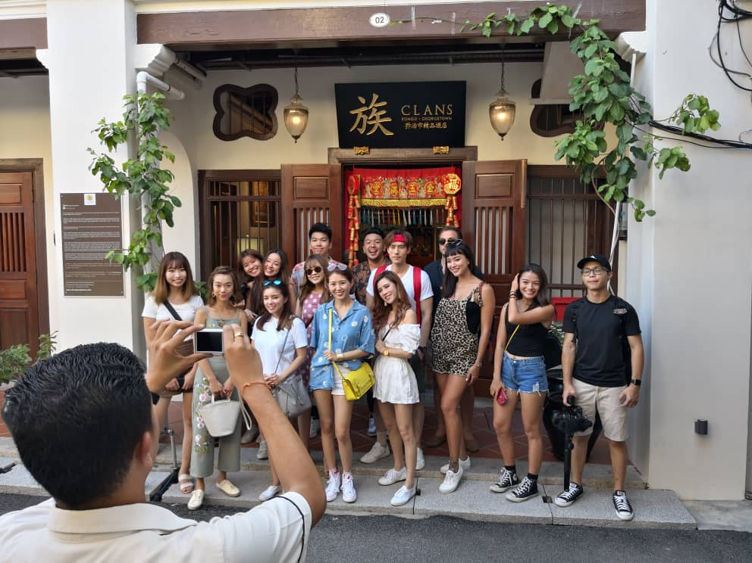
 | 26-31 January 2019 | Agent | Romania | QATAR AIRWAYS ROMANIA FAM  -Penang Global Tourism, Tourism Malaysia Istanbul and Qatar Airways will collaborate to organize a familiarization trip for travel agents from Romania on 26-31 Jan 2019.  -The accommodation is hosted by Holiday Inn Resort, Penang Global Tourism will be hosting the ground arrangement  -Such as transportation, tours, and meals throughout their stay here  Agents participating are as follows:  - Mrs. Alina anca brodoceanu – Eturia  - Mrs. Ciuplea antoaneta iosefina- New concept travel  - Mrs. Kruzslicz corina nicoleta – Fibula air travel  - Mr. Cristian stefan – Travel time d&r  - Mrs. Cristina-ileana basangeac – Magic holiday  - Mrs. Mirela hristoff – Accent travel & events  - Mrs.Elena noema corcodel - Smart tours  - Mrs. Ana ceban -Skyline  - Mr. Ereik sofian - Z Tour  - Mrs. alexandra georgiana sirbu – Qatar Airways  - Ms. Syafinaz bujang - Tourism Malaysia Istanbul  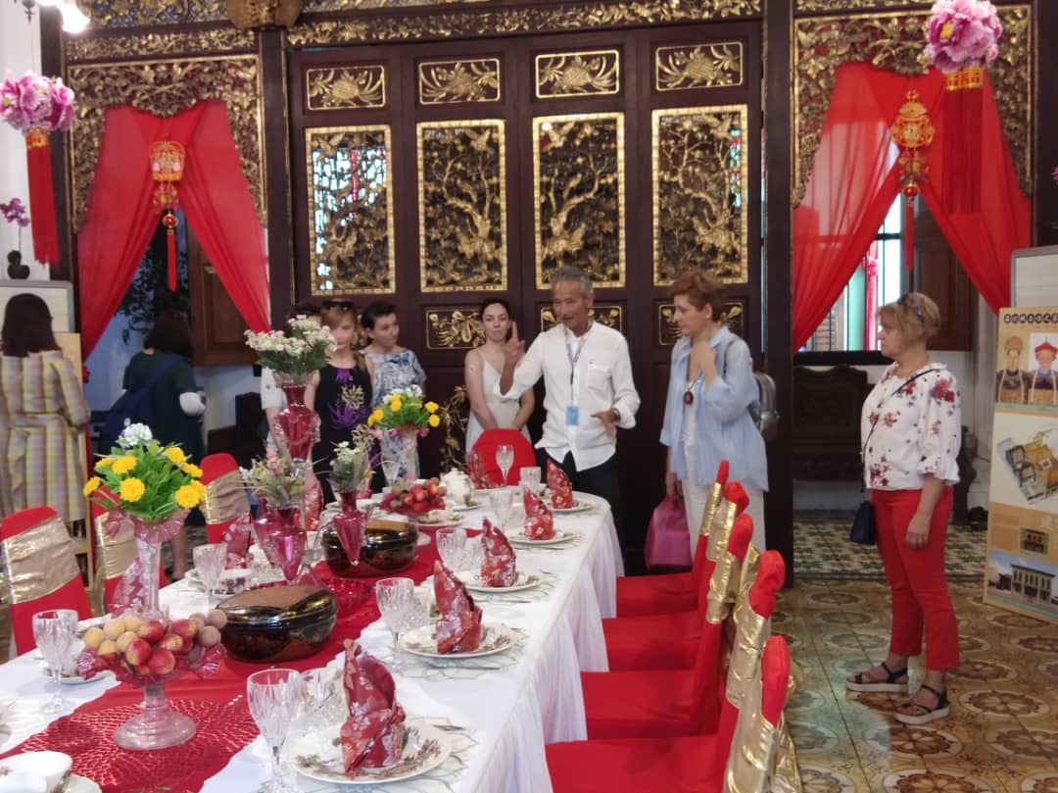  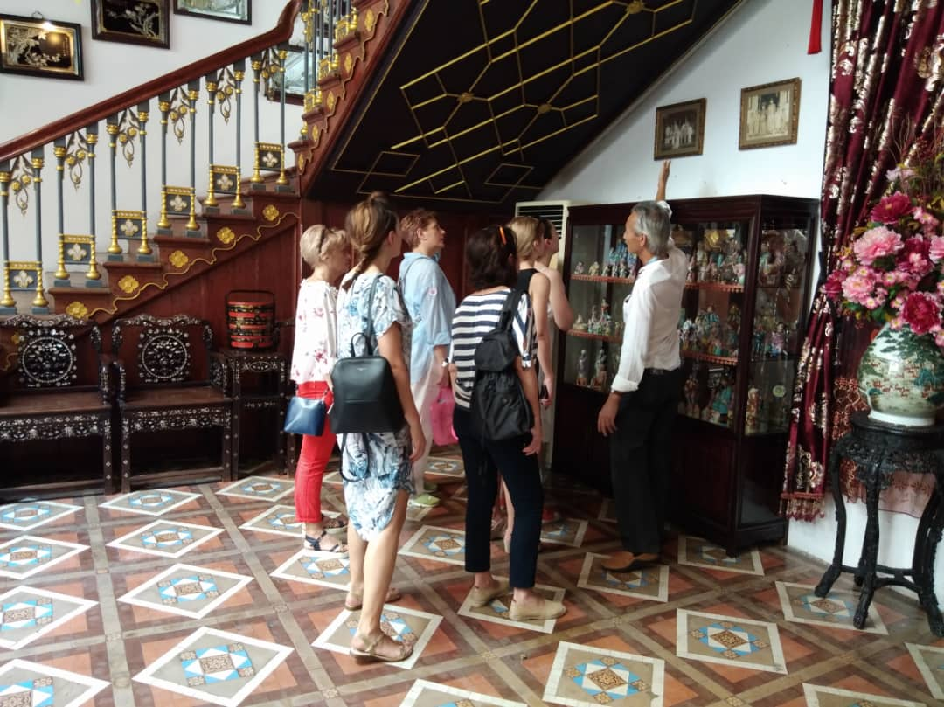
 | 31January- 03  February 2019 | Agent | Kuwait | QATAR AIRWAYS KUWAIT TRAVEL AGENT FAM  -Penang Global Tourism, Tourism Malaysia Dubai and Qatar Airways Kuwait will collaborate to organize a familiarization trip for travel agents from Kuwait on 31 January-03 February 2019.  -The accommodation is hosted by Hard Rock Hotel and Lexis Hotel. -Penang Global Tourism will be hosting the ground arrangement  Such as transportation, tours, and meals throughout their stay here  -The purpose of this familiarization trip is to introduce and promote tourism product in Penang to the travel agents.  -Especially as each travel agencies targeted on different petroleum and petrochemical companies in Kuwait.  Agents participating are as follows:  - Mr. Umar Malik -Sales Manager, Cozmo Travel / Kuwait Drilling Company  - Mr. Arun S Panicker- Senior Travel Consultant, Badur Travel / Kuwait Petroleum International  - Mr. Latif Mansoor Ali-Office Supervisor, Jumbo Travel / KIPIC Implant  - Mr. Mohammad Tabbaa- Senior Travel Consultant, Boodai Aviation / Kuwait National Petroleum Company  - Mr. Zia Ali- Business Development Manager, Al Waseet Travel / Kuwait Finance House  - Mr. Abdullah Cheaib- Contract Manager, Boodai Aviation / Petrochemical Industries Company  - Mr. Tareq Quttaineh- Key Account Manager, Barakat Travel  - Mr. Mr. Abdallah Zayat- Senior Travel Consultant, Boodai Aviation / Kuwait Oil Company  - Ms. Rachna Norris- Assistant Manager, Al Ghanim Travel / Al Ghanim industries  - Mr. Ahmed El Sisy-Senior Sales Executive, Qatar Airways  - Mr. Amir Muhammad  - Hanif- Marketing Manager, Tourism Malaysia  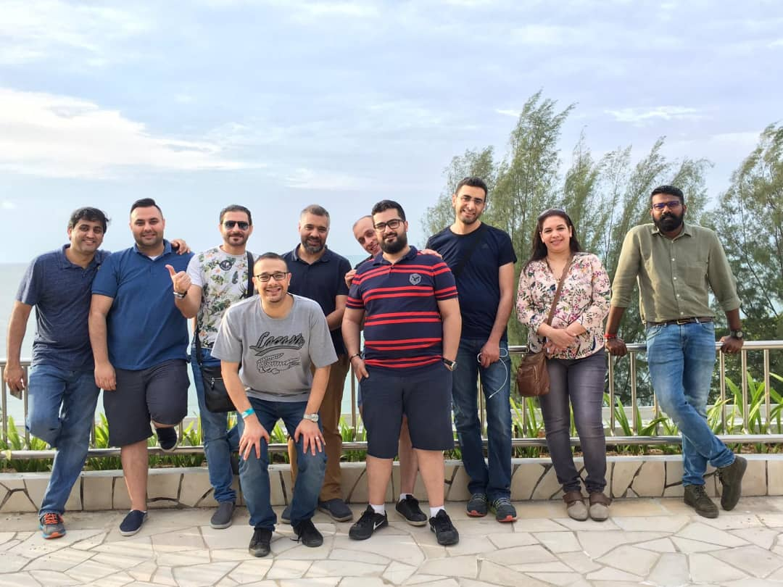  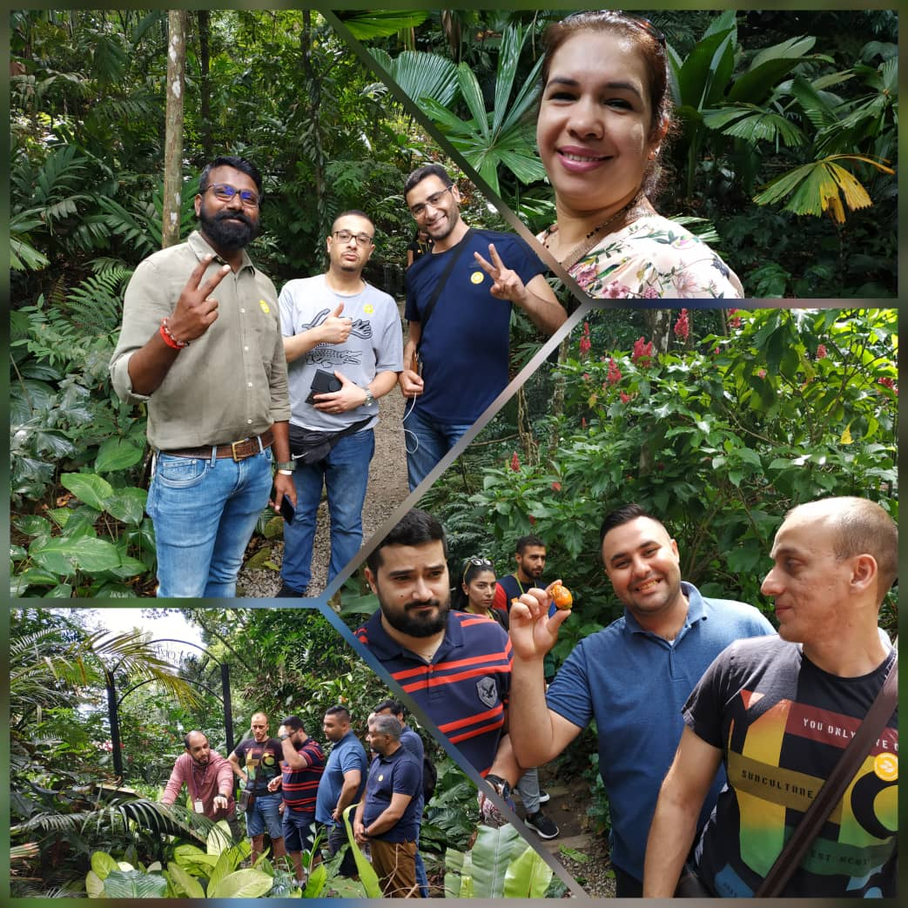
2 | 10- 13 February  2019 | Media | Istanbul | BONE MAGAZINE MEDIA FAM  -Tourism Malaysia Istanbul office will be collaborating with Penang Global Tourism organise a familiarization media trip for Bone Magazines to Malaysia from 9-19 February 2019.  - The group will start from Penang on 10-13 February 2019, followed with Langkawi, Melaka and lastly Kuala Lumpur.  -Bone Magazine is a monthly travel and trend magazine that defines the modern global culture of traveling by exploring the hippest places to stay, eat and see around the world.  -Bone Magazine is specially designed as a major source of reference for a luxurious and distinguished living experience.  -Penang Global Tourism hosted their ground arrangements such as transportations, tours, and meals throughout their stay here  Media list as follows:  - Ms.Beste Zeybel- Photographer, Dukkan Publishing and creative agency  - Mrs.Derya Gursel Arslan-Publising Coordinator, Dukkan Publishing and creative Agency  - Ms. Damla Kurklu- Editor in Chief, Dukkan Publishing and Creative Agency  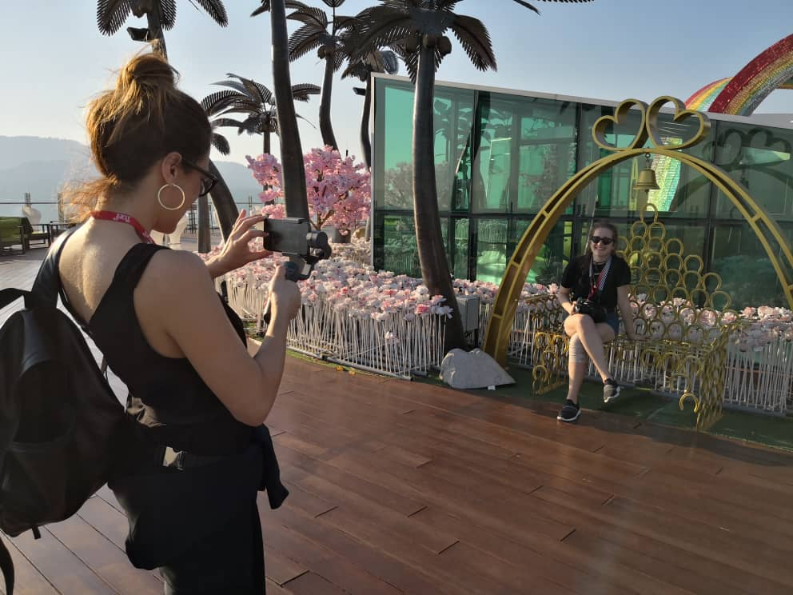
3 | 13-17 February 2019 | Media | London | CATCH52 BLOGGER LONDON FAM  -Malaysian Airlines partnership with foodie blogger will be collaborating with Penang Global Tourism organise a familiarization trip to Penang as a prize for winning the best travel blog 2018 award. -Catch52 is a popular luxury food and travel blog in London run by Em. Besides that, Catch52 also has a loyal following for her expertise in Food, culture as well as nature in her coverage.  -Catch52 highly engaged with community via social media, with over 40,000 combined followers.  -Em from Catch52 able to provide Professional Photography, Social Media coverage plus permanent posts along with stories using hastags and handles throughout the trip in Penang.  -Penang Global Tourism will be hosting 5-hours (9am to 2pm) George Town walking tour with transportation, tours and meals.  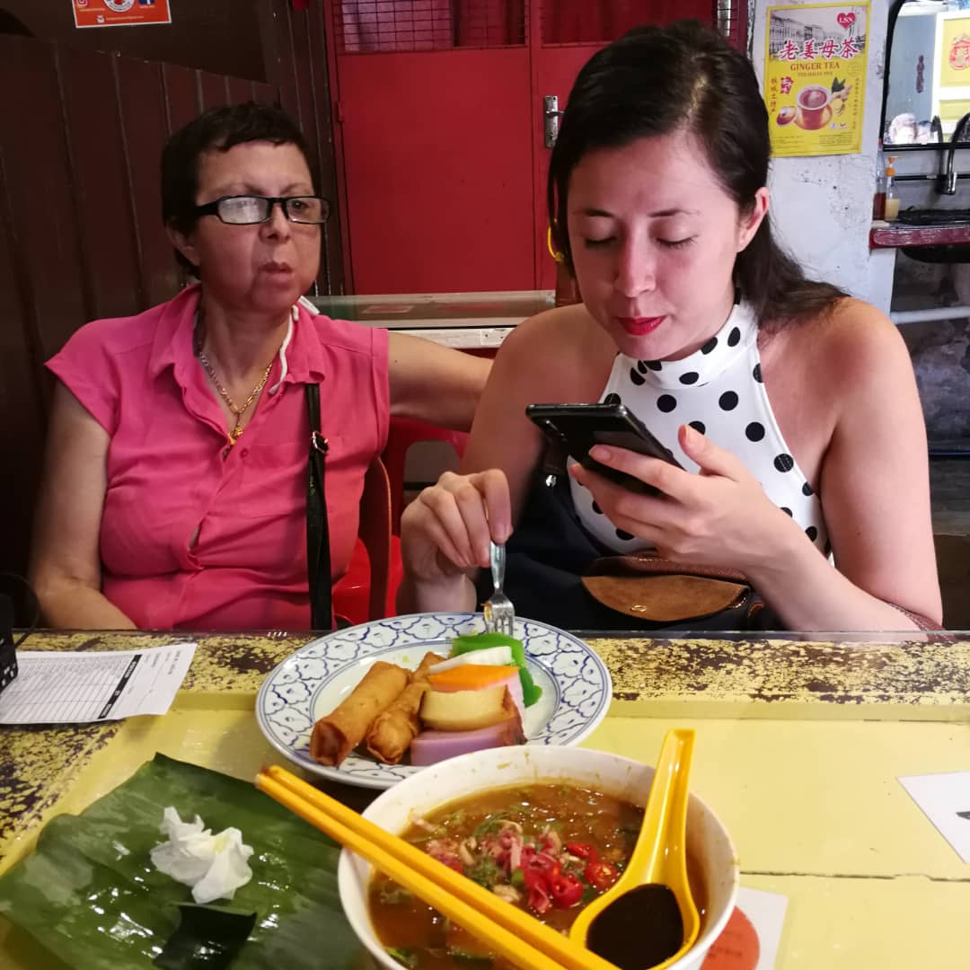  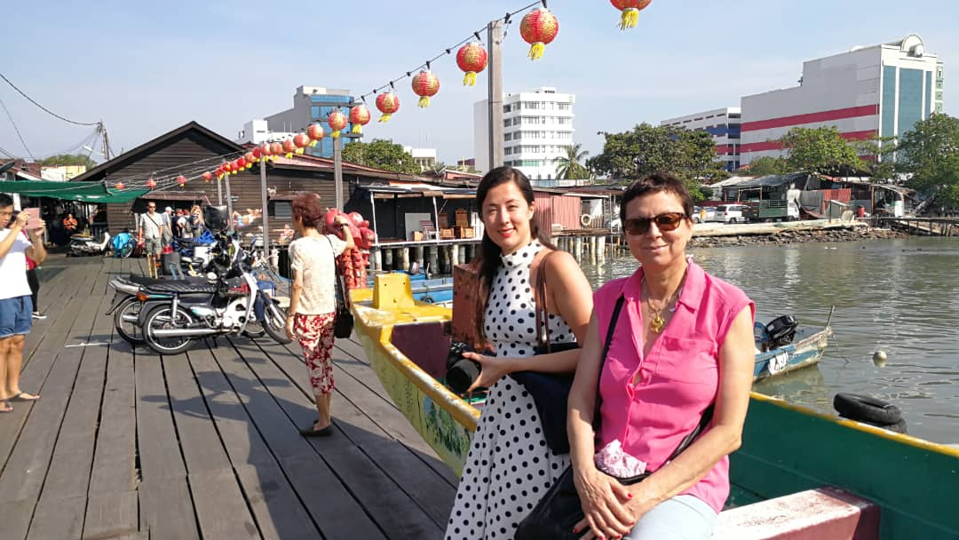
4 | 17-21 February  2019 | Agent | Sudan | QATAR AIRWAYS SUDAN FAM  -Penang Global Tourism, Tourism Malaysia Sudan and Qatar Airways Sudan will collaborate to organize a familiarization trip for travel agents from Sudan on 17-21 Feb 2019.  -The accommodation is hosted by Double Tree Resort by Hilton Hotel, Penang Global Tourism will be hosting the ground arrangement  -Such as transportation, tours, and meals throughout their stay here.  Agents participating are as follows:  - Fatima Badawi Abueldahab Badawi – Aldiwania Travel  - Mahad Mohamed Gasmelsied Ahmed – Dartex Travel  - Rehab Mohameed Albadry Moohammed – Snas Travel  - Shaza Sirelkhatim Ahmed Elkhidir – Mak Teo Travel  - Mehira Allazim Hamid Gadalla – Zijing Agency  - Heba Nasr Fahmy Salama – Lisamin Travel  - Eman Sadig Abdelnour Melaik – Olympia Agency  - Sally Farouq Ahmed Unis – Razaz Travel  - Asmahan Suliman- Malaysia Embassy Sudan  - Samira Omer Ismail Hashim – Qatar Airways Sudan  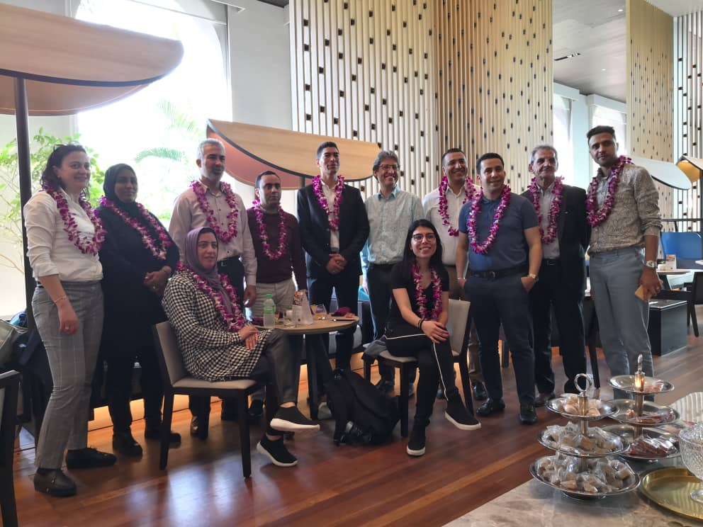
5 | 22 February 2019 | Media | America | AMERICAN MEDIA ‘HONEST COOKING’ FAM  -Journalist (Lilit Mkrtchyan) from Honest Cooking will be writing articles on the topic “Culinary Travel through Penang” which will be published on American Media Honest Cooking.  -Honest Cooking is an international online culinary magazine with the ambition to truly change the face of online food media.  - Besides That, this magazine features over 900 of the world’s most interesting food. They will be visiting Penang from 18 February 2019.  -Penang Global Tourism will be hosting 5-hours (9am to 2pm) George Town walking tour with transportation, tours and meals.  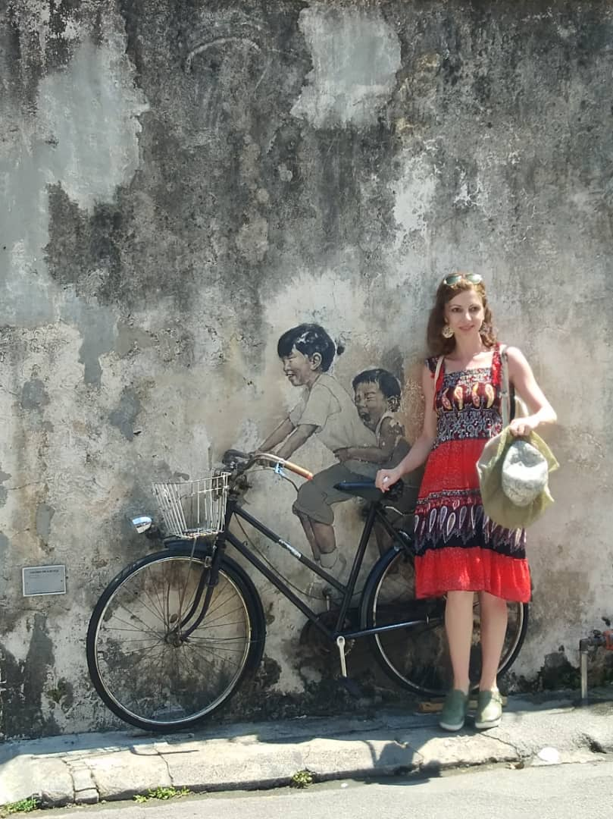  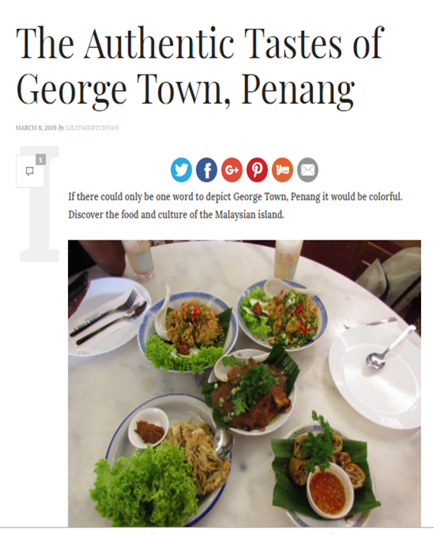  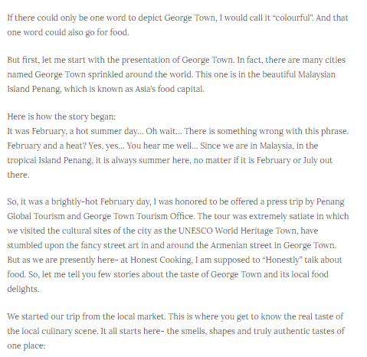  http://honestcooking.com/authentic-tastes-george-town-penang/  Article by LILITMKRTCHYAN
6 | 22- 27 February 2019 | Agents | UK | QATAR AIRWAYS UNITED KINGDOM CORPORATE TRAVEL AGENTS  -Penang Global Tourism, Qatar Airways will collaborate to organize a familiarization trip for the Top corporate travel agencies in United Kingdom to Penang and they will be decision makers and sales influencers from 22 to 27 February 2019.  -The accommodation is hosted by ParkRoyal Resort; Penang Global Tourism will be hosting the ground arrangement such as transportation, tours, and meals throughout their stay here.  Agents participating are as follows:  - BCD Travel  - CTM  - Egencia  - Statesman  - Advantage  - Ian Allan  - Clarity  - Reed & Mackey  - Qatar Airways Representative  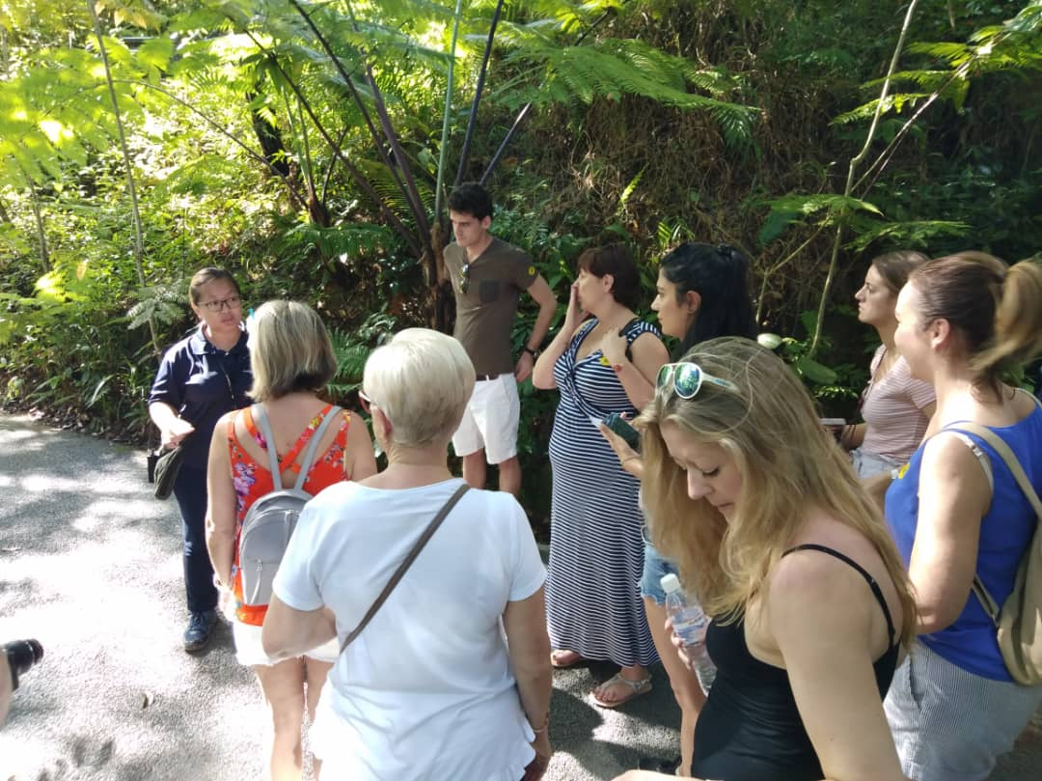
7 | 26 -28 February 2019 | Agent | UAE | SINGAPORE AIRLINES FAM  -Penang Global Tourism, Tourism Malaysia Dubai and Qatar Airways Sudan will collaborate to organize a familiarization trip for travel agents from UAE to Penang on 26-28 Feb 2019.  -The accommodation is hosted by E&O hotel. Penang Global Tourism will be hosting the ground arrangement such as transportation,tours, and meals throughout their stay here.  Agents participating are as follows:  - Mr. Wilson Aby Mathew -Sales Manager, Orient Agency  - Mr. Ahamed Muster- Senior Travel Consultant, Cozmo Agency  - Mr.Vijay Bangar-Team Leader, ATPI Agency  - Mr. Mohan Singh- Team Leader, Kanoo Agency  - Mr.Ashok Narayanan- Senior Consultant, Uranus Agency  - Mr. Fazeel Ashraf- Assistance Team Leader, FCM Agency  - Mr. Uzair Ahmad- Travel Consultant, AI Tayer Agency  - Mr. Ma Apolonia Bradecina- Travel Consultant, Satguru Travel  - Mr. Mohamad Ghulam –Senior Consultant ,Arabian Air Travel  - Malaysia Embassy Dubai Representative  - Mr. Syed Khalid Qadir-Singapore Airways Representative  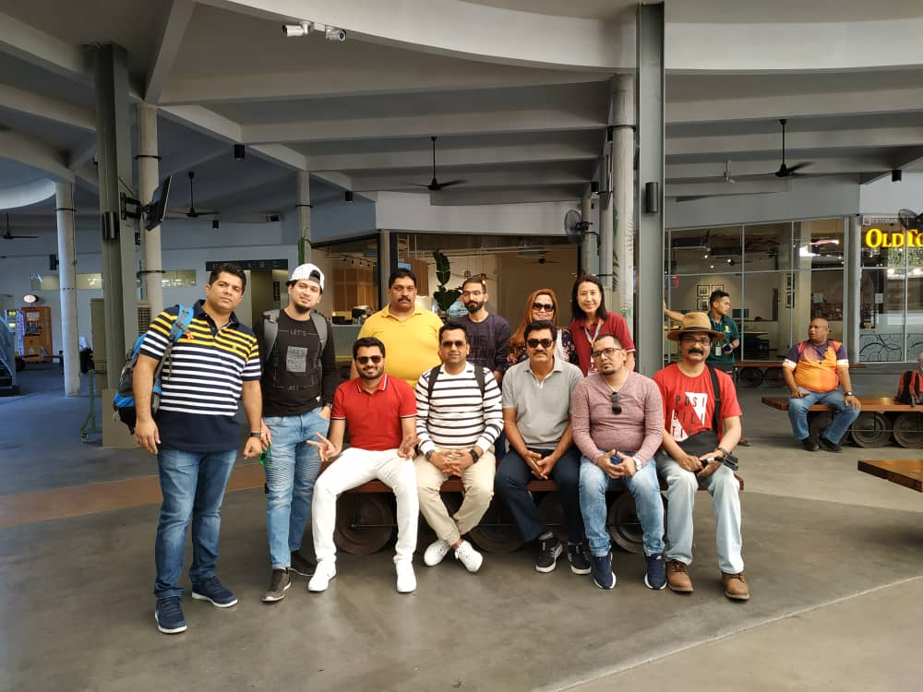  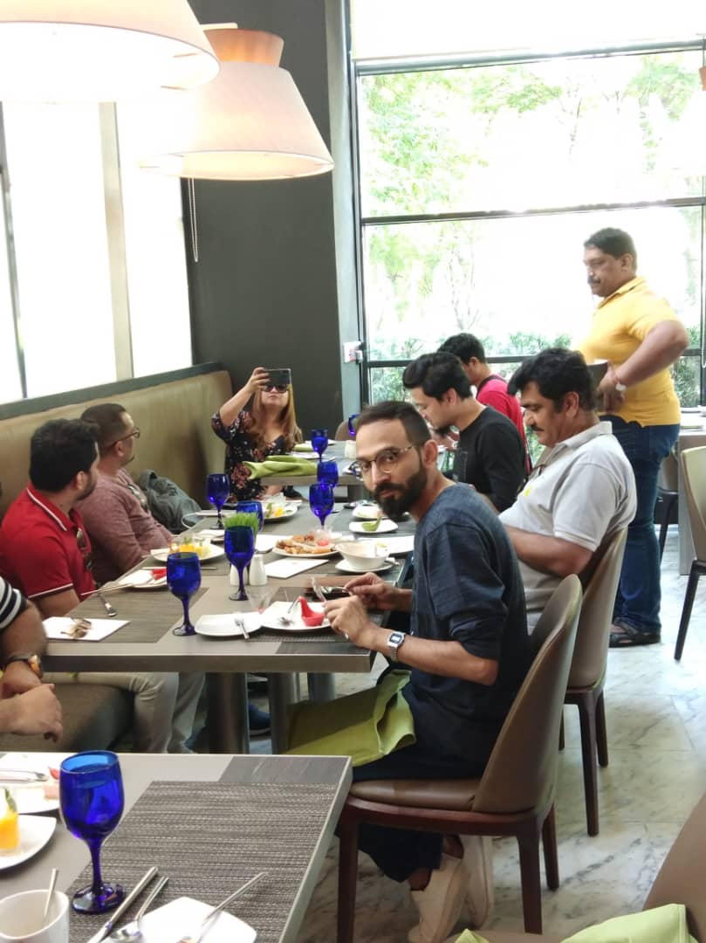
8 | 26 Feb – 02 March 2019 | Agents | UK | QATAR AIRWAYS UK TRAVEL AGENTS FAM  -Penang Global Tourism, Tourism Malaysia and Qatar Airways United Kingdom will collaborate to organize a familiarization trip for travel agents from United Kingdom to Penang on 26 February to 02 March 2019.  -The accommodation is hosted by Shangri-la and E& O. Penang Global Tourism will be hosting the ground arrangement such as transportation, tours, and meals throughout their stay here.  Agents participating are as follows:  - Ms. Susan-RSM,Virgin Holidays  - Mr.Leigh - Assistant Store Manager, Kuoni  - Ms.Louise- Counsellors,Travel Counsellors  - Mr.Martin - Asia Operations, Gold medal  - Mr.Jason - Asia Reservations  - Ms.Kyra colleen joy- Marketing Executive, Travelbag  - Ms.Jodie- Sales consultant, Hayes and Jarvis  - Ms.Caitlyn- Travel expert ,STA  - Mr.Daniel- Account Manager, Qatar Airways Representative  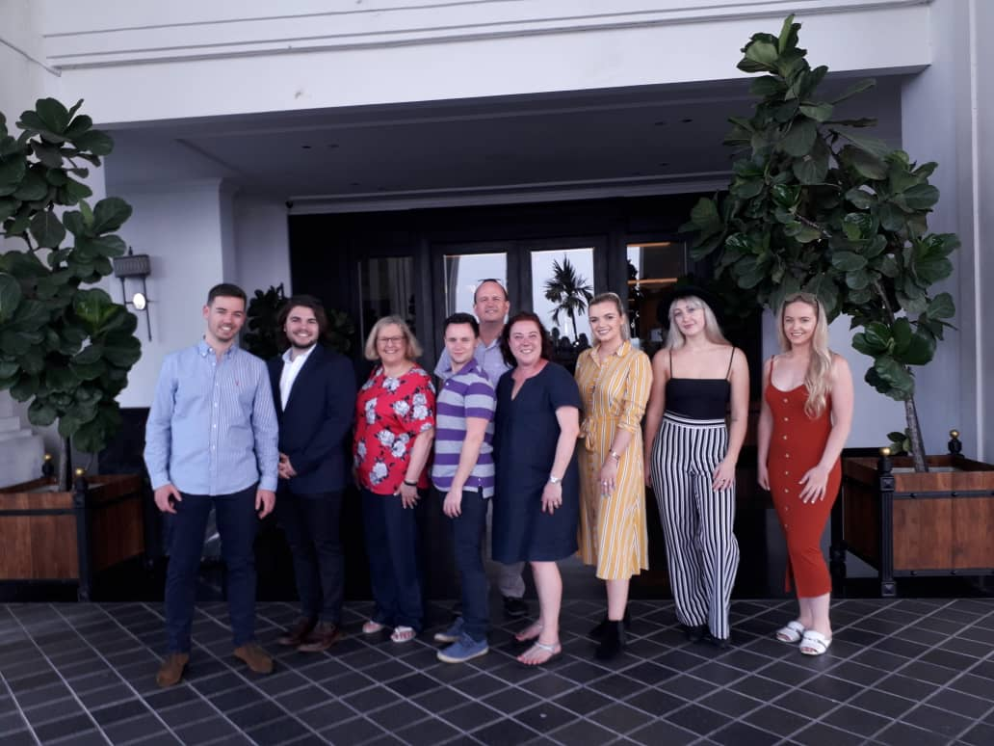  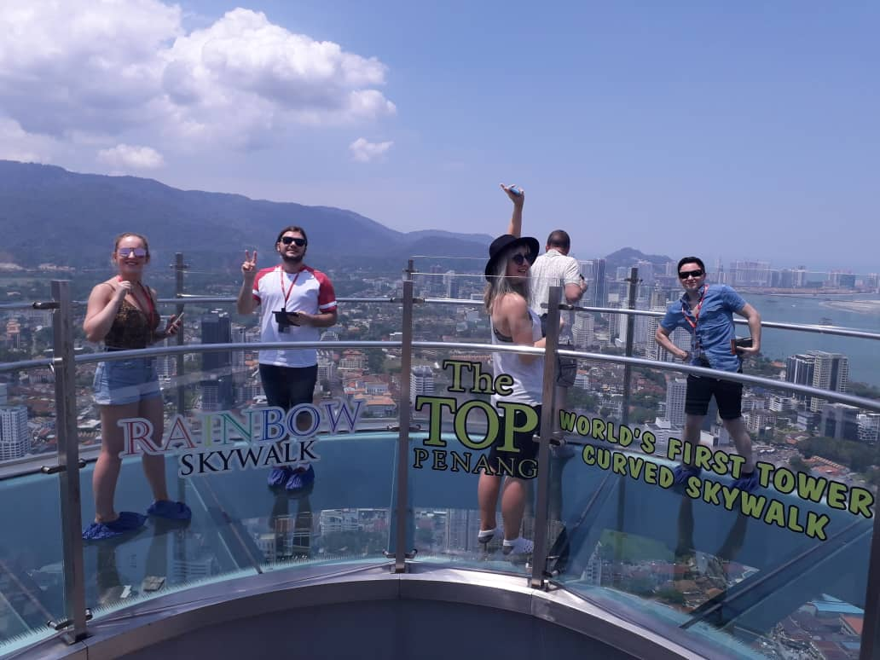
9 | 01-04 March  2019 | Agents & Media | Japan | AIRASIA X FUKUOKA TRAVEL AGENT & MEDIA FAM  -AirAsia X is flying direct from Fukuoka to Kuala Lumpur starting 1 March 2019.  -Penang Global Tourism and Air Asia X will collaborate to organize a familiarization trip for travel agents and media from Fukuoka on the inaugural flight to Penang and Kuala Lumpur.  -The accommodation is hosted by Muntri Grove. Penang Global Tourism will be hosting the ground arrangement such as transportation, tours, and meals throughout their stay here.  Agents and Media participating are as follows:  - H.I.S Kyushu  - Hankyu Travel Inti’ I Kyushu  - JTB (Kyushu)  - Travel West  - Travel Westv  - Mr. Kanda, AirAsia Representative  - Mr. Hidehiro Yamaguchi (media)  - Nishinihon Shimbun  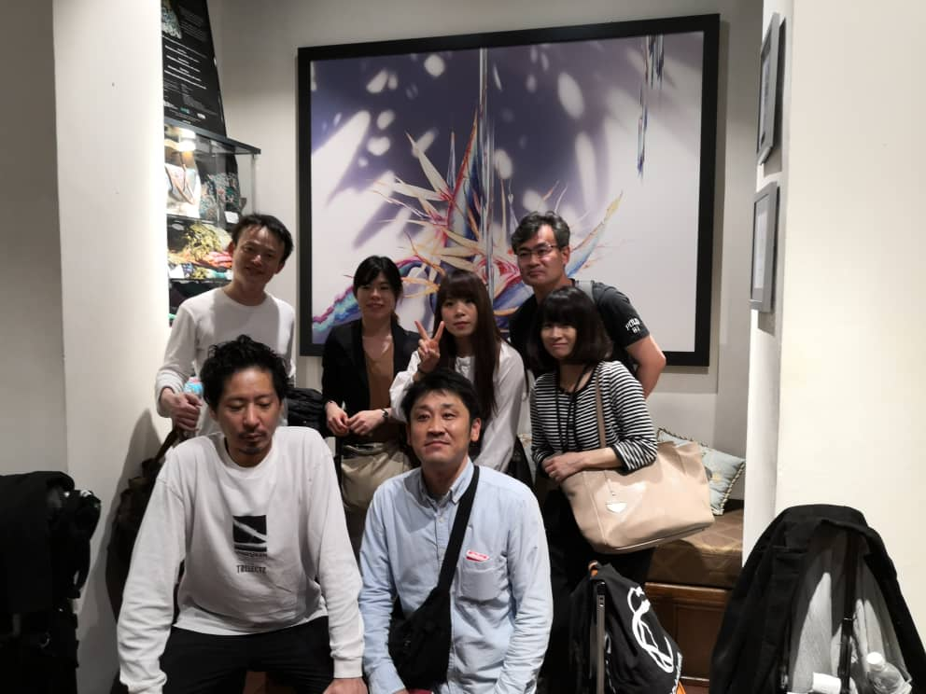
 | 09- 12 March 2019 | Agents | Sudan | QATAR AIRWAYS CASABLANCA FAM  -Penang Global Tourism, Qatar Airways Casablanca and Tourism Malaysia Jedah office is organizing a familiarization tour for travel agents from Sudan to Penang from 09-12 March 2019.  -The group of 11 pax consists of; 10 pax travel agents and 1 Qatar Airways officer  -The accommodation is hosted by PARKROYAL Resort Penang and Penang Global Tourism will be hosting the ground arrangement such as transportation, tours, and meals throughout their stay here  Agents participating are as follows:  - Mrs. Gouram Meryem- Sales Responsible, EI Yakout Voyages  - Mr. Al Hariri Fouad- Sales Manager, Atlantis Voyages  - Mr. El Hadaji Abdelhak- Manager, Venizia Travel  - Mrs. Abdellaoui Houcine- Sales Manager, Assafa Asfar  - Mr. Aabadou Said-Sales Manager, Aljazira Tourisme Travel  - Mr.Khouyoui Kamal- Tourism Sales Responsible, Terratour  - Mrs. Saielhaq Nadia- Sales Manager, Nassim Voyages  - Mrs. Khelloufi Naoual- Tourism Manager, Chellah Voyages  - Mr. Elkhadiri Reda- Tourism Manager, Safari Voyages  - Mrs. Bouazzaoui Lamiae- Sales Manager, Premices Voyages  - Mr. Sajid Taoufik- Account Manager, Qatar Airways  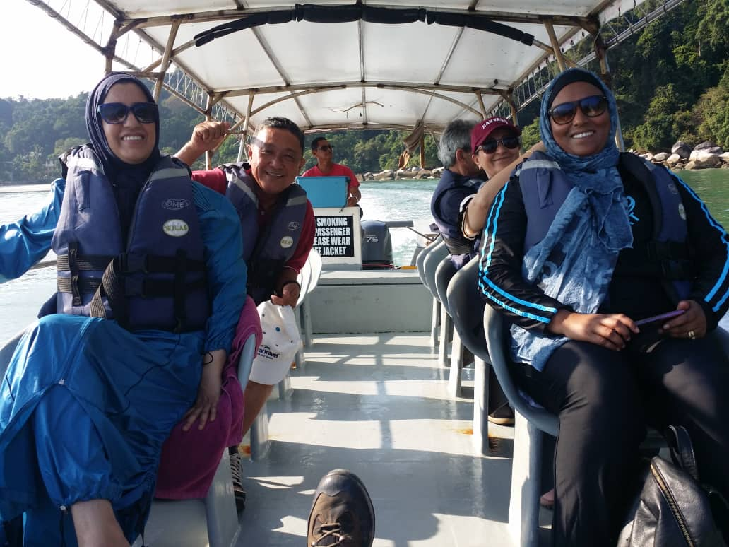  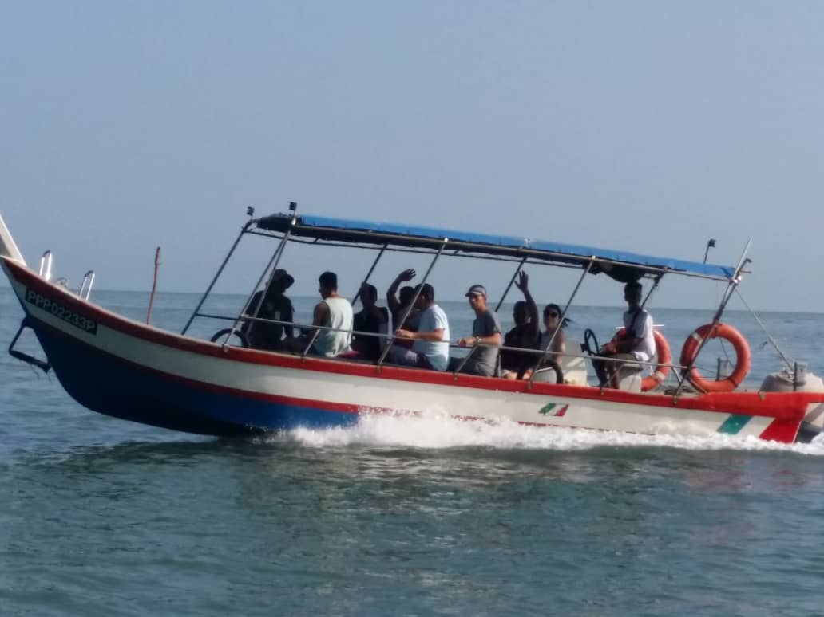
10 | 07-10 March 2019 | Agents | Dubai | QATAR AIRWAYS TM- DUBAI FAM  -Penang Global Tourism, Qatar Airways and Tourism Malaysia Dubai is organizing a familiarization tour for Corporate agents from Dubai to Penang from 07-10 March 2019.  -The group of 10 pax consists of; 8 pax corporate agents, 1 Qatar Airways officer, and 1 Malaysia Embassy Staff.  -The accommodation is hosted by ParkRoyal and Penang Global Tourism will be hosting the ground arrangement such as transportation, tours, and meals throughout their stay here.  Agents participating are as follows:  - Mr.Wesam Ghanam - Travel manager, Power Holding Group  - Mr. Teophanes Stratupholi - HR & Admin Manager, Aktor SA  - Mdm. Mariam Khan- Travel coordinator Business Trading Company  - Mr.Ashraf Valappil -General services supervisor, Dolphin Energy  - Mr.Akash Achenkunju- HR Manager, Gulf Warehousing Company  - Mr.Elie Azzi – CHRO, ENSERV group  - Mr. Ozcan Alkac -Office manager , Hamad Bin Jasem group  - Mr. Ewan Cameron –CFO, Mannai Corporation  - Mr. Hichem El Ouej-Sales Executive, Qatar Airways Representative  - Mr.Mohamed Lotfy -Tourism Malaysia Representative  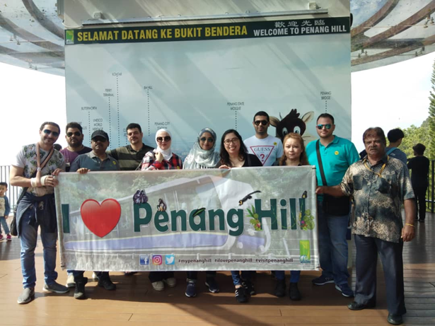
11 | 16-18 March 2019 | Media | Georgia | QATAR AIRWAYS GEORGIA MEDIA FAM  -Qatar Airways and Essence of Asia is organizing a familiarization tour for top media agencies, publications, as well as bloggers from Georgia to Penang from 16 -18 March 2019.  -This familiarization trip to promote Penang among Georgian citizens. The group of 7 pax consists of; 6 media representatives, 1 Qatar Airways officer.  -The accommodation is hosted by Shangri-la and Penang Global Tourism will be hosting the ground arrangement such as transportation, tours, and meals throughout their stay here.  Agents participating are as follows:  - Mr. Georgia Isakadze-Forbes Magazine Georgia  - Ms. Maia Tsereteli- Editor In Chief, Ok Magazine  - Ms. Tea Agladze-Editor in Chief, Beaumonde  - Mr.Giorgi Chanadiri- Blogger  - Mr. George Sharashidze-Editor in Chief, Economist & Georgia  - Ms.Lika Lazariashvili-Senior Media Consultant, Palitra Media  - Mr. Khatuna Nodia-Qatar Airways Representative  - Mr.Yusaini Amir –Tourism Malaysia  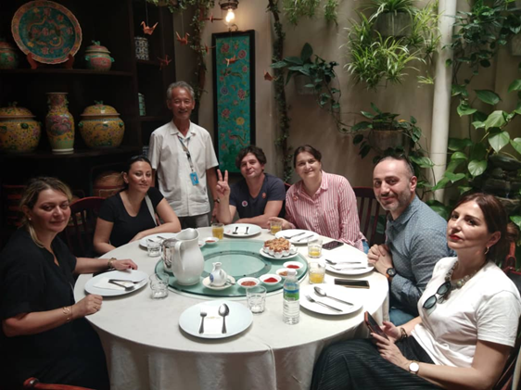  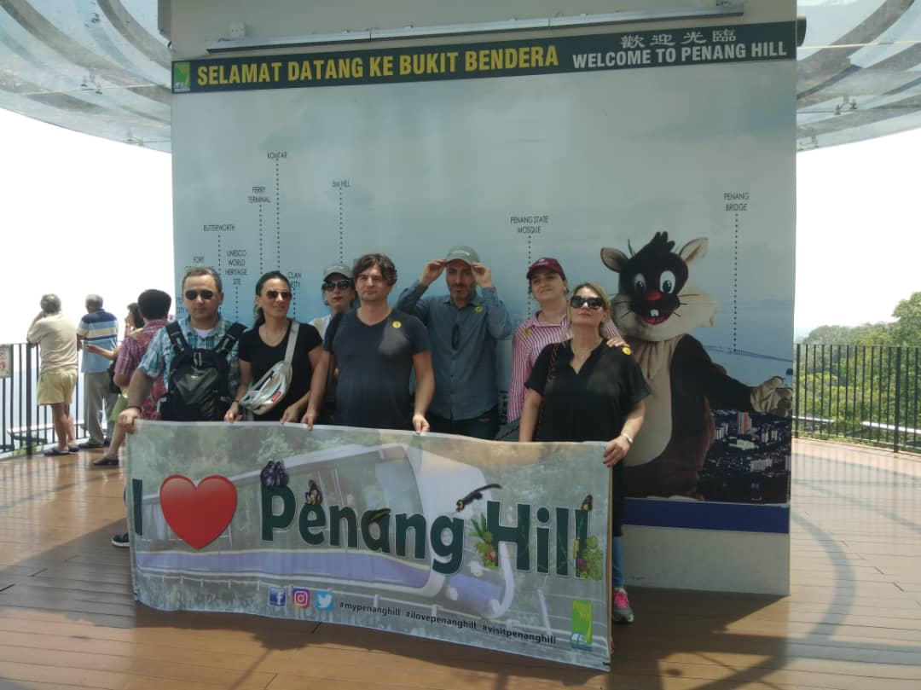
12 | 19-21 March 2019 | Agent | Algeria | QATAR AIRWAYS ALGERIA AGENT FAM  -Penang Global Tourism, Qatar Airways and Tourism Malaysia Jedah is organizing a familiarization tour for Corporate agents from Algeria to Penang from 19-21 March 2019.  -The group of 8 pax consists of; 7 pax corporate agents and 1 Qatar Airways officer  -The accommodation is hosted by Shangri-la Rasa Sayang and Penang Global Tourism will be hosting the ground arrangement such as transportation, tours, and meals throughout their stay here  Agents participating are as follows:  - Mr.Yacine Hebbad- Manager, Gauraya Tours  - Mr. Faouzi Brahimi- General Manager, Nouba Travel  - Mr.Ali Yahi- General Manager, Bitcha Voyage  - Mr. Nidhal Djerioui- General Manager, Djerioui Voyages Cite  - Mr. Amir Belhadj Mostefa- Manager, Numidia Travel Service  - Mr.Zakaria Bouazouni-General Manager, Youmid Tours  - Mr. Sofiane Zane- Manager, Idhourar Tours  - Mr. Houcine Khelaifi- Account Manager, Qatar Airways  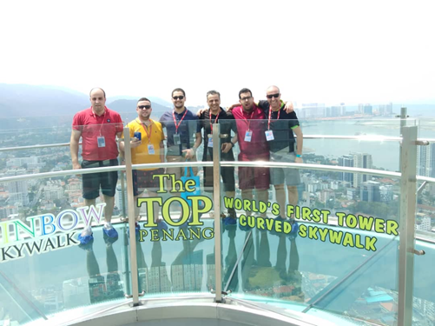  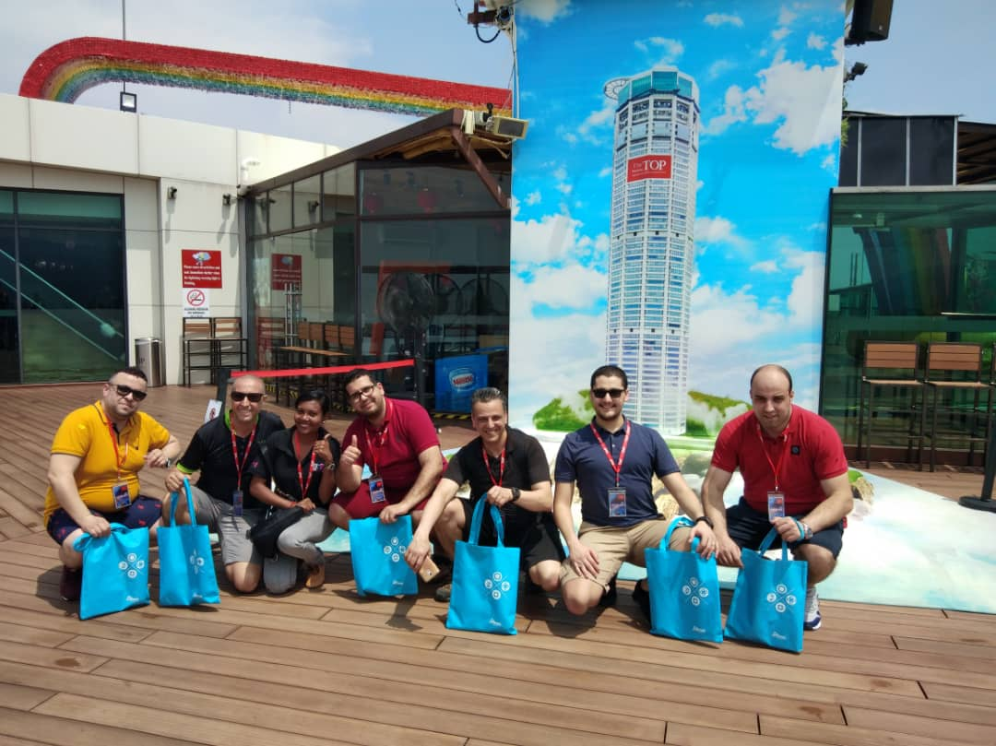
 | 23-26 March 2019 | Agent | Amman | QATAR AIRWAYS AMMAN AGENT FAM  Penang Global Tourism, Qatar Airways and Tourism Malaysia Jeddah is organizing a familiarization tour for Travel agents from Amman to Penang in-conjunction of the new flight from Doha to Penang.  -This group will be in Penang from 23-26 March 2019. The group of 10 pax consists of; 9 Travel Agent and 1 Qatar Airways officer.  -The accommodation is hosted by PARKROYAL Hotel and Penang Global Tourism will be hosting the ground arrangement such as transportation, tours, and meals throughout their stay here  Agents participating are as follows:  - Raad Elshurafa- Partner, Shurafa  - Majed Al Bustanji-Owner, Taqarob  - Abdel Rahim Shalby- Ticketing Senior Officer, Booking Express  - Ismail Abu Saoud- Partner, JET  - Raed AlOufi- Ticketing Manager, Green Meadows  - Malek Al Jabrah- Owner, Magic  - Eyad Al Kilani- Owner, Global  - Victor Tannous- Partner, Sky Reps  - Wisam Nimer- Partner, Diamond  - Maher Rizik- Sales Executive, Qatar Airways  