4. Marketing and Promotions

4.2 Familiarization Trip / Official Visit (June 2020 to November 2020)
No | Project Date | Type | Country | Familiarization Trip/Official Visit | Media Exposure
1 | 20 – 23 July 2020 | Agent | Malaysia | OUTBOUND TRAVEL AGENTS & MEDIA FAM TO PENANG -FIRST BATCH  Penang Tourism Economy Recovery Advisory Board (PETERAB) organized a FAM trip for Top outbound Travel Agencies in Klang Valley to Penang. There have 2 groups involved which are bumiputras and non-bumiputras group and the first batch is non-bumiputras followed by TV2 and TTG media person.  The objectives of familiarization tour held in Penang to convert the outbound travel agencies' customers to planned their holidays in Penang and also for corporate incentives events in Penang.  The agents stayed in Penang for 4 days 3 followed by TV2 Media person and they covered a new attraction in Penang such as Kampung Agong, Fruit farm, and Genting Hill leisure park & Restaurant. 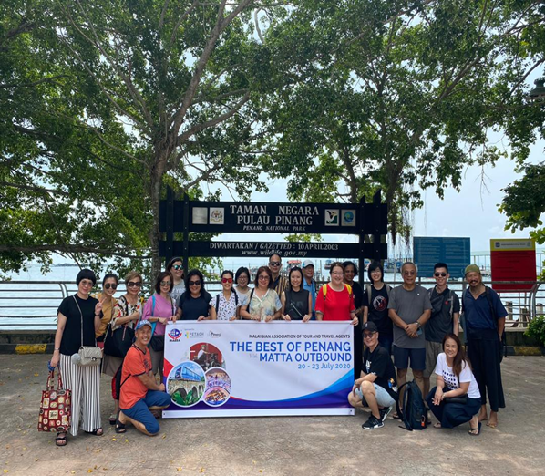  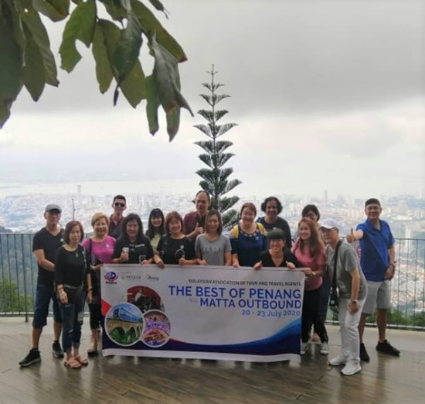 | 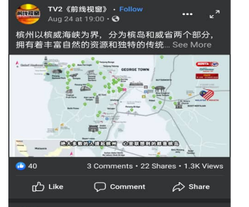  https://www.facebook.com/114544091918888/posts/3550520804987849/?vh=e&extid=0&d=n
2 | 10 -13 August 2020 | Agent | Malaysia | OUTBOUND TRAVEL AGENTS & MEDIA FAM TO PENANG -SECOND BATCH  Penang Tourism Economy Recovery Advisory Board (PETERAB) organized another FAM trip for Top outbound Travel Agencies in Klang Valley to Penang. The second batch agents are bumiputras.  The objective remain same as the first batch is to convert the outbound travel agencies' customers to plan their holidays and corporate events to be held in Penang. RTM have been joining this group to get maximum media coverage in Klang Valley, which is the source marketing.  To make the itinerary more interesting group covered more on island hoping in Penang such as Pulau Aman, Pulau Gedung, Pulau Batu Puyung,  Monkey beach and Pulau Jerejak.  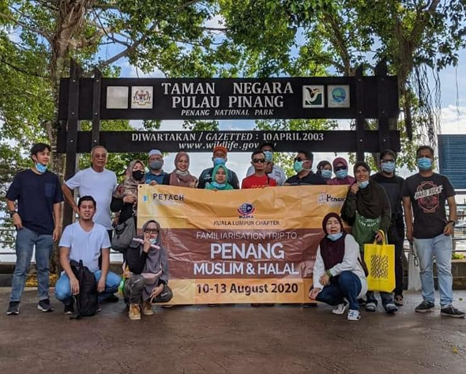  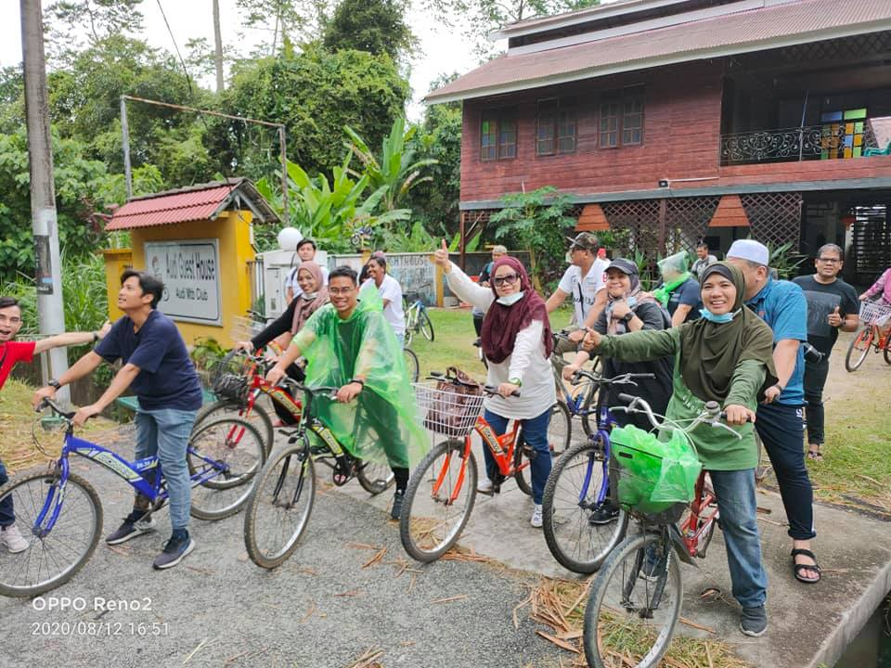 | 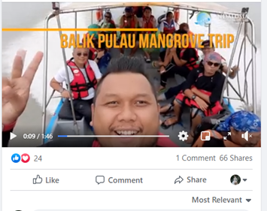  https://www.facebook.com/588137364542234/posts/3304104999612110/?vh=e&extid=0&d=n
3 | 25 – 27 September 2020 | Association | Malaysia | MICA (MALAYSIA INBOUND CHINESE  ASSOCIATION) KOL FAM  MICA (Malaysian inbound Chinese Association) has organized FAM for KOL from different state to promote Penang. The main objective of the Association is to assist and gather all tour operators and tourism-related industry members.  Malaysian Inbound Chinese Association is a registered non-government and non-profit organization under the registrar of Society of Malaysia. The FAM trip tour will be covering all tourism areas include Mainland.  The objective of this FAM to reactive Penang Tourism and encourage people to explore Penang and support domestic market. Total 12 KOL participate in this FAM who built their names on popular niche blogs and social media in return they will promote the attraction on their social media page.  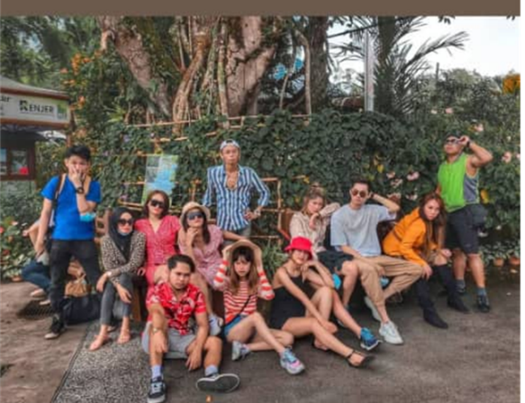  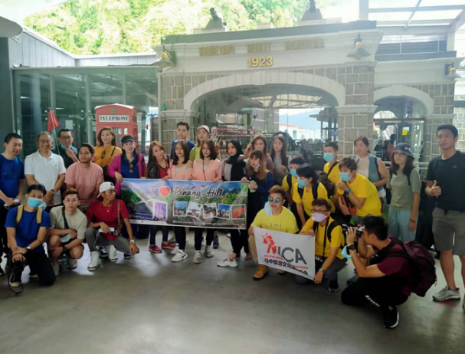 | 1. 2aty_ (237 k)  https://www.instagram.com/2aty_/  2. _l0lli (72.9k)  https://www.instagram.com/_l0lli/  3. adzroolasri (29.5k)  https://www.instagram.com/adzroolasri/  4. therealshashaaa (67.4)  https://www.instagram.com/therealshashaaa/  5. therealyaayaa (68.7k)  https://www.instagram.com/therealyaayaa/  6. shrains_ (8.6k)  https://www.instagram.com/shrains_/  7. lalalandance (6.3k)  https://www.instagram.com/lalalandance/  8. williamtan922 (8.33k)  https://www.instagram.com/williamtan922/  9. aprilchan.vv (10.7k)  https://www.instagram.com/aprilchan.vv/  10. may.s_627 (2.71k)  https://www.instagram.com/may.s_627/  11.sarahmaylow (48K)  https://www.instagram.com/sarahmaylow/
4 | 2 – 4 September 2020 | Association | Malaysia | MCTA TRAVEL AGENTS FAMILIARIZATION TRIP  Malaysian Chinese Tourism Association (MCTA) is incorporated by a group of concerned and dedicated Malaysian Chinese travel agents. It was officially registered with the Registrar of Societies (ROS) on 14th Sept 1992. MCTA has a total membership of 1,005 members nationwide.  The Malaysian Chinese Tourism Association (MCTA) Penang Chapter has organized FAM trip for 40 travel agents from different state. The objective of this FAM trip to encourage the Malaysian to focus on domestic tourism as an international border still closed and to boost Tourism industry of Penang. PGT hosted Penang Hill entrance fee for the members and B2B Session.  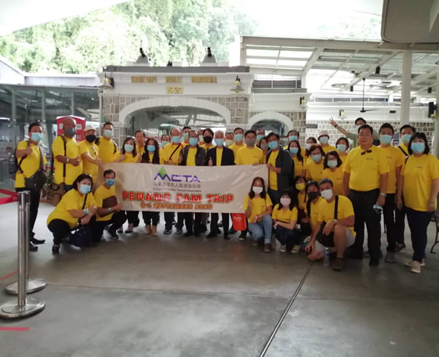  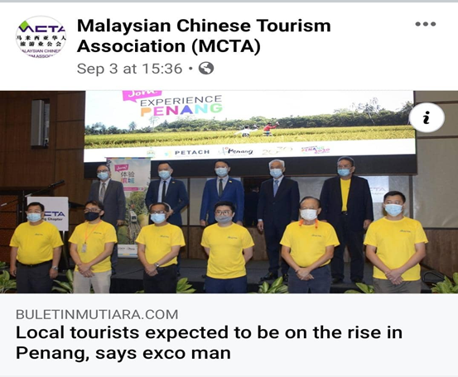
5 | 9-11 August 2020 | Agents | Russia | FAM TRIP FOR EMBASSY ALLIANCE TRAVEL  Penang Global Tourism collaborated with Embassy Alliance Travel by organized a familiarization trip for key person in the organization.  Embassy Alliance Travel specializes in FIT and GIT inbound Tourism, MICE & Business Tourism, Education Tourism and also with different packages around Malaysia and Singapore. The main markets are Russian & CIS, European, Middle East and Asia market coming soon.  The objective of familiarization trip is to create best packages by gather and collect information about Penang. The packages will be promoted and sell to their supporting tour operators worldwide.  The group consists of 3 pax as per below:  1. Ms Polina Eletskaya (Head of Education & campus)  2. Ms Yuliya Yunusmetova (Interpreter Russian Language)  3. Mr Alex Vukovski (E-Commerce Business Development)  