Marketing and Promotions

Travel Meet Asia
No | Event Date | Venue | Virtual Roadshow / B2B | Images
1 | 9 – 10 December 2020 | Virtual Meeting | Travel Meet Asia – South Asia 2020  Penang Global Tourism collaborated with Travel Meet Asia series of B2B virtual events. The two full day of business meeting showcase key buyers and outstanding conferences with leading brands in Tourism industry. Travel meet Asia series has travel roadshow throughout the year.  South Asia is the planet’s second fastest-growing outbound market with 22 million Indians travelling overseas in 2017 spending approximately USD 19 billion. The average propensity to spend of Indian holidaymakers are impressive with family travel and MICE, the South Asia proves to be a very valuable market.  Overall, this event has brought together over 300 attendees and more than 100 invited buyers. The event focused on South Asian countries such as Afghanistan, India, Pakistan, Bangladesh, Sri Lanka, Nepal, Bhutan and Maldives. The buyer’s profiles have been included in MICE, Corporate and Leisure segments at each exclusive virtual networking session.  The virtual meeting session with PGT participated by 9 Travel agents. The session begins with introduction of both side and continue with product explanation end of Presentation the agents asked few questions such as the status of Malaysia border opening date and the flight details.  During the meetings due to time limitation and internet connection some of meeting not able to connected. |   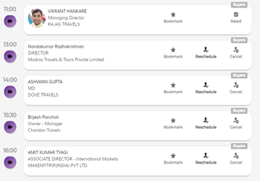  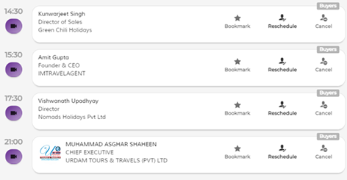  < Business Matching list >  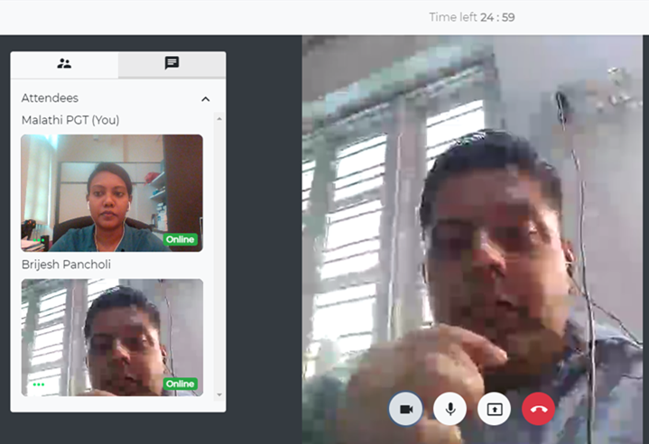  <Meeting with MR Brijesh Pancholi Chandan Travels>  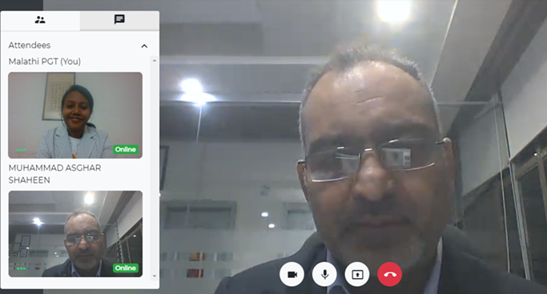  <Meeting with MR Asghar Urdam Travels>
2 | 24 – 25 February 2021 | Virtual Meeting | Travel Meet Asia – Southeast Asia 2021  Travel Meet Asia second  Conference focused on Southeast Asia. Two days B2B virtual event and online business focused on the Southeast Asia Region (Brunei, Myanmar, Cambodia, Timor-Leste, Indonesia, Laos, Malaysia, The Philippines, Singapore, Thailand and Vietnam). The business matching for exhibitors and buyers brings 300 attendees and 100+ buyers on the MICE, Corporate and Leisure sector.  The virtual meeting session with PGT participated by 3 Business Matching partners such as Madam Melody Palomares  President of MAVP Travel & Tours, Ms. Amee Shah  International Business Development Manager from  Puratech Solutions India Pvt Ltd and lastly Mr Aimee Carmela Vergara  Global Executive of  ConferenceDirect.  In this session has explored various trends in destination marketing that have emerged from the pandemic and also provide insights on what destinations and hospitality providers are doing to remain attractive to travelers now. |   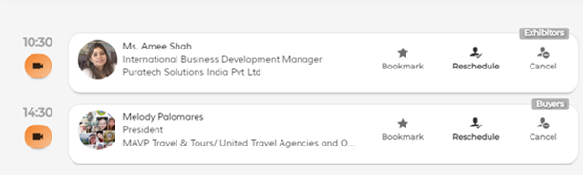    < Business Matching list >  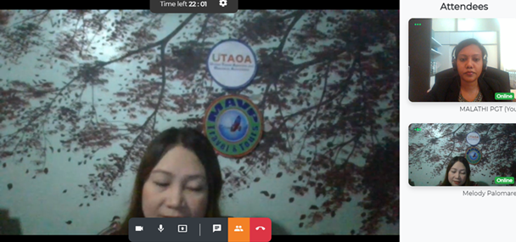<Meeting with Madam Melody Palomares>  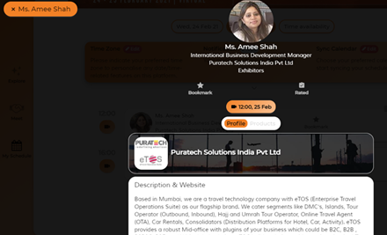  < Ms. Amee Shah profie >  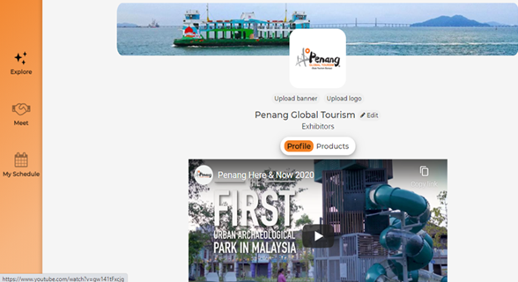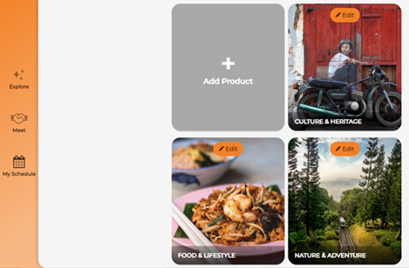  < PGT page>

